CD 485 Computer Applications in Communication Disorders and Sciences
MODULE 3
SECTION V IDENTIFYING THE APPROPRIATE DATABASES FOR BOOKS

After living around Library Card Catalogs (and now Library Computers) for too many years I have come to the conclusion that in the Library Universe, there are two kinds of matter: Books and not-Books. To find books in our field of Communication Disorders, there are a number of places to look. But at this point in time, four particularly useful online sources come to mind:

A. GEAC (The CSUN Online Library Catalog that indexes all the books in the CSUN Library);
B. The CSUN Union Catalog (which indexes books in all the CSU Libraries);
C. World CAT (which indexes books all over the world);
D. Google Book Search (which includes books in libraries as remote as Venus (for women) and Mars (for men).

(As you read on, it might be more interesting if you opened another page in your Browser and followed along using the links as they are described.)

A. IDENTIFYING THE APPROPRIATE DATABASES – BOOKS FROM THE GEAC, THE UNIVERSITY LIBRARY ONLINE CATALOG

The CSUN Library contains one of the most impressive collections of books in the country related to the topic of Communication Disorders and Sciences, thanks to the diligence of our librarian, Marcia Henry! Hence, you may frequently want to check the University Library Online Catalog, for books and journals. The information and tutorials on how to use this Catalog are all available online; but there are a few helpful features, which I would like to particularly draw to your attention.

There is, of course, as we saw previously, a basic Catalog Search Engine on the Library Home Page.

GEAC Catalog Basic Search
http://library.csun.edu
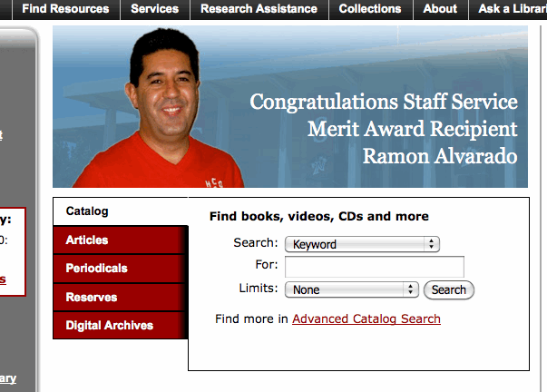

To get to a more sophisticated GEAC search strategy, we can click on the ““Advanced Catalog Search” link.

GEAC Catalog Advanced Search
http://library.csun.edu/mhenry/bibcd.html

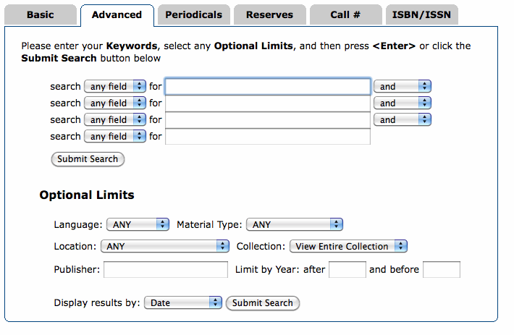

Another way to get to the Library Catalog is from the Communication Disorders: Research Guide for Speech, Hearing, Language page which was also described earlier.

Communication Disorders: Research Guide for Speech, Hearing, Language (Top)
http://library.csun.edu/mhenry/bibcd.html
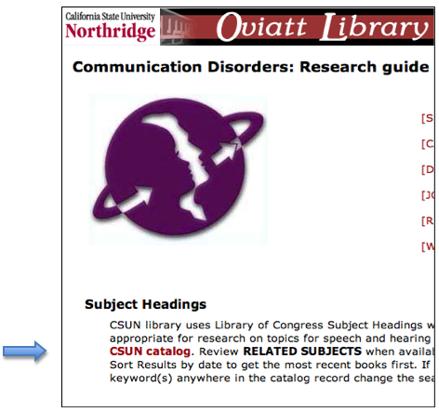

When we click on either link, we will be presented with a Basic search form to begin our search.

CSUN Library Online Catalog (Quick Search Strategy)
http://suncat.csun.edu/

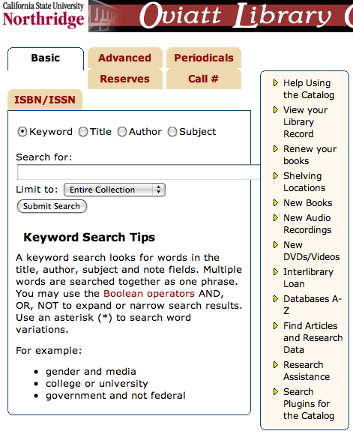

Before we do any searching, I suggest we check out the Help Using the Catalog link (in the right hand column)! This will give us some crucial hints that will save much time, and increase the efficiency of our search strategy. Also, two important concepts to look for are Truncation Symbol and Boolean Operators. Clicking on the Boolean Operator link (shown in red in the illustration above) will bring us to an explanation of the Boolean concept (shown below), plus the value and use of the "Truncation" symbol “ and “Wild Cards”
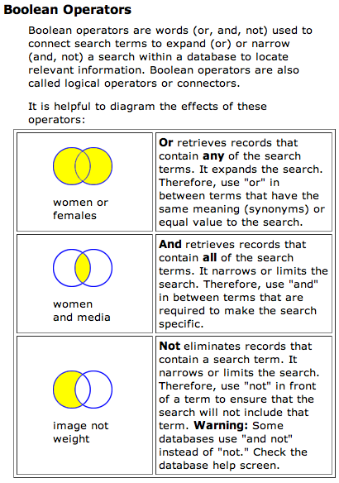

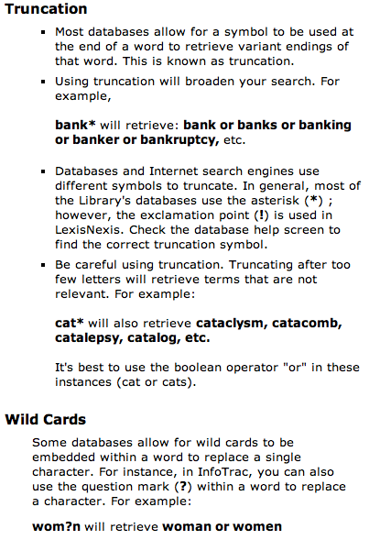

These are important search tools and are worth mentioning here also. In regards to Truncation, for example, if you type in a word like “Communication” for a key word search, that is what the search engine will look for and we might miss a reference that used the word Communicate, Communicator or Communicative etc. But if we use the truncation symbol (*) after the root of the word, as in Communicat*, the search engine will pick up all references with this base. This widens our search considerably. One asterisk can replace from 1 to 5 characters. If we think there may be more, we would have to use two asterisks. Other databases use a truncation symbol, and some even use the asterisk, but not all do! So it is important to check out the instructions to find out what the truncation symbol is for a particular database.

The use of Operators to make a Boolean Search is also a very important part of the search strategy. In an Online Library Catalog keyword search, typically, multiple words presented adjacent to each other are searched for as an exact phrase. For example, if we type in “Alternative Devices for Communicatively Disabled Persons,” this exact phrase must appear in the reference before it will be reported by the search engine. But, there are words called “Linking words,” which are provided by the search engine, like “and,” “or,” and “not” which can be used in creative ways to shape the search. For example if we use “and” in a keyword search, (e.g., augment* and alternat*,”) the search engine will report only references that have both those words in any order in the reference. But if we use “or” (e.g., “augment* or alternat*,”) it will report references that have at least one or both of the terms. But if we wanted to exclude references dealing with alternative devices, we would use the operator (and not), (e.g., augment* and not alternat*.” )

In a Boolean search strategy, we should also pay close attention to the use of parentheses. If we use for our search, the words “augment* and alternat* and not hearing,” the search engine would exclude references including a mention of hearing devices that were alternative, but include hearing devices that were augmentative. To have hearing devices excluded from both, we would have to search for “(augment* and alternat*) and not hearing.”

Now back to the University Library Catalog and its search engine.

CSUN Library Online Catalog (Quick Search Strategy)
http://suncat.csun.edu/

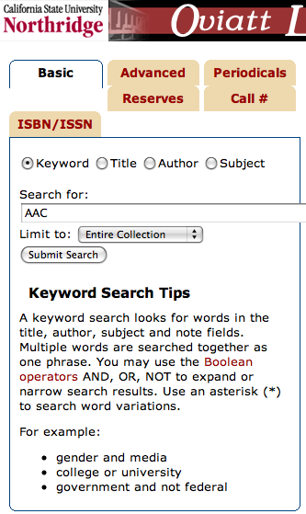

If we know the Title, the Author, The Subject, the Call Number or the ISBN/ISSN Number of the book we want, we will be able to go directly to the reference by using those options in the Search Engine. If not, we should search by using a relevant keyword or words that might appear in the title, index or text.

University Library Online Catalog (Initial Reference List of Books from Quick Search)
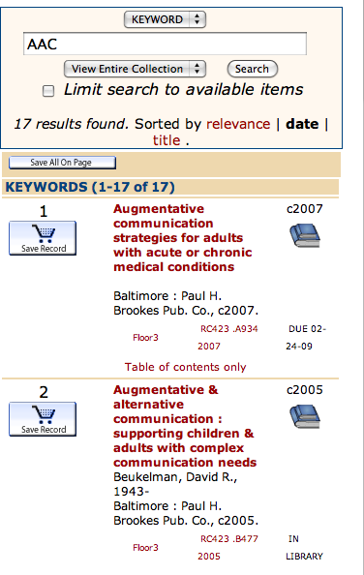

If we don’t want to do a Boolean Search, we can use this “Quick” search strategy (illustrated above). As a first step, for example, to see what is out there, we might type in “AAC,” a common abbreviation for Augmentative and Alternative Communication. This rudimentary Quick Search gave us, at this time, 17 references, twelve of which are quite germane to our topic. Number 1, for example, is “Augmentative communication strategies for adults with acute or chronic conditions.” If we click on the Title of reference Number 1, we will get the full reference with more important information. This includes among other things, the Call Number, the ISBN number and the fact that the Table of Contents is available electronically.

University Library Online Catalog (Full Reference)
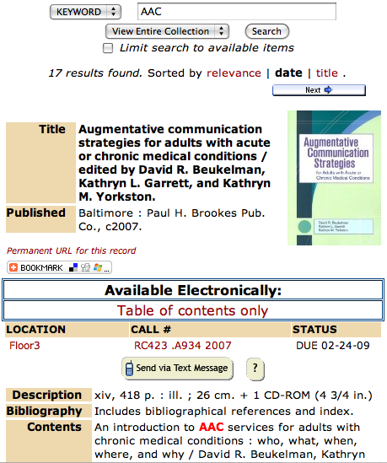

More importantly for DE students, the notes opposite the “Subject” category (see below) can be very useful in providing additional relevant words (other than those that were used for the search) that we can use in further search efforts.

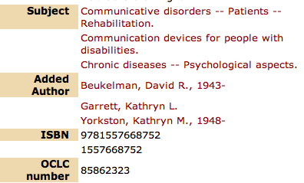

For example, we see the words “Communication, devices and disabilities,” which may be better search terms than simply AAC.

Of course, all this came about through the “Quick Search” option. If we wanted a more extensive or exclusive list of references we might go to the ADVANCED Keyword Search strategy with its more precise Boolean search capability.

CSUN Library Online Catalog--ADVANCED Keyword Search Strategy (Top of form)
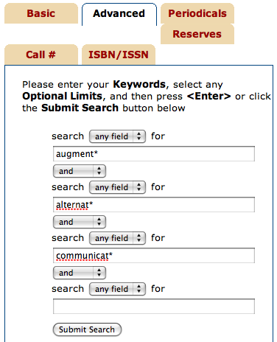

We can get to this form by clicking on the ADVANCED tab at the top of the form. There are a number of useful options on this page. Please remember also that there is the box to the right of the form (shown earlier but not here) with a number of links, one of which is called “Research Assistance.” This summarizes some of the more important research tools at our disposal.

But I digress. If we enter in the keywords,” augment*" and "alternat*" and "communicat*”, we can limit our search to references in English (i.e., by language) and within a certain time period, etc., and then we can have them presented by Date so that the most recent are listed first. These last options are available farther down on the same form.

CSUN Library Online Catalog--ADVANCED Keyword Search Strategy (bottom of form)
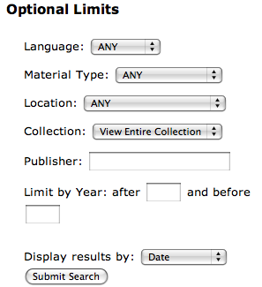

With this search strategy we get at this time 29 very relevant reference listings.

UNIVERSITY LIBRARY ONLINE CATALOG (REFERENCE LIST OF BOOKS FROM ADVANCED SEARCH)
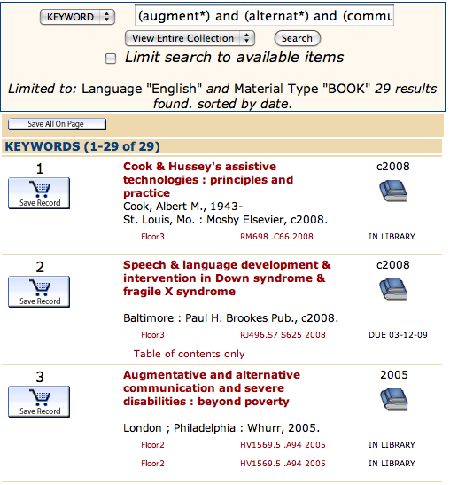

As before, the full reference can be obtained by clicking on the title.

Once we find a reference we want, there is information provided as to the floor in the Library it is on, The Call Number and it’s status, i.e., whether or not it is in, or when it is due or if there is a hold on it etc.

B. IDENTIFYING THE APPROPRIATE DATABASES – BOOKS FROM THE CATALOG OF THE CALIFORNIA STATE UNIVERSITY LIBRARIES (CSU UNION CATALOG)

If we wanted to cast a wider net so that the availability of a book in another CSU Library could be detected, we could use the Catalog of the California State University Libraries’ Search Engine. We might want to do this, for example, if we lived near another CSU Campus, or were writing a dissertation that required an exhaustive search of the literature. In the latter case, we could use the Inter Library Loan service. However, for this class, there is neither need nor time for such an action. To access this catalog, we can start from the Communication Disorders & Sciences Library Home Page.

Communication Disorders & Sciences Research Guide for Speech, Haring & Language Page (Top)
http://library.csun.edu/mhenry/bibcd.html

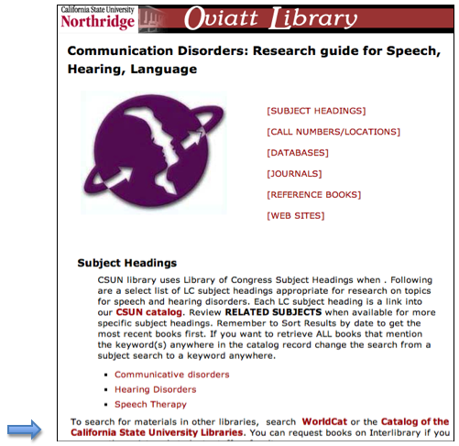

This will take us to the search engine for all the CSU Libraries.

Catalog of the California State University Libraries’ Search Engine
(CSU Union Catalog)

If your screen does not look as complete as the illustration above, click on the “More Options” link below the word search and these Advanced Search Terms and Limits will appear. We can enter our search words under the General Keyword category, as before, and limit (or in this case widen) the search to all Locations.

SEARCH RESULTS

Using the search words, “augmentative, alternative, and communication,” we received at this time 4 germane references. Clicking on the title of any particular one (for example the first) will give us the list of CSU Libraries that have the source…

…and to the right, (see below) are examples of three different reference style for citing this Reference: APA, MLA and Turabian. This is really handy if we are requested to use a particular reference style.

If we click on a particular library that has this book, we will be taken to that Library Catalog, which will give us specific information about where it is located and if it is in etc.

Clicking on the Title, as we know, will give us the full citation

C. IDENTIFYING THE APPROPRIATE DATABASES – BOOKS FROM WORLDCAT

WorldCat is important because it can be used to order books for delivery. It is true that the University On-Line Catalog provides some important extra information on books, such as related Subject Headings, Call Numbers, location and whether or not the book is checked out. WorldCat , however, provides easy access to the Inter Library Loan (ILL) service.

To search for and obtain books, we can log into the database called WorldCat. Like the University Library Catalog, this is really nothing more than a computerized version of what used to be the old Library Card Catalog, except that this covers the World. For the one or two students in the program who like me remember the slogan, “I Like Ike”, you may also remember those cabinets that used to be in the front of every library with drawers and drawers of cards with references for all the books, Like Ike, the cabinets and cards are gone now, and in their place we have computers and a software called WorldCat. WorldCat is a computer-access online database that can be used not only to find out if the CSUN Library has a book (or a journal) but also if any other Library in the State or Nation, or the World has it in their collection. This is not just of academic interest, because if a Library other than CSUN has the book, it may be in a location near to you (like Hawaii, or even Palmdale California) and you may be able to go there and check it out! In the not too distant future, I suspect, many of these book themselves will be totally on-line, text and all, and we will be able to access them from our home computer. Of course, most of the books at CSUN are listed in WorldCat, although, specific information, such as call numbers and availability, is not included. Let me also underscore the fact that you can find out through WorldCat (and the University Library Catalog too) whether or not our Library has a certain Journal. But, you cannot, of course, search for particular articles in that Journal in WorldCat. For that you must go to other databases, which we will discuss later.

It is very easy to access World CAT. But before we do, let me first mention the “middle man,” called FIRST SEARCH. The University does not maintain World Cat directly. Instead, it subscribes to a Provider Service that does maintain it. We, as students and faculty of CSUN, have access through the University to this service. The name of the service is FIRST SEARCH. There are many ways to get to FIRST SEARCH and hence, WorldCat. For now we can access it through the WorldCat link on the Communication Disorders & Sciences Library Home Page, developed by our Librarian, Marcia Henry.

Communication Disorders Research Guide Page (Top)
http://library.csun.edu/mhenry/bibcd.html

You have probably noticed that there are two WorlCat links listed. The first, Worldcat, is outside of the First Search Service and hence is free to the general public. It lacks, however some nuances, like the Find Text link. The latter, available only to CSUN Students, has the full range of capabilities. As is characteristic of a Provider Service, when we log into FIRST SEARCH for a book database (like World CAT), the screen will have a layout that is distinct for the Service. If we look up some other database in this service, the format of the layout will always be very similar. Here is an example of what the Provider First Search looks like:

First Search (featuring WorldCat)
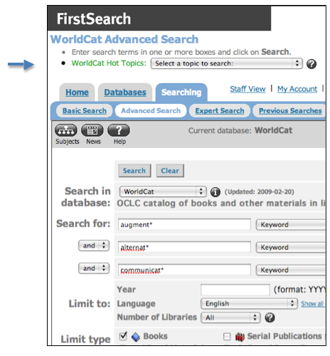

Any database in First Search will have the above format. Because there are very few nuances that are not shared between the databases on FIRST SEARCH, it will be easy to forget which database we are using. But FIRST SEARCH will always have it posted in somewhere on the page (see the arrow above).

For a very helpful, brief tutorial-like introduction to FIRST SEARCH and how to use it, check out the following URL…

http://www.oclc.org/firstsearch/about/tour/default.htm#top

When First Search opens on the screen from our Research Guide page, it will be focused on the WorldCat database. We are ready to begin our search.

Let me say again that linking into the tutorial on how to use FirstSearch, mentioned above, would be well worth our while before we do this.

I also suggest that at this point we explore all the pull-down menus on the page, and remember that in most cases, the instructions for what we need to do are posted somewhere on the screen.

One of the big decisions we have to make first in our search for a book is, what our strategy will be for the search. For example, we could use, “keywords” as opposed to “author” or a phrase in the “title.” And the keywords I might suggest off the top of my head might be “Alternative, Augmentative and Communication.” We could even use their truncated form (*).

We might wish to limit the search to English unless we speak more than one language; and we might also want to arrange the findings by date so we get the most recent books listed first.

This strategy, as simple as it is, yields some productive references: 423 book references in all. Interestingly, without the truncation symbol we would have received 317.

Reference Numbers 1, 2 & 3 of the 423 located by WorldCat through FirstSearch
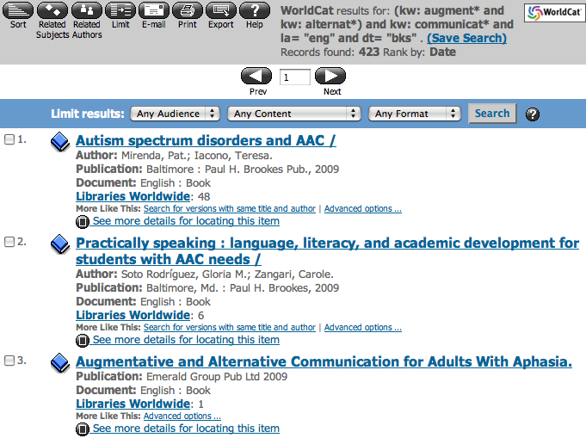

We will probably be looking for a book that is in our CSUN Library, since these are the only ones that we can get delivered as a Distance Education Student. One way we can tell if the book is in the CSUN Library is that the reference will include the following icon …

WorldCat includes this icon if it has been notified that CSUN has the book. If the icon is not there, WorldCat may recommend that we check the CSUN Library Catalog to see if the book has been obtained yet.

If the book is not in the CSUN Library, we may wish to see what libraries do have it. If we wish to have it delivered through Inter Library Loan, we may find one library, which has the reference in our vicinity. In the first example reference above 48 libraries Nation wide have the book. I can get a list of them by clicking on the “Libraries World Wide” link.

Universities that Own the Reference Listed by WorldCat through FirstSearch
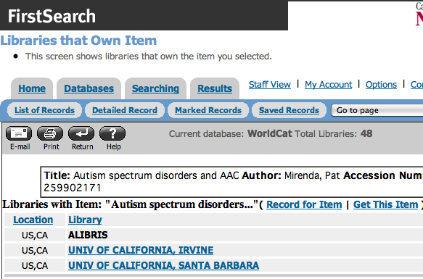

There are in this case three locations in California. If we live near one of these, for example, we may be able to go to that library in person and check out the book.

Please note that if the above list had included a CSUN Library because it had a copy of this book, that line itself would be an active link that would take us directly to the same reference in the CSUN Library Catalog where more information, like the Call Number, can be obtained.

Now, if we go to the full reference in WorldCat by clicking the cursor on the main title of the article, we can also get some additional important information. Besides the usual name, author, publisher and description etc., we will also find some subject descriptors or terms (not shown in the window below). These could be very useful particularly if we only had found a few references using the terms “augmentative, alternative, communication.” Other terms, for example, might be “Communication Aids for Disabled.”

The Full Reference Located by WorldCat through FirstSearch

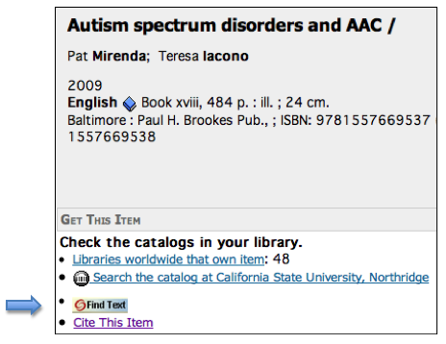
Another important link on this Full Reference page is the “Find Text” link. This is a common link connected with many references. In this case this link leads us to a message that tells us that there is no electronic copy of the book online. If there was, we could click on this link to go to the reference in the CSUN GEAC Catalog.
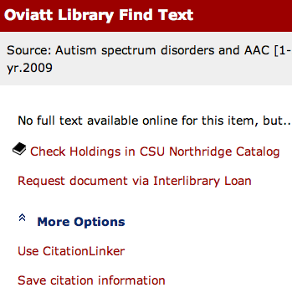

Equally important, however, under the ”More Options” pull-down menu is the link to the “Save citation information.” What is useful about this is that it gives us the option to save the citation in a number of different formats, one of which is APA.

Save Citation Information Menu
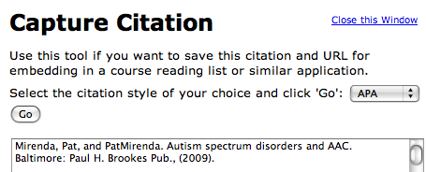

When we click “Go” it rearranges the format of the citation to the selected format.

Citation Changed to APA Format
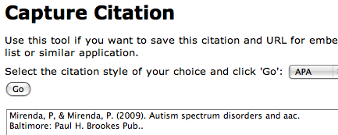

This can be copied and pasted into our citation list at the end of our paper. A word of caution is needed here, however. We need to always check the citation to be sure some element of the citation may not have been overlooked by the computer, like the authors, etc. If that happens, we will need to fill in the missing information. This automatic formatting procedure will work anytime we see a “FIND TEXT” link!

As a general rule, the CSUN Library now provides an Inter Library Loan Service (ILL) link, which is connected to the Find Text link; but the ILL link on Find Text is currently set up to NOT provide an ILL link when CSUN owns an item.

D. IDENTIFYING THE APPROPRIATE DATABASES – BOOKS FROM THE GOOGLE BOOK SEARCH.

The most direct way to go to Google Book Search is to go to…

http://books.google.com

This takes us to the Google Search Page…

Google Search Page

Using the search words “AAC and communication,” we get 789 references.

Google Book Search Results
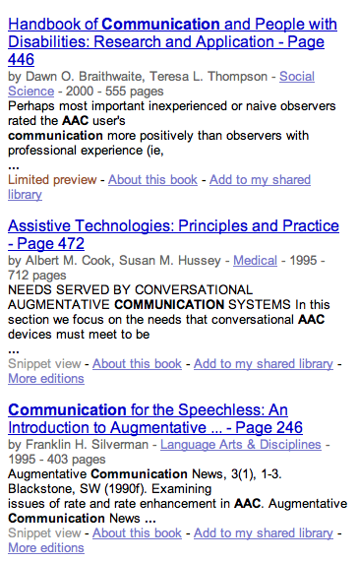

What is particularly interesting about the Google Book Search is that when we click on the reference we get a citation that has a limited preview of the text.

Google Books Full Citation with Limited Preview

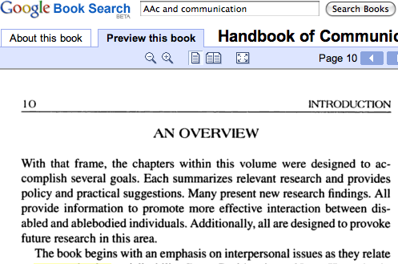

It is also possible to access Google Book Search from within the CSUN Library web page structure. We could start as before on the Communication Disorders & Sciences Library Home Page and scroll down to the middle where the Databases are listed.

Communication Disorders & Sciences Library Home Page (Middle)
http://library.csun.edu/mhenry/bibcd.html

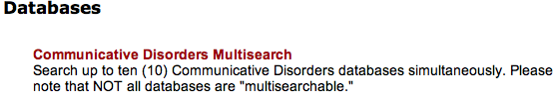

If we click on Communicative Disorders Multisearch, we will come to a Service that lists many of the Databases useful for Communication Disorders Students. We will discuss this Service later. But for now, we can go to the bottom of the list and check Google Book Search.

Communicative Disorders Multisearch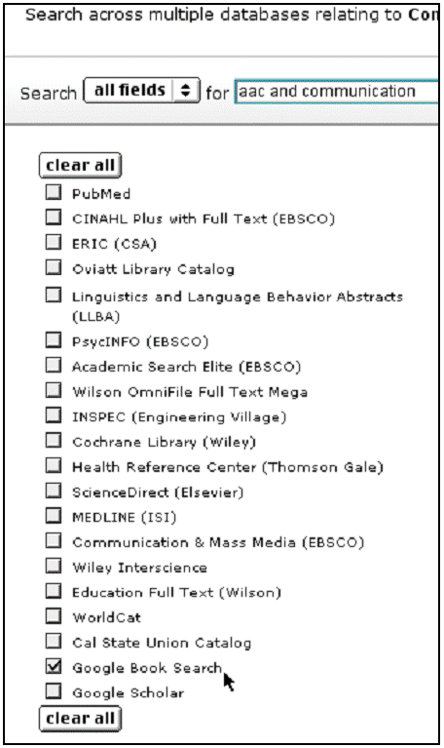

Using the search strategy “aac and communication” and checking Google Book Search we come up with 604 references.

Communicative Disorders & Sciences Multisearch Results

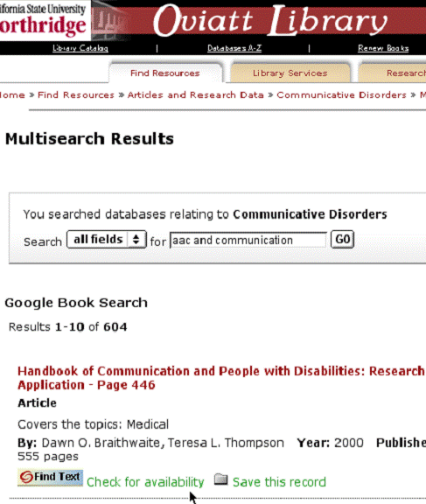

The advantage, of course, of using the Google Book Search within the CSUN Library Structure is that if we find a reference we like, we can check to see if it is in the CSUN Library through the “Check Availability” link.

Find Text (Check for availability in CSUN Library)

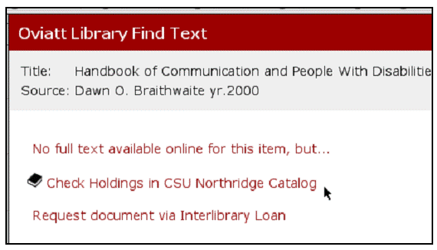

On the way, we may note that there is no electronic copy of the book online, but we can continue to see if the book is available in the CSUN Library.

University Library Online Catalog (Initial Reference List of Books)
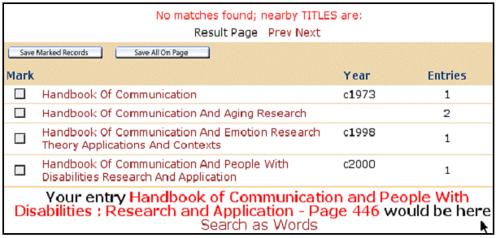

In this instance, the book is not in the CSUN Catalog and we would have to go to the CSU Union Catalog or to WorldCat to find where this book may be located.

There are many other ways to look for books than the four that we have singled out here. We will undoubtedly come across many of these in our wanderings through the maze of online library links, but for now let's go to another Section of this Module and look at some ways to find Journal Articles.

