Books

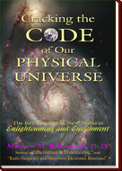
Cracking the Code of Our Physical Universe
(June 2006)
What if you could raise your understanding toward a higher plateau of knowledge and enjoy a more powerful life filled with enlightened decisions. This book lays the trail map of any and all things that Man has discovered, and shows you how to bring about new discoveries and understandings regarding our remarkable universe!
- Table of Contents and Preface
- Testimonial
- News Release
d) Published Book Review

************

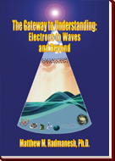

The Gateway to Understanding:
Electrons to Waves and Beyond
(March 2005)
The subject of waves particularly, electronic waves, has been piecemealed to a point where every text covers only a small part of the subject and leaves the rest to someone else to develop.
To view each, please CLICK on it:
- Table of Contents and Preface
- Testimonial
- News Release
d) Published Book Review

************

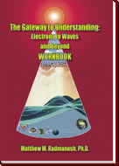

The Gateway to Understanding:
Electrons to Waves and Beyond
WORKBOOK
(May 2005)
Learning the subject of electricity and electronics through the study of this workbook is tremendously more beneficial than simply purchasing and reading the book on your own.
************

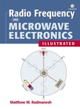

Radio Frequency and
Microwave Electronics Illustrated
(January 2001)
This highly illustrated resource makes grasping the fundamentals of RF and microwave electronic theory and design easier and faster.
a) To DOWNLOAD a free CD-ROM on Microwave Circuit Design, please CLICK HERE.
(This is a standard zip file that can be unzipped with PKZIP, WINZIP, FREEZIP)
b) To view the Errata Sheet, please click HERE.

************

