Accounting Rules Should Avoid Impairment
Heard on the Street By MICHAEL RAPOPORT The Wall Street Journal, page C18, April 1, 2009 accessed online at: http://online.wsj.com/article/SB123853741935475351.html?mod=djem_jiewr_AC#
Plenty of banks have succumbed to the credit crunch. Now, accounting rules look set to join the list of casualties.
Accounting rule makers will vote Thursday on proposals to soften "mark-to-market" accounting, the controversial rules requiring companies to peg their investments' value to the market's ups and downs. Many banks blame the rules for worsening their current problems, by locking in losses that they say are merely temporary.
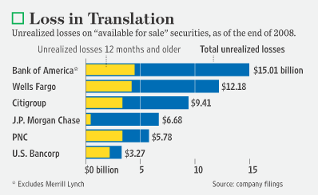
The banks' claims are largely bogus -- after all, no accounting rule forced them to create and invest in the toxic securities that helped cause this crisis. But the Financial Accounting Standards Board is being pressured to water down the rule.
And one of the proposals that the board will vote on Thursday, to relax the standards under which companies must take impairment charges on their "available-for-sale" investments, would be particularly worrying for investors.
Companies record declines in their value of these securities as "unrealized" losses that get assessed on the balance sheet but don't affect earnings or regulatory-capital levels.
If the losses are later determined to be "other than temporary," however, companies must take impairment charges that lower net income and regulatory capital.
FASB's proposal makes it much less likely that stressed banks would take those charges in a timely fashion. Under the plan, all banks would have to do is say they don't intend to sell an "available-for-sale" investment that has incurred mark-to-market losses and probably won't be forced to sell before it recovers. Then, only "credit losses," the amount a company expects to lose if it holds an investment to maturity, would have to be recognized in earnings. The other declines in market value would only go onto the balance sheet, as now.
The loophole is big enough to fit a bloated bank balance sheet through: The risk is that banks wouldn't admit to a major credit loss on such securities unless the losses really were so obvious they simply couldn't be ignored. Banks could instead try to explain away low market values because of external factors such as liquidity risk, and many losses would never get recognized on the income statement.
That could be very important for some banks where toxic securities, with serious mark-to-market losses, comprise a big part of the capital structure. The unrealized losses on "available-for-sale" securities in effect for at least a year are equivalent to 6.6% of risk-weighted capital at U.S. Bancorp and 3.2% at Wells Fargo. That is another reason why investors should focus on tangible common equity as a capital measure instead, which does include such unrealized losses.
A rule change would be good for the banks -- not good for investors who need accurate valuations of companies' assets, reported clearly, on which to base their investment decisions. In fact, making things easier on the banks may only make already-cynical investors even more suspicious of the numbers that the banks are reporting.
This is happening now because of pressure on FASB Chairman Robert Herz from politicians who, at a recent hearing, threatened to eviscerate fair-value accounting if the changes didn't happen. So it isn't just the fair-value rules that are at stake here -- it is FASB's independence in setting all accounting rules. The risk is that plans to water down mark-to-market rules are only the start.
Write to Michael Rapoport at Michael.Rapoport@dowjones.com

