Classwork ASSIGNMENT: PLOT
Fill in the blanks below to complete a Freytag Pyramid on the story you have chosen.
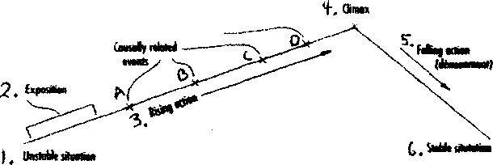
1. Unstable Situation (primary conflict):
2. Exposition:
3. Rising Action: A.
B.
C.
D.

4. Climax:
5. Falling Action:
6. Stable Situation:

