The five characteristics of strategic thinking are discussed in the article on strategic thinking found in the course pack and on the course web site. The five characteristics of strategic thinking are as follows:
http://www.csun.edu/sites/default/files/strategic.thinking.pdf

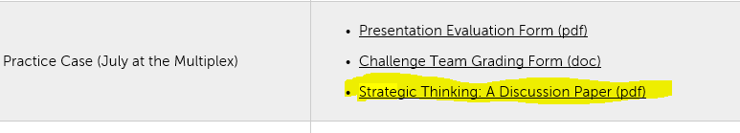

  - Systems Perspective: Seeing the Big Picture or thinking “holistically”

  - Intent-Focused: Having a sense of direction or destiny that is driven by a unique point of view about what the future will look like

  - Intelligent Opportunism: Openness to new experiences in order to take advantage of alternative strategies

  - Thinking In Time: Understanding and dealing with the gap between the current reality and the intent for the future

  - Hypothesis Driven: Use of creative and critical thinking using facts and not inferences

