Accessibility - 7 Quick Key Points

Promoting, Purchasing, Supporting Technology

- Can you tab through each area on a website or software application? Do you see a visual indication of where your cursor is on the screen such as a dotted line around a link, or a clickable area becoming larger and a different color? Below is a screen shot of some typical regions of navigation on a website or application.
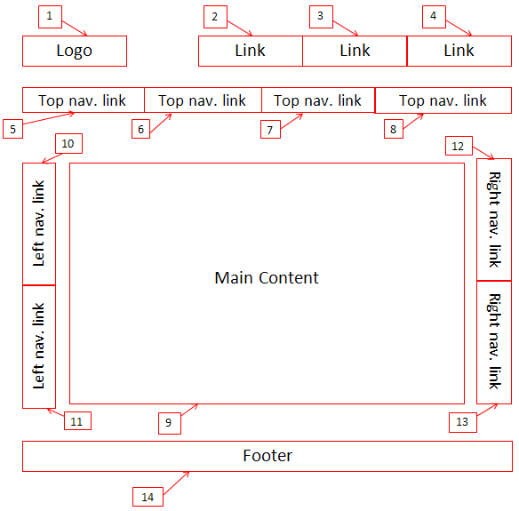
- Can you complete the functions of the website or application without a mouse?

- Does the color used on the page appear hard to read? This could mean that the contrast in the colors used is not sufficient for other users. For example a light gray text on a light gray background is hard to read for many people. Below is a gray circle with light gray text which is hard to distinguish.
Light Gray TEXT is harder to read

- Can you enlarge the screen without distorting the text? This can be done using the Ctrl + key stroke. Below is a screen shot of a website that has overlapping text when it is enlarged.
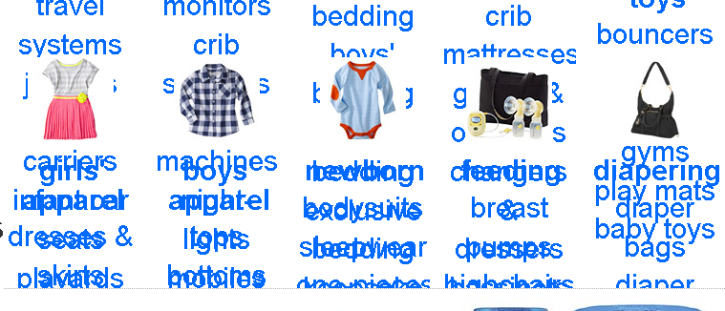
- Do meaningful images have a description in the text around the image, as done in this document? Or do images have meaningful Alternative Text? 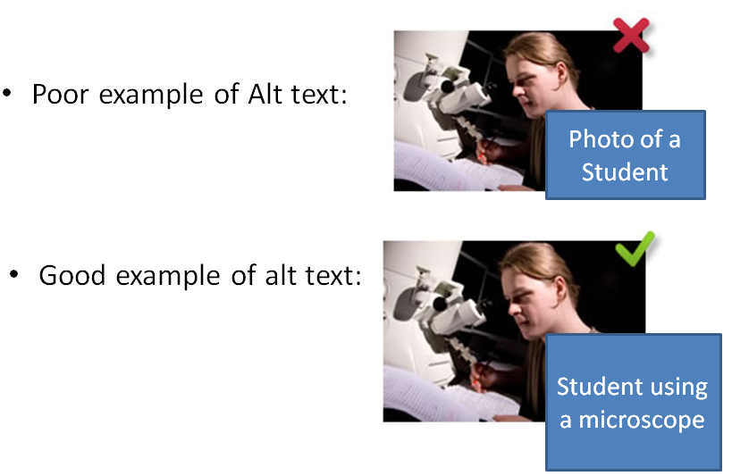
- If the product has form fields are the labels associated with them so that nonvisual users can understand what to enter into the form field? To test for a label, use the WAVE Toolbar. UDC can instruct you on the use of this toolbar.

- Ask the company for a Voluntary Product Accessibility Template (VPAT). This is a statement from the company regarding their alignment with federal guidelines for accessibility. If purchasing a product, share the CSU ATI Polices with the company and request a statement in the contract that outlines their ability to comply with the CSU polices. Executive Order 926, contains the basis for the polices and the updated Coded Memo AA-2013-03 provides the current vision for ATI.
EO 926: http://www.calstate.edu/AcadAff/codedmemos/AA-2013-03.html
ATI Coded Memo: http://www.calstate.edu/AcadAff/codedmemos/AA-2013-03.html

*Note: UDC can help you review products and interpret the findings from the review and VPATS. You may also find support through your ATI Coordinator. A list of coordinators can be found on the Universal Design Center webpage (www.csun.edu/udc)

