A film by Konstantin Khabensky
«SOBIBOR»

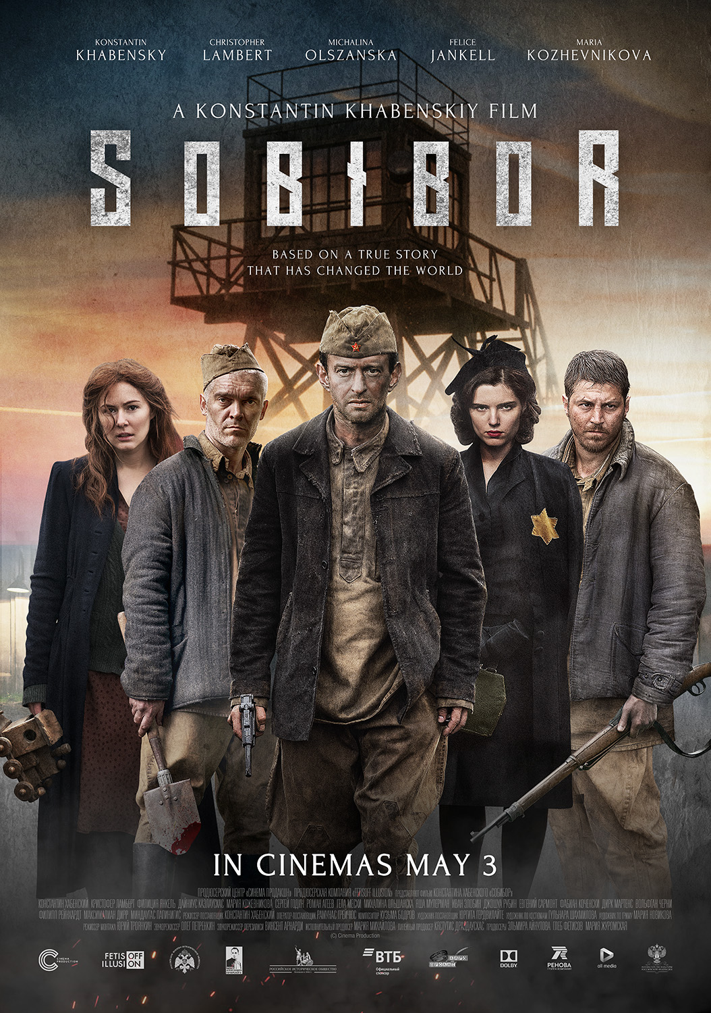

IN THEATRES MAY 3

Stills: https://yadi.sk/d/tP2NUi6F3Swsfx

Director Konstantin Khabensky
Cast Konstantin Khabensky, Christopher Lambert, Michalina Olszanska, Philippe Reinhardt, Mariya Kozhevnikova, Felice Jankell, Dainius Kazlauskas, Gela Meskhi. Sergey Godin, Roman Ageev
The Narrator Sergey Burunov
Art Director Andrey Malyukov
Script Konstantin Khabensky with the participation of Alexander Adabashyan, Anna Chernakova, Andrey Nazarov
Cinematography by Ramunas Greicius
Production Design by Jurgita Gerdvilaite
Producers Elmira Aynulova, Gleb Fetisov, Mariya Zhuromskaya
Production by Cinema Production, «Fetisoff Illusion» with the support of Alexander Pechersky Foundation, Russia, 2018
Based on the book by Ilya Vasilyev “Alexander Pechersky: Breakthrough to Immortality”
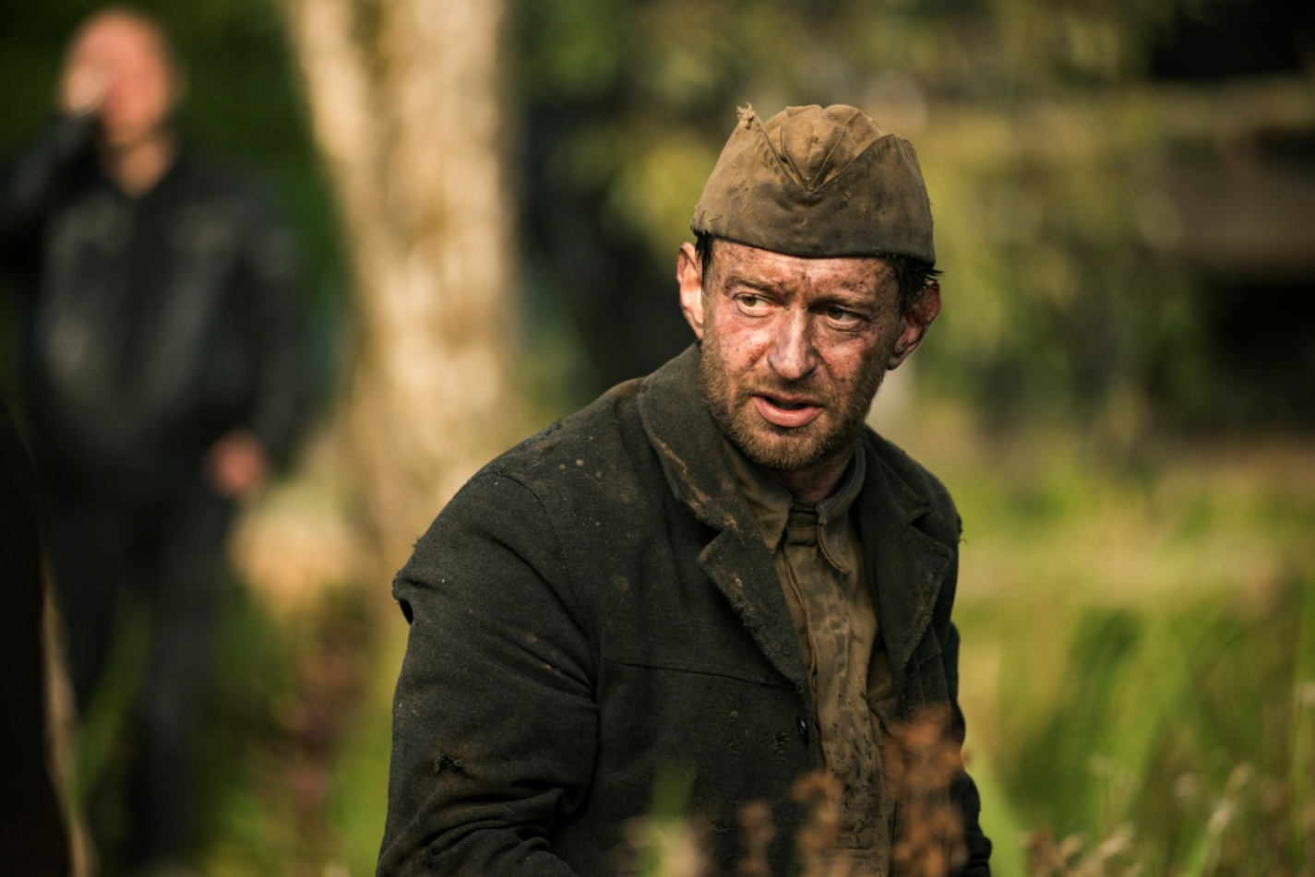

SYNOPSIS

This is a story of the rebellion of the human spirit again the mindless exterminating machine. In October 1943 the prisoners of the Nazi camp Sobibor led by Alexander Pechersky organized a revolt – the only successful rebellion in the death camps in history.

ABOUT THE FILM

The feature film «Sobibor» was produced by companies Cinema Production and «Fetisoff Illusion» with the support of Alexander Pechersky Foundation. The release of the film is dedicated to 75th anniversary of the rebellion in the Nazi death camp Sobibor. The only successful uprising of the prisoners during the World War II was made possible by the leadership abilities and courage of its leader – the Soviet officer Alexander Pechersky. It was he who could bring together hundreds of the prisoners from many European countries who were doomed to death.

Konstantin Khabensky played the main part in the film that also became his director’s debut. “Sadly, but the topic of Nazism and genocide will be always relevant”, - says Konstantin Khabensky assuredly. – We see that people hate and kill each other because of the “wrong” language, faith, skin color, eyes shape. Nazism is a maximum level of evil. It is the rebellion to such pure evil that gives rise to heroism that remains forever. One of such heroes was Alexander Pechersky”.

The acting cast is represented by the actors of different countries. The main roles are played by Christopher Lambert (“Highlander”, “Mortal Kombat”), Michalina Olszanska (“Matilda”), Philippe Reinhardt (“Stalingrad”, “The Groom”), Mariya Kozhevnikova (“Battalion”) and others.

STORY OF CREATION

The unique and inspiring story of the escape waited long to be filmed. The film was based on the book “Alexander Pechersky: Breakthrough to Immortality” that includes the memoirs of Alexander Pechersky and the poem “Luca” by Mark Geylikman. In 2011 the poem triggered the international campaign dedicated to memorialization of the heroes of the rebellion in Sobibor. Ilya Vasilyev, the author and compiler of the book, is also Head of Alexander Pechersky Foundation and a creative producer of the film.

The producers of ‘Sobibor” are Elmira Aynulova and Mariya Zhuromskaya (“Chastnoe pionerskoe”) and Gleb Fetisov (“Loveless”, “Duelist”). «The story of the rebellion in Sobibor is a story of the unique heroic deed that surpasses all our perceptions of how strong the human spirit can be, - speaks Elmira Aynulova with conviction. – It wouldn’t be possible but for the particular faith in victory that the Soviet officers and soldiers brought to Sobibor. Pechersky arrived at Sobibor with his comrades who he spent one year in the “working” camp in Minsk with. These people had military experience and consciousness of the soldiers with active duty who were ready to combat evil and conquer it”.

«I remind you of the famous saying: the heroes of Sobibor didn’t aim at saving their lives, they fought for the pride of all humanity, - says Gleb Fetisov. – We’d like to show the epic and breathtaking drama in the film, about living on edge, about coping with the things that one cannot overcome, about ordinary people who become titans. They had no chance against the professional and experienced killers. But they won».

DEVELOPMENT PERIOD

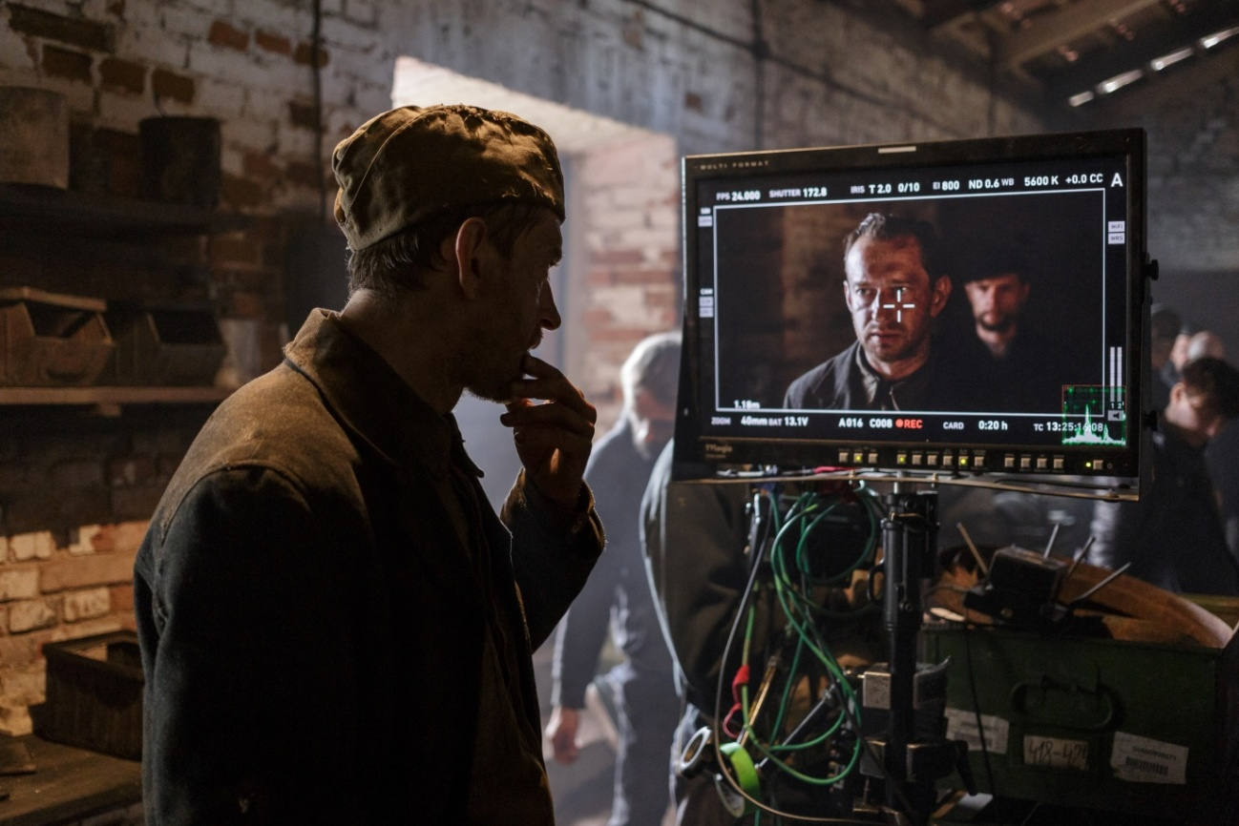

From the very beginning Konstantin Khabensky joined the project as the male lead but soon the producers realized that no one would direct this film better than he and managed to convince him of this.
«At some point I felt like I wanted to look at the story in general, “from above”, to understand how different storylines interact and combine in one picture, - tells Konstantin Khabensky. – I worked with outstanding directors and I know how they approach the process. The topic also played the important role: there are lots of films about war, but the story about peoples’ lives in death camps is a rare subject in Russian cinema».

Director Andrey Malyukov, the creator of such popular WW2 films as “Back in Time» and «Match», contributed to “Sobibor” as an art director.

The producers invited European stars to play prisoners and guards of the camp, some of them are well-known to the Russian audience. «We understood that the story of this rebellion is the one that will be clear to any person in the world, no matter where he or she lives. That’s why our project must be international”, - explains Konstantin Khabensky. The actors were auditioned via Skype.

While working at the film its authors were consulted by Head of Alexander Pechersky Foundation and the author of two books about Sobibor – Yulia Makarova and Alexander Pechersky’s descendants – his daughter Eleonora Grinevich and his granddaughter Natalia Ladychenko. A literary critic and theorist of literature Mikhail Edelstein became an academic advisor of the film.

«We had good consultants from Alexander Pechersky Foundation. They are well aware of the story and explained some of the controversial points, - continues Khabensky. – Besides, there are memoirs and video recordings. We tried to study them all. I cannot say that I became a specialist in history of Sobibor but I certainly plunged into the topic. But there is another side to it. It’s important not to make it seem too realistic. We know how it happened or how could have happened and then we use our imagination that makes each fiction film alive. Yes, we do try to handle historical events very carefully but it doesn’t mean that all lines in the film should be based on real facts. Pechersky, his comrades and antagonists could have been different but they could have been like this judging by their characters and historical circumstances. It’s even more important than to look exactly like prototypes».

PRINCIPAL PHOTOGRAPHY

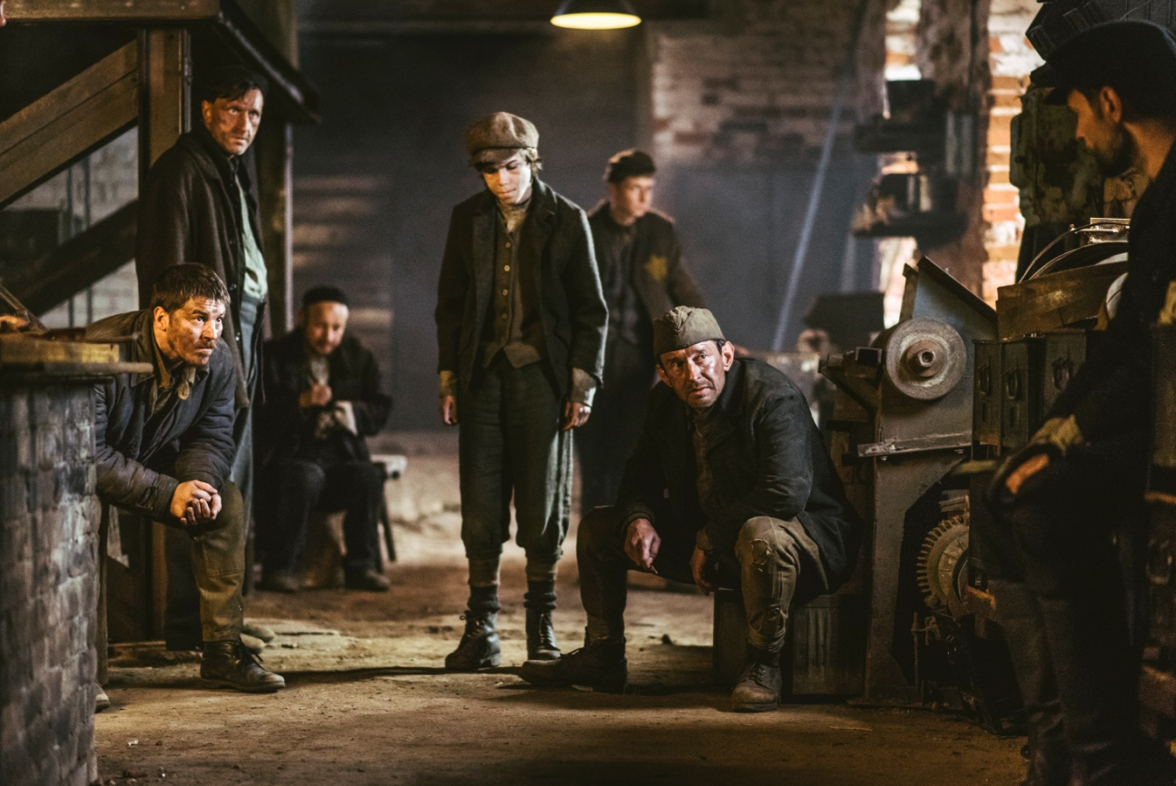

The principal photography of “Sobibor” started in Lithuania in autumn 2016 and lasted for 3 months. It is known that Pechersky and his friends arrived at the camp on September 22, so the shooting had to be held at the same season.

Up to 1000 actors took part in crowd scenes. All prisoners wore thin clothes and challenging weather conditions caused lots of troubles to the filming team. «Autumn in the Baltics is not the friendliest season, - Elmira Aynulova remembers the shooting period. – Our actors were under the wind and rain for hours in the thin “camp” clothes. They and the whole filming crew had to show the acting skills as well as extraordinary physical strength».

The main setting was created with historical accuracy according to the blueprints of the Nazi death camp under the control of the production designer Jurgita Gerdvilaite (“Hero”).

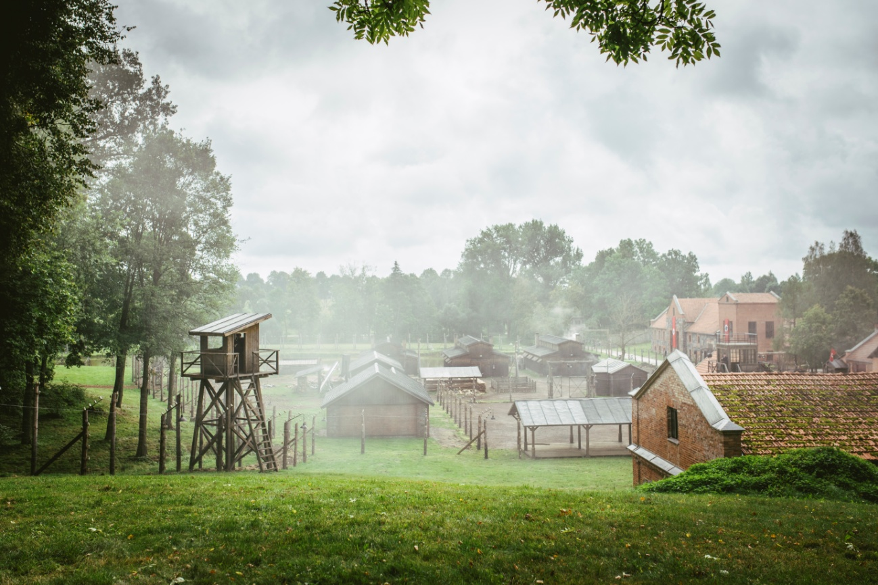

Producer Elmira Aynulova describes the complicated and thorough process of camp recreation: «Even though the Germans destroyed the camp to hide the traces of their crimes, nothing stays buried forever… Thanks to the specialists from Alexander Pechersky Foundation we were lucky to examine the dozens of drafts, blueprints and layouts that were created by ex-prisoners, as well as SS-officers who served there. We examined the most detailed description of the camp that were kept in the criminal case files against Sobibor guards. We used all this as a valuable basis for our further work. We collected all the stage props, equipment, weapons literally from all over Europe, we recreated the train that brings the prisoners in the camp in detail, we rented a couple of old cars. In such film as “Sobibor” each detail is important. If there is even one goof, an eagle-eyed viewer will stop believing in what is happening on the screen. Thanks to our advisers we could get the information from the chiefs of the archaeological team that had been working in Sobibor for a long time leading the excavations in the place of the former death camp, we could read the prisoners’ memoirs and study the archive documents. We did our best to reconstruct the tragic past in its every detail”.

A famous Lithuanian cinematographer Ramunas Greicius (“The Excursionist”, “Dzhentlmeny, udachi!”, “Hero”) was invited to “Sobibor” as a cinematographer of the project. He is a member of European film academy and an award-winner of many prestigious honors.

“Sobibor” characters speak 5 languages: Russian, German, Polish, Holland and Yiddish. The main languages of communication on the shooting location were Russian and English. «We tried to be absolutely authentic in everything, in every detail, in each frame as we understood that if the film would look inaccurate, then there would be no dialogue with the audience about good and evil, - tells Konstantin Khabensky about making of the film. – That’s why it was essential that the Germans spoke German, for instance. But there is another point. The viewer sees people who speak different languages from different countries with different life experience and understands how complicated it was for Pechersky to unite this Babylon anthill and turn it into a little army. A titanic work, confidence in himself, charisma, fury - that’s what the viewer should feel about Pechersky».

PRISONERS OF SOBIBOR

Konstantin Khabensky describes the major challenges that he had as Director: «There are always some difficulties in shooting all kind of scenes: crowd scenes, small scenes, action scenes, pauses. Strange as it may seem but the most complicated scenes were the “silent” ones which depict “peaceful” life of the camp: talks and walks. It seems quite routine but the viewer should feel that action takes place on the verge of death, in hell. That’s the biggest challenge for the actors and the director”.

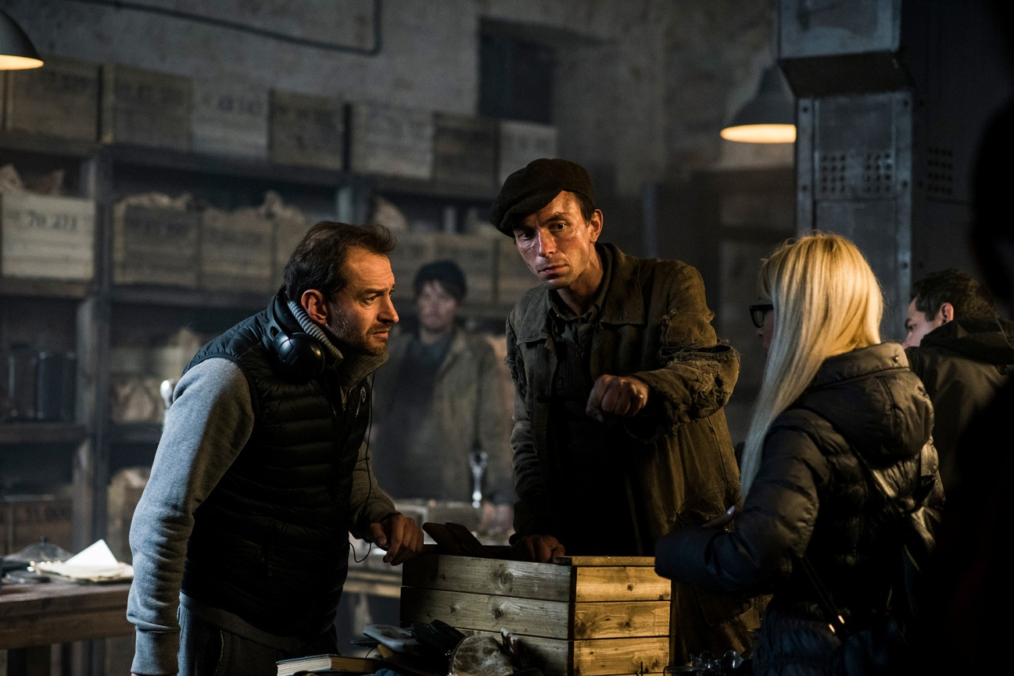

The producers searched for the actor who would fit into the role of the camp commandant for quite a long time. One member of the team thought about Lambert. Tough “highlander” was the perfect choice for the difficult character. «I felt quite excited about playing along the actor whose films grew up several generations on, who played his main roles when you were in high school, - shares Konstantin Khabensky. - He has this glance of a wolf that is mad and confused at the same time. We were taught that the actor should justify for his character, and Christopher tried to justify for his. We found some sensitive moments in his story that a viewer could understand to explain why he happened to be on the side of those who exterminated people. But all the same no matter how his character was treated, there can be no justification for these people. There is a slight understanding that the fate played the practical joke on him, but he still had a choice. Lambert manages to show all this by his acting».

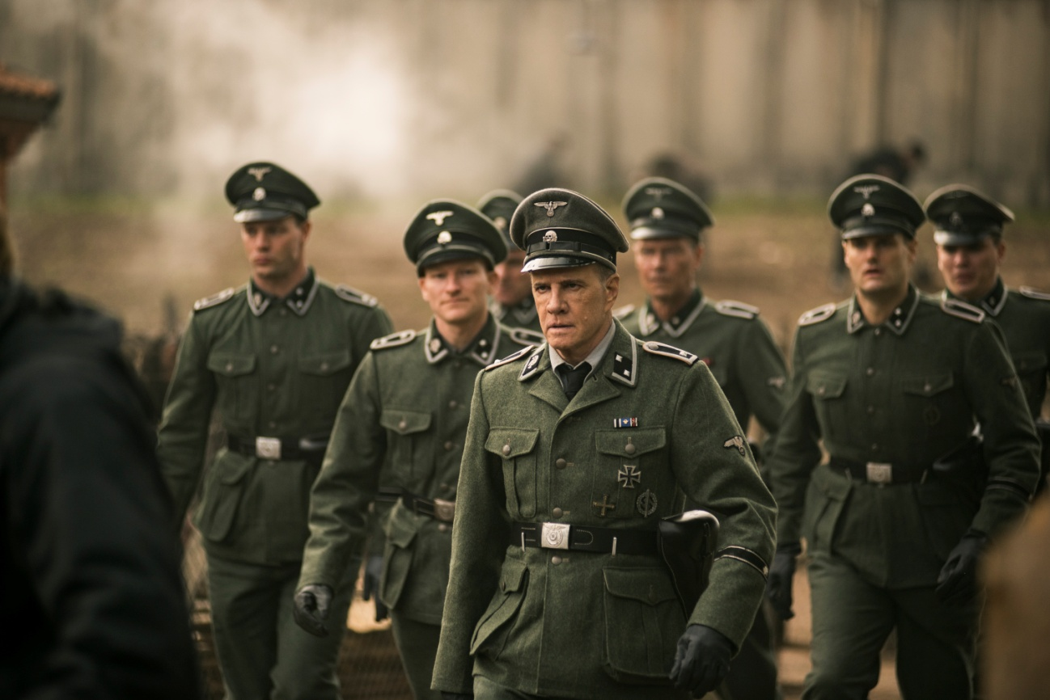

«When I was told that the film would be about the Nazi camp, and we would spend a few weeks into the closed space, it gave me chills, and I remembered pictures from the Stanford prison experiment, - recalls actor Philipp Reinhardt. – But it turned out to be quite the opposite, and now Elmira, Konstantin and I frequently call each other. I’ve never had such warm relationships with my colleagues after the filming was over».

SOUNTRACK

The soundtrack for the film was composed by Kuzma Bodrov. The recording took place in the legendary Mosfilm recording studio featuring Russian State symphonic orchestra conducted by Sergey Skripka and The Chamber Choir of Moscow Conservatory conducted by Alexander Solovyev.

HISTORICAL DETAILS

The death camp Sobibor was situated on the south-east of Poland and operated for one year and a half from spring 1942 till October 15th, 1943. For this time around 250 thousand of Jews were exterminated there.

On October 1943 the rebellion burst out in the camp: after killing 12 SS-officers 300 prisoners managed to break the fences and hid in the forest. Around 50 prisoners survived till the end of the WWII including the leader of the rebellion, a lieutenant Alexander Pechersky who was 34 when the rebellion happened. Soon after the escape the camp was destroyed and the land it was situated on was ploughed and trees were planted on it.

Pechersky dedicated his whole postwar life to following Nazi criminals who served in the camp, searching of the members of the rebellion and escape who spread out all over the world, collecting and distributing the information about the heroic deed and tragedy of Sobibor prisoners.

Unfortunately, the heroic deed of Sobibor received little recognition in the world. The English-Yugoslavian film “The escape from Sobibor” feat. Rutger Hauer that was released in 1987 did not change the situation. Alexander Pechersky died in 1990 and only 20 years after that the poem “Luca’ dedicated to Sobibor rebellion by the Russian poet and public figure Mark Geylikman gave rise to the international campaign of memorialization of the rebellion leader and his comrades.

In February 2016 by decree of the President of Russia dated January 2016 Alexander Pechersky was posthumously awarded the Order for Bravery. Finally, the heroes of Sobibor received the official recognition: trains and streets were named after them, including some in the capital of Russia, the details about the rebellion included into school history books. The activity is being coordinated by Alexander Pechersky Foundation. Before our eyes the rebellion in Sobibor is becoming one of the symbols of the strength of the human spirit and to its ability to fight evil even being on the edge of the abyss.

This year the hero’s first bust will be unveiled. The exhibition dedicated to him will take place in the Museum of Victory, and the publishing house “Eksmo” will issue three books about the feat of Sobibor prisoners.

– FILM «SOBIBOR» –
IN THEATRES, MAY 3

