Marshann G. Varley  Managing Director, Resident Sales Director  Aon Risk Insurance Services West, Inc.  707 Wilshire Blvd, Suite 2600  Los Angeles, CA 90017  Office: +1.213.630.1303  Mobile: +1.213.219.8857  Marshann.Varley@aon.com |  | 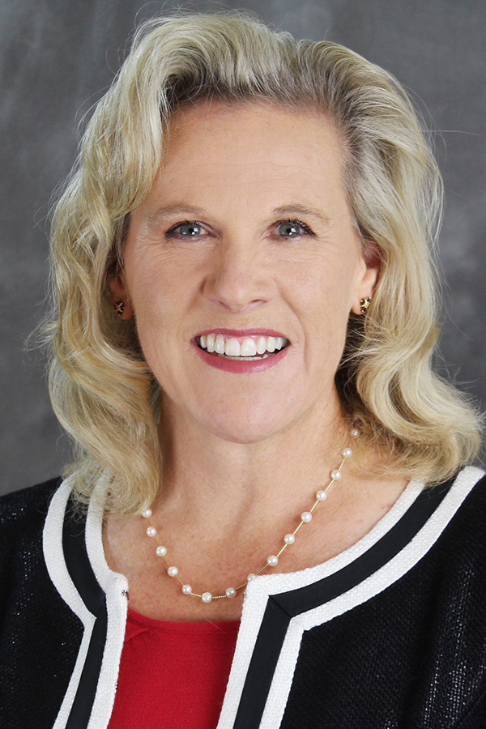
Responsibilities  Marshann Varley is a Managing Director, the Resident Sales Director and an Account Executive in the Los Angeles office. Marshann is responsible for developing and executing on the overall business development strategy including marketing for Southern California. Marshann manages a team of Production executives. She is part of the Executive Committee for Southern California, a co-leader of the Women in Insurance (WIN) business resource group for Southern California and a member of the national WIN leadership group. Los Angeles is Aon’s third largest office, employing over 300 colleagues and is a hub for Western Region activities. Aon is a full-service organization offering risk management services, consulting and human capital management consulting for small, mid-sized and global clients.  Experience  Marshann has been in the insurance brokerage industry for more than 25 years. Her background ranges from casualty underwriting and broking responsibilities earlier in her career to handling large, global risk management clients as an Account Executive for 15 years. Marshann was the Asia Pacific Risk Manager for General Motors for five years in Singapore and she also was the Global Property and Marine Risk Manager in Detroit.  Prior to joining Aon in 2016, Marshann spent a total of 16 years at Johnson & Higgins and Marsh & McLennan, Inc., as a Managing Director, working as a Client Executive in addition to roles as the Automotive Regional Leader, Pacific South Chief Retention Officer, Producer Unit Manager and Casualty Client Advisor. Marshann was involved in the creation of a Mentoring program in the LA office and launched the internal education platform for colleague growth and development.  Marshann has been identified as a Power Broker by Risk & Insurance magazine three consecutive years and as a finalist for one year. She has been on the Board of the CFO Leadership Council in Los Angeles for the past two years and a member of TechGC. |  | Education  Marshann earned a BA in Economics / Business University of California, Santa Barbara and a MBA in Finance/Marketing with an emphasis in International Business from University Southern California.  Marshann is actively involved in the community through National Charity League, Whittier. She has been on the Board of NCL and is involved with other charities in Southern California. Marshann is also a Board Member of the West Region Insurance Industry Charitable Foundation(IICF).

