**California State University Northridge**

**A Middle Eastern and Islamic Studies Event**

**Nonviolence, Islam and the Paradigm of Cordoba**

A Book Talk by Ramin Jahanbegloo, Department of Political Science, York University

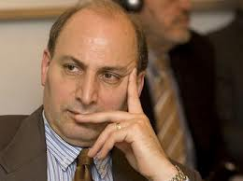

**Introducing the New Book by Dr. Jahanbegloo:**

**The Gandhian Moment (Harvard University Press, 2013)**

**Ramin Jahanbegloo** is a well-known Iranian-Canadian philosopher. He received his B.A. and M.A. in Philosophy, History and Political Science and later his Ph.D. in Philosophy from the Sorbonne University. In October 2009 Jahanbegloo became the winner of the Peace Prize from the United Nations Association in Spain for his extensive academic works in promoting dialogue between cultures and his advocacy for non-violence.

**Date: November 19th, 2013**

**Location: Jack and Florence Ferman**

**Room**

**Oviatt Library, CSUN**

**Time: 12:15 pm**

**(Reception: 1:45 pm)**

The Middle Eastern and Islamic Studies (MEIS) Program at CSUN is an interdisciplinary minor offering courses in the languages, histories, religions, cultures, sociology and politics of the Middle East. It seeks to enhance students’ understanding of Islamic cultures and the Muslim communities both internationally and within the United States: [www.csun.edu/meis](http://www.csun.edu/meis)

Contact:

MEIS, Office of Interdisciplinary Studies, CSU, Northridge, Sierra Hall 194, Telephone: (818) 677-6762