FINANCIAL ACCOUNTING

Topic 10: Differentiate Between the Various Forms of Business Ownership

Reference: Kimmel, Paul. D., Weygandt, Jerry. J. & Kieso, Donald. E. (2006). Financial Accounting: Tools for Business Decision Making (4th ed.). Hoboken, NJ: John Wiley & Sons. Used with permission from the publisher.

Forms of Business Organization

Suppose you graduate with a marketing degree and open your own marketing agency. One of your initial decisions is what organizational form your business will have. You have three choices—sole proprietorship, partnership, or corporation. A business owned by one person is a sole proprietorship. A business owned by two or more persons associated as partners is a partnership. A business organized as a separate legal entity owned by stockholders is a corporation.

You will probably choose the sole proprietorship form for your marketing agency. It is simple to set up and gives you control over the business. Small owner-operated businesses such as barber shops, law offices, and auto repair shops are often sole proprietorships, as are farms and small retail stores.

Another possibility is for you to join forces with other individuals to form a partnership. Partnerships often are formed because one individual does not have enough economic resources to initiate or expand the business. Sometimes partners bring unique skills or resources to the partnership. You and your partners should formalize your duties and contributions in a written partnership agreement. Retail and service-type businesses, including professional practices (lawyers, doctors, architects, and certified public accountants), often organize as partnerships.

As a third alternative, you might organize as a corporation. As an investor in a corporation you receive shares of stock to indicate your ownership claim. Buying stock in a corporation is often more attractive than investing in a partnership because shares of stock are easy to sell (transfer ownership). Selling a proprietorship or partnership interest is much more involved. Also, individuals can become stockholders by investing relatively small amounts of money. Therefore, it is easier for corporations to raise funds. Successful corporations often have thousands of stockholders, and their stock is traded on organized stock exchanges like the New York Stock Exchange. Many businesses start as sole proprietorships or partnerships and eventually incorporate. For example, in 1896 Leo Hirshfield started Tootsie Roll as a sole proprietorship, and by 1919 the company had incorporated.

Other factors to consider in deciding which organizational form to choose are taxes and legal liability. If you choose a sole proprietorship or partnership, you generally receive more favorable tax treatment than a corporation. However, proprietors and partners are personally liable for all debts of the business; corporate stockholders are not. In other words, corporate stockholders generally pay higher taxes but have no personal liability. We will discuss these issues in more depth in a later chapter. Illustration 1 highlights the three types of organizations and the advantages of each.

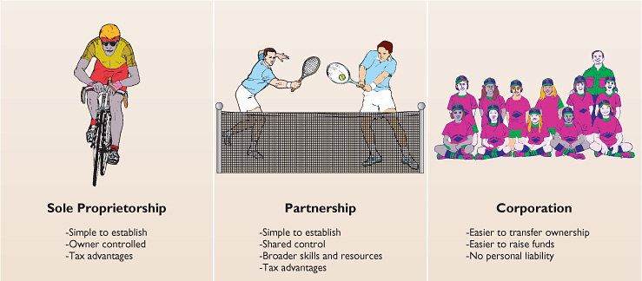
Illustration 1 Forms of business organization

The combined number of proprietorships and partnerships in the United States is more than five times the number of corporations. However, the revenue produced by corporations is eight times greater. Most of the largest enterprises in the United States—for example, Coca-Cola, ExxonMobil, General Motors, Citigroup, and Microsoft—are corporations. Because the majority of U.S. business is transacted by corporations, the emphasis in ACCT 220 is on the corporate form of organization.

