FINANCIAL ACCOUNTING

Topic 7: Compute the Time Value of Money

Reference: Kimmel, Paul. D., Weygandt, Jerry. J. & Kieso, Donald. E. (2006). Financial Accounting: Tools for Business Decision Making (4th ed.). Hoboken, NJ: John Wiley & Sons. Used with permission from the publisher.

Would you rather receive $1,000 today or a year from now? You should prefer to receive the $1,000 today because you can invest the $1,000 and earn interest on it. As a result, you will have more than $1,000 a year from now. What this example illustrates is the concept of the time value of money. Everyone prefers to receive money today rather than in the future because of the interest factor.

Nature of Interest

Interest is payment for the use of another person's money. It is the difference between the amount borrowed or invested (called the principal) and the amount repaid or collected. The amount of interest to be paid or collected is usually stated as a rate over a specific period of time. The rate of interest is generally stated as an annual rate.

The amount of interest involved in any financing transaction is based on three elements:
1. | Principal (p): The original amount borrowed or invested.
2. | Interest Rate (i): An annual percentage of the principal.
3. | Time (n): The number of years that the principal is borrowed or invested.

Simple Interest

Simple interest is computed on the principal amount only. It is the return on the principal for one period. Simple interest is usually expressed as shown in Illustration 1.
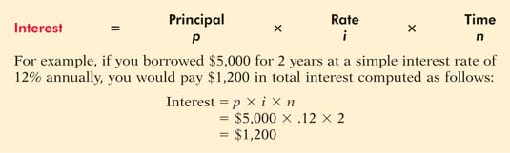
Ilustration 1 Interest Computation
Compound Interest
Compound interest is computed on principal and on any interest earned that has not been paid or withdrawn. It is the return on (or growth of) the principal for two or more time periods. Compounding computes interest not only on the principal but also on the interest earned to date on that principal, assuming the interest is left on deposit.

To illustrate the difference between simple and compound interest, assume that you deposit $1,000 in Bank Two, where it will earn simple interest of 9% per year, and you deposit another $1,000 in Citizens Bank, where it will earn compound interest of 9% per year compounded annually. Also assume that in both cases you will not withdraw any interest until three years from the date of deposit. Illustration 2 shows the computation of interest to be received and the accumulated year-end balances.
 | Illustration 2 | Simple versus compound interest

Note in Illustration 2 that simple interest uses the initial principal of $1,000 to compute the interest in all three years. Compound interest uses the accumulated balance (principal plus interest to date) at each year-end to compute interest in the succeeding year—which explains why your compound interest account is larger.

Obviously, if you had a choice between investing your money at simple interest or at compound interest, you would choose compound interest, all other things—especially risk—being equal. In the example, compounding provides $25.03 of additional interest income. For practical purposes, compounding assumes that unpaid interest earned becomes a part of the principal, and the accumulated balance at the end of each year becomes the new principal on which interest is earned during the next year.

Illustration 2 indicates that you should invest your money at the bank that compounds interest annually. Most business situations use compound interest. Simple interest is generally applicable only to short-term situations of one year or less.

Section One Future Value Concepts

Future Value of a Single Amount

The future value of a single amount is the value at a future date of a given amount invested, assuming compound interest. For example, in Illustration 2, $1,295.03 is the future value of the $1,000 investment earning 9% for three years. The $1,295.03 could be determined more easily by using the following formula:

FV = p x (1=i)^{n}

^{Illustration 3}

where:
FV | = | future value of a single amount
p | = | Principal (or present value)
i | = | interest rate for one period
n | = | number of periods

The $1,295.03 is computed as follows:

The 1.29503 is computed by multiplying (1.09 × 1.09 × 1.09). The amounts in this example can be depicted in the time diagram shown in Illustration 4.

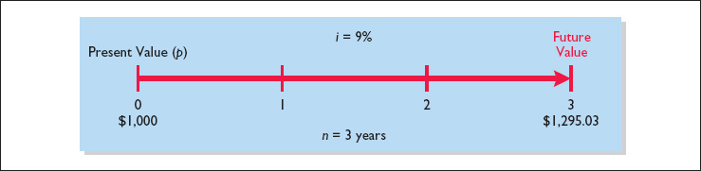
Illustration 4 | Time diagram

Another method used to compute the future value of a single amount involves a compound interest table. Table 1 at the end of the module shows the future value of 1 for n periods.

In Table 1, n is the number of compounding periods, the percentages are the periodic interest rates, and the 5-digit decimal numbers in the respective columns are the future value of 1 factors. In using Table 1, you would multiply the principal amount by the future value factor for the specified number of periods and interest rate. For example, the future value factor for two periods at 9% is 1.18810. Multiplying this factor by $1,000 equals $1,188.10—which is the accumulated balance at the end of year 2 in the Citizens Bank example in Illustration 2. The $1,295.03 accumulated balance at the end of the third year can be calculated from Table 1 by multiplying the future value factor for three periods (1.29503) by the $1,000.

The demonstration problem in Illustration 5 shows how to use Table 1.

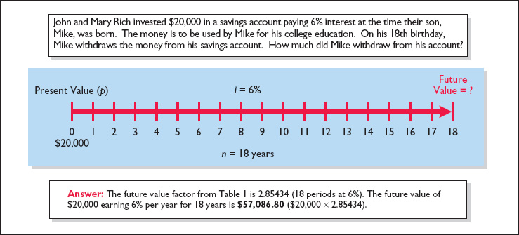
Illustration 5 | Demonstration problem—Using Table 1 for FV of 1

The preceding discussion involved the accumulation of only a single principal sum. Individuals and businesses frequently encounter situations in which a series of equal dollar amounts are to be paid or received periodically, such as loans or lease (rental) contracts. Such payments or receipts of equal dollar amounts are referred to as annuities.

The future value of an annuity is the sum of all the payments (receipts) plus the accumulated compound interest on them. In computing the future value of an annuity, it is necessary to know (1) the interest rate, (2) the number of compounding periods, and (3) the amount of the periodic payments or receipts.

To illustrate the computation of the future value of an annuity, assume that you invest $2,000 at the end of each year for three years at 5% interest compounded annually. This situation is depicted in the time diagram in Illustration 6.

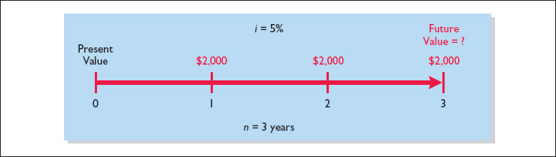

Illustration 6 | Time diagram for a three-year annuity

The $2,000 invested at the end of year 1 will earn interest for two years (years 2 and 3), and the $2,000 invested at the end of year 2 will earn interest for one year (year 3). However, the last $2,000 investment (made at the end of year 3) will not earn any interest. The future value of these periodic payments could be computed using the future value factors from Table 1, as shown in Illustration C-7.
 | Illustration 7 | Future value of periodic payment computation

The first $2,000 investment is multiplied by the future value factor for two periods (1.1025) because two years' interest will accumulate on it (in years 2 and 3). The second $2,000 investment will earn only one year's interest (in year 3) and therefore is multiplied by the future value factor for one year (1.0500). The final $2,000 investment is made at the end of the third year and will not earn any interest. Consequently, the future value of the last $2,000 invested is only $2,000 since it does not accumulate any interest.

Calculating the future value of each individual cash flow is required when the periodic payments or receipts are not equal in each period. However, when the periodic payments (receipts) are the same in each period, the future value can be computed by using a future value of an annuity of 1 table. Table 2 at the end of this module is such a table.

Table 2 shows the future value of 1 to be received periodically for a given number of periods. We can see from Table 2 that the future value of an annuity of 1 factor for three periods at 5% is 3.15250. The future value factor is the total of the three individual future value factors as shown in Illustration 7. Multiplying this amount by the annual investment of $2,000 produces a future value of $6,305.

The demonstration problem in Illustration 8 shows how to use Table 2.

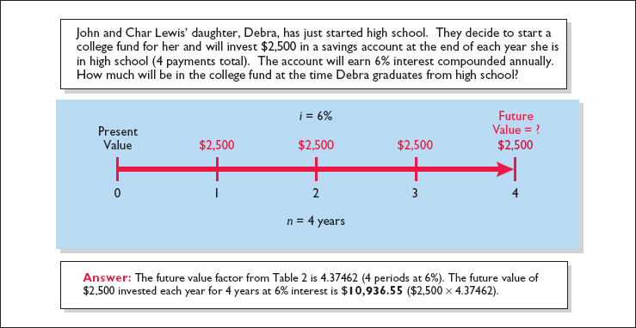
Illustration 8 | Demonstration problem—Using Table 2 for FV of an annuity of 1
Section Two Present Value Concepts

Present Value Variables

The present value is the value now of a given amount to be paid or received in the future, assuming compound interest. The present value, like the future value, is based on three variables: (1) the dollar amount to be received (future amount), (2) the length of time until the amount is received (number of periods), and (3) the interest rate (the discount rate). The process of determining the present value is referred to as discounting the future amount.

You can use present value computations in measuring several items. For example, they can be used to compute the present value of the principal and interest payments to determine the market price of a bond. In addition, determining the amount to be reported for notes payable and lease liability involves present value computations.

Present Value of a Single Amount

To illustrate present value, assume that you want to invest a sum of money that will yield $1,000 at the end of one year. What amount would you need to invest today to have $1,000 one year from now? If you want a 10% rate of return, the investment or present value is $909.09 ($1,000 ÷ 1.10). The formula for calculating present value is shown in Illustration 9.
 | Illustration 9 | Formula for present value

The computation of $1,000 discounted at 10% for one year is as follows:
INSERT FORMULA

The future amount ($1,000), the discount rate (10%), and the number of periods (1) are known. The variables in this situation can be depicted in the time diagram in Illustration 10.
 | Illustration 10 | Finding present value if discounted for one period

If the single amount of $1,000 is to be received in two years and discounted at 10% [PV = $1,000 ÷ (1 + .10)²], its present value is $826.45 [($1,000 ÷ 1.21), depicted as shown in Illustration 11.

If the single amount of $1,000 is to be received in two years and discounted at 10% [PV = $1,000 ÷ (1 + .10)²], its present value is $826.45 [($1,000 ÷ 1.21), depicted as shown in Illustration 11.

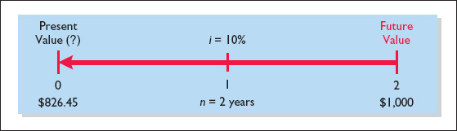
 | Illustration 11 | Finding present value if discounted for two periods

The present value of 1 may also be determined through tables that show the present value of 1 for n periods. In Table 3, n is the number of discounting periods involved. The percentages are the periodic interest rates or discount rates, and the 5-digit decimal numbers in the respective columns are the present value of 1 factors.

When using Table 3, the future value is multiplied by the present value factor specified at the intersection of the number of periods and the discount rate.

For example, the present value factor for one period at a discount rate of 10% is .90909, which equals the $909.09 ($1,000 × .90909) computed in Illustration 10. For two periods at a discount rate of 10%, the present value factor is .82645, which equals the $826.45 ($1,000 × .82645) computed previously.

Note that a higher discount rate produces a smaller present value. For example, using a 15% discount rate, the present value of $1,000 due one year from now is $869.57 versus $909.09 at 10%. Also note that the further removed from the present the future value is, the smaller the present value. For example, using the same discount rate of 10%, the present value of $1,000 due in five years is $620.92 versus the present value of $1,000 due in one year, which is $909.09.

The following two demonstration problems (Illustrations 12, 13) illustrate how to use Table 3.
 | Illustration 12 | Demonstration problem—Using Table 3 for PV of 1

 | Illustration 13 | Demonstration problem—Using Table 3 for PV of 1

Present Value of an Annuity

The preceding discussion involved the discounting of only a single future amount. Businesses and individuals frequently engage in transactions in which a series of equal dollar amounts are to be received or paid periodically. Examples of a series of periodic receipts or payments are loan agreements, installment sales, mortgage notes, lease (rental) contracts, and pension obligations. As discussed earlier, these periodic receipts or payments are annuities.

The present value of an annuity is the value now of a series of future receipts or payments, discounted assuming compound interest. In computing the present value of an annuity, it is necessary to know (1) the discount rate, (2) the number of discount periods, and (3) the amount of the periodic receipts or payments. To illustrate the computation of the present value of an annuity, assume that you will receive $1,000 cash annually for three years at a time when the discount rate is 10%. This situation is depicted in the time diagram in Illustration 14. Illustration 15 shows computation of the present value in this situation.

 | Illustration 14 | Time diagram for a three-year annuity

 | Illustration 15 | Present value of a series of future amounts computation

This method of calculation is required when the periodic cash flows are not uniform in each period. However, when the future receipts are the same in each period, there are two other ways to compute present value. First, the annual cash flow can be multiplied by the sum of the three present value factors. In the previous example, $1,000 × 2.48686 equals $2,486.86. Second, annuity tables can be used. As illustrated in Table 4 at the end of this module, these tables show the present value of 1 to be received periodically for a given number of periods.

Table 4 shows that the present value of an annuity of 1 factor for three periods at 10% is 2.48685.¹ This present value factor is the total of the three individual present value factors, as shown in Illustration 15. Applying this amount to the annual cash flow of $1,000 produces a present value of $2,486.85.

The following demonstration problem (Illustration 16) illustrates how to use Table 4.
 | Illustration 16 | Demonstration problem—Using Table 4 for PV of an annuity of 1

Time Periods and Discounting

In the preceding calculations, the discounting was done on an annual basis using an annual interest rate. Discounting may also be done over shorter periods of time such as monthly, quarterly, or semiannually.

When the time frame is less than one year, it is necessary to convert the annual interest rate to the applicable time frame. Assume, for example, that the investor in Illustration 14 received $500 semiannually for three years instead of $1,000 annually. In this case, the number of periods becomes six (3 × 2), the discount rate is 5% (10% ÷ 2), the present value factor from Table 4 is 5.07569, and the present value of the future cash flows is $2,537.85 (5.07569 × $500). This amount is slightly higher than the $2,486.86 computed in Illustration 15 because interest is computed twice during the same year; therefore interest is earned on the first half year's interest.

The above discussion relied on present value tables in solving present value problems. Electronic hand-held calculators may also be used to compute present values without the use of these tables. Many calculators, especially the “business” calculators, have present value (PV) functions that allow you to calculate present values by merely inputting the proper amount, discount rate, periods, and pressing the PV key.

TABLE 1 | Future Value of 1
(n)
Periods | 4% | 5% | 6% | 8% | 9% | 10% | 11% | 12% | 15%
-
1 | 1.04000 | 1.05000 | 1.06000 | 1.08000 | 1.09000 | 1.1 0000 | 1.11000 | 1.12000 | 1.15000
2 | 1.08160 | 1.1 0250 | 1.12360 | 1.16640 | 1.18810 | 1.21000 | 1.23210 | 1.25440 | 1.32250
3 | 1.12486 | 1.15763 | 1.19102 | 1.25971 | 1.29503 | 1.33100 | 1.36763 | 1.40493 | 1.52088
4 | 1.16986 | 1.21551 | 1.26248 | 1.36049 | 1.41158 | 1.46410 | 1.51807 | 1.57352 | 1.74901
5 | 1.21665 | 1.27628 | 1.33823 | 1.46933 | 1.53862 | 1.61051 | 1.68506 | 1.76234 | 2.01136
6 | 1.26532 | 1.34010 | 1.41852 | 1.58687 | 1.67710 | 1.77156 | 1.87041 | 1.97382 | 2.31306
7 | 1.31593 | 1.40710 | 1.50363 | 1.71382 | 1.82804 | 1.94872 | 2.07616 | 2.21068 | 2.66002
8 | 1.36857 | 1.47746 | 1.59385 | 1.85093 | 1.99256 | 2.14359 | 2.30454 | 2.47596 | 3.05902
9 | 1.42331 | 1.55133 | 1.68948 | 1.99900 | 2.17189 | 2.35795 | 2.55803 | 2.77308 | 3.51788
10 | 1.48024 | 1.62889 | 1.79085 | 2.15892 | 2.36736 | 2.59374 | 2.83942 | 3.10585 | 4.04556
11 | 1.53945 | 1.71034 | 1.89830 | 2.33164 | 2.58043 | 2.85312 | 3.15176 | 3.47855 | 4.65239
12 | 1.60103 | 1.79586 | 2.01220 | 2.51817 | 2.81267 | 3.13843 | 3.49845 | 3.89598 | 5.35025
13 | 1.66507 | 1.88565 | 2.13293 | 2.71962 | 3.06581 | 3.45227 | 3.88328 | 4.36349 | 6.15279
14 | 1.73168 | 1.97993 | 2.26090 | 2.93719 | 3.34173 | 3.79750 | 4.31044 | 4.88711 | 7.07571
15 | 1.80094 | 2.07893 | 2.39656 | 3.17217 | 3.64248 | 4.17725 | 4.78459 | 5.47357 | 8.13706
16 | 1.87298 | 2.18287 | 2.54035 | 3.42594 | 3.97031 | 4.59497 | 5.31089 | 6.13039 | 9.35762
17 | 1.94790 | 2.29202 | 2.69277 | 3.70002 | 4.32763 | 5.05447 | 5.89509 | 6.86604 | 10.76126
18 | 2.02582 | 2.40662 | 2.85434 | 3.99602 | 4.71712 | 5.55992 | 6.54355 | 7.68997 | 12.37545
19 | 2.10685 | 2.52695 | 3.02560 | 4.31570 | 5.14166 | 6.11591 | 7.26334 | 8.61276 | 14.23177
20 | 2.19112 | 2.65330 | 3.20714 | 4.66096 | 5.60441 | 6.72750 | 8.06231 | 9.64629 | 16.36654
TABLE 2 .Future Value of an Annuity of 1
(n)
Periods | 4% | 5% | 6% | 8% | 9% | 10% | 11% | 12% | 15%
-
1 | 1.00000 | 1.00000 | 1.00000 | 1.00000 | 1.00000 | 1.00000 | 1.00000 | 1.00000 | 1.00000
2 | 2.04000 | 2.05000 | 2.06000 | 2.08000 | 2.09000 | 2.10000 | 2.11000 | 2.12000 | 2.15000
3 | 3.12160 | 3.15250 | 3.18360 | 3.24640 | 3.27810 | 3.31000 | 3.34210 | 3.37440 | 3.47250
4" | '4.24646 | 4.31013 | 4.37462 | 4.50611 | 4.57313 | 4.64100 | 4.70973 | 4.77933 | 4.99338
5 | 5.41632 | 5.52563 | 5.63709 | 5.86660 | 5.98471 | 6.10510 | 6.22780 | 6.35285 | 6.74238
6 | 6.63298 | 6.80191 | 6.97532 | 7.33592 | 7.52334 | 7.71561 | 7.91286 | 8.11519 | 8.75374
7 | 7.89829 | 8.14201 | 8.39384 | 8.92280 | 9.20044 | 9.48717 | 9.78327 | 10.08901 | 11.06680
8 | 9.21423 | 9.54911 | 9.89747 | 10.63663 | 11.02847 | 11.43589 | 11.85943 | 12.29969 | 13.72682
9 | 10.58280 | 11.02656 | 11.49132 | 12.48756 | 13.02104 | 13.57948 | 14.16397 | 14.77566 | 16.78584
10 | 12.00611 | 12.57789 | 13.18079 | 14.48656 | 15.19293 | 15.93743 | 16.72201 | 17.54874 | 20.30372
11 | 13.48635 | 14.20679 | 14.97164 | 16.64549 | 17.56029 | 18.53117 | 19.56143 | 20.65458 | 24.34928
12 | 15.02581 | 15.91713 | 16.86994 | 18.97713 | 20.14072 | 21.38428 | 22.71319 | 24.13313 | 29.00167
13 | 16.62684 | 17.71298 | 18.88214 | 21.49530 | 22.95339 | 24.52271 | 26.21164 | 28.02911 | 34.35192
14 | 18.29191 | 19.59863 | 21.01507 | 24.21492 | 26.01919 | 27.97498 | 30.09492 | 32.39260 | 40.50471
15 | 20.02359 | 21.57856 | 23.27597 | 27.15211 | 29.36092 | 31.77248 | 34.40536 | 37.27972 | 47.58041
16 | 21.82453 | 23.65749 | 25.67253 | 30.32428 | 33.00340 | 35.94973 | 39.18995 | 42.75328 | 55.71747
17 | 23.69751 | 25.84037 | 28.21288 | 33.75023 | 36.97351 | 40.54470 | 44.50084 | 48.88367 | 65.07509
18 | 25.64541 | 28.13238 | 30.90565 | 37.45024 | 41.30134 | 45.59917 | 50.39593 | 55.74972 | 75.83636
19 | 27.67123 | 30.53900 | 33.75999 | 41.44626 | 46.01846 | 51.15909 | 56.93949 | 63.43968 | 88.21181
20 | 29.77808 | 33.06595 | 36.78559 | 45.76196 | 51.16012 | 57.27500 | 64.20283 | 72.05244 | 102.44358

TABLE 3 | Present Value of 1
(n)
Periods | 4% | 5% | 6% | 8% | 9% | 10% | 11% | 12% | 15%
- | - | - | - | - | - | - | - |  | -
1 | .96154 | .95238 | .94340 | .92593 | .91743 | .90909 | .90090 | .89286 | .86957
2 | .92456 | .90703 | .89000 | .85734 | .84168 | .82645 | .81162 | .79719 | .75614
3 | .88900 | .86384 | .83962 | .79383 | .77218 | .75132 | .73119 | .71178 | .65752
4 | .85480 | .82270 | .79209 | .73503 | .70843 | .68301 | .65873 | .63552 | .57175
5 | .82193 | .78353 | .74726 | .68058 | .64993 | .62092 | .59345 | .56743 | .49718
6 | .79031 | .74622 | .70496 | .63017 | .59627 | .56447 | .53464 | .50663 | .43233
7 | .75992 | .71068 | .66506 | .58349 | .54703 | .51316 | .48166 | .45235 | .37594
8 | .73069 | .67684 | .62741 | .54027 | .50187 | .46651 | .43393 | .40388 | .32690
9 | .70259 | .64461 | .59190 | .50025 | .46043 | .42410 | .39092 | .36061 | .28426
10 | .67556 | .61391 | .55839 | .46319 | .42241 | .38554 | .35218 | .32197 | .24719
11 | .64958 | .58468 | .52679 | .42888 | .38753 | .35049 | .31728 | .28748 | .21494
12 | .62460 | .55684 | .49697 | .39711 | .35554 | .31863 | .28584 | .25668 | .18691
13 | .60057 | .53032 | .46884 | .36770 | .32618 | .28966 | .25751 | .22917 | .16253
14 | .57748 | .50507 | .44230 | .34046 | .29925 | .26333 | .23199 | .20462 | .14133
15 | .55526 | .48102 | .41727 | .31524 | .27454 | .23939 | .20900 | .18270 | .12289
16 | .53391 | .45811 | .39365 | .29189 | .25187 | .21763 | . .18829 | .16312 | .10687
17 | .51337 | .43630 | .37136 | .27027 | .23107 | .19785 | .16963 | .14564 | .09293
18 | .49363 | .41552 | .35034 | .25025 | .21199 | .17986 | .15282 | .13004 | .08081
19 | .47464 | .39573 | .33051 | .23171 | .19449 | .16351 | .13768 | .11611 | .07027
20 | .45639 | .37689 | .31180 | .21455 | .17843 | .14864 | .12403 | .10367 | .06110
TABLE 4 | Present Value of an Annuity of 1
(n)
Periods | 4% | 5% | 6% | 8% | 9% | 10% | 11% | 12% | 15%
 |  |  |  |  |  |  |  |  | -
1 | .96154 | .95238 | .94340 | .92593 | .91743 | .90909 | .90090 | .89286 | .86957
2 | 1.88609 | 1.85941 | 1.83339 | 1.78326 | 1.75911 | 1.73554 | 1.71252 | 1.69005 | 1.62571
3 | 2.77509 | 2.72325 | 2.67301 | 2.57710 | 2.53130 | 2.48685 | 2.44371 | 2.40183 | 2.28323
4 | 3.62990 | 3.54595 | 3.46511 | 3.31213 | 3.23972 | 3.16986 | 3.10245 | 3.03735 | 2.85498
5 | 4.45182 | 4.32948 | 4.21236 | 3.99271 | 3.88965 | 3.79079 | 3.69590 | 3.60478 | 3.35216
6 | 5.24214 | ..5.07569 | 4.91732 | 4.62288 | 4.48592 | 4.35526 | 4.23054 | 4.11141 | 3.78448
7 | 6.00205 | 5.78637 | 5.58238 | 5.20637 | 5.03295 | 4.86842 | 4.71220 | 4.56376 | 4.16042
8 | 6.73274 | 6.46321 | 6.20979 | 5.74664 | 5.53482 | 5.33493 | 5.14612 | 4.96764 | 4.48732
9 | 7.43533 | 7.10782 | 6.80169 | 6.24689 | 5.99525 | 5.75902 | 5.53705 | 5.32825 | 4.77158
10 | 8.11090 | 7.72173 | 7.36009 | 6.71008 | 6.41766 | 6.14457 | 5.88923 | 5.65022 | 5.01877
11 | 8.76048 | 8.30641 | 7.88687 | 7.13896 | 6.80519 | 6.49506 | 6.20652 | 5.93770 | 5.23371
12 | 9.38507 | 8.86325 | 8.38384 | 7.53608 | 7.16073 | 6.81369 | 6.49236 | 6.19437 | 5.42062
13 | 9.98565 | 9.39357 | 8.85268 | 7.90378 | 7.48690 | 7.10336 | 6.74987 | 6.42355 | 5.58315
14 | 10.56312 | 9.89864 | 9.29498 | 8.24424 | 7.78615 | 7.36669 | 6.98187 | 6.62817 | 5.72448
15 | 11.11839 | 10.37966 | 9.71225 | . 8.55948 | 8.06069 | 7.60608 | 7.19087 | 6.81086 | 5.84737
16 | 11.65230 | 10.83777 | 10..1 0590 | 8.85137 | 8.31256 | 7.82371 | 7.37916 | 6.97399 | 5.95424
17 | 12.16567 | 11.27407 | 10.47726 | 9.12164 | 8.54363 | 8.02155 | 7.54879 | 7.11963 | 6.04716
18 | 12.65930 | 11.68959 | 10.82760 | 9.37189 | 8.75563 | 8.20141 | 7.70162 | 7.24967 | 6.12797
19 | 13.13394 | 12.08532 | 11.15812 | 9.60360 | 8.95012 | 8.36492 | 7.83929 | 7.36578 | 6.19823
20 | 13.59033 | 12.46221 | 11.46992 | 9.81815 | 9.12855 | 8.51356 | 7.96333 | 7.46944 | 6.25933

