# csun_logo_med

## CONSOLIDATED BUSINESS CONTINUITY PLAN

## Academic Affairs, Admissions and Records, Oviatt Library and Tseng College of Extended Learning

## DIVISION: Academic Affairs

## DATE OF PLAN: December 2008

## UPDATED: October 2019

### 1.Introduction

Business continuity planning is designed to enable academic and administrative units to continue to provide critical campus functions if a significant disruption interrupts or diminishes access to essential campus resources. The crisis-event could be widespread or local, caused by environmental impacts (earthquake, fire, pandemic); humans (civil disturbance, crime, accident); or infrastructure failure (office flood due to water pipe break, crashed servers or hard drive).

The fundamental planning goal is to continue university operations for students at sufficient levels, notwithstanding a major disruption that limits or prevents access to campus buildings or infrastructure. As those who managed through the 1994 Northridge earthquake know, decisions about how to best continue campus operations are dependent upon many variables. Decisions are influenced by the nature and effect of the disruption, as well as the academic calendar, particularly during periods when classes are in session. It is this event- and time-dependency that determines which responses can be planned in advance and what response is best determined at the moment, based on available resources. **Figure 1** maps the decision process within Academic Affairs:

A flow chart showing the business continuity plan decision process which is initial recovery from disruptive event, damage assessment, executive decisions and finally management decisions.


Critical functions are those activities that must be continued at sufficient levels under any and all circumstances. Following the initial emergency response and stabilization of disruptive circumstances, the executive leadership in Academic Affairs (Provost’s Council) will take two primary actions. First, the lines of authority and decision-making will be stipulated, based on available leadership. It is entirely possible that the normal organizational structure may not be in place, depending on the access managers will have to the campus and the technology infrastructure. Second, in consultation with the President’s Cabinet, the executive leadership in Academic Affairs will ensure the initiation of documented continuity plans and will decide on the most appropriate initiatives to support on-going instruction and business processes.

Based on damage assessments of the campus, some initiatives will follow previously written plans. For other functions, the most appropriate response will be formulated as the situation warrants. Unless an organization’s critical functions are correctly and completely identified, its plan may not effectively ensure that the most vital services can be sustained following a disaster. Figure 2 lists the operations within Academic Affairs that have been determined to be critical to the business continuity of the campus.

**Figure 2**

List of critical functions, who has functional planning responsibility, which form or template to use and the recovery priority level.


Recovery priorities are based on Recovery Time Objectives (RTO). An RTO is an estimate of the maximum tolerable duration between when a disruption occurs and when the function is resumed (i.e., the maximum amount of time the function can be unavailable). The following classification system is used for critical functions priorities.

* Priority Level 1: 0 to 3 days
* Priority Level 2: 4 to 14 days
* Priority Level 3: 2 to 4 weeks, or longer

### 2. Written Plans

The campus planning objective is to continue to provide as many instructional, research, and essential services as possible through a crisis-event. If that is not possible, then the objective is to resume core instructional, research, and essential services as quickly as possible. Written plans are typically voluminous, addressing a broad scope of issues including such things as strategies, policies, dependencies, consequences, costs, and detailed descriptions of resources, responsibilities, and anticipated responses.

To avoid the trappings of plans that sit on bookshelves, Academic Affairs will develop concise written plans for those functions in which preparation prevents the loss of resources, or establishes a decision-making structure in advance. Templates will be used to document the following business processes or preservation of resources: (A) communications with students, faculty, and staff; (B) protection of data, records, and files; (C) protection of faculty intellectual property & research; (D) class scheduling; (E) student advisement and (F) community service programs. Examples of the templates to be used are illustrated in Figures 3-8. Additionally, units will develop narrative plans to address other critical functions listed in Figure 2. Checklists were created to assist the units in completing the templates and narratives; Figures 9-11. They were designed to be used as guides providing key points to address for each of the critical functions.

**Figure 3 – Example of Communications Planning**

**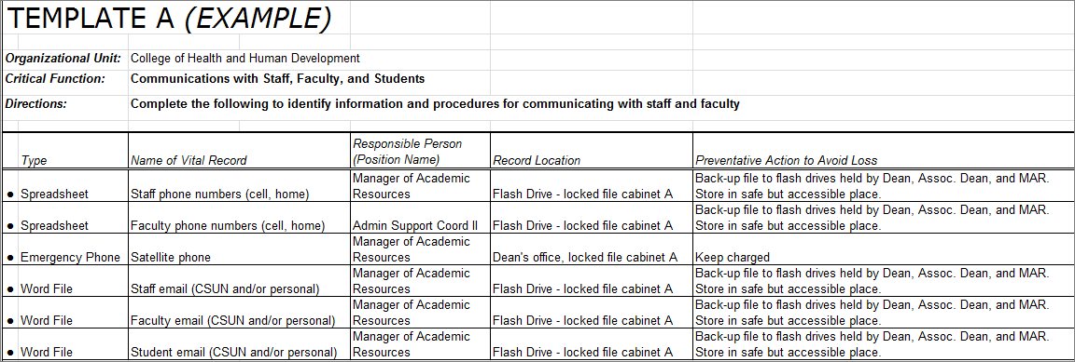**

**Figure 4 – Example of Data, Files, and Records Protection Planning**

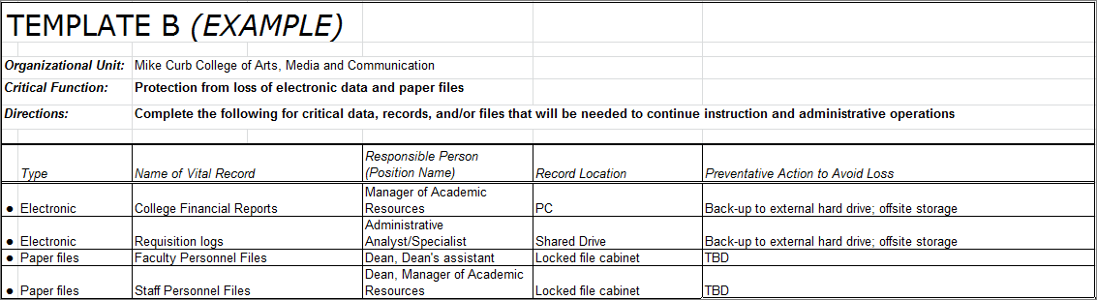

**Figure 5 – Example of Faculty Intellectual Property and/or Research Protection Planning**

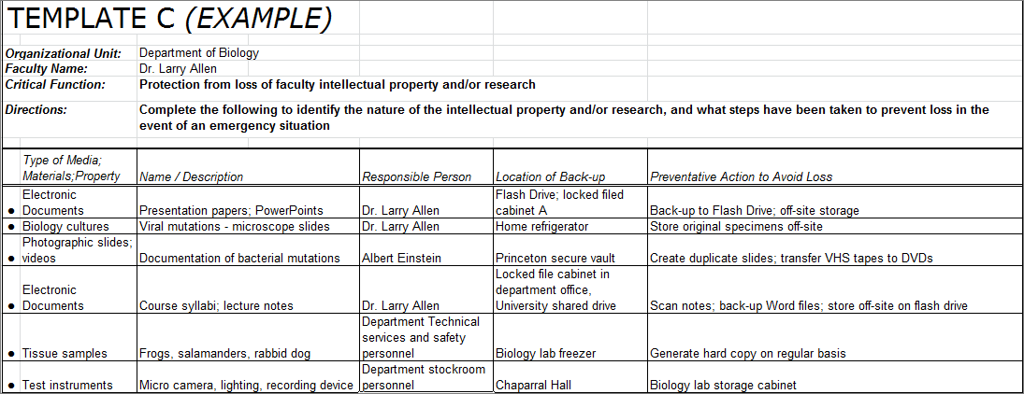

**Figure 6 – Example of Class Scheduling (SOC worksheet, class rosters, APDB, course syllabi**

**and materials, etc.) Protection Planning**

An example of how to complete Template D.


**Figure 7 – Example of Student Advisement Protection Planning**

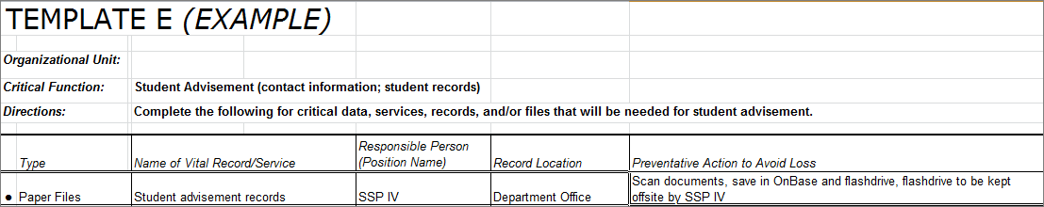

**Figure 8 – Example of Community Service Programs Protection Planning**

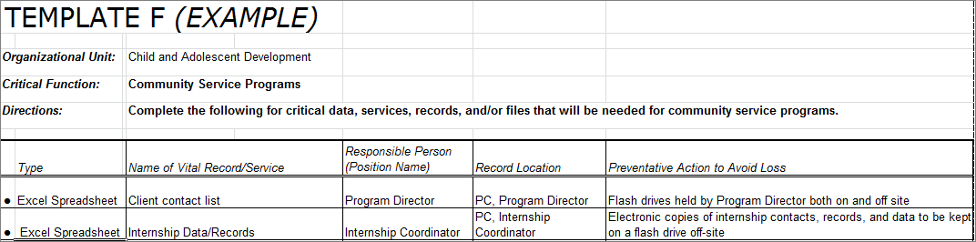

**Figure 9 - Guidelines/Checklist for Academic Affairs**

Questions to ponder when completing the critical function forms.

**Figure 10 – Guidelines/Checklist for Colleges and Administrative Units**

Questions for the college or administrative unit to ponder when completing the critical function forms.

Questions to ponder when completing the critical function forms for classroom instruction and student advisement.

**Figure 11 – Guidelines/Checklist for Departments and Programs**

Questions for the departments to ponder when completing their critical function forms.

Questions to ponder when completing the back-up and access to data critical function forms.

Questions to ponder when completing the college narrative forms.

The format of narrative plans for other critical functions should contain this common information:

**Organizational Unit:\_\_\_\_\_\_\_\_\_\_\_\_\_\_\_\_\_\_\_\_\_\_\_\_\_\_\_\_\_\_\_\_\_\_\_\_\_ Date:\_\_\_\_\_\_\_\_\_\_\_\_**

**Planning Responsibility:\_\_\_\_\_\_\_\_\_\_\_\_\_\_\_\_\_\_\_\_\_\_\_\_\_\_\_\_\_\_\_\_\_\_\_\_\_\_\_\_\_\_\_\_\_\_\_\_\_\_\_**

**Critical Function:**

**Vulnerability:**

**Planned Response:** *(chronological order)*

**Approval:\_\_\_\_\_\_\_\_\_\_\_\_\_\_\_\_\_\_\_\_\_\_\_\_\_\_\_\_\_\_\_\_\_\_\_\_\_\_\_\_\_\_\_\_\_Date:\_\_\_\_\_\_\_\_\_\_\_\_**

Colleges and departments are required to complete Templates A - F, and written narrative plans for all appropriate critical functions, with one exception. A faculty member’s intellectual property is just that…their property. While it may have relevance to courses taught by the faculty, it is not considered a campus business process over which the university has purview. Therefore, faculty are *encouraged* to complete Template C for their own benefit (protection of faculty intellectual property & research), but are not required to submit to or keep records for the department. Help Desk technical support staff (x1400) in the Division of Information Technology (IT), or IT technicians in the college may be available to assist faculty with this.

The campus’ ability to continue to provide instruction and student support activities will necessitate, at minimum, the functionality of the campus IT network and access to buildings and classrooms. Of special importance to students is the availability of course web pages, syllabi and instructional materials. Depending on the time period within an academic year and the availability of the faculty member, it may be necessary to have back-up copies of course syllabi available for students, and potentially substitute faculty. Departments must maintain a copy of course syllabi for all courses being offered in the current academic year. Faculty should submit their course syllabi, in electronic form, to their department and as appropriate publish their course syllabi via an accessible web page prior to the beginning of the semester. Departments will collect and store electronic syllabi for each course on a medium that makes it portable and restorable (e.g., flash drive, external hard drive, campus U-drive). Academic Affairs is in the process of providing an automated procedure to publish Syllabi via the web as part of the campus’ Disaster Recovery Process. Much work is needed prior to having the system in place, and we provide additional information about the proposed approach in Attachment A.

College and department Business Continuity templates, as well as narrative plans, will be reviewed each calendar year, and updated as necessary. Relative documentation for all critical functions will be maintained by the appropriate unit in both secure office storage and, as appropriate, off-site in the manager’s home and/or car. In addition, The Provost’s Office will maintain copies of all Academic Affairs unit’s business continuity planning materials.

### 3. Plan Implementation

Academic Affairs’ business continuity planning (BCP) document was presented for approval to members of the Provost’s Council (PC) on February 5, 2008. The Provost’s Council members include the executive leadership for all colleges, library, and division administrative units. The BCP was approved and it was agreed that all units would complete the BCP Communication Plan template by April 30; the Records and Files template by June 30, 2008; and program-specific narrative plans by August 30, 2008.

As shown in Attachment B, the provisions to address each critical function are impacted by specific vulnerabilities. All units in Academic Affairs share three primary vulnerabilities: facilities, data and records, and personnel. On a large scale, the unavailability of classrooms and offices would necessarily close the campus. Immediately following the 1994 Northridge earthquake the campus was fortunate to acquire 400+ portable classroom and administrative trailers and have the green space to locate them on campus. Today, the availability of enough portable buildings to accommodate the larger campus population would be highly improbable. However, on a smaller scale, the campus may be able to find alternative space to accommodate the unavailability of a small number of classrooms and/or offices. The campus response would depend on the time of year, extent of damages, and room size and functionality.

The other two major vulnerabilities can be planned for in advance, as outlined in this document. Both the Communications template and the Protection from Loss of Data and Records template set forth a structure to document faculty and staff contact information as well as prepare in advance to secure the availability of important data and records. ATTACHMENT A

**Planning guidelines for protection of faculty & course Web Pages and Syllabi**

**Overview**

For instruction to resume after a major disruptive event, core communication capabilities are needed to allow departments and faculty to inform students about revised meeting locations and curriculum changes, as well as to re-engage students into the academic setting. The three key IT-related communication capabilities necessary to resume instruction ASAP following a disruptive event include:

1. Web publishing of key faculty and course materials (e.g., course syllabus, faculty web page)
2. Bulletin Board posting of information accessible by all members of a course
3. Email services for general dissemination of course related information

In this attachment, we provide recommendations on preparatory steps that should be taken to enable the web publishing of a course syllabus. To provide bulletin board and email services, it is envisioned that an email ASP (e.g., Google, Yahoo, etc.) could be used. Appropriate steps, however, need to be taken to automatically provision group accounts.

**Recommendations:**

1. Departments should collect and post syllabi on the campus web server ([www.csun.edu)](http://www.csun.edu/).
   * Faculty web pages and syllabi should be incorporated into the design of department web pages. In Web-One (our campus web content management system), faculty web pages and course syllabi should be included as links from the faculty bio section of department web pages.
   * It should be noted that two efforts are currently underway regarding syllabi that affect the timeline of this implementation. First, Faculty Senate committees are considering changes to the syllabus policies. Second, the Academic Affairs Web Team is developing standard templates in Web-One that faculty may choose to use.
   * Many faculty are using learning management systems (LMS), Canvas on our campus, to post course syllabi and updates for students.
2. Faculty should inform students at the beginning of each academic term where to find information (e.g., faculty web page, course syllabus, LMS) about changes in course meeting times, locations, and requirements should a disruptive event occur.
3. The student information system (SOLAR) contains student rosters and email addresses for both routine communication and communication after a disruptive event.
   * As noted above, alternative email services may need to be provided after a disruptive event.
     + - Days and Hours
       - Course Number (a.k.a. ticket number)
   * The page should provide a browse capability to locate course information based upon “Course of Study” (as defined by the CSUN catalog).
   * The page should contain additional information used to provide salient information to students..

#### ATTACHMENT B



#### ATTACHMENT C

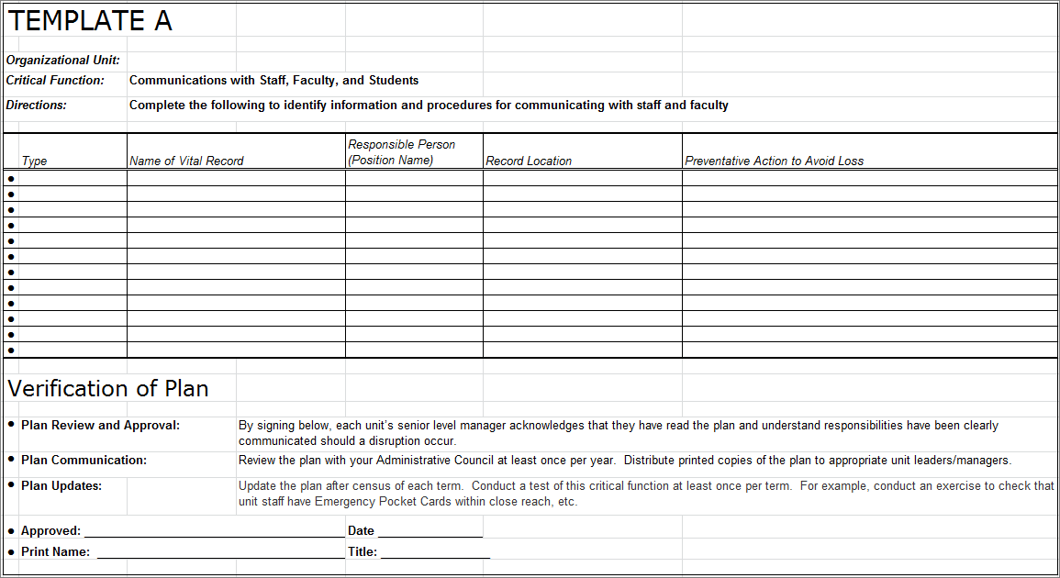

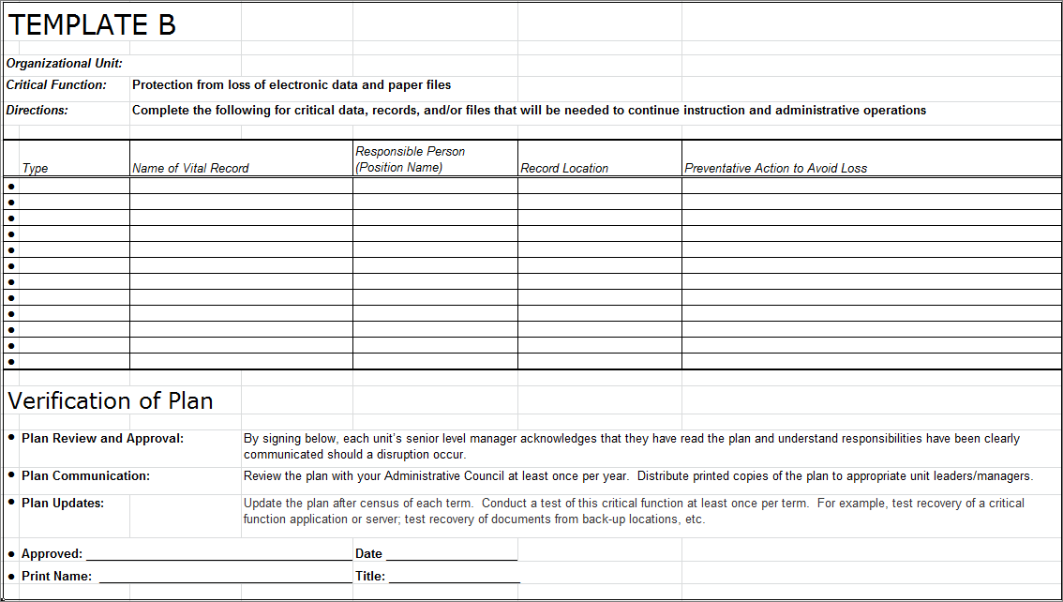

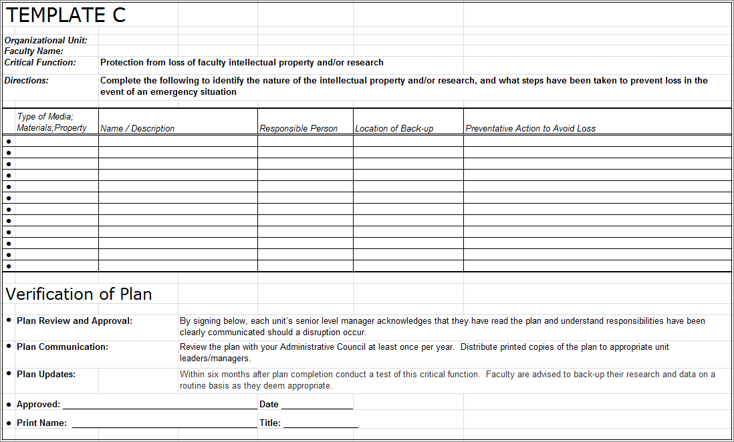

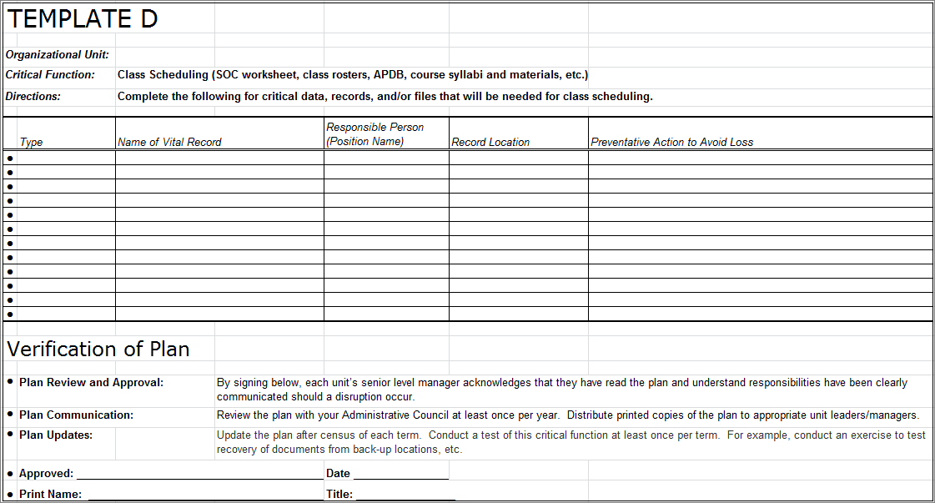

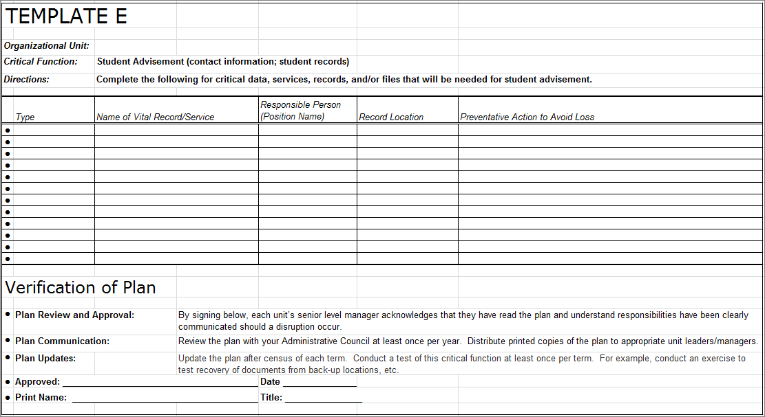

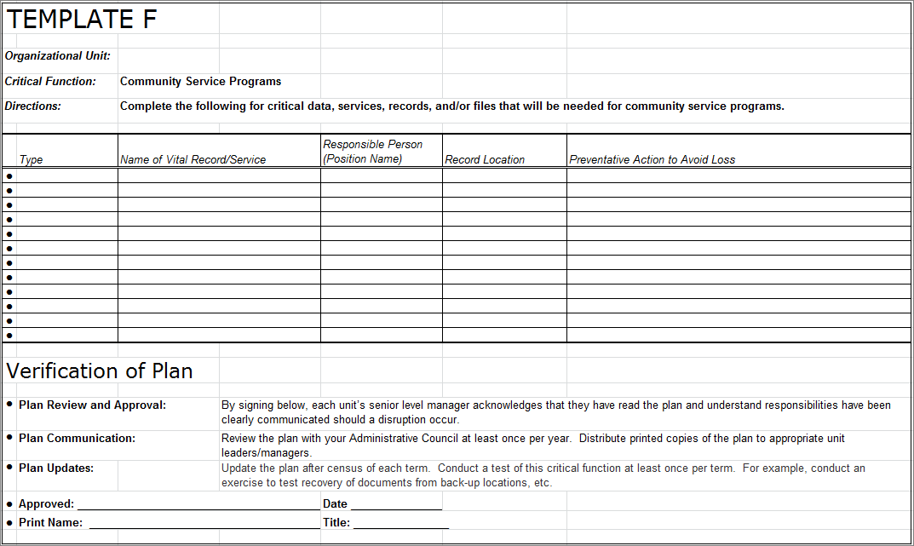

California State University, Northridge

Academic Affairs

**Business Continuity Plan**

## DIVISION CRITICAL FUNCTION NARRATIVE

Date: November 1, 2018

Organizational Unit: Academic Affairs

Planning Responsibility: Diane Stephens

Critical Function(s):

##### CLASSROOM / ONLINE INSTRUCTION

***Vulnerability:***

The campus’ ability to provide classroom instruction is dependent on the safety and availability of buildings and classrooms, the ability for faculty, students and staff to travel to campus, access to power, and the functionality of the CSUN Portal, SOLAR, and CSUN websites. Online instruction is dependent on the access to power, and the functionality of Canvas, the CSUN Portal, SOLAR, and CSUN websites

***Planned Response:***

The Provost’s Office and Academic Resources and Planning will work closely with CSUN’s Emergency Operations Center (EOC) and Physical Plant Management to ascertain the safety of buildings and classrooms for occupancy. There will be constant communication with staff, faculty, and students with status updates on the physical space and the plans for continuation of instruction. In the event that classrooms are unavailable, staff in Academic Resources and Planning will use the Event Management System (EMS) to locate available alternative spaces on campus for instruction. The continuation of online instruction is completely dependent on the access to power in the immediate area to campus. If there is damage to the University’s information technology infrastructure, Information Technology has a failover plan with CSU Sacramento to restore services needed for online instruction. These include the CSUN Portal, SOLAR, Learning Management Systems, and CSUN websites. The Faculty Technology Center is available to provide resources to faculty for online instruction and alternate instructional methods such as lecture capture.

##### CLASSROOM AVAILABILITY

***Vulnerability:***

Assignment of classrooms is dependent on the availability of power, the EMS scheduling system, campus SOLAR portal, email, phone system, internet, and network access.

***Planned Response:***

In the event of a disruptive event, administration of Room Reservations will continue to operate with the staff available in Academic Resources and Planning. There are currently two full time staff (Senior Resource Analyst and Scheduling Coordinator) responsible for scheduling classrooms for departments and colleges and a third staff member (Administrative Analyst/Specialist) trained to use the EMS system. In the event of a power failure, or the inability to access campus computers, the staff in Academic Resources and Planning are able to access the EMS scheduling system from the EMS web client using laptops. If SOLAR and/or the CSUN Portal are not available, it will be possible to continue using EMS to schedule classrooms without the SOLAR interface for a short period of time.

College SOLAR Coordinators are trained to locate rooms in EMS for their college’s classes during the semester schedule builds. Although rooms are often scarce during the semester, in the unlikely event that no one in Academic Resources and Planning is available to find a room in an emergency situation, the department requesting the room could view EMS to locate an open room in the building desired.

##### SMART CLASSROOMS FUNCTIONALITY (inventory; vendor information)

***Vulnerability:***

Loss of power, email, phone system and internet, network access, and equipment failure.

***Planned Response:***

In the event of an emergency, overseeing the functionality and maintenance of instructional equipment will continue as follows: currently, there are full-time media equipment technicians in IT. The department of Academic Resources and Planning will alert IT of equipment needs. If phone lines are down, then cell phones will be used to alert IT. There may be a limitation on what can be corrected if the problem is due to network and internet failure. The systems technicians in IT will work on resurrecting those services and the media equipment technicians will help faculty to ensure teaching resumes.

##### CSUN Pandemic Response Plan

##### Academic Units

**Introduction**

Academic Affairs protocols and activities will be developed and implemented consistent with the existing CSUN Emergency Management Plan Policies and Procedures, the Campus Closure Integrated Communication Protocol, and the business continuity plans articulated elsewhere in the CSUN Pandemic Response Plan.

Existing Campus and Chancellor’s Office policies and procedures will govern decisions regarding students engaged in academic off-campus learning experiences or in international study programs.

**Phase 1 – Interpandemic Period**

1. All academic units will establish workflow procedures that clearly indicate chain of command and succession plans in the event the pandemic alert period is entered.
2. Units will follow current procedures which govern ensuring the continuity of instruction in the event of instructor/student illness and absence. These include substitute instructors and alternative assignments.
3. All academic units should post, and place on their respective web pages, policies regarding absences and information on preventing the spread of the virus.
4. Criteria for the suspension of classes will be developed consistent with the existing campus policies.
5. Deans and Chairs will consult with faculty to develop contingency plans for the continuity of instruction.
6. Colleges and Departments will work collaboratively to collect instructional materials that can be easily scanned into PDF, html files, WebCT, or other electronic formats which can be placed on the web portal as needed. ITR can provide access pathways for each class and section by class number.
7. Identify resource professionals in colleges and departments and begin training on the conversion of instruction materials to PDF, html, or WebCT formats as appropriate.
8. Many academic units currently use virtual administration practices. The remaining will develop policies, procedures, and practices to provide for virtual administration of their respective units and programs.

**Phase 2 –Pandemic Alert Period**

1. Alternatives to classroom instruction will be initiated. Colleges will provide, and/or coordinate with departments to provide, support to faculty to scan and convert teaching materials into the appropriate electronic formats.
2. Consistent with collective bargaining agreements, each academic unit will identify essential personnel who can provide the continuity of critical services.
3. Academic Affairs, in conjunction with ITR, will provide the means for faculty to place critical teaching and research materials on a campus or remote location server or electronic medium.

**Phase 3 – Pandemic Period**

1. All academic units will report faculty and staff absences and potential cases of illness to the University Influenza Manager and to HR.
2. Academic Affairs will utilize the Campus Closure Integrated Communication Protocol to communicate and implement campus closure decisions.