Table of Contents

Section Page #

Comparative History of Intel and AMD microprocessors 1

The Intel 860 Chipset 5

Via Apollo P4X266A chipset 8

VIA Apollo KT400 chipset 10

AMD 760 MPX Dual Processor Chipset 14

Questions 18

Section 1: Comparative History of Intel and AMD Microprocessors

Through the years Intel has generally been the dominant producer of microprocessor chips. While from time to time there have been competitors, it was not until the mid nineties before Intel had any real competition. AMD having been in the high tech computer business for some thirty years was able to break Intel’s strangle hold on the market. Intel was clearly unhappy with facing serious fore; however, as a result consumers were provided with lower prices on CPU’s with increased performance. In essence, the competition between Intel and AMD stimulated the computer industry by producing new and innovative microprocessors in the hope of capturing, if not at all, then a large portion of the market place. The Intel versus AMD legacy is enrooted in the eighties and began to blossom in the mid nineties. Herein lies their history.
In the early 1980’s, Intel was then the only true producer of marketable computer processors. Intel introduced its 80286 (aka “286”) CPU in 1982. This processor was innovative in that it was able to run all the software instructions of its prior microprocessors. According to Intel, within 6 years of the release of the 286, there were 15 million 286’s installed in computers around the world. Because of the high demand for Intel’s processors, Intel allowed third party companies to produce 286’s and variants under licensed production agreements. AMD (Advanced Micro Devices) was one of these third party companies that produced Intel’s 286’s. It is during this time that AMD became very efficient and capable of being a producer of microprocessors.
Eventually in 1985, Intel released its 32-bit 386 microprocessor. This new chip was faster and capable of multitasking, i.e. the new chip was able to process and run multiple programs simultaneously. Intel met with great success with the 386 chip, and again AMD, under licensed production, produced 386 chips which allowed Intel to meet the market demands. However, it was during the long reign of the 386 process when AMD decided to produce its own CPU that would eventually compete with Intel. In 1987, AMD began legal arbitration over rights to produce their own computer chips. This legal battle ensued for 5 years whereupon the Courts sided with AMD, giving them the right to produce microprocessors similar to that of Intel’s microprocessors.
While fighting AMD, in 1989 Intel released its new 486DX processor. This improved processor allowed users to move away from using a command line to instead, point and clicking. Intel’s 486 was initially twice as fast in processing power than its predecessor, the 386. Intel continued to upgrade on the 486, reaching speeds of 66 MHz. Finally, in March of 1991 AMD decided to get its feet wet by releasing its first Am386 microprocessor. Although AMD’s first processor was a 386, while Intel had released a 486 two years prior, AMD felt there was still a market for 386 chips. By October of that same year, AMD had sold one million units of the Am386 chip.
A year after AMD wins their legal battles with Intel in the spring of 1993, AMD releases its first real competing chip, the Am486. By 1994, AMD introduces improvements with the Am486DX chip, making huge gains processing upwards of 100 MHz. However, Intel realizing that they could not place a trademark on the numbers “x86” thereby preventing AMD of essentially cloning Intel’s chips. Thus, in 1993, Intel decides to dub its new chip the Pentium instead of introducing it as the “586” microprocessor. As a result, Intel’s Pentium chips were safe of being merely copied by AMD. The new chip was able to handle and process more media types such as speech, sound, and photographic images. The processor was also superscalar, which meant that it could execute more than one instruction concurrently in the same pipeline stage. The Pentium became well entrenched in the market place, offering multiple processing speeds up to 200 MHz. Furthermore. Intel eventually added MMX instructions to their chip which enabled the Pentium to better process high end graphics. During the era of the Pentium, Intel truly dominated.
In 1995, AMD makes its first initial attempt to compete with the Pentium chip by introducing their AM5x86 chip. This computer chip was not a legitimate alternative to the Pentium. The AM5x86 was simply for computer users who wanted to upgrade their 486 motherboards without having to make the jump to the Pentium motherboard. As a result, AMD did not fare well with this chip. Because AMD could no loner “borrow” Intel technology, they were forced to produce entirely a new generation computer chip that could compete with Intel’s Pentium chip. In 1996, AMD was able to finally produce a new chip comparable in power to the Pentium, which they called the AMD K5. AMD’s new K5 chip was designed to go head to head with the Pentium. It could be placed in the same motherboard as the Pentium, making it compatible. However, because AMD’s new chip was released three years after the Pentium, it was met with cool reception and little fanfare. Also in the previous year of 1995, Intel had released an improved Pentium chip, called the Pentium Pro. The Pentium Pro was able to handle more instructions per clock cycle. As a result, Intel’s ability to get a new chip on the market before AMD, has had the effect of heavily overshadowing any of AMD’s processors.
It is not until 1997 that AMD would finally make their mark. In 1996, AMD with a shrewd move bought out the company Nex Gen, who at the time was designing a new microprocessor of their own. By buying out Nex Gen, AMD was able to use their processor and develop into what would become the AMD K6 chip. AMD used Nex Gen’s core 686 processor and slapped on Intel’s MMX code, making it compatible with Pentiums. When the K6 was released in the early part of 1997, it had speeds of 166 MHz to 200 MHz. Also the K6 was significantly cheaper than the Pentiums, providing a serious threat to Intel’s dominance. The K6 chip was able to move up to speeds as high as 300 MHz, out performing the Pentiums. However, Intel was more than ready for the challenge posed by AMD’s K6.
Later that year in 1997, Intel unveils its new chip: the Pentium II. The Pentium II chip came fully equipped with MMX instructions, ready to handle video, audio, and graphics data. The new Pentium was more capable at handling video editing, sending media via the Internet, and reprocessing music. By 1998, with a little reworking by Intel, the Pentium II began to climb up in processing speed, culminating at speeds of 450 MHz.
While AMD is slaving away in their laboratories working on producing a new chip, AMD’s K6 chip was doing well as a cost effective alternative to the Pentium II. Granted, the K6 was not as powerful as the Pentium II, but it was a lot cheaper. To some extent, Intel was annoyed that consumers were choosing an inferior chip (albeit a cheaper chip) to their own superior chip. In response in 1998, Intel unveiled its own cheap and inferior microprocessor: the Celeron. The Celeron was basically a stripped down version of the Pentium II, resulting in lower performance. Now Intel was able to offer an affordable but inferior process that could compete with AMD’s K6.
In 1998, while Intel was trying to secure the lower end of the market, AMD fights back with an enhanced K6 chip, known as the K6-2 chip, in order to take on the almighty Pentium II. AMD’s K6-2 chip was a further tweaked version of the old K6 chip; however, AMD added what they called “3DNow” technology. 3DNow is an additional twenty-two instructions to better handle audio, video, and graphic intensive programs. AMD shortly thereafter releases K6-3, a more powerful version of the K6-2 chip. AMD was now a serious threat to Intel. Consumers were beginning to sway to AMD chips, which had equal performance but at a much cheaper price.
In typical Intel style, by 1999 Intel responds by coming out with a completely new chip of its own: the Pentium III. The new Pentium III came with an additional seventy instructions, which greatly improves its ability to process advance imaging, 3D, streaming audio, video, and speech recognition programs. One goal of the Pentium III was to enhance the Internet experience. However, AMD was now up to the challenge and in that same year unleashed the Athlon (formely known as K7). The Athlon chip was a completely new chip from the ground up. AMD designed a new chip from scratch, allowing them to compete with Intel head on. The Athlon chip could do everything that the Pentium III chip could do, matched speed for speed, and the Athlon cost entirely less. As a result the Athlon was beating out the Pentium III.
Intel now realizing they were faced with a fierce competitor, decided that in the following year of 2000 to launch a two pronged attack against AMD. First, Intel fights again for the low-end market by delivering the Celeron II. The Celeron II ranges in speed between 500 and 1100MHz, but it really is just a stripped down processor with enhanced speed. However, the Celeron II is fairly cheap, making it quite competitive. Second, Intel introduces an entirely new high-end chip: the Pentium IV. The Pentium IV is an entirely new chip with four main new technologies being introduced, namely a Hyper Pipelined Technology, Rapid Executing Engine, Execution Trace Cache and a 400 MHz system bus. The first major improvement of the Pentium was increased speed, initially starting with 1.5 GHz and the ability for tremendous expansion, increasing speed dramatically. As can be seen today, the Pentium IV is now reaching upwards to a remarkable 3GHz. While processing speed is rising to astronomical proportions, the Pentium IV can now produce high quality video; stream radio and TV quality information across the Internet; render upscale graphics in real-time; and perform several applications simultaneously while connected to the Internet. As a result from Intel’s great attack on AMD, Intel is once again dominating while AMD appears to be faltering a bit.
In response to the Celeron II, AMD quickly reacted in the same year of 2000 with its own low budget microprocessor: the Duron. The Duron is simply a geared down version of the Athlon, but slightly edges out the Celeron. The Athlon chip, which was destroying the Pentium III, is now destined to the graveyard. In response to the Pentium IV, AMD enhanced the Athlon by coming out with the XP series. Albeit the Athlon XP cannot match the Pentium IV in speed, tests have shown that an Athlon XP running 1.4 GHz performs nearly as well as a Pentium running 2GHz. The Athlon XP is still a quality chip, but it is quickly fading away under the onslaught of the heavy performance of the Pentium IV.
While Intel now holds the edge over AMD in chip technology, it is rumored that AMD is developing a new powerhouse chip called the ClawHammer. The ClawHammer is apparently in a testing stage. AMD has proven in the past to be a strong competitor, and it is only a matter of time before they start giving Intel a run for their money.

Section 2: The Intel 860 Chipset

We have thus far described the competition that has existed between Intel and AMD in regards to microprocessors. Are goal has been to understand the history and details of this competition and their processors. Also of significant importance is the chipsets of Intel and AMD processors. Understanding such details are important when deciding who is better: Intel or AMD?
A chipset is a group of integrated circuits, sold as one unit, designed to perform one or more related functions. For example, a chipset may provide the basic functions of a modem. However, we are primarily focused on chipsets that provide functionality for the CPU of a computer. A typical chipset is the Intel 430HX PCIset for the Pentium microprocessor. A chipset for a workstation platform is the Intel 860. It was created based on the Xeon processor.
The Intel 860 chipset is based on the Xeon processor and is created with high bandwidth specifically geared for workstation platforms. According to Intel, with the Xeon processor, the Intel 860 chipset is intended to give great performance, scalability, and end-user productivity. In addition, it has the capability of holding 2 CPU’s.

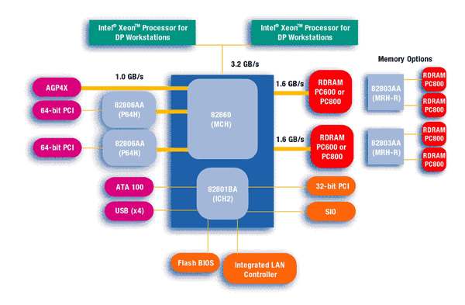
Figure 1
The structure of the chips revolves around the Memory Controller Hub (MCH) and the I/O Controller Hub (ICH2) (see figure 1). The MCH is essentially the interface between the processor and the main bus. The chips are capable of supporting a 400 MHz bus. Additionally, the 860’s RDRAM memory channels allows memory to be installed onboard of speeds up to 800 MHz. The RDRAM channels together have a combined bandwidth of 3.2 GB/s.
Three categories exist of the memory address ranges: High Memory Range, Extended Memory Range, and DOS Compatible Area. The High Memory Range consists of DRAM only and exists between 4 and 16 gigabytes. The Extended Memory Range exists between 1 Megabyte and 4 gigabytes. The Dos Compatible Area is used for DOS legacy space and bios legacy devices. The DOS Compatible Area ranges below 1 Megabyte (see figure 2).

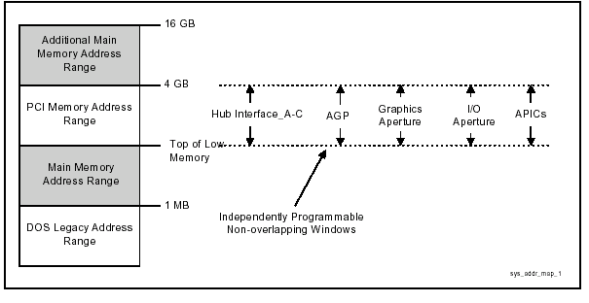
Figure 2

The MCH amazingly tolerates a 3.2 GB/s transfer rate between the processors and itself. It has a built in channel which directly connects to the AGP (accelerated graphics port) by way of a high speed bus with a connection speed of 1 GB/s. Moreover, there are two direct connections to the RDRAM at a transfer rate of 1.6 GB/s.
The MCH can support dual interfaces of Rambus Direct and RDRAM. THE MCH also supports two different operation modes: Single Channel-Pair Mode and Multiple Channel-Pair Mode. With the Single Channel-Pair Mode, a maximum of 64 Direct RDRAM devices are supported on the paired channels without external logic. With the Multiple Channel-Pair Mode, the MCH can use the Memory Repeater Hub for Direct RDRAM (MRH-R) to allocate a two-way bandwidth to the memory modules. The MRH-R is a component that basically allows the system to expand the number of Rambus Channels. Each Intel MRH-R connects one primary Rambus channel to two subordinate Rambus channels (http://www.intel.com/design/chipsets/860). Including two MRH-R’s connected to the MCH, the 860 chipset can therefore hold 4 memory modules.
The scalable chipset incorporates a 64-bit Peripheral Component Interconnect (PCI) Controller Hub. The remarkable architecture allows for a high speed connection between the PCI and MCH.
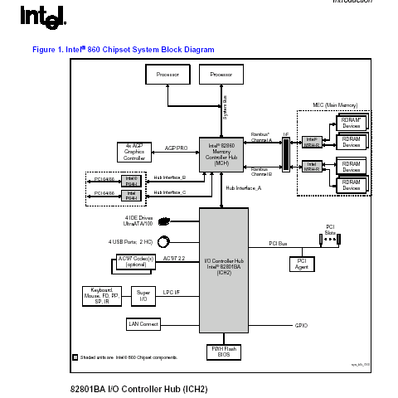
Figure 3

The I/O Controller Hub (ICH2) provides a dedicated path between the peripherals and the MCH. It includes support for Ultra ATA/100, an integrated LAN controller and dual USB controllers, and six channels of digital audio. The Ultra ATA/100 is the latest version of the Advanced Technology Attachment (ATA) which is a disk drive implementation that integrates the controller on the disk drive itself (http://www.webopedia.com/TERM/A/ATA.html).

Features and Benefits f the 860 Chipset:

Features |  | Benefits
Supports two Intel Xeon Processors with |  | NetBurst Microarchitecture and hyper-Threading teconlogy
512 KB L2 chacke for dual-processing server platforms
400 MHz System Bus Capability |  | Balances the system bus band withd with the memory
Intel Hub Architecture with option P64H |  | Dual 64-bit 66 MHz I/O segments for fast drive access
 |  | and high speed networks
AGP 4X |  | 1 GB/s of Graphics bandwidth allows high performance
 |  | Graphics
MRH-R (RDRAM Based repeater Hub) |  | Extends RDRAM memory capacities and increases
 |  | System scalability
Dual RDRAM channels |  | Maximum memory performance(3.2 GB/s or 400MHz)
Prefetch Cache |  | System concurrency so that simultaneous process
 |  | do not impact system performance
Dual USB Controllers |  | Enhanced plug and play with four full band width
 |  | USB ports

Overall, the architecture of this chipset is extensively structure. The CPU, main memory, and graphics accelerator are interconnected at a very high speed bus, the MHC. The peripherals and hard disk drives, on the other hand, are connected to the slower ICH controller. The 860 provides the motherboard, sever, and the desktop power and efficieny.

Section 3: Via Apollo P4X266A chipset

VIA Technologies is separate entity from AMD and Intel that develop highly integrated chipsets for motherboards. According to VIA Technologies, they are a “leading innovator and developer of PC core logic chipsets, microprocessor, and multimedia and communication chips.” VIA’s goal is to deliver to the PC industry market a range of platform solutions by creating “high-performance” equipment in a cost effective way. VIA Technologies, headquartered in Taipei, Tawain, is a rising company whom in 2000 had annual revenues of nearly $1 billion. In addition to creating chipsets, they also design and construct a wide-range of such equipment as: Ethernet networking switches; controllers and phyciever chips; precision optical disc drive solutions for CD-ROM and DVD-Rom devices; and audio and video technologies (http://www.via.com.tw /en/company/overview.jsp).
VIA’S Apollo chipset line constitutes a wide range of core logic chipsets for all types of processor platforms. The VIA Apollo chipsets offers a blend of performance, flexibility, reliability. The latest model of the Apollo line is the P4X266A. The purpose of its design is to optimize the Intel Pentium 4. It is a high performing chipset that fully utilizes the “industry standard” DDR266 memory. This high end chipset supports graphics accelerators up to 4X. The chipset oversees the graphics accelerator.
The structure of the chipset revolves around the North and South bridges (see figure # below). Its V-link structure was developed by VIA and is designed to free up the PCI bus for peripheral devices only. The North Bridge is charged with the system bus; the system bus runs at about 400 MHz. The North Bridge takes advantage of the quad pumped bus of the Pentium 4 processor. The chipset can support up to 4 gigabytes of main memory. It utilizes DDR200 or DDR266 memory, but it is also backwards compatible with the PC 100 and PC 133 memory modules. The speed of the bus between the North Bridge and the memory reaches speeds of 266 MHz. A slight problem, however, arises when the North Bridge is working at full speed. When it runs at full speed, a queue begins to build up from the slower running memory as it cannot keep up with the high speed between the CPU and main bus.
The South Bridge and the North Bridge are connected at 266 MB/s. The South Bridge is in charge of the slower bus dedicated to the peripherals and human interface devices. The South Bridge can be either the “VT8233 offering VIA Ethernet MAC, the VT8233C featuring 3Com Ethernet MAC, or the VT8233A supporting the new ATA/133 drive standard…” (Via Apollo white paper, 9). This wide array of combinations allows for up to 6 motherboards to be created from this structure. They are only distinguished by what target market they are designed for.
The VT8233 and VT8233C consist of two high-speed ATA-100 IDE controllers, six USB ports, six PCI slots, and an I/O Advanced Programmable Interrupt Controller. The VT8233A is a cost effective South Bridge that supports the ATA/133 drive interface and allows speeds up to 133MB/s. The VT8233 does not include an integrated Ethernet MAC, but does include two USB controllers for four ports, as well as the standard features of VT8233/C.
All VIA V-Link (hub structure) South Bridges include top of the line 6 channel AC/97 2.2 sound support and a MC/97 software modem interface. These high quality features can be integrated right onto the system board.

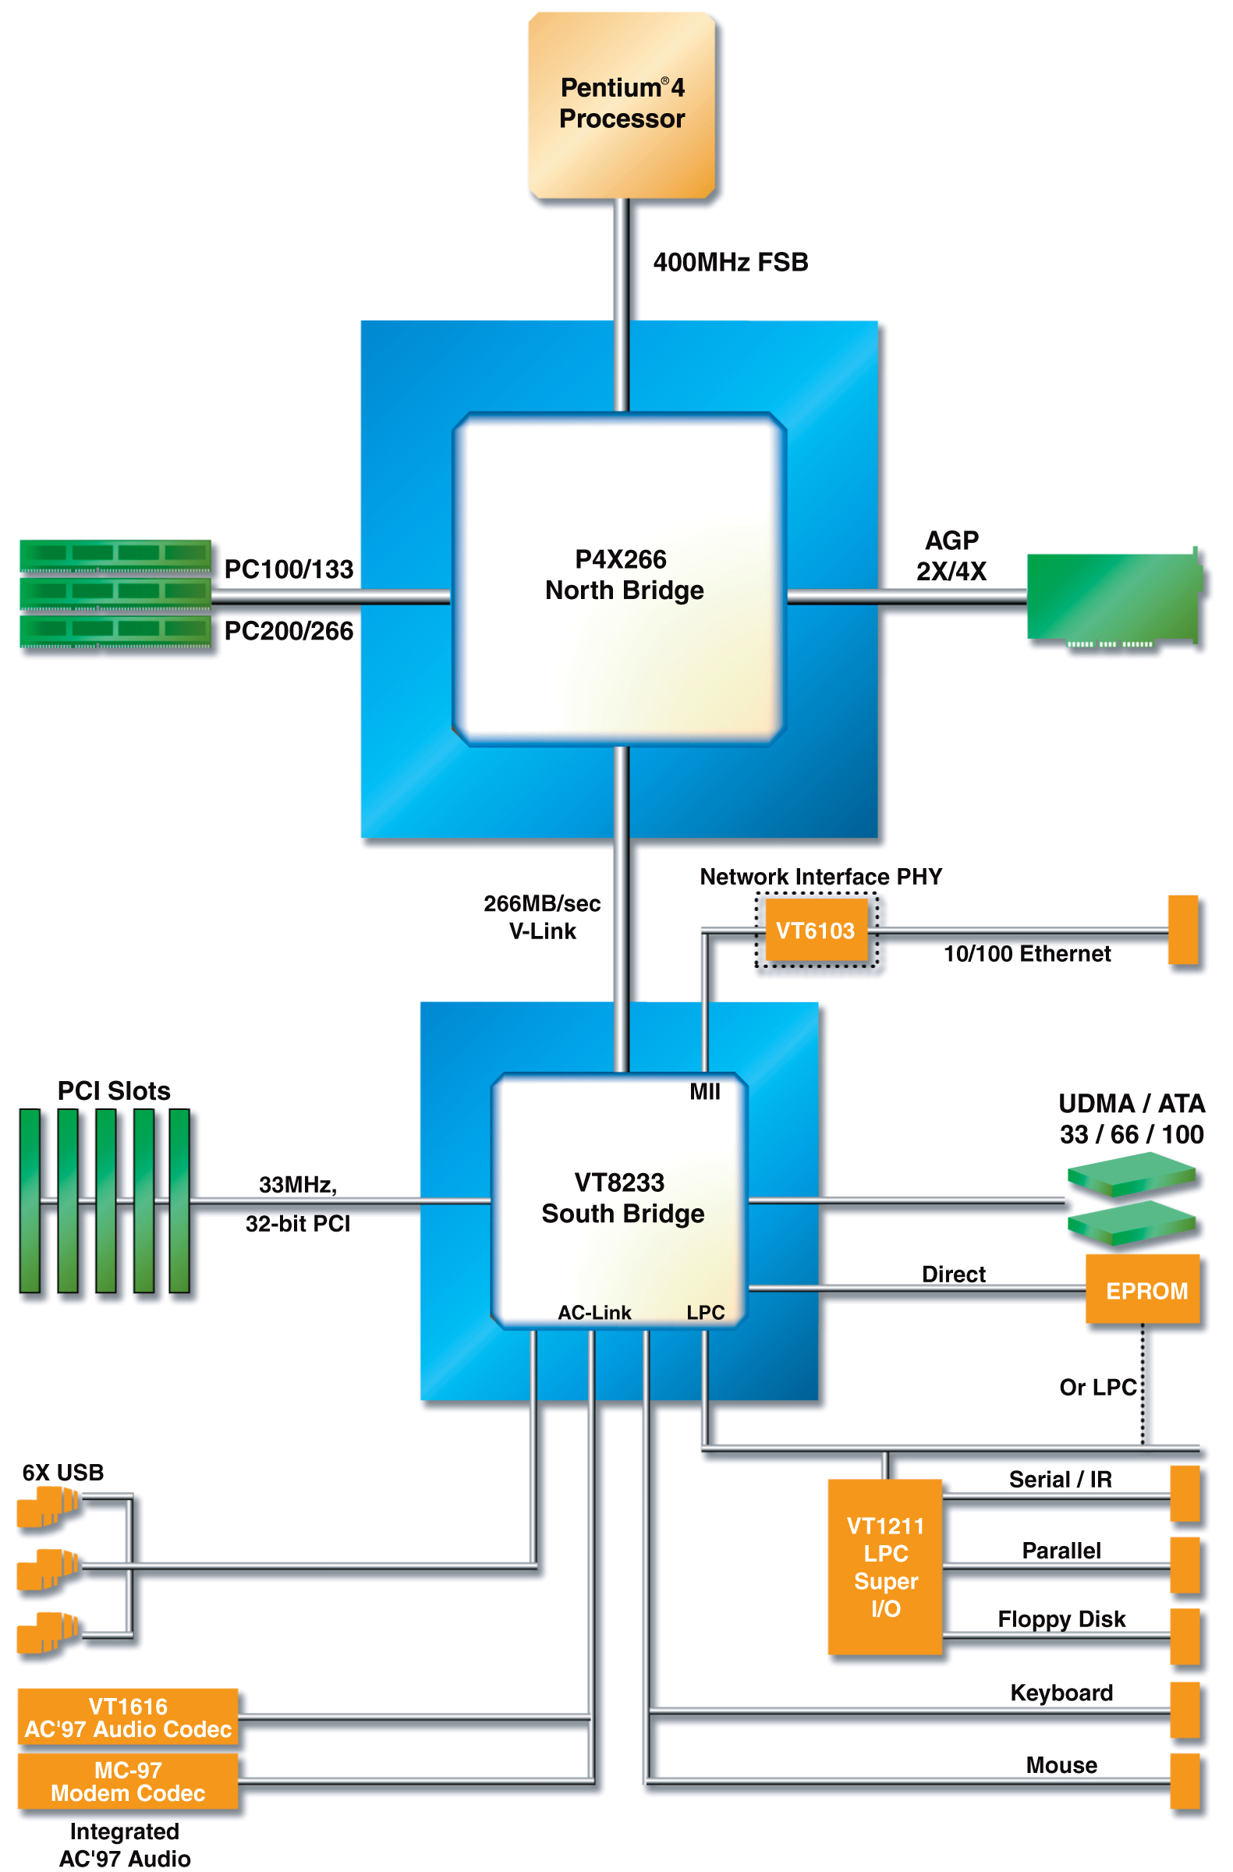
Figure 4

The overall features VIA Technologies declare of the Apollo P4X266A VIA are:

- Supports Intel Pentium 4 Processor
- 400MHz (Quad 100) FSB setting
- AGP4X graphics
- Supports DDR200/266 SDRAM as well as PC100/133 SDRAM
- Ultra fast 266MB per second V-Link between North and South Bridge
- Support for Advanced Communications Riser (ACR)
- AC'97 and MC'97 Audio/Modem
- Integrated 3Com 10/100Mb Ethernet Media Access Controller (VT8233C) or 10/100Mb Ethernet, 1/10Mb Home PNA (VT8233)
- Support for 2 ATA 33/66/100 interfaces
- 6 USB ports, UHCI compliant
- Integrated KBC, PS/2 Mouse Interface, RTC
- Advanced power management capabilities
- 664-pin BGA VT8753 North Bridge
- 376-pin BGA VT8233C or VT8233 South Bridge

VIA Technologies declare the following benefits of the Apollo P4x266a chipset:

- Highly structured bus (North and South Bridge)
- North Bridge handles
- Enhanced processor bus interface (efficient use of Pentium 4 processor’s quad bus interface)
- 400 MHz bus
- Supports up to 4 GB of DDR200 or DDR 266 memory
- AGP4X graphics support
- Modular architecture trough it’s V-Map
(http://www.via.com.tw/en/apollo/P4X266a.jsp)

The Apollo P4X266A is targeted to consumers that want the least costly chipset for its value and in general, this chipset has limited functionality. There are several combinations of chipsets which are possible from the V-link architecture that VIA has developed. This architecture may allow them to corner the “value seeker” market; however, compared to the structure of Intel’s 860 chipset, the VIA chipset lacks performance and it is an inferior chipset.

Section 4: VIA Apollo KT400 chipset

The VIA chipset consists of two main chips: the VT8368 North Bridge and the VT8235 South Bridge. The VT8368 contains the processor interface, DDR memory controller, the AGP 8X interface, and the 8X V-Link interface. The VT8235 houses the south end of the V-Link interface, a 6 channel audio, a ATA 133 IDE interface controller, a built-in MC’97 modem, the new USB 2.0 controller, a built in Ethernet controller, and the PCI bus controller. VIA states that “the VIA Apollo KT400 takes the AMD Athlon XP processor to the summit of system performance with enhanced support for a DDR33, SDRAM, ultra fast AGP 8X graphics, ATA-133, USB 2.0, and an 8X V-Link chip interconnect.” (http://www.via.com.tw/en/apollo/kt400.jsp).

A list of the KT 400 features is provided:
- Supports AMD Athlon™ XP processors
- 200/266/333MHz FSB settings
- 200/266/333MHz System bus settings
- Support for AGP 2X/4X/8X
- Supports up to 4.0GB DDR200/266/333SDRAM
- 8X V-Link 533MB/s high bandwidth North/South Bridge interconnect
- Support for Advanced Communications Riser (ACR) Card Standard
- Integrated 6 channel Surround Sound AC-97 Audio
- Integrated MC-97 Modem
- Integrated 10/100 Ethernet MAC
- Support for ATA 33/66/100/133
- Support for USB 2.0, 6 USB ports, UHCI compliant
- Advanced power management capabilities including ACPI/OnNow
- 664-pin BGA VT8368 North Bridge
- 487-pin BGA VT8235 South Bridge
The VT8368 North Bridge moves at speeds up to 333MHz to the CPU from the front side bus (FSB). Supporting a DDR200/ 266/333 memory, the North Bridge provides lighting fast access to the system memory and can reach a peak bandwidth of 2.7 GB/s. Moreover, the DDR333 memory operates at 400 MHz. A key feature of this new chipset is the integration of the new AGP 8X technology. The implementation of the AGP (accelerated graphics port) 8X on the Apollo KT400 North Bridge, according to VIA Technologies, “offers 2.1GB/s of dedicated bandwidth to the next generation of discrete 3D graphics solutions.” They further stat that this move allows end users ease at upgrading and guarantees that there is “enough performance headroom for a solid return on their motherboard investment.” The North Bridge is connected to the South Bridge using 8X V-Link. As mentioned earlier with the P4X266A chipset, the V-Link is a creation of VIA technologies that was developed to free up the PCI bus bottleneck. VIA’s 8x V-Link provides a dedicated bus of 133MHz between the North and South Bridge. Therefore, the PCI bus handles peripheral devices at “4 times the bandwidth of the original PCI interconnect.” (http://www.via.com.tw/en/apollo/kt400.jsp)
The VT8235 South Bridge connects to the North Bridge at a high speed with the 8X V-link as mentioned above. A new feature with this chipset is the use of the new USB 2.0 standard. This standard allow for 6 new ports with ability to handle 128 devices daisy-chained. The USB 2.0 is about 40X times faster than the older USB 1.1 version. This increase of speed permits a faster communication between the computer and peripheral devices, such as a digital camera.
“VIA has long recognized the potential of USB as a universal interconnect system, designing USB 1.1 support into our award winning core logic chipsets well in advance of the proliferation of USB-enabled PC peripherals.”

Following the widespread adoption of the USB 1.1, VIA believes that the USB 2.0 is a natural advancement to meet the demands of greater bandwidth speeds, while being backwards compatible with existing peripherals. As a member of the USB Implementers Forum, VIA is helping to facilitate an industry-wide move towards adoption of the latest USB specifications, by integrating full support for high bandwidth technology into upcoming core logic chipsets, and by expanding our product lineup of Hi-Speed USB 2.0 discrete chips.
VIA is also one of the first to incorporate ATA 133 into their chips. ATA (Advanced Technology Attachment) 133 offers unsurpassed connectivity features to guarantee the ultra fast processor and memory are not restricted by peripheral bottlenecks.

“ATA-133 FastDrive™ is the fastest IDE standard currently available on the market, and allows each IDE controller to burst up to 133MB/s. This offers a significant performance improvement in data intensive professional applications and in consumer applications including gaming, audio and video. The faster interface will also save time when booting up the system and opening new applications. In the VIA VT8235 South Bridge, each controller also supports up to two devices, for a total of four ATA-133 capable drives. In multiple configurations including RAID, the performance benefits of the faster interface are particularly apparent.”

In addition to the innovative USB 2.0 and ATA 133, VIA also boosts integrated Dolby Digital surround sound, an Ethernet connect for fast LAN or internet connections and a modem chipset. The audio portion of the VT8235 supports the AC’97 version 2.2 standards. When theVT8235 is connected to a compatible codec, it can support 6-channel audio for a complete surround sound listening experience. Moreover, the interface can support S/PDIF digital outputs and optional features such as tone and loudness control and 3D stereo enhancement.
Some of the motherboard manufacturers that se this chipset in their motherboards include Soyo, Abit, Asus, among many others. At this point, it would be interesting to compare the KT400 chipset using an AMD CPU with its rival, the Pentium 4. A Soyo SY-KT400 Dragon Ultra motherboard with a KT400 chipset was used for the comparison. The first test used is the SiSoft Sandra Memory bandwidth test. Here, the KT400 seems to offer just a bit more memory bandwidth than the KT333, but it is not a significant amount (see figure 5). The 333MHz bus helps things considerably in this area, but the Pentium 4 still wins handily.

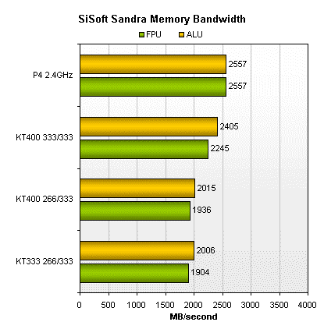

Figure 5

Another important test to measure is the Business Winstone 2001 test. This test measures a PC's overall performance by running today's top-selling Windows-based 32-bit applications (see figure 6). 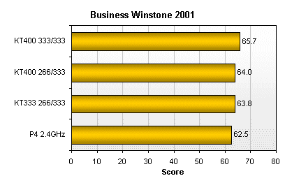
Figure 6

Here, The Pentium 4 drops to the bottom of the pack here, while the KT400 remains just ahead of the KT333. Upping the bus speed is good for another 1.7 points. Another test worth noticing is used by motherboard testers, the Quake III test. This test clearly shows the difference among the diverse bus speeds (see figure 7).

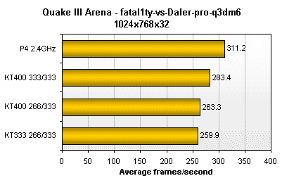
Figure 7

“This one isn't as bad for the Athlon as the Xmpeg results, but Quake III Arena has always been the Pentium 4's playground. Q3A loves memory bandwidth, however, and the jump to 333MHz is good for an extra 20 frames per second or so” (http://www.tech-report.com/reviews/2002q3/kt400-dragon/).

Section 5: AMD 760 MPX Chipset

AMD, as discussed in section 1, is a growing company and competitor of Intel. They are continuously innovative, while trying to being “cost-effective.” AMD’s main products are its CPU’s and chipsets, but besides those, AMD has branched off into other areas of computing such as networking. Recently, AMD announced its brand new CPU family that now offers 333MHz front side bus (FSB). However, since these new CPU’s do not have corresponding chipsets available from AMD, we shall discuss their latest chipset, the AMD 760MPX.
AMD is coming out with faster and smaller CPU’s to compete with Intel, but unlike Intel, AMD has been lagging with its supporting chipsets. Currently, AMD only offers the AMD 760 MPX chipset, which is its somewhat outdated, but still competitive dual CPU chipset. The following description can be found on AMD’s website:

“The AMD-760MPX chipset is a high performance two-way multiprocessor core logic solution for AMD Athlon TM MP class processors, offering Multi-Processor eXtended (MPX) performance over the AMD-760 MP chipset. Extended performance is offered by the 66-MHz/64-bit/32-bit PCI bus and a feature-rich peripheral bus controller offering PCI-to-PCI bridging capability along with AC ‚97 audio. The high-performance of the chipset is attributed to an enhanced AMD Athlon system bus, support for DDR (Double Data Rate) memory technology, and AGP-4X Graphics Interface. The AMD-760 MPX chipset consists of the following components: AMD-762 System Controller (Northbridge) and the AMD-768 Peripheral Bus Controller (Southbridge). Together, these components provide a powerful solution for Workstation and Server class platforms.” (http://www.amd.com/usen/assets/content_type/white_papers_and_tech_docs/24494.pdf).

The key features of the chipset are as follows:

- Dual high-speed 266 MHz 1 AMD Athlon system buses, supporting up to two processors
- PC2100 2 DDR memory subsystem supporting up to 4 GB of memory
- AGP-4X Graphics Interface (supports 1X and 2X modes)
- Primary PCI 2.2 compliant 66-MHz/64-bit/32-bit PCI Bus
- Secondary PCI 2.2 compliant 33-MHz/32-bit PCI Bus
- Two-channel ATA 33/66/100 support
- Thirty-two general-purpose IO (GPIO) pins
- USB OHCI host controller supporting four ports

The AMD-762 system controller provides the bridging function between the high speed host-processor buses, AGP graphics subsystem, DDR memory subsystem, and the PCI interface. A key feature of the AMD-762 system controller is two 266MHz point to point AMD system buses which provide uniprocessor or two-way symmetric multiprocessor capability. Each bus is able to provide 266 MHz speeds for combined speeds of 533 MHz. The main memory uses PC2100 DDR memory at 266 MHz. The memory controller supports up to 4 GB of memory space (supports four Registered DIMM slots). Unfortunately, since this is an older design than the VIA KT400, some of the features may seem outdated. For video cards, the North Bridge has an AGP-4X interface (support 1X and 2X modes). One main distinction between this design and the VIA KT400 is the location of the PCI bus. AMD offers a Dual Mode PCI 2.2 Compliant PCI bus interface, a 66 MHz clock with a 32-bit and 64-bit data path support (and supports up to two PCI slots). This bus connects directly with the bus that connects the North Bridge with the South Bridge. Since the devices that connect onto the available PCI slots are allowed practically direct communication with the memory and CPU, transfer speeds are dramatically increased. There are also five more PCI slots available, but at half the speed: 33MHZ clock with 32bits. These PCI slots are connected to a PCI bus that is connected into the South Bridge and must compete for resources.
The AMD-768 peripheral bus controller is an Integrated Circuit (IC) that serves as the I/O hub, interface module, or Southbridge component of personal computer chipsets. The AMD-768 peripheral bus controller connects to a host memory controller through the PCI bus and provides a secondary PCI-bus bridge. Its has several functions. The most important, but already mentioned is a secondary 33MHz/32-bit PCI bus interface (PCI 2.2 Compliant), this includes a PCI bus arbiter with support for up to eight external devices. It is also responsible for AC ‚97 Soft Audio Controller; UDMA 33/66/100 compatible EIDE bus master controller; support for a primary and a secondary dual-drive port; OHCI-based USB host which includes a root hub and supports for four ports; thirty-two General Purpose I/O (GPIO) pins (Many pins are multiplexed with other hard-wired functions.); and Legacy-AT Compatible Logic.

Some of the motherboard manufacturers that use this chipset in their motherboard include Tyan, ASUS, MSI and Gigabyte. This chipset uses and Athlon MP CPU, which is Intel’s Xenon equivalent. Therefore, we can not compare performance values with Pentium 4. The four mentioned manufacturers were put together in a test and test numbers were generated. The first test used by this particular tester was, once again, the SiSoft Sandra Memory bandwidth test (see figure 8). If we compare the number with that of VIA’s KT400, we can quickly see AMD lags behind. Out of the four motherboards here, the MSI and Tyan seem to be the fastest.

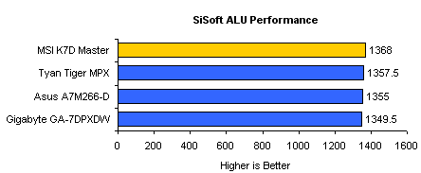

Figure 8

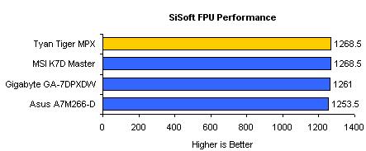

Figure 9

Of course, this is not where a dual CPU system pays off. In another test the tester compared AMD MP CPU’s and Intel’s Xeon and according to the graphs, AMD beat Intel in 3D rendering (See figure 9).

3D Rendering Performance
3D Studio MAX 4.26 (Render Time in Minutes - Lower is Better)
  AMD Athlon MP 1900+ (1.6GHz)
  AMD Athlon MP 1.2GHz
  Intel Xeon 1.7GHz
  6.1
  7.9
  8.33
  |  0 | |  2 | |  3 | |  5 | |  7 | |  8 | |  10

Figure 10

This test shows howmuch faster a slower 1.6Ghz AMD MP is compared with the Intel Xeon 1.7 GHz using the 3D rendering test.
Now for a side-by-side comparison of true speed, Content Creation Winstone 2002 test was used. Here we’ll provide a chart for both the AMD MPX chipset as well as VIA’s KT400. First, the AMD chipset versus the Intel Xeon (see figure 10)

Content Creation Performance
Content Creation Winstone 2002
  AMD Athlon MP 1900+ (1.6GHz)
  AMD Athlon MP 1.2GHz
  Intel Xeon 1.7GHz
  36.6
  31.5
  29.6
  |  0 | |  7 | |  15 | |  22 | |  29 | |  37 | |  44

Figure 10

Again, it is clear how much faster AMD is. According to the testers, “Content Creation Winstone 2002 provides a picture we're much more used to seeing, with the Athlon MP 1900+ CPUs coming out 24% faster than the dual Xeons.” Now let us compare these dual CPU setups with VIA’s KT400 chipset, which uses a single CPU.

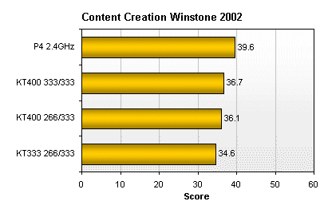
Figure 11

For this test, the tester used Athlon XP 2200+ CPU operating at 1.8Ghz compared with the P4 2.4 GHz. Looking at the two charts, it is obvious that the dual AMD setup offers better performance (the dual Athlon MP 1900+ vs. the single Athlon XP 2200+) than the single AMD setup. Of course, if we look at the P4, its is clearly faster, but it is also a 2.4Ghz CPU (See figure 11).

