GET INTO THE NEW TREND:
LCD Monitors

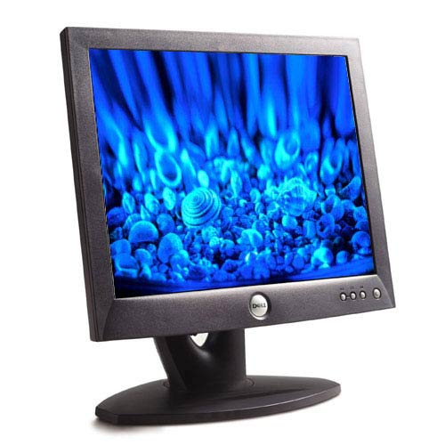

Jerry Garcia
Sici Jacquez
Julio Ramirez
Gil Ran
Beatrice Zepeda

IS 311 – IT in Business
Glen L. Gray, PhD, CPA
November 19, 2002

Table of Contents

 | Page
I. Table of Contents | 2-3
1.0 Monitor Overview | 4-6
1.1 Monitor Trend | 4
1.2 How Monitors Work | 5
1.3 Monitor Classifications | 5
1.4 Monitor Size | 6
2.0 LCDs | 6-7
2.1 LCD History | 6
2.2 How LCDs work | 7
3.0 Display Technology | 7-8
3.1 Color Graphics Adapter (CGA) | 7
3.2 Enhanced Graphics Adapter (EGA) | 8
3.3 Video Graphics Adapter (VGA | 8
3.4 Multi-Scanning Monitors | 8
4.0 Pre-IBM | 8-9
4.1 Apple II | 8
4.2 TRS-80 | 9
4.3 The Heath Desktop | 9
5.0 IBM | 10
5.1 IBM PC-1981 | 10
6.0 Windows Screen Shots Throughout Time | 11-14
6.1 MSDOS | 11
6.2 Windows 3.x | 12
6.3 Windows 95 | 12
6.4 Windows 2K | 13
6.5 Windows XP | 14
7.0 Advantages and Disadvantages | 15-19
7.1 Advantages and Disadvantage of an LCD | 15
7.2 Advantages and Disadvantages of a CRT | 17
7.3 Sales of both LCD’s and CRT’s | 18
7.4 Disposal Fees for CRT (Cathode Ray Tubes) | 19
7.5 Case Study | 19
8.0 Current LCD Technology | 20-24
8.1 Business Aspect | 20
8.2 Technology Aspect | 21
8.3 Improving Viewing Angles | 22
8.4 Active vs. Passive display | 22
9.0 Future LCD Monitor Trends | 25-27
9.1 Features/Performance | 26
9.2 Future Developments | 27
10.0 Buyer’s Guide | 27-28
Works Cited | 29-32

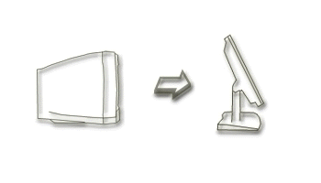

- MONITOR OVERVIEW:

A monitor is the device that is connected to a computer and displays information on a screen. The term “monitor” refers to the entire box where the term “display screen” can mean just the screen. Monitor can also often imply graphical capabilities. The display is the most-used output device on a computer. It provides instant feedback by showing text and graphic images. Most desktop displays use a cathode ray tube (CRT), while portable computing devices such as laptops incorporate liquid crystal display (LCD), light-emitting diode (LED), gas plasma or other image projection technology. Because of their slimmer design and smaller energy consumption, monitors using LCD technologies are beginning to replace the venerable CRT on many desktops. (Tyson)

The most popular display remains the cathode ray tube monitor, which has been available for more than 70 years. CRT monitors (Gowan):

- Create vivid colors and render detailed images and text.
- Cost much less than their nearest competitors, liquid crystal displays.
- Continue to evolve, with developments such as flat screens and shorter tubes.

1.1 Monitor Trend:

CRT monitors are bulky, heavy and rely on vacuum tube technology that was invented in the 19th century. In contrast, LCD's are light, sleek, energy-efficient and have a sharper picture. John West, director of the Liquid Crystal Institute at Kent State University, has been working on LCD technology since 1984. He says the market for flat screen LCDs grew rapidly during the '90s with the huge success of laptop computers. "Even with this rapid growth, it has been slower than predicted at matching the market share of the traditional CRT," he said. (Benner)

A series of innovations has finally allowed the LCD to go head-to-head with CRT monitors. In the late '80s, early LCDs made the laptop revolution possible. But they were small, black and white and could only be viewed straight ahead. Color LCDs for laptops hit the market in the early '90s. In the latter part of the decade, new films were developed that, when laminated onto the screen, improve off-axis viewing. And, finally, new plants in Asia that could produce larger sizes of LCD glass reduced the price of stand-alone monitors with bigger screens. (Benner)

Only now have LCDs become popular enough for vendors to mass-produce them for the desktop PC market. Like the CRT monitor, the LCD monitor has undergone many changes since its introduction. The first LCD laptop monitors were very small due to manufacturing costs. The quality of these monitors wasn’t exactly great either, due to the small number of transistors available in the LCD display technology. (Engelking)

Initially, LCD monitors used a passive matrix display, which consisted of two transistors charging the intersecting axes of an x/y grid to control pixel color. However, the onset of the active matrix display has greatly benefited LCD monitors. Active matrix displays contain a transistor for each pixel, and this produces a greater quality image due to the increased amount of transistors. Most LCD monitors now have active matrix displays. (Engelking)

1.2 How Monitors Work:


Most computer monitors use a cathode-ray tube (CRT) as the display device. A CRT is a glass tube that is narrow at one end and opens to a flat screen at the other end. The CRTs used for monitors have rectangular screens, but other types of CRTs may have circular or square screens. The narrow end of the CRT contains a single electron gun for a monochrome, or single-color monitor, and three electron guns for a color monitor, one electron gun for each of the three primary colors: red, green, and yellow. The display screen is covered with tiny phosphor dots that emit light when struck by electrons from an electron gun. (Microsoft)

Following signals sent by the PC's graphics controller, a beam sweeps quickly back and forth across the thick end of the tube. The phosphors light up when hit with electrons, mixing red, green, and blue to create the colors that are seen on the screen. The point where one set of adjacent red, green, and blue phosphors meet constitutes a pixel (short for "picture element"), the smallest dot in a display. Because the phosphors that make up a pixel light up only briefly, they need to be constantly refreshed, which is why the beam continually and rapidly sweeps the inside of the tube. (Microsoft)

1.3 Monitor Classifications:

There are many ways to classify monitors. The most basic is in terms of color capabilities, which separates monitors into three different classes (Monitor):

- Monochrome: Monochrome monitors actually display two colors, one for the background and one for the foreground. The colors can be black and white, green and black, or amber and black.
- Gray-Scale: A gray-scale monitor is a special type of monochrome monitor capable of displaying different shades of gray.
- Color: Color monitors can display anywhere from 16 to over 1 million different colors. Color monitors are sometimes called RGB monitors because they accept three separate signals -- red, green, and blue.

Monochrome monitors have only one type of phosphor dot while color monitors have three types of phosphor dots, each emitting red, green, or blue light. Pixels are arranged together in rows and columns and are small enough that they appear connected and continuous to the eye.

Manufacturers describe the quality of a monitor’s display by dot pitch, which is the amount of space between the centers of adjacent pixels. Smaller dot pitches mean the pixels are more closely spaced and the monitor will yield sharper images. Most monitors have dot pitches that range from 0.22 mm (0.008 in) to 0.39 mm (0.015 in). (Monitors)

The resolution of a monitor indicates how densely packed the pixels are. More pixels indicate a sharper image. Most modern monitors can display 1024x768 pixels. Some high-end models can display 1280x1024, or even 1600x1200. (Monitors)

1.4 Monitor Size:

The distance from one corner of the display to the diagonally opposite corner measures the screen size. A typical size is 38 cm (15 in), with most monitors ranging in size from 22.9 cm (9 in) to 53 cm (21 in).(Monitor) In addition to their size, monitors can be either portrait (height greater than width) or landscape (width greater than height). Standard monitors are wider than they are tall and are called landscape monitors. Monitors that have greater height than width are called portrait monitors. Monitors that are 16 or more inches diagonally are often called full-page monitors. (Microsoft)

The screen size is sometimes misleading because there is always an area around the edge of the screen that can't be used. Therefore, monitor manufacturers must now also state the viewable area, the area of the screen that is actually used. (Monitor)

2.0 LCDs:
LCD is the technology used for displays such as notebooks, small computers, pagers, phones, and other instruments. The display uses a combination of fluorescent-based backlight, color filters, transistors, and liquid crystal to create and illuminate images. Like LED and gas plasma technologies, LCDs enable displays to have a smaller form factor than the traditional CRT. They also consume much less power than LED and gas plasma because they block light rather than emit it. An LCD has either a passive or active matrix display grid. The widely used active matrix, also known as thin film transistor (TFT) design, places vertical and horizontal TFT lines on one plane to form a true matrix, requiring less current. (LCD)
2.1 LCD History:

Today, LCDs are everywhere we look, this evolution did not happen overnight. It took a long time to get from the discovery of liquid crystals to the multitude of LCD applications we are now familiar with. Liquid crystals were first discovered in 1888, by Austrian botanist Friedrich Reinitzer. (Tyson) Reinitzer observed that when he melted a curious cholesterol-like substance (cholesteryl benzoate), it first became a cloudy liquid and then cleared up as its temperature rose. Upon cooling, the liquid turned blue before finally crystallizing. Eighty years passed before RCA made the first experimental LCD in 1968. Since then, LCD manufacturers have steadily developed creative variations and improvements on the technology, taking the LCD to high levels of technical complexity. (Tyson)

2.2 How LCDs Work:

LCD displays utilize two sheets of polarizing material with a liquid crystal solution between them. An electric current passed through the liquid causes the crystals to align so that light cannot pass through them. Each crystal, therefore, is like a shutter, either allowing light to pass through or blocking the light. (LCD)
Monochrome LCD images usually appear as blue or dark gray images on top of a grayish-white background. Color LCD displays use two basic techniques for producing color, passive matrix and thin film transistor (or active-matrix). Passive matrix is the less expensive of the two technologies. Thin film transistor produces color images that are as sharp as traditional CRT displays, but the technology is expensive. (LCD)
Until recently, LCD panels were used exclusively on notebook computers and other portable devices. In 1997, however, several manufacturers began offering full-size LCD monitors as alternatives to CRT monitors. The main advantage of LCD displays is that they take up less desk space and are lighter. Currently, however, they are also much more expensive. (LCD)

3.0 DISPLAY TECHNOLOGY:

Displays have come a long way since the blinking green monitors in text-based computer systems of the 1970s. The following are advances made by IBM over the course of a decade (Tyson):

- In 1981, IBM introduced the Color Graphics Adapter (CGA), which was capable of rendering four colors, and had a maximum resolution of 320 pixels horizontally by 200 pixels vertically.
- IBM introduced the Enhanced Graphics Adapter (EGA) display in 1984. EGA allowed up to 16 different colors and increased the resolution to 640x350 pixels, improving the appearance of the display and making it easier to read text.
- In 1987, IBM introduced the Video Graphics Array (VGA) display system. Most computers today support the VGA standard and many VGA monitors are still in use.
- IBM introduced the Extended Graphics Array (XGA) display in 1990, offering 800x600 pixel resolutions in true color (16.8 million colors) and 1,024x768 resolutions in 65,536 colors.

3.1 Color Graphics Adapter (CGA):
The first mainstream video card to support color graphics on the PC was IBM's Color Graphics Adapter (CGA) standard. The CGA supports several different modes; the highest quality text mode is 80x25 characters in 16 colors. Graphic modes range from monochrome at 640x200 to 16 colors at 160x200. The card refreshes at 60 Hz. (Kozierok)
3.2 Enhanced Graphics Adapter (EGA):
IBM's next standard after CGA was the Enhanced Graphics Adapter or EGA. This standard offered improved resolutions and more colors than CGA, although the capabilities of EGA are still quite poor compared to modern devices. EGA allowed graphical output up to 16 colors at screen resolutions of 640x350, or 80x25 text with 16 colors, all at a refresh rate of 60 Hz. (Kozierok)
3.3 Video Graphics Adapter (VGA):
The replacement for EGA was IBM's last widely accepted standard: the Video Graphics Array or VGA. VGA, supersets of VGA, and extensions of VGA form today the basis of virtually every video card used in PCs. Introduced in the IBM PS/2 model line, VGA was eventually cloned and copied by many other manufacturers. When IBM fell from dominance in the market, VGA continued on and was eventually extended and adapted in many different ways. (Kozierok)

3.4 Multi-Scanning Monitors:

More than a decade, NEC announced the MultiSync monitor. Up to that point, most monitors only understood one frequency, which meant that the monitor operated at a single fixed resolution and refresh rate. You had to match your monitor with a graphics adapter that provided that exact signal or it wouldn't work.

The introduction of NEC MultiSync technology started a trend towards multi-scanning monitors. This technology allows a monitor to understand any frequency sent to it within a certain bandwidth. The benefit of a multi-scanning monitor is that it can change resolutions and refresh rates without having to purchase and install a new graphics adapter or monitor each time. Because of the obvious advantage of this approach, nearly every monitor purchased today is a multi-scanning monitor. (Tyson)

4.0 PRE-IBM:

4.1 Apple II:

The Apple II became an instant success when released in 1977. The Apple II was based on the Apple I design, but with several additions. The first was the design of a plastic case, a rarity at the time--which was painted beige. The second was the ability to display color graphics. The system included a printed circuit motherboard, switching power supply, keyboard, case assembly, manual, game paddles, A/C power cord, and cassette tape with the computer game "Breakout." When hooked up to a color television set, the Apple II produced brilliant color graphics. (Computer)
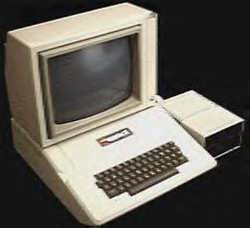

The system was the first true “personal computer". It was factory built, in expensive, easy to learn and use and was the first personal computer capable of color graphics. It could display 6 colors at 280x192 and 4-bit color at 40x48. (Veit)

4.2 TRS-80:

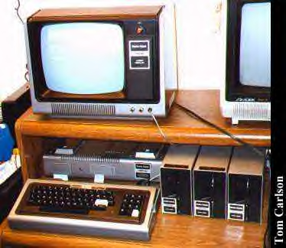

Radio Shack’s TRS-80 sold for about $500 complete with video monitor and BASIC, it took the personal computer market by storm. It was the first product in store history to fetch more than $500. It was developed back in the late 1970's when the only home computers available to the general public were things like the Altair kits, and the first Apple machine. The CPU board of the computer was contained in the keyboard unit, and it used a separate black and white monitor. The monitor was basically an RCA TV with the tuner removed. The Model III, which was housed in one case, became the most popular personal computer in schools and homes rivaling the Apple II. (Benner)

4.3 The Heath Desktop:

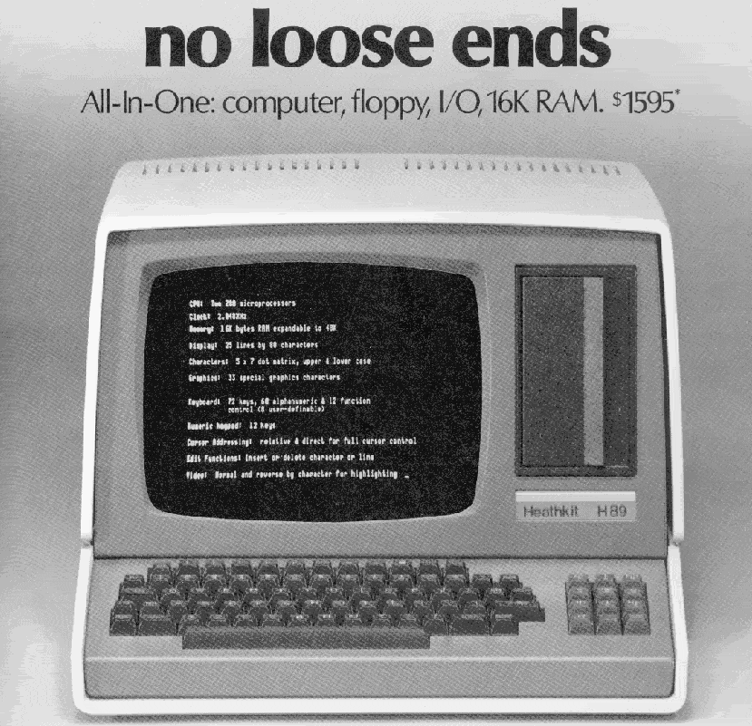
The Heath Desktop was one of the first computers designed as complete desktop machines including monitor, floppy disks and keyboard. Heath made a full line of computers and was later bought out by Zenith. (Veit)

5.0 IBM:

5.1 IBM PC-1981:

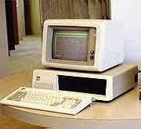
In the Beginning....
IBM sparked the personal computer revolution with the introduction of its 5150 model in 1981. The PC featured a 5-MHz Intel processor, 18 Kilobytes of memory and an optional color monitor. Starting price: $1,565. (Veit)

What really made the IBM PC different from previous IBM computers was that it was the first one built from off the shelf parts (called open architecture) and marketed by outside distributors (Sears & Roebucks and Computerland). The Intel chip was chosen because IBM had already obtained the rights to manufacture the Intel chips. IBM had used the Intel 8086 for use in its Displaywriter Intelligent Typewriter in exchange for giving Intel the rights to IBM's bubble memory technology. (Bellis)

6.0 WINDOWS SCREEN SHOTS THROUGHOUT TIME:

6.1 MSDOS:

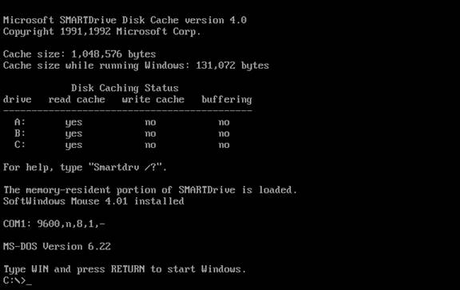

6.2 Windows 3.x:

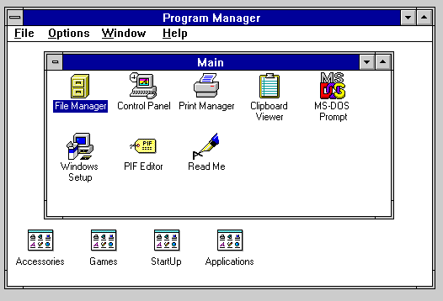

6.3 Windows 95:

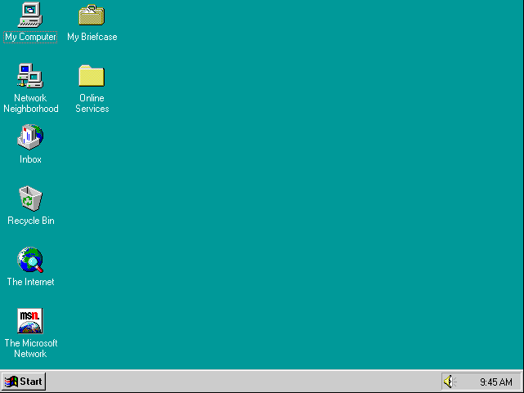

6.4 Windows 2K:

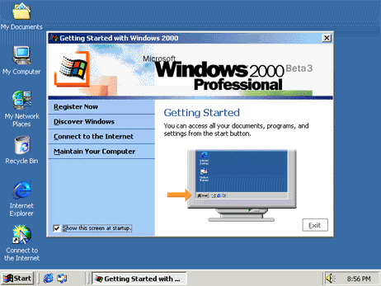

6.5 Windows XP:

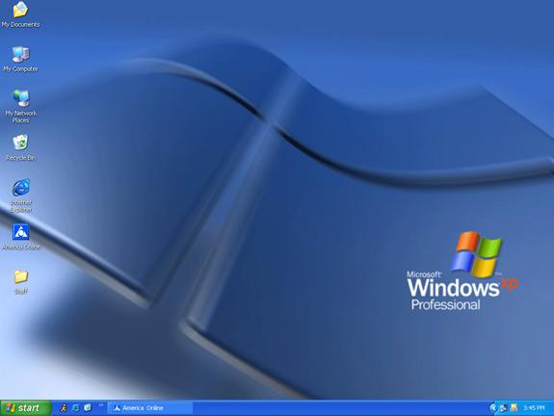

7.0 ADVANTAGES AND DISADVANTAGES:

There are advantages and disadvantages when choosing a monitor. CRT and LCD monitors are based on completely different technologies and therefore have different characteristics. Discussed are the benefits and downfalls of choosing an LCD or a CRT.

7.1 Advantages and Disadvantage of an LCD:

LCD type monitors are based on new technology and are becoming very popular. LCD monitors come a number of sizes and they range from around “12 to 20 inches in size and come in two sorts: computer LCD monitors and video LCD monitors.” (Plasma)
Thanks to advances in LCD technology, color flat panel LCD monitors are now available that are comparable in screen size to traditional CRT monitors. Shown here, a 12.1" LCD display (left) has only a slightly smaller viewing area than a typical 14" CRT monitor. Newer, larger LCD monitors are also appearing …that are comparable to the largest CRT monitors. One thing to note is that LCD monitors are typically sized by their actual viewable diagonal measurement, but CRTs typically are not. (Comparing)

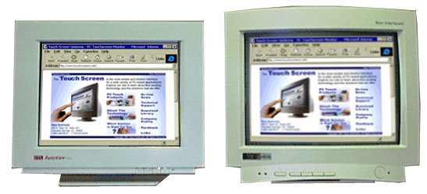

The LCD is ergonomically designed. A noticeable “advantages of LCD monitors is that they are compact and lightweight. An LCD monitor is based upon a very thin screen as opposed to the bulky tube of a CRT monitor.” (Comparing)

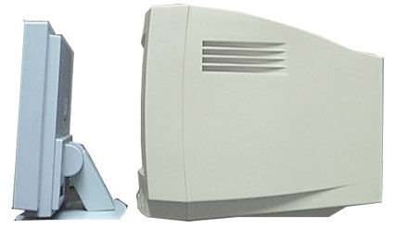

The LCD design saves space at the desk/workstation and can be mounted on a wall or panel. Many of the more sophisticated models include built-in speakers, TV tuners and pivoting capabilities for landscape or portrait viewing... Flat panel LCD’s improves viewing clarity, which cause less eyestrain. Although it is not scientifically validated, most people feel that there is less eyestrain when the image is larger, crisper and properly distanced. LCD’s are not subject to electromagnetic interference and don't glare or flicker like CRTs… Most LCD panels are more durable than their CRT counterparts. A typical CRT loses approximately 50 percent of its brightness after 10,000 hours. An LCD bulb will maintain its brightness anywhere from 25,000 to 50,000 hours. Additionally, the LCD uses less energy and consumes fewer watts than a CRT. An LCD will use an average of 30 watts compared to 120 watts for the CRT in power consumption. (Conway)
The LCD flat panel display consumes much less energy. “On the average, about 40 watts” and therefore can noticeably have a reduction of 40-85% on the electric bill. (LCD Monitors) This is probably not much of a concern for an individual user but can be of great importance for a company that has a large number of employees using computers. CRT monitors are generally more affordable than LCD monitors. In the past LCD monitors have been very expensive but their costs have come down quite a bit in the last 1-2 years. “One thing to consider is the up-front cost versus the long-term cost. A CRT monitor will cost less up front but will use more energy than a flat panel monitor. An LCD monitor will cost more up front but will conserve energy in the long run.” (Comparing)Another basic advantage is that it offers a faster return from sleep mode.
LCD monitors offer an alternative to CRT... While LCD monitors have been used on laptops for many years, only now have these devices become popular enough for vendors to mass-produce them for the desktop PC market… Cost is currently one of the major drawbacks of LCD monitors…

Another drawback to LCD monitors is the plug interface that is needed to connect to the computer. Some LCD monitors require a special digital plug-in interface in order to work with the monitor. The problem is that this plug is not available on most computers, so another video card or adapter must be purchased to plug these LCD monitors into the computer. (Engelking)
7.2 Advantages and Disadvantages of a CRT:
Many companies see LCD adoption growing but they continue to invest in new CRT technologies because according the Rhonda Alexander they “expect standard monitors to be around for a long time.” (Mainelli) CRT monitors still outperform LCDs in several areas, such as in the capability to offer multiple resolutions and in response time.
CRT monitors are usually capable of displaying multiple video resolutions... LCD monitors, however, usually has what is called a Native resolution, or the resolution that it displays best. The native resolution is generally the highest resolution that the LCD can display and this is the display resolution that will appear the crispest/sharpest. (Comparing)
For those who watch videos or play games on their PC’s response time is critical. “The fastest LCDs offer a response time of about 25 milliseconds, whereas CRTs respond in about 13 milliseconds. The delay on an LCD can cause a ghosting effect on images it displays.” (Mainelli)
Another advantage of a CRT over an LCD is that a CRT screen can be looked at from a very wide angle, practically from the side, but an LCD monitor normally has a smaller viewing angle. With some LCD’s it is required to be viewed directly from the front. From the side the images on an LCD screen can seem to disappear or the colors can seem to be inverted. With new technology newer displays that are coming out have wider viewing angles so this is not as much of an issue as it has been in the past. (Comparing)
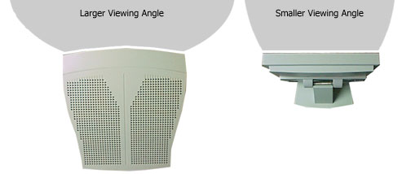

Users who prefer CRT monitors are Graphic artists “because they show truer colors and greater nuance, whereas people who work mostly with text gravitate toward LCDs because pixels on an LCD have well-defined edges, resulting in sharply focused letters.” (How to Buy) Gamers also prefer CRT’s because LCD’s “redraw their screens more slowly, and as a result, moving images can sometimes leave visible trails. ” (How to Buy) CRT monitors are also capable of displaying unlimited colors.” (Comparing) While some LCD monitors are only capable of hundreds or thousands of colors, but most modern and newer LCD's are capable of unlimited colors.
CRT monitors may have been around for a while, but they aren’t without their hazards. Did you know that CRT monitors hold a dangerous electrical charge even after they’re turned off? The charge can actually last up to several years and be hazardous and even deadly to anyone who opens a CRT monitor casing. Then there is the additional danger of radiation… a metal shield behind the glass of your monitor protects your body from a flood of radiation… CRT monitors have also been known to cause fires due to electrical malfunctions and excessive heat if the ventilation holes are accidentally covered up. (Engelking)
7.3 Sales of both LCD’s and CRT’s:
Despite a sluggish global economy, worldwide sales of …LCDs, will rise 64 percent in 2002, while sales of traditional …CRT, monitors will drop 6 percent, according to Eric Haruki, an analyst for the consulting firm… "Flat displays are the future," Haruki said. He predicts that flat screens will capture the majority of market share from CRT monitors by 2006. If he's right, it means a dramatic shift in the monitor market over the next five years. Last year 15.5 million flat screen displays sold worldwide. But shoppers lugged home nearly 90 million traditional monitors... Thanks to new production facilities in Taiwan that have come online over the past two years, prices for flat screens have been dropping steadily -- about 20 percent over the last year… CRTs will still be a little cheaper than flat displays for at least another five years, according to Habuki. (Benner)
According to Mostafa Maarouf’s Gartner article “Liquid Crystal Displays: The Price Puzzle,” three factors will increase demand for LCD monitors over the next five years. First, LCD supply increases will result in lower prices. Second, improvements in performance of LCD monitors will narrow the price/performance gap between LCD and CRT monitors, resulting in greater demand for LCD monitors. Third, PC system price excluding the monitor will continue to fall. This will allow consumers to spend more on the display. (Detwiler)
It has been observed by ARS, based in La Jolla, CA, that the average price on the market today for a low-end LCD display [15-inch] is approximately $249. As reported by TWICE in CES Daily [January 8-10, 2002], that price has dropped nearly 76% since January 2001, when it was $1,016! (EnergyStar)
7.4 Disposal Fees for CRT (Cathode Ray Tubes):
According to the National Safety Council, an estimated 20 million PCs are becoming obsolete in the US every year, which is accounting for about two million tons of trash every year. (Fergurson) Recently published articles have been mentioning disposal fees with regards to CRT monitors. Recycling CRT monitors in some states consider the disposal a hazardous waste (due to the lead content in the phosphors) and, therefore, companies must pay to have them disposed of properly. (Fergurson) Many PC vendors will charge an additional fee of $5 to $35 per monitor depending on volume for CRT recycling.
Some companies offer cheaper CRT disposal options (on average it only costs $2 to $12 depending on volume) to ship the monitors to landfills in China, Vietnam or India; however, that is not an environmentally friendly method of disposing monitors. (Fergurson)
Companies are strongly encouraged to contact their local and state disposal operations because many areas have special periods when they will accept CRTs free of charge. (Fergurson) These disposal fees will continue as long as CRT’s are produced on the other hand an LCD monitor does not require such fees and are much environmentally friendly.
7.5 Case Study:
Keeping up technology, there are many companies who are already benefiting from LCD technology in the marketplace. Many businesses have made the transition to LCD because of a combination of benefits. One of these stories is described below.
New York Stock Exchange
Described in a PixelVision press release published on November 12, 1996, one of the most prestigious stock exchanges in the world was set to install its second wave of LCD monitors by March 1997. In an initiative to upgrade its Online Comparison System by the spring, the New York Stock Exchange (NYSE) hired the prominent flat-panel technology firm, PixelVision, to overhaul its exchange floor. As described by its then-vice president, Dennis Covelli, "By incorporating flat-panel monitors into the trading environment we will be able to maximize our space and carry out more efficient business by providing the most advanced technology available." The first wave of upgrade took place over the course of a few years prior. It included the installation of 2,500 flat-panel monitors as part of its Integrated Technology Plan to maximize the NYSE's exchange capacity and volume. (Energy Star)

8.0 Current LCD Technology
Thanks to display technology buyers have decided that flatter is better, and flat-screen sales have gone through the roof in the last 2 years. We should note that the CRT manufacturers have done what they could to fight back. In addition to dropping CRT monitor prices drastically over recent years, the companies have also developed display tubes with flat faces that are designed to give the user an experience similar to an LCD monitor. (Poor)
We’ll be looking at two aspects of the LCD phenomena. One is the business aspect and what was the reason why LCD monitors sales have been skyrocketing in the last 2 years. Second will be the technological advances that have enabled to improve performance of the LCD monitors.
8.1 Business aspect:
The production capacity of LCD Monitors is still relatively small, and demand is extremely price-sensitive. This means that if the price drops by even a little bit – sales go up very sharply. Add to this the fact that LCD production facility takes a long time to come online, and you got yourself a very sensitive market. (Poor)
During 1999, there was a very high demand for LCD panels. Laptop and notebook makers, which were the main buyers for LCD, were not able to fill orders because they could not get the displays to complete them. As a result, panel manufacturers poured money into the construction of new factories. What they didn’t see coming was the collapse of the computer market at the end of 2000, which greatly reduced demand for computer components such as LCD panels. (Poor) As a result surplus was created. The solution was to cut prices, but in order to stimulate the market sufficiently, the prices had to be slashed. Some producers reportedly ended up selling their products at prices below manufacturing costs.
The following are some figure to emphasize the drastic change. (Poor)
Quarter
Average Price
1Q 2001
$1,148
2Q 2001
$1,003
3Q 2001
$887
4Q 2001
$781
1Q 2002
$773
2Q 2002
$757
3Q 2002
$735
4Q 2002
$676

8.2 Technology Aspect:
Another factor in the success of LCD desktop monitors in the past year has been improved technologies. One of the most significant changes was better handling of analog signals.
Computers images have pixels that can be defined by a coordinate set. Additional data can be used to define the brightness level for that point. For most monitors, this data is run through a digital-to-analog converter (DAC), which converts this digital data into analog signals. The signals are then sent monitor, where the signals drive the electron beams. (Poor)
In a CRT monitor, if the beam's position for a given pixel varies slightly from one pass to the next, the difference probably won't be noticeable, as the beam has a soft edge and one pixel blends with the next to a certain degree. LCD panels do not behave as gracefully when interpreting slight changes in the analog signal. Direct-address displays such as LCD panels are precise in displaying a pixel's position. These displays must take the analog signal, and convert it back again to digital data for each individual pixel. If the analog wave is interpreted a bit differently on different passes, the position of a single pixel might be displayed in one LCD cell at one instant, and in an adjacent cell the next instant. The result is "pixel jitter", in which the image seems to shimmer or move. (Poor)
When LCD monitors first appeared, their controlling circuitry often was not up to the task, and the resulting image was not stable. Laptops and notebooks don't have the same problem of pixel jitter, because there is no need for a DAC since the digital signal goes directly to a digital interface on the LCD panel. LCD monitor makers decided to take a similar approach, and developed desktop graphics adapters with digital outputs that produced rock-steady images. Several standards have been tried and finally, the industry settled on the digital video interface (DVI), which was designed to handle analog or digital signals. One connector could accept either type of signal. Similar connectors could accept only one type of signal: DVI-D accepts digital only, and DVI-A accepts analog only. (Poor) The connectors are designed so that you should not be able to connect a digital-only device to an analog-only one.
The digital portion of DVI works great with LCD monitors, and creates excellent images with no jitter. However, two things happened to change the situation within the past year. First, in spite of the fact that we are now seeing increasing number of boards with DVI capabilities, DVI adaptation has been considerably slow. Unlike the case of USB ports that were added to all computers for a couple of years before they really caught on, many LCD panels don't have DVI connectors, few computers systems have them, and no CRT monitors have them. (Poor) As a result, it's almost certain that you'll have to upgrade your graphics adapter in order to take advantage of a digital DVI connection on an LCD monitor.
The other development was that the controlling circuitry for the analog-to-digital conversion process in LCD monitors became substantially better in a very short time. Now, the majority of LCD monitors can automatically sync on an analog signal, and not only get the image position and size correct, but also the fine timing adjustments required to eliminate pixel jitter. Many even have a single-button on their control panels to make it easy for the user to initiate this autosync process. In many cases, it's nearly impossible for the average user to see any difference between analog and digital signal images on new LCD monitors today. As a result, LCD monitors with analog-only interfaces now perform better and are easier to use than they were a year or two ago, and they generally cost less than monitors that offer dual analog and digital interfaces. (Poor)
Additional advances have been made in other departments. One of them is LCD backlight. LCD monitors rely on fluorescent backlights behind the LCD panel to provide the illumination that creates the image. These lamps have to be very bright, since the LCD material consumes most of the available light, even when showing a white screen. The tubes are bent so that they snake back and forth behind the screen. This results in brighter displays for two reasons: the light doesn't have to come in through the display and therefore does not lose part of the intensity, and the lighting system can be made more intense than ambient light (which is used in devices such a calculators). Back lighting has the disadvantage of being very power intensive. Back lighting systems are used in more complex displays such as laptop computer screens. (History)
In early LCD monitors, the brightness was not uniform, and you could sometimes see brighter regions where the backlights were located. Now, display manufacturers have developed more sophisticated diffusing materials that eliminate these "hot spots" and provide a more uniform brightness across the entire screen. (Poor)
Even more important is the issue of viewing angle. Early LCDs had problems with images inverting--dark areas became light and light areas dark -- if you moved the point of view too far off the center axis of the panel.
You'll find that most panels exhibit fairly uniform color from all angles, though brightness will likely drop off considerably once you get past about 45-degrees off-axis horizontally. The big problem comes up when viewing dark images, such as you might encounter in a slide show with a dark pattern in the background, or in a movie or photograph of a dimly-lit scene. These images show the shortcomings of viewing angles most clearly, as you'll find the dark shades getting much lighter depending on your viewing angle. Since the bright levels stay about the same with changes in angle, and dark images get lighter, you end up losing contrast in the image. (Poor) Strong contrast is one of the key factors in what most users would judge to be an attractive display.
Another important fact to keep in mind is that when you're viewing the center of a panel on-axis, you are viewing the corners of that panel off-axis. With a 15-inch LCD monitor, this is not a huge factor, but as the LCDs get larger, the effect is more significant. If you're seated two feet from an 18-inch LCD panel directly on-axis for the center of the screen, your view to the corners of the display is at about a 20-degree angle. (Poor) This is why some large panels seem to have brightness uniformity problems in the corners, because you're point of view is at such an angle that you're seeing the brightness shift in the dark shades due to the off-axis viewing angle. As the panels get larger or you move closer to the display, the angle to the corner increases. The problem can sometimes be seen in projection TV as well.

8.3 Improving Viewing Angles:
There are a few ways to improve viewing angels but the most effective and inexpensive is changes to the structure of the liquid crystals themselves. There are three different cell designs presently in use that are intended to increase viewing angle: vertical alignment (VA), in-plane switching (IPS), and multi-domain. (Poor)
- Vertical Alignment Cell Design
A standard liquid crystal cell has the molecules arranged in a spiral alignment when off (black), and when turned on, the molecules align at an angle pointed toward the front of the panel. The VA design causes the crystals to all line up vertically when in the off state, and horizontally in the on state. (Poor) This approach actually produces much better contrast than the standard structure, as less light leaks out in the off state.
- In-Plane Switching Cell Design
Standard liquid crystal cells use transparent electrodes at the top and bottom of the cells to apply a voltage to the material, which causes the molecules to align in different ways. IPS panels use pairs of electrodes at the sides of each cell, and the current runs horizontally through the material. This approach keeps the liquid crystals parallel to the front of the panel, increasing viewing angle. The problem with this design is that the electrode structures make the cells smaller, reducing the aperture ratio for the panel. This means that the transparent area of the cell is smaller, so less light is transmitted. (Poor) Thus a brighter backlight is required to produce a display with the same brightness as a panel that has a larger aperture ratio.
- Multi-Domain Cell Design
The multi-domain design works by dividing the individual liquid crystal cell into multiple regions. The liquid crystal material is then induced to align in different ways in the different regions, using a technique that is sometimes referred to as "pre-tilt." (Poor) This may be accomplished by building physical structures on the surface of the substrate, though other means can be used. Multi-domain technology can be used with standard liquid crystal material, or can be combined with other designs; it is often paired with VA technology to provide a display with good viewing angle and faster cell response times.
8.4 Active VS. Passive display:
Passive display is addressed by a set of multiplexed transparent electrodes, perpendicular to one another, above and below the liquid crystal layer in a row and column formation.
Active matrix displays are currently available in high-end laptop computers. In this type of display, the addressing takes place completely behind the liquid crystal film. A thin film transistor (TFT) acts as a switch for each individual pixel. The TFT is addressed by a set of narrow multiplexed electrodes (gate lines and source lines) running along the gaps between pixels. (Display)

An active matrix display does not suffer from many of the limitations of the passive display. It can be viewed at an angle of up to 45 degrees and has a contrast of 40:1, meaning that the brightness of an "on" pixel is 40 times greater than an "off" pixel. (Display) It does, however, require a more intense back lighting system because the TFT's and the gate and source lines are not very transparent and therefore block a fraction of the light.

Passive Display

Active Display

9.0 Future LCD Monitor Trends

Numerous sources are indicating that LCD monitor prices are expected to go down in the next few months. The dock work’s strike and the slow economy are two of the main reasons. (Mainelli) However, if LCD monitors follow the same pricing patterns as other electronic devices have had in the past, they will continue to go down in price for years to come. Electronic devices such as calculators, microwaves CRTs and LCD projectors have all become cheaper over time. If the laws of supply and demand hold for LCD monitors, they will also be added to the list of low priced electronic items.

On the supply-side of the equation, as more and more manufacturers produce an item, there is downward price pressure. (Leiter 165-148) Lower price pressure also occurs as part of certain manufacturer’s marketing price strategy, which is to increase market share by lowering their prices.

Additionally, all profitable manufacturers have increases in production productivity. Having worked in manufacturing for eight years, I have firsthand experience with two different leading edge biomedical companies. During my tenure there I witnessed a slow but ever-increasing level of production for all the devices manufactured there. By the very nature of product’s lifecycle, when a product is in its prototype stage, there are only a handful of individuals that know how to build the device. During this stage the product goes through several modifications over a period of months, if not years. There is great care and attention that takes large amounts of time to produce prototypes. Only highly experienced engineers and technicians are employed in the manufacturing of prototypes, and they are all highly compensated. The equipment, materials and individuals employed to produce the device in R & D are all expensive. When the prototype is finally ready to go into production, the most experienced and well compensated production workers are called upon to build the product. Additionally, during this period these elite production workers advise the engineering staff of any manufacturing problems encountered. Any additional adjustments needed for the production process are made, and some of these adjustments can be expensive.

When this phase is completed, and the product goes into regular production there is still the period when production is slow since all production workers need to be trained to produce the new product. Beyond this point there is the period of time needed for production staff to gain practice in building the product. Again, payroll expenses are higher during this phase, not to mention the opportunity costs of not being able to employee production workers in more profitable activities. With practice there are marginal increases in productivity over time.

When products go into the regular production phase, management directs the production staff to produce more units. Just by producing five more units one week and five more in the next three weeks, over time it adds up to hundreds of additional units produced, therefore with economies of scale manufacturing costs drop. (Leiter 177)

Lastly, what had been dubbed the “crystal cycle” may now have smoother curves within each phase. The “crystal cycle” refers to supply of LCD panels: shortages causing higher prices and over supply causing lower prices. As more LCD panel manufacturing facilities come on-line, the supply becomes more stable in a maturing industry. Additionally, consumer expectations of low prices play a major role in price stability. (Poor Feb. 2002 PC Magazine)

9.1 Features/Performance:

After reviewing the Web sites of 23 LCD Vendors, I found that both Samsung and Sharp Web sites offer more LCD monitor information. It seems that in this case the little things carry a lot of significance. Both companies offer leading edge LCD monitors. Sharp in particular uses the information on their Web Site as a strong selling point. The two white papers, one on Gamma Correction and the other on their LL-T1820 LCD monitor, not only point out the product’s advanced features, they point to the future of LCD monitor technology.

Image redrawing, viewing angles, contrast ratios, thin bezels, brightness, portrait & landscape modes, number of pixels, and auto adjustment of image are all factors that contribute to image quality of LCD monitors. (Poor 25 Jun. 2001 PC Magazine) And slowly but surely the LCD industry is all individually moving toward these image quality features.

By looking at what leading edge LCD monitor companies are doing now, we can see the general direction that all LCD manufactures are headed. Some of the LCD features that are moving forward are wider viewing angles; increase back-light life span, higher screen refresh rates, thin bezel design, less reflection and glare, and what Sharp calls Zero-Voltage Black (Phillips MaximumPC Aug 2002: 40)
It seems like just yesterday that we had to be almost directly in front of a laptop’s LCD screen in order to see what was displayed. Today’s viewing angles of 170 horizontal and vertical on top of the line monitors are clearly a very desirable trend for all LCD to have someday.

Sharp has LCD monitors with 50,000 hour-long life spans. Fifty thousand hours is at the high end of LCD lamp life. That’s a life span of 25 years when working 40 hour workweeks. This is more than twice the life span of the today’s typical LCD monitors, which is 15,000 to 20,000 hours. And with Mitsubishi’s introduction of LCDs as the backlight source of LCDs we may expect even longer life spans & more energy efficient screens. (Electronics Weekly 27 Mar. 2002)

Whereas video game playing on LCDs was not something you would want to do in the early days of LCD monitors, today the speed in which monitors redraw their screen images has improved to the point that games are starting to be played on LCDs. Game software is starting to be made for multiple CRTs. (MaximumPC Jul. 2002: 28-37) LCDs may not be far behind this trend since they are less affected by electromagnetic radiation like CRTs are, they can be placed side-by-side.(Poor Feb. 2002 PC Magazine) However, the refresh rate of a LCD is about 25 milliseconds, which is still twice the rate of a CRTs 13 milliseconds. (Mainelli)

Thin bezels allow multiple LCDs to be placed side-by-side. Whether horizontally, vertically or both, a thin bezel provides for easier and faster eye movement from one screen to another. And since speed and ease-of-use is the goal of having multiple images at once, then having a thin bezel facilitates this. (LL-T1820 Whitepaper 5 Apr. 2002) Not to mention the space saving in settings where four or more screens are needed at a workstation.

Reduced reflection and glare from ambient light is a problem that all monitors have, and LCDs are no exception (10-bit Gamma Whitepaper 25 Oct. 2002). Commonly just referred to as glare, this, in addition to screen refresh rates, is the one thing that strains the eyes of all my coworkers when sitting in front of a CRT monitors all day. Since LCDs have both a flat screen and no screen flicker, they greatly reduce eyestrain. And now a feature called AGLR by Sharp is a screen quarter-wavelength coating filter. It is like a muffler for reflecting light. Instead of glare being reflected it is cancelled by being reflected 180 out of phase. (LL-T1820 Whitepaper 5 Apr. 2002)

9.2 Future Developments:

Instead of using the conventional cold cathode fluorescent lamps (CCFLs) that are used in LCDs today, NEC/Mitsubishi will be using LCDs that have 50,000-hour life spans with double the brightness of CCFLs. “’We believe that this technology will eventually replace CCFL lamps in most monitors on the market,’ said Eishi Gofuku, application engineering manager for Mitusbishi’s LCD division.” (Electronics Weekly 27 Mar. 2002: 3)

From as far back as I can remember, I’ve heard people talking about why TV picture tubes were so big. “Why can’t manufactures make them without the TV extending so far back,” they would say. In the last few years I’ve heard people say the same thing about CRT monitors, but soon their questions could be history. Candescent Technologies Corporation has created a flat CRT that will compete with LCD monitors. The company claims that it will be cheaper to make them than LCD monitors and that they “will offer superior brightness, sharpness, pixel response and off-axis viewing.” (MaximumPC Oct 2001: 13)

10.0 BUYER’S GUIDE:

Buying a monitor does sound simple, but it can actually take some time. There are a variety of monitors one can choose from. The LCD monitor is probably your best bet. Images are clearer and they consume less energy. Once you have decided that an LCD monitor is best for you, one has to consider a few things. You have to consider what applications are going to be used, how much room you have on your desk, how much space you have on your virtual desktop, and how much you want to spend. (How to Buy) Once you have taken this into consideration, you are ready to go out and purchase the perfect monitor. There are also key features to the LCD that one has to analyze before purchasing any monitor, whether it is an LCD or a CRT. These key features include native resolution, viewing angles, contrast ratio, dot pitch, and digital versus analog.

The native resolution of an LCD monitor is an indicator of image quality. Because an LCD uses a matrix of cells to display its image it has a fixed or native resolution at which the display looks best. A 15 inch LCD has a native resolution of 1024 by 768, while a 17 or 18 inch model looks its best at1280 by 1024. (How to Buy) Dot pitch is another indicator of image quality. The higher the dot pitch, the image quality is better. It is more expensive though.

The viewing angle indicates how you can move to the sides or below the center of the screen before the image is being displayed. An angle of 160 degrees is recommended. A narrower angle will make the screen look as if you were viewing it through a tunnel.

The contrast ratio, as mentioned earlier, is the difference in light intensity between the brightest white and the darkest black that an LCD can produce. It helps determine how rich the color will be on on-screen images. We recommend a monitor to have a contrast ratio of 300:1 or better. (How to Buy)

If you have a graphics card with digital video-out, we recommend you purchase an LCD that has digital input. The image will be a lot clearer because it wont have to convert from analog to digital and back and forth.

Once you have analyzed these features you can look at the price range for different panel sized LCD monitors. The $200 - $500 range includes monitors that are 15 inches and have a native resolution of 120 by 100 to 140 by 120 degrees and a contrast ratio of 200:1 to 300:1. (How to Buy) For a price ranging from $500 to $800, you can buy an LCD monitor with a panel size of 15 – 17 inches with native resolution of 120 by 100 to 140 by 120 degrees and a contrast ratio of 300:1 to 350:1. (How to Buy) If you are willing to spend more than $800 for a good LCD monitor you will be looking at 17 to 19 inch panel sized monitor with a native resolution ranging from 150 by 140 to 170 by 170 degrees and a contrast ratio of 300:1 to 400:1. (How to Buy) The more you want to spend, the sharper the images and color get, along with the overall resolution. If you have a small budget and do not want to spend a lot of money, we recommend you stick with a 15- inch monitor. The screen size and price balance out well. It is the cheapest. When buying an LCD monitor, we recommend you look for a wide viewing angle. This helps in making presentations and working effectively in teams. Not only does this indicate a higher quality panel with better brightness and color sharpness, it has a less tendency to leave trails on the screen. (How to Buy) The best tip we can give when going out to purchase an LCD is actually looking at what you are purchasing. Viewing the actual monitor and trying it is always best. Do not buy online or by mail unless the seller has some sort of return policy.

Hopefully by now you have an idea what to look for when buying an LCD. You may ask yourself where is the right place to go and find your desired LCD. Electronic stores such as Best Buy, Circuit City, Fry’s, and Compaq have very reasonable prices. The lowest prices we found were on websites. The only problem with websites, as I mentioned earlier, is that you cannot see what you are purchasing until it is delivered.

Fortunately for us consumers, prices on LCD monitors have been falling over the past two years and will continue to decrease in the near future. LCD’s provide clearer images and do not contain toxic materials and lead that will destroy our soil. Now we will be seeing more LCD purchases because of the price being so affordable. By looking at the LCD key features and tips for buying a LCD monitor you should be ready to choose the right LCD model suited just for you for the possible lowest price.
WORKS CITED
1. Bellis, Mary. Inventors of the Modern Computer-- The History of the IBM PC - International Business Machines. 2002. WhatYouNeedToKnowAbout.com. Nov. 8, 2002. <http://inventors.about.com/library/weekly/aa031599.htm>
2. Benner, Jeffrey. A Flat, Flat, Flat Screen World. January 15, 2002.Wired.com. October 29, 2002. <http://www.wired.com/news/technology/0,1282,49602,00.html>
3. “I Can See Clearly Now, Says Doctor.” Popular Science Aug 2001: 17

4. Comparing Conventional CRT and Flat Panel LCD Monitors. Touchscreens.com.
November 2, 2002. < http://www.touchscreens.com/intro-producttypes.html

5. Computer History Museum. ComputerHistory.org
Nov. 8, 2002. <http://www.computerhistory.org/timeline/1977/index.page>

6. “Computers & Software: The Sharpest Image.” Popular Science Dec 2001: 41
7. Conway, Carol. Flat panel LCD monitors are definitely the wave of the future.
June 2, 2002. Naples Daily News. November 4, 2002.
< http://www.naplesnews.com/02/06/business/d776686a.htm>

8. Detwiler, Bill. LCDs are slowly closing in on CRT’s dominance. August 23, 2001.
TechRepublic.com. October 29, 2002.
<http://www.techrepublic.com/search/result.jhtml?_DARGS=%2Fsearch%2Fquery.jhtml>

9. Display Addressing. Summer 2002. Polymers & Liquid Crystals by ALCOM.
17 Nov. 2002 <http://plc.cwru.edu/tutorial/enhanced/files/lcd/address/address.htm>

10. Energy Star Labeled LCD Monitors. October 7, 2002.
Energy Star. November 16, 2002. <http://yosemite.epa.gov/estar/consumers.nsf/content/LCDorCRT.htm>

11. Engelking, Ed. Should you use LCD over CRT? December 22, 2000.
TechRepublic.com. November 2, 2002.
<http://www.techrepublic.com/search/result.jhtml?_DARGS=%2Fsearch%2Fquery.jhtml>

12. Fergurson, Adria. PC recycling: What to do before throwing out the old clunker.
June 15, 2002. Giga Information Group. November 11, 2002
< http://www.ciol.com/content/news/trends/102061501.asp>

13. Gamma Correction – What is it and why do I care. 5 Apr. 2002 Sharp Systems of America, 10-bit Gamma Whitepaper 25 Oct. 2002 <http://www.sharpsystems.com/data/Gamma%20Correction.doc>

14. “Grand Award Winner IBM Metapad.” Popular Science Dec 2002: 80 & 128

15. Gowan, Michael. How It Works: CRT Monitors. March 20, 2000. PCWorld.com
Nov.1, 2002. <http://www.pcworld.com/howto/article.asp?aid=15765>
16. History of the TFT LCD 12 Nov 2000. Samsung Electronic. 17 Nov. 2002 <http://www.samsungelectronics.com/semiconductors/tft_lcd/technology/ what_is_TFT/what_is_TFT.htm>
17. How to buy a Monitor. PCWorld.com. November 2, 2002. <http://www.thevisualink.com/LCD_Monitors/LCD_Monitors.html>
18. “If The LCD Fits, Buy It. Now.” PC Magazine (Sales Ad) 26 Jun. 2001:41

19. Jantz, Richard. “The Skinny On Big, Flat Screens.” PC World Mar. 2002: 117.

20. Kirschner, Suzanne Kantra. “5 Ways to Buy A Big Screen.” Popular Science
Nov. 2002: 30

21. Kozierok, Charles M. Color Graphics Adapter (CGA). The PC Guide.
Site Version:2.2.0. April 17, 2001. PCGuide.com. Nov. 8, 2002.
<http://www.pcguide.com/ref/video/stdCGA-c.html>

22. “LCD Display: Sharp LL-T1820.” MaximumPC Sep 2002: 30

23. LCD Monitor. Jupitermedia. Webopedia.com. March 12, 2002. Nov. 1, 2002.
<http://www.webopedia.com/TERM/L/LCD_monitor.html>

24. LCD Monitors. TheVisuaLink.com. November 13, 2002.
< http://www.thevisualink.com/LCD_Monitors/LCD_Monitors.html>

25. “The LCD Price Barrier Has Officially Been Broken.” PC Magazine (Salas Ad)
26 Jun. 2001: 67

26. Mainelli, Tom. Prices Drop on Giant LCDs. October 23, 2002.
PCWorld.com. November 16, 2002.
<http://www.pcworld.com/news/article/0,aid,106260,00.asp>

27. Microsoft Encarta Encyclopedia. Rel. 2001. CD-ROM.
Microsoft Corporation. 1993-2000.

28. “Mitsubishi To Backlight Monitors With LEDs.” Electronics Weekly 27 Mar. 2002: 3.

29. “Monitor.” Jupitermedia. Webopedia.com. August 6, 2002. Nov. 1, 2002. <http://www.webopedia.com/TERM/m/monitor.html>

30. Phillips, Jon. “Sharp LL-T1820.” MaximumPC Aug 2002: 40

31. Plasma Screen Technology. January 1, 2002. Soundscapeav.com
November 11, 2002. <http://www.soundscapeav.com/plasma/plasma.html>

32. Poor, Alfred. Buying Guide: Displays. 25 Jun. 2001 PC Magazine 12 Nov. 2002 <http://www.pcmag.com/print_article/0,3048,a=5660,00.asp>.

33. Poor, Alfred. Flat-Out Brilliant. 26 Feb. 2002 PC Magazine 12 Nov. 2002
<http://www.pcmag.com/print_article/03048,a=21843,00.asp>.
34. Poor, Alfred. LCD Monitors: Technology Update. 2 Jan. 2002 Extreme Tech. 17 Nov. 2002. <http://www.extremetech.com/article2/0,397,16150,00.asp>.
35. Regenold, Stephen, and Julie Hill. “Samsung Syncmaster TFT-LCD Monitor.” Presentations Sep 2002: 14

36. Russell, Kay. “Big Deals in Flat Screens.” Computerworld 2 Sep. 2002: 32.

37. Russell, Kay. “Flat Screens At Thin Prices.” Computerworld 25 Jun. 2001: 58.

38. “The Sharp LL-T1820 LCD Monitor – A New Standard in Display Technology.”
5 Apr. 2002 Sharp Systems of America, LL-T1820 Whitepaper 25 Oct. 2002 <http://www.sharpsystems.com/tmplproduct_T1820.asp>

39. Sharp Shines Up On-Glass Circuitry. 22 Oct. 2002 Reuters 22 Oct. 2002 <http://www.reuters.com/news.jhtml?type=technology>.

40. Spooner, John G. Study: Flat-panel prices will dive. 2 Oct. 2002 ZDNet News
4 Oct. 2002 <http://zdnet.com.com/2100-1103-960425.html>.

41. “Tech Rreview Flat Panels: 24 Inches of Decadence.” MaximumPC Jun. 2001: 15

42. “ThinCRT: The Wait is Over.” MaximumPC Oct 2001: 13

43. Tyson, Jeff. How Computer Monitors Work. 1998-2002. HowStuffWorks.com.
Nov. 1, 2002. <http://www.howstuffworks.com/monitor.htm>

44. Veit, Stan. Pre-IBM PC Computers. PC History.org.
Nov. 8, 2002. <http://www.pc-history.org/>

45. “Viewsonic V150 Smart Display.” Popular Science Dec 2002: 79

46. Wildstrom, Stephen H. “Finally, Flat Is Better.” Business Week 24 Sep. 2001: 20.

47. “You Say You Want A Resolution.” Popular Science Oct. 2001: 15

