Routers

by

Albert Zenuni
Adrian Sifuentes
Victor Ponce
Pontea Nadar
Jordan Kao

Information Systems 311
Professor Gray

Table of Contents

Introduction 1
Information Economy 3
Router Types 4
Home Routers 4
Small Organization and Office Routers 5
High End Routers 6
Notable Issues 14
Routing Algorithms 15
Flooding the Network 16
Adding Complexity 16
Types of Routing 17
Centralized Routing 17
Decentralized Routing 17
Static Routing 17
Dynamic Routing 17

Introduction
Routers have become ubiquitous in the world of networking computing. Without routers, transporting data across computers would be very limited, if not impossible. But what exactly is routing? Routing is the process that allows data to travel from location to location. Moreover, it is the process of determining the route or path through the network that a message will travel from the sending computer to the receiving computer. It is the technology that has been largely responsible for allowing the Internet to work. Today’s networks are large masses of routers located throughout the world and maintained by governments, private enterprise, non-profit organizations, and other entities.
Routers work by taking data in the form of e-mail, web browser requests, and file transfers and delivering these data items to their appropriate destinations. More specifically, routers work by reading the contents of data packets in the aforementioned data formats and determining the correct source and destination for the packet. The router can also discover the best way to get the packet to its destination. The Internet itself is a large network comprised of interconnected routers. In this case, routers take requests from their local users and forward those requests to the appropriate server.
With the advent of the Internet and network computing, routers have become essential in today’s interconnected world. Without routers every computer would have to be connected together and every user would need to know the address of every website they wanted to visit as well as the computers you would need to pass through to get there.
With the interconnectivity available to us today, sending data is an easy task. For example, to reach a specific web site a user enters a URL address in a web browser (such as Microsoft Internet Explorer or Netscape Navigator). CSUN’s URL address, for example, is http://www.csun.edu. The following scenario occurs to transmit the message.
- The browser sends a message to the Internet service provider’s (“ISP”) routers.
- The message notifies router that you want to see the information stored at www.csun.edu.
- The routers then translate the URL address to 130.166.1.55 (CSUN’s IP address), and send the request to the routers that service this address.
- The request then travels to the ISP’s routers. Each router examines the request, determines which IP address is being requested and which address is the requester, and matches the information against its own routing table (routing tables are discussed later in this document).
- The routing table tells it where to find the IP address being requested. If the routing table doesn’t contain that information, it will know the address of another router to forward the request to.
This process continues until the request finally reaches www.csun.edu. With this example, the routing tables would keep track of who made the request and then send the information back to the user.
There are many ways to describe and analyze data communications networks. All networks provide the same basic functions to transfer a message from sender to receiver, but each network can use different network hardware and software to provide these functions. All of these hardware and software products have to work together to successfully transfer a message. A common approach to accomplish this is to break down the set of communications functions into a series of layers, each defined separately. This is beneficial for vendors, who can then develop the hardware and software for each particular layer.
Network layers can be designed in a number of ways. One of the most important network models is the Open Systems Interconnection Reference (OSI). The OSI has seven layers (Figure 1): (1)

- Physical Layer | Primarily concerned with transmitting data bits over a communication circuit.
- Data Link Layer | Manages the physical transmission circuit and converts it into a circuit that is free of transmission errors.
- Network Layer | Performs routing.
- Transport Layer- | Deals with end to end issues.
- Session Layer | Responsible for initiating, maintaining, and ending each logical session between end users.
- Presentation Layer | Formats the data for presentation to the user.
- Application Layer | the end user’s entrance to the network

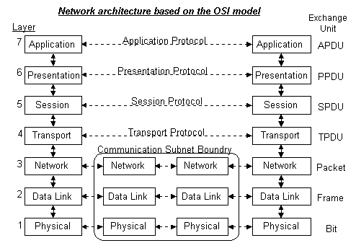
Figure 1 (2)

Data is created at the Application layer and makes it way down through each layer. As it passes through each layer, it may add header or a trailer (see Figure 2).This is known as encapsulation. Each lower layer treats the complete packet, including the header, from the top layer as data. In other words, it does not concern itself with the encapsulation of the top layers.

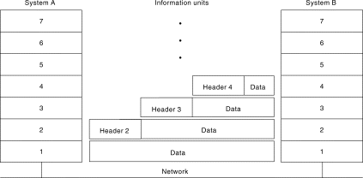
Figure 2 (1)

Information Economy
Networking is influenced from the shift toward an information-based business economy and the Internet. Organizations have learned to adapt to this shift and now realize that information must be stored, retrieved, manipulated, and shared within their organizations as well as others. Several common devices are used to connect these network segments. Routers will be the focus of discussion.
Routers operate at the network layer. Its purpose is to connect two or more network segments that use the same or different data link protocols but the same network protocol. Additionally, they may connect the same or different types of cable. Routers strip off the data link layer packet and process the network layer packet. They forward only those messages that need to go to other networks, on the basis of their network layer address.

Router Types
Routers may come in a plethora of types, including black boxes, computers with several network interface cards, or special network modules in computers or other devices. Manufacturers of routers include Cisco Routers, 3Com, D-Link, IBM, Intel, Nortel Networks and Juniper. Each one of these manufacturers creates different kinds of routers that can be used for various reasons. Routers can be used to connect computers together in an office environment. In another instance, backbone routers are use to support large organizations and small businesses. Routers come in different sizes. For example:

Home Routers
If you have enabled Internet connection sharing between two computers, you're using one of the computers (the computer with the Internet connection) as a simple router. In this occurrence, the router does very little. It is simply looking at data to see whether it's intended for one computer or the other, and if it can operate in the background of the system without significantly affecting the other programs you might be running.
Home routers are usually simple and are used to connect several computers in a home environment. For example, the Linksys EtherFast Cable/DSL Voice Router (Figure 3) connects to a high speed broadband Internet connection or a 10/100 Ethernet backbone. It features Voice over IP telephone installed by Netphone. With this router installed, no special hardware to make telephone called while using the internet is needed.
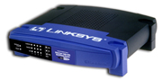

.Figure 3

D-LINK Routers
The D-Link Router’s claim to fame is its 22mbps “Plus” Mode which is twice as fast as the usual (11-mbps) 802.11 wireless connection. It is made possible by a new Texas Instruments chip set found in products from U.S. Robotics and others. However, there are other advantages besides speed. It offers 256-bit encryption—the strongest available—extensive parental control features, and deep firewall configuration options. (3)
The router’s firewall features are excellent and easy to implement. For example, you can designate particular computers as Web or FTP servers, which are visible to the Internet. You can even set schedule for access. Home users will probably make the greatest use of the special application support.

Small Organization and Office Routers
Slightly larger routers, the sort used to connect a small office network to the Internet, will do a bit more. These routers frequently enforce rules concerning security for the office network (trying to secure the network from certain attacks). They handle enough traffic that they are generally recognized as stand-alone devices rather than software running on a server.

3-Com SuperStack
SuperStack by 3Com (Figure 4) provides lower equipment costs with integrated features such as dial-in/dial-out access and LAN-WAN routing via dialed or Frame Relay & leased line PPP connection. This product allows your Internet access products to be managed with the same application as your LAN products.
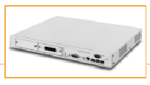

Figure 4

The 3Com SuperStack 3 Remote Access System (RAS) 1500 consists of three stackable components that provides multi-protocol remote access server and full function WAN router technology for small & medium sized businesses. It provides customers with a complete Internet access solution, allowing the ability to use V.34 modems and 64K-256K ISDN BRI cards, & ISDN PRI access unit with V.90 56K connectivity. (4)

With the3Com SuperStack 3, it is easy to install a HTML browser-based Wizard guided graphical user interface (GUI) and documentation. It offers secure access Authentication and has advanced ease of features which include NAT/PAT (Network Address Translation/Port Address Translation). It also contains full DHCP (Dynamic Host Configuration Protocol) server, and along with relay and proxy functions, provide simplified LAN access for local and remote users. The RAS 1500 can serve as the central DHCP server for both remote and LAN-based users. In addition, it can “proxy” or “relay” IP addresses to another central server. This feature simplifies network administration and enhances the mobility of both remote and local users. This router can be configured to filter internal users’ access to the Internet and be used as an Internet firewall against unwanted outside intruders. The EtherFast Cable/DSL Voice Recorder handles and telephony needs in one integrated unit. This will allow organizations to save money in the long run. (5)

High End Routers
The largest routers, those used to handle data at the major traffic points on the Internet, handle millions of data packets every second and work to configure the network most efficiently. These routers are large stand-alone systems that have far more in common with supercomputers than with a typical office server.

Nortel Networks
One of the manufacturers for high end routers is Nortel Networks. The company provides large, high performance, scalable routing devices capable of delivering all types of data quickly and efficiently over any network topology with no interruptions in service. Routers in these distributed environments must also provide all the necessary wide area network (WAN) interfaces, while delivering the highest possible throughput across expensive WAN bandwidth. Organizations need their routers to perform optimal levels well into the future.
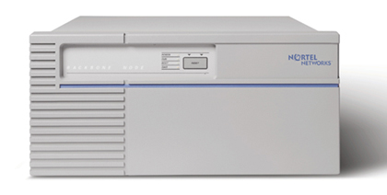

Figure 5

Nortel Networks enterprise requirements for high-performance multiprotocol routing entail the Backbone Node (BN) router family, comprising the Backbone Link Node (BLN) and Backbone Concentrator Node (BCN) products (Figure 5). The BN router family delivers enhanced network performance and availability, multi-vendor interoperability, and investment protection. High-performance packet forwarding is made possible by unique symmetric multiprocessor (SMB) architecture, in which multiple processors function as a single logical router. (6)

Benefits of the Nortel Networks:

- Enhance network performance
Nortel Networks BLN and BCN deliver the most demanding internetworks using Fast Ethernet, Gigabit Ethernet, FDDI, ATM and SNA backbones.
- High Network availability
Nortel Networks BLN and BCN routers set the standard for network availability required for mission critical applications in multiprotocol environments.
- Network investment protection
The BLN and BCN routers underscore Nortel Networks commitment to delivering enterprise scale, standards-based products. The BLN and BCN routers also support the latest technologies so customers can continue to leverage today’s network investment far into the future.

IBM
Another high end router is the IBM 2210 Nways Multiprotocol (Figure 6), which provides network-computing solutions for a range of applications. Offering connectivity and multiprotocol support to work with everything from a small local area network (LAN) to a large Transmission Control Protocol/Internet Protocol (TCIP/IP) based wide area network (WAN), the Nways will tailored to your computing computer needs. While offering the scalability to grow to meet tomorrow’s networking demands, the 2210 can be configured to work within the limits of today’s budget and still provide optimized computing across a broad range of remote locations, branch offices and regional sites.
The 2210 Nways Multiprotocol Router’s Network Dispatcher features allow system administrators to build and manage scalable Web servers. This provides load balancing and high availability to users in environments with multiple servers, high traffic volume and many clients. Superior to Domain Name Servers’ round-robin queuing, it enables large numbers of individual servers to be linked into large, virtual-server clusters for efficient management. Network Dispatcher is a separately charged program and requires a use-authorization license for each server to be supported. (7)

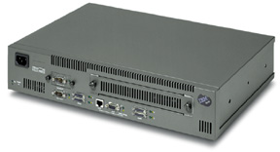

Figure 6

Cisco Systems

Cisco Systems, the worldwide leader in networking equipment once again showed their dominance of the networking world by reporting net sales of 4.8 billion, as of August 6, 2002. Since they are the dominating force in their field, this analysis will use their popular 7200 series routers to describe what a router contains and the capabilities of a router.
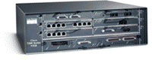

Figure 7

Cisco 7200 series routers

The 7200 series routers (Figure 7) provide high performance routing capabilities and a wide variety of configurations, making it adaptable to just about any network environment. It delivers exceptional performance/price, modularity, and scalability in a compact form factor with a wide range of deployment options. With processing speeds up to 1 million packets per second, port adapters ranging from NxDS0 to OC-12, and an unparalleled number of high-touch IP services, the Cisco 7200 is the ideal WAN edge device for enterprises and service providers deploying any of the following solutions: (8)
- WAN edge—Award-winning quality-of-service (QoS) feature performance
- Broadband aggregation—Up to 8,000 Point-to-Point Protocol (PPP) sessions per chassis
- Multiprotocol Label Switching provider edge (MPLS PE)—Number one choice for provider edge deployment today
- Voice/video/data integration— Time-division multiplexer (TDM)-enabled VXR chassis and voice port adapters
- IP Security virtual private networking (IPSec VPN)—Scalable to 5,000 tunnels per chassis
- High-end customer premises equipment (CPE)
The Cisco 7200 addresses these solution requirements by integrating functions previously performed by separate devices into a single platform. Through this integration, the Cisco 7200 provides a single, cost-effective platform that supports:
- High-density LAN and WAN interfaces
- Broadband subscriber services aggregation, including PPP, RFC 1483 termination, and Layer 2 Tunneling Protocol (L2TP) tunneling
- Digital T1/E1 TDM trunk termination for voice, video, and data
- High-density multichannel T3/E3 and T1/E1 with integrated channel service unit/data service unit (CSU/DSU)
- ATM, Packet over SONET (POS), and Dynamic Packet Transport (DPT) connectivity
- Direct ATM Circuit Emulation Standard (CES) connectivity for voice, video, and data
- Direct IBM mainframe channel connectivity
- Light-density Layer 2 Ethernet switching
There are two different types of routers under the 7200 series; the 7204VXR router and the 7206VXR. Both are similar except the 7206VXR can handle more components. Each of these routers is modular based, making them extremely flexible. These routers are only as powerful as the modules inserted into them. The design of the routers supports the following components: (8)
Modules | Cisco 7204VXR | Cisco 7206VXR
Configurable Slots | 4 | 6
Ethernet (10BASE-T) Ports | 32 | 48
Ethernet (10BASE-FL) Ports | 20 | 30
Fast Ethernet (TX) Ports | 4 | Up to 6
Fast Ethernet (FX) Ports | 4 | Up to 6
EtherSwitch Port Adapters | 2 | 2
100VG-AnyLAN Ports | 4 | Up to 6
FDDI (FDX, HDX) Ports | 0 | 0
ATM Ports (T3, OC-3) | 4, 4 | Up to 6, 4
Packet over SONET | 2 | 2
ATM-CES Port Adapters (Data, Voice, Video), Dual-Wide | 1 | 1
Token Ring (FDX, HDX) Ports | 16 | 24
Synchronous Serial Ports | 32 | 48
ISDN BRI Ports (U, S/T) | 16, 32 | 24, 48
ISDN PRI, Multichannel T1/E1 Ports | 32 | 48
Multichannel T3 Ports | Up to 4 | Up to 6
HSSI Ports | Up to 8 | Up to 12
Packet over T3/E3 Ports (Integrated DSU) | Up to 8 | Up to 12
IBM Channel Interface Ports (ESCON and Parallel) | 6 | 6
VPN Acceleration Module | 1 | 1

One of the components shown is an EtherSwitch. An EtherSwitch means the router also has switching capabilities. A switch means it can do Data Link (layer 2) capabilities making it a whole lot more robust.
In addition to having modular I/O slots, the routers also have a modular processing unit. They can be configured with either of the following processing boards (Figure 8):
- NPE-G1
- NPE-400
- NSE-1
- NPE-225

All four of the processing boards contain the following:

- Network Controller Board- the main board of the processing board.
- System Controller- allows access to memory (DRAM), PCI bus, and the processor
- Process Engine board- contains a RISC (Reduced Instruction Set Computing) microprocessor and external cache. Processors supported:
  - RM5270 primary cache (internal): 16 KB instructions, 16 KB data
  - RM5271 primary cache (internal): 32 KB instructions, 32 KB data
  - External Cache- Both support 2 MB external cache
    - Configuration of external cache: 4 x 256 x 18 bits = 64 bit plus 4 parity bits

- Midplane connectors- the interface between the chassis and the module
- Boot ROM (EEPROM)- contains the code to boot up the module.
  - Capacity 512 KB
- Temperature sensor- make sure the module stays at a operating temperature of 32° to 104° F (0 to 40° C)
- Main Memory

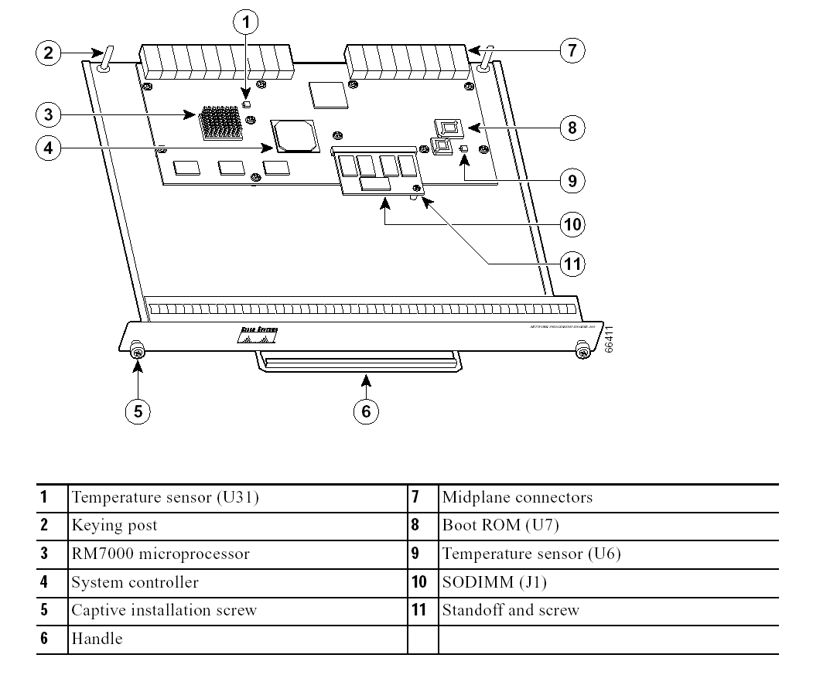
NPE-G1
NPE-400
Figure 8
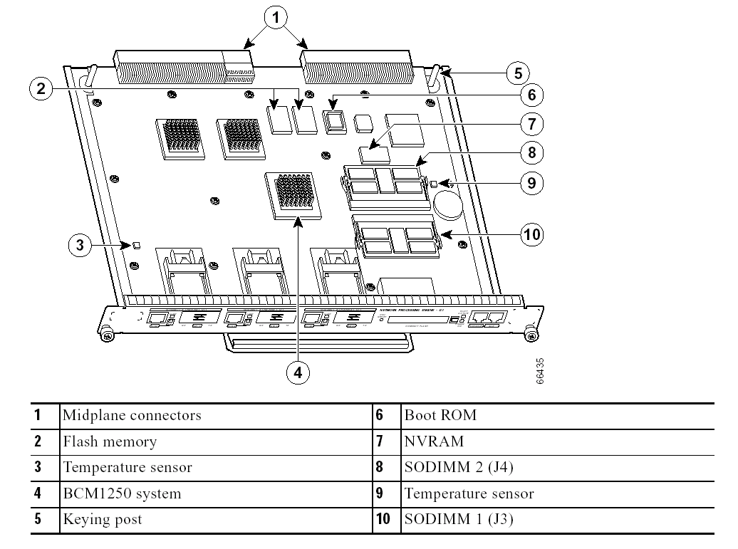

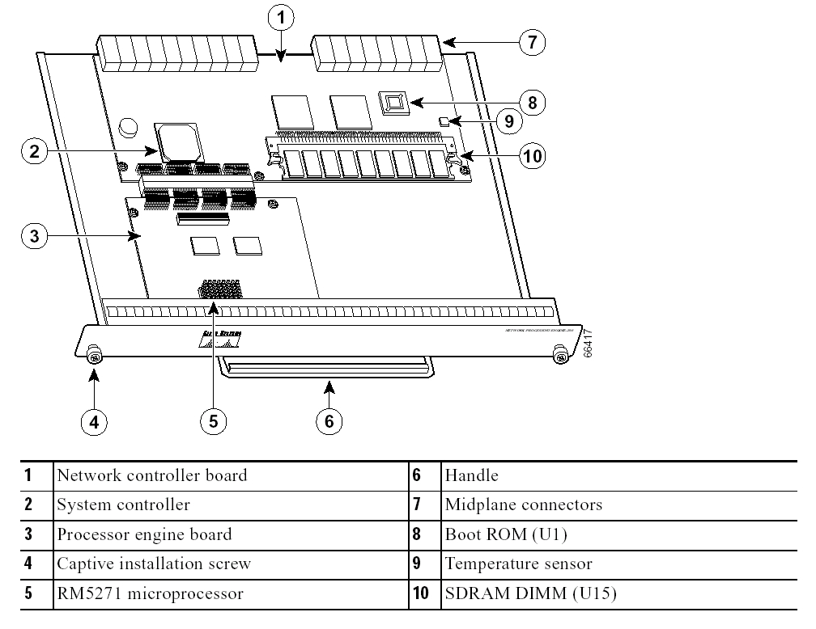
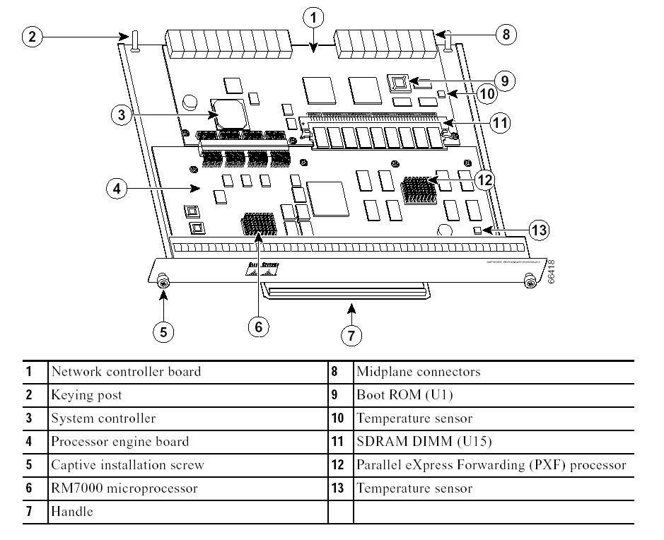
NSE-1
NPE-225
The following table identifies the differences between the four processing boards.

 | NPE-225 | NSE-1 | NPE-400 | NPE-G1
Microprocessor | RM5271  262MHz | RM7000 262MHz | RM7000 350MHz | BCM1250  700MHz
Memory | SDRAM  DIMM  Max: 128 | SDRAM  DIMM  Max: 256MB | SDRAM  SODIMM  Max: 512MB | SDRAM  SODIMM  Max: 512MB
Primary Cache | 32K Instr.  32KB Data | 16KB Instr.  16KB Data | 16KB Instr.  16KB Data | 16KB Instr.  16KB Data
Secondary Cache | 2MB | 256KB | 256KB Fixed | 512KB
Tertiary Cache |  | 2MB Fixed | 4MB
Boot ROM | 512KB | 512KB | 512KB | 512KB
NVRAM |  |  |  | 512KB
Flash Memory |  |  |  | 16MB

Notable Issues

Larger internetwork spanning multiple workgroups, subnetworks, and host computers create special problems for system administrators. Like managers of local networks, they must deal with products from multiple vendors, get different network operating systems to communicate, and justify the costs of new services and applications.
But they also face the task of selecting, managing, and maintaining bridges, routers, and gateways - the internetworking devices that permit widely separated clusters of networks to communicate. These products offer important capabilities to help network managers solve particular problems, but each poses special implementation challenges, too.
This is especially true of routers and their associated routing protocols. Routers, connect logically separate networks operating under the same transport protocol, such as the Transmission Control Protocol/Internet Protocol (TCP/IP).
Routers, which operate at the network (or third) layer of the Open Systems Interconnection (OSI) reference model, are protocol-dependent devices. That is, they must support each routing protocol on that LAN.

Routing Algorithms
The primary role of a router is to transmit similar types of data packets from one machine to another across wide area communications links such as T1 lines or Fiber Distributed Data Interface (FDDI) rings. Ideally, the router exchanges data by selecting the best path between the source and destination machines. It determines what is best via routing algorithms, which are complex sets of rules that take into account a variety of factors. (1)
In operation, these algorithms' first task is to determine which of the paths on the internetwork will take a data packet to its destination. Because multiple paths often exist between any two routers, the algorithms are used to select the best paths. These decisions are based on a prescribed set of conditions, which might include the fastest set of transmission media or which network segment carries the least amount of traffic.
Every computer that performs routing has a routing table developed by the network manager that specifies how messages will travel through the network. The routing table simply is a two-column table. The first column identifies every computer in the network. The second column lists the computer to which each computer should send messages if they are destined for the computer identified in the first column.
A router examines every packet, and compares the destination address to a table of addresses that it holds in memory. If it finds an exact match, it forwards the packet to an address associated with that entry in the table. This associated address may be the address of another network in a point to point link, or it may be the address of the next-hop router. If the router doesn't find a match, it runs through the table again, this time looking for a match on just the network ID part of the address. Again, if a match is found, the packet is sent to the address associated with that entry.
If a match is still not found, the router looks if a default next-hop address is present. If so, the packet is sent there. If no default address is present, the router sends an ICMP "host unreachable" or "network unreachable" message back to the sender. If this message is presented, it usually indicates a router failure at some point in the network. The difficult part of a router's job is not how it routes packets, but how it builds up its table. In the simplest case, the router table is static; it is read in from a file at start up. This is adequate for simple networks.

Flooding the Network
Without microprocessors to perform the complex mathematical calculations required by routing algorithms, early routers were slow. The networks they ran on were equally low-powered, with little bandwidth and not complex. This meant that routers could be simple and operate without knowing much about where the other routers on the network were located.
These types of routers were isolated in that they did not exchange network routing information with other routers on the network. As a result, they forwarded data merely by flooding every path with packets. Data packets eventually reach their destination in this scheme, but flooding also risks creating routing loops, in which certain packets can travel around the network indefinitely.
Several measures can be taken to help flooding-type routers choose reasonable paths. One is called backward-learning. In this scheme, a router remembers the source addresses of all incoming packets and notes the physical interface it came in on. When it's time to forward a packet to that address, the router bases its decisions on this stored information. (10)
Some routers avoid the entire issue of path-finding by relying either on a human or host computer to make these decisions. In the former case, the network manager provides each router with a block of static routing configuration information at start-up, including the information needed to make routing decisions.
In the host-router implementation, end hosts place information in every packet they place on the network. This information indicates every path and the immediate router the data must pass through to get to its destination. This is source-routing.

Adding Complexity
More complex networks require dynamic routing solutions. In large wide area networks with multiple links between networks, routers perform more efficiently when they understand how the network is linked together. An integrated router does this by exchanging information about the network's topology with other integrated routers. As a result of this exchange, integrated routers create routing tables that show the best paths between the various links on the internet.
Algorithms for integrated routers must be able to quickly determine the network topology. This process, called convergence, must take place rapidly; otherwise routers with obsolete or incorrect data about the network can send data into dead-end networks or across unnecessary links. (10)

Types of Routing

Centralized Routing
All routing decisions are made by one central computer or router. Centralized routing typically is used in host computers, which makes routing decisions rather simple. All computers are connected to the central computer, meaning that any message that needs to be routed is sent to the central computer, which in turn retransmits the message on the appropriate circuit to the destination.

Decentralized Routing
All computer or routers in the network make their own routing decisions following a formal routing protocol. The routing table is developed by the network manager in larger networks. In smaller networks, the routing tables used by all computers on the network are usually developed by one individual or committee. Most decentralized routing protocols can automatically adapt to changes in the network configuration.

Static Routing
Routing decisions are made in a decentralized manner by individual computers or routers. The routing table is developed by the network manager, and it changes only when computers are added or removed from the network. When new computers are added to the network, they announce their presence to the other computers, who automatically add them into their routing table. Static routing is commonly used in networks that have few routing options that seldom change. (10)

Dynamic Routing
With dynamic routing, routing decisions are made in a decentralized manner by individual computers. Unlike static routing, it is used when there are multiple routes through a network and it is important to select the best route. Dynamic routing attempts to improve network performance by routing messages over the fastest possible route, away from busy circuits and busy computers. An initial routing table is developed by the network manager but is constantly updated by the computers themselves to recognize changing network conditions.
There are two drawbacks to dynamic routing. First, it requires more processing by each computer or router in the network than does centralized or static routing. Computing resources are devoted to adjusting routing tables rather than to sending messages, which can slow down the network. Second, the transmission of routing information wastes network capacity. Some dynamic routing protocols transmit status information every minute, which can significantly reduce performance. (10)
Works Cited
- Dennis, Allen. Fitzgerald, Jerry. Business Data Communications & Networking. Wiley and Sons, 2001.

- http://www.rad.com/networks/1994/osi/layers.htm.
- http://www.dlink.com. Updated: November 19, 2002. Accessed: November 19, 2002
- http://3com.com. Updated: November 18, 2002. Accessed: November 18, 2002.
- www.ftp://ftp.linksys.com/datasheet/befn2ps4ds.pdf.
- http://www.nortelnetwork.com. Updated: November 18, 2002. Accessed: November 18, 2002.
- http://www.ecc400.com/ibm/framerelay/220prod.htm
- http://web.lexisnexis.com/universe/document?_m=7081c6fdc26e3b56f8ed cec47754d886&_docnum=22&wchp=dGLbVzblSlzV&_md5=ee8875f 0cfc1deeb3a74640349353600.
- http://www.cisco.com/en/US/products/hw/routers/ps341/products_da ta_sheet09186a008008872b.html.
- DiMarzio.J.F. SamsTeach Yourself Routing in 24 Hours. US. Sams Publishing 2002.

