ACCT 460: Flowcharting Project
One important technique in documenting and understanding a client’s internal controls is flowcharting the applicable financial reporting processes. This project has the following broad objectives:
- To practice interviewing a client to collect pertinent information about a process.
- To learn how to gain an understanding of a client through developing a narrative description and flowchart of the process.
- To identify aspects of the flowchart that will impact the remainder of the audit.

Project Tasks and Deliverables
The basis steps to conduct this project are as follows:
- Identify a “client” for your project and identify a specific process to flowchart. You want to be careful to pick a process that’s not too small or too big. For a large organization, one accounting cycle (even part of a cycle) would be a good choice. For smaller organization, you might need to flowchart more than one cycle if the cycle is too small.
- Call or email your contact to schedule an initial 1-hour meeting with the contact. Agree on a date and time that best works for the contact and your team.
- Arrive early for your appointment. Look sharp. Interview the contact. Take good notes. Request copies of any forms and reports that the contact mentions during the interview.
- Create narrative description from interview notes.
- Create a flowchart based on the narrative description.
- Prepare the following audit documentation for my (the audit manager) review that includes the following:
  - A cover memo that summarizes what is included in your documentation
  - The narrative description
  - The flowchart
  - A table like Exhibit 5.13 in textbook for each of the applicable ASB assertions about events and transactions and assertions about account balances. Note: Not all assertions are necessarily applicable to all processes. [See ASB assertions in Exhibit 1.5.]
  - Create an ICQ with at least one question for each control (d).
  - Design an audit plan to test internal control from part (c).
[Appendices at the end of Chapters 6 through 10 have examples of specific ICQs and audit plans for different accounting cycles.]
  - Exhibits: Copies of every form, report, and other documents mentioned in the narrative and flowchart.
Due: May 4, 2015
Warning: I reserve the right to return your flowchart for revisions before your grade is officially recorded, so it is a good idea for me to review your flowchart before it’s due!
[LATE PROJECTS NOT ACCEPTED!]

Tips & Suggestions

Interviewing
The narrative (and flowchart) should include four characteristics:
- The origin of every document and record in the process
- All processing steps that takes place
- The disposition of every document and record in the process (e.g., filing, sending documents to customers or other departments, or destroying documents)
- An indication of the controls relevant to assessment of control risk (e.g., separation of duties, authorizations and approvals, internal verification)
The people you are going to interview have probably been interviewed before, so this will not be a completely new experience for them. In fact, they will probably help you interview them.
The interview process is very linear—and not too difficult. Start by asking what starts the process. The answers will be something like, “I get an email requesting….” “I get an application for…” “I get a form requesting…” Then just keep asking what happens next.
When you interview your contact, he/she will have a tenancy to skip steps because most of what they do is so automatic to them, they don’t even think about some steps. So, you have to have a keen ear to identify when something is be skipped over. For example, your contact might say, “I take a quick look at the form and see if is complete and then I enter the data into the computer. Next, I…” Then you interrupt and ask, “What do you do if is not complete?” The contact might say, “If the account number is missing, I send an email to Bob and request the missing information. Next I…” You might interrupt again (but don’t be rude) and ask, “Bob is in what department and what’s his job title? And what do you do with the form while waiting for Bob to respond? For example, do you have a ‘pending’ folder where you keep these forms?” Depending on the answer, you might ask, “Do you review the pending folder periodically to see if there are forms that have been there for a while?”
Eventually, you will arrive at the end of the process. While you are still with the contact, look over your notes to see if there are still some open issues. Ask your teammates if they have any questions. Make sure you have copies of forms and reports discussed during the interview. The contact might have to send you the reports later after he/she blanks out student data.
Thank the contact for helping you and leave.
Type up your narrative. If you find holes in your narrative, call or email your contact to discuss needed information.
When you are done with your narrative, you are ready to start flowcharting.

Flowcharting
For this project, you are going to use Microsoft Visio software to create what it calls “cross functional flowchart” and you will use basic flowchart shapes like those below.
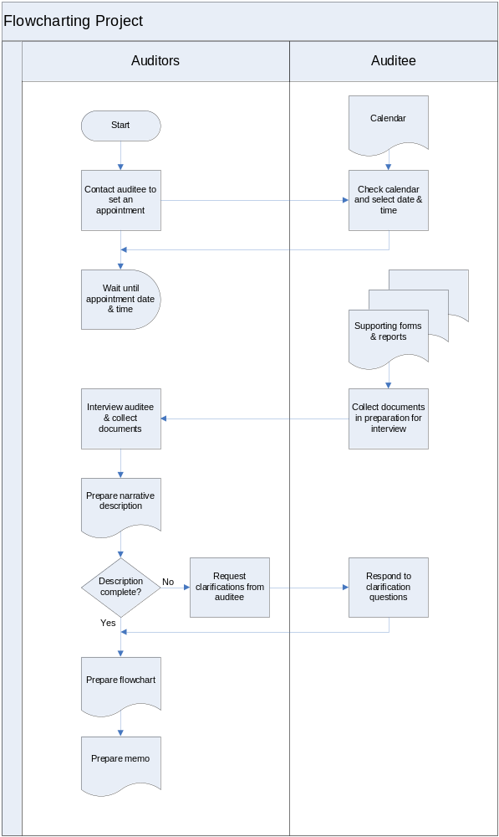

To get started, start Visio, select New on File menu, select Flowchart, and select Cross Functional Flowchart.
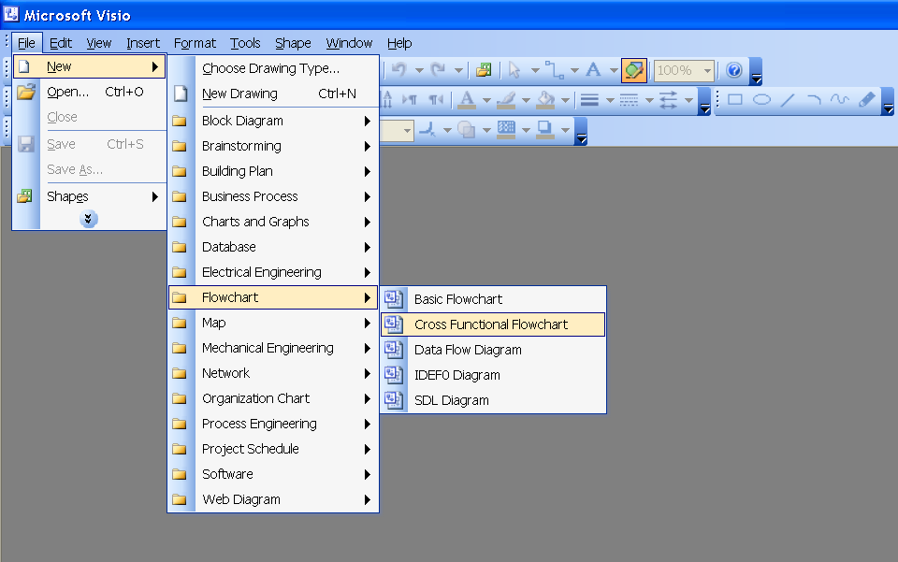
On the next screen, select Vertical and the Number of bands (one band for each separate function you need to represent.
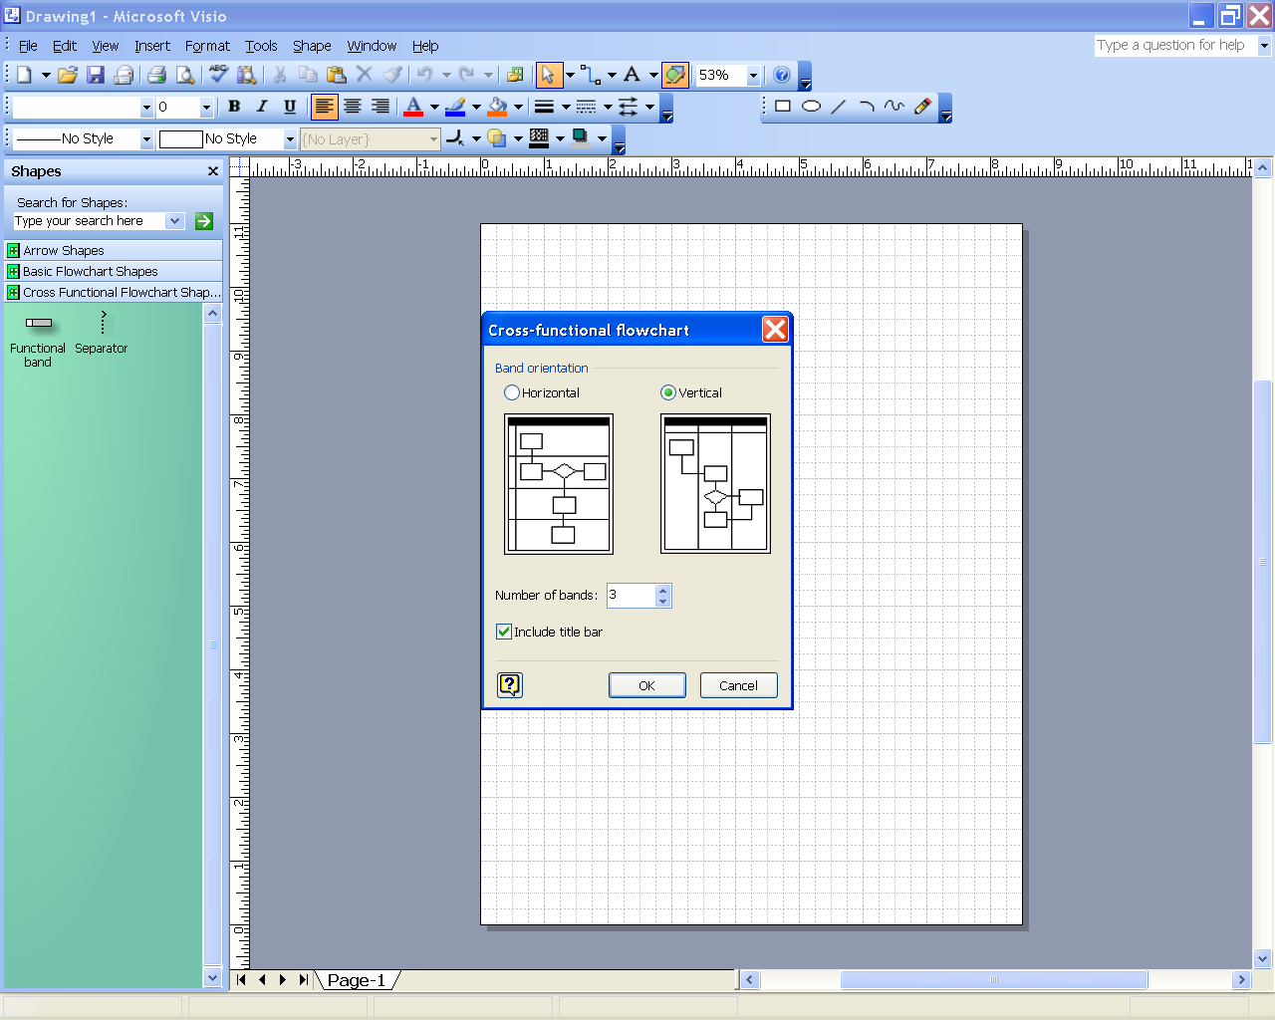
Then you will something like:
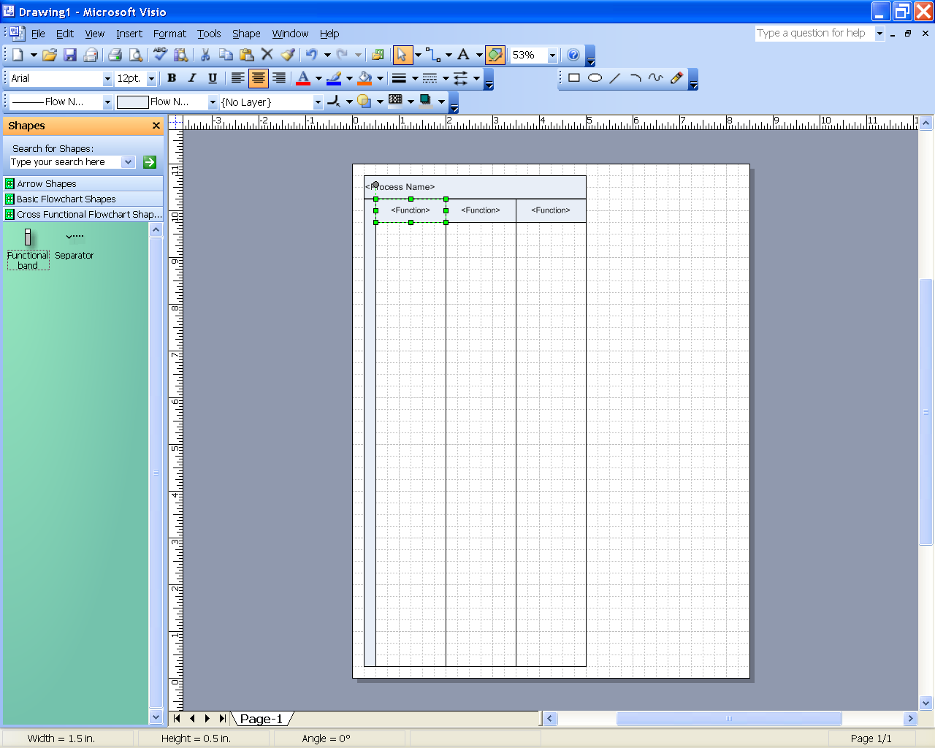

On the left side of the screen, click on Basic Flowchart Shapes and you will see the shapes you can select for your flowchart.
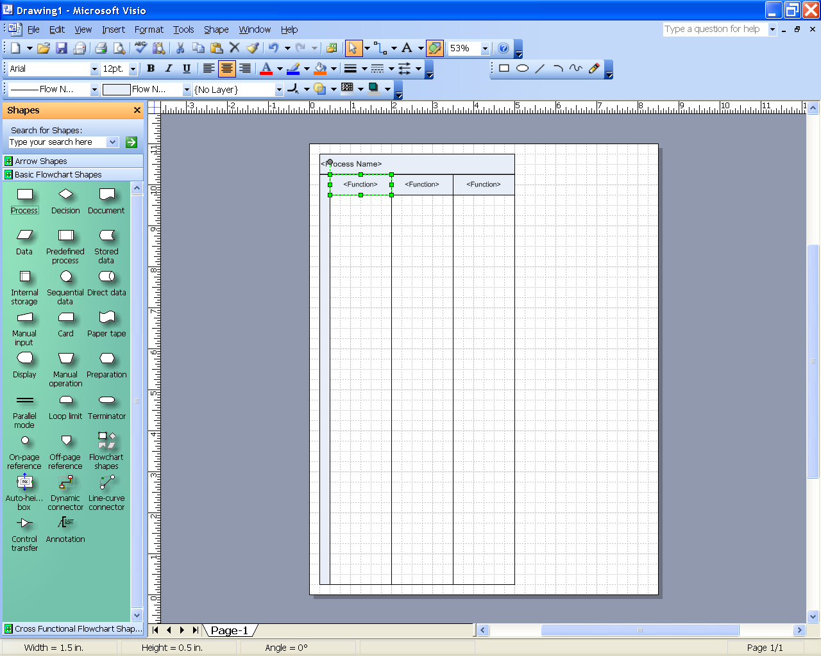
Double click on each bracketed item (e.g., <Process Name>) in the column headings and enter the appropriate names.
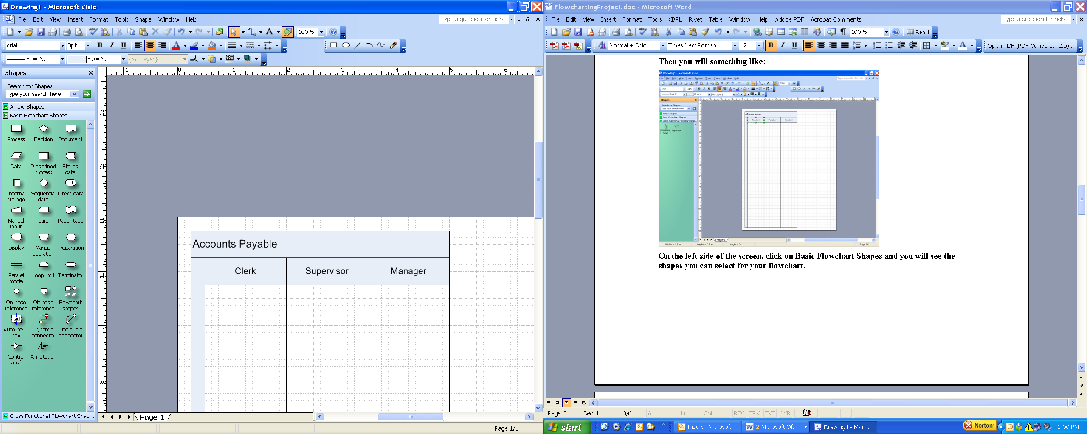
Now, it is a simple matter of dragging, dropping, and labeling the flowchart shapes to reflect your written narrative. Use the Connection Tool to connect shapes.
Connection Tool

Flowchart Shapes
Creating flowcharts, selecting shapes, laying out the shapes, and labeling the shapes are as much an art as it is a science. No two people would create exactly the same flowchart from the same narrative. As you can see, there are many basic flowchart shapes—and if you explore Visio, you will find many more shapes.
These are the shapes you will use the most frequently.
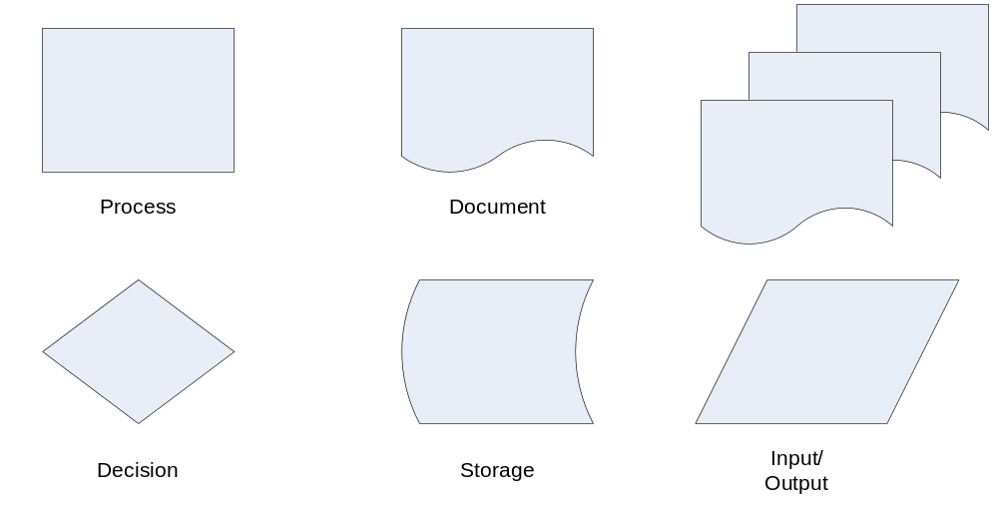

My advice is to not over do trying to use the widest number of different symbols.

Appendix A

Sample Narrative
Internal Control and Audit Program Case
The following description of the accounting system and internal controls for materials purchases by the Johnson Machinery Company, a medium-sized firm that builds special machinery to order.
Materials purchase requisitions are first approved by the plant foreman, who then sends them to the purchasing department. Purchasing department employees enter the purchase requisition information into the computer, which automatically generates a purchase order in sequential order. The system automatically generates a paper copy of the purchase order, which is sent by purchasing department employees to the vendor. The receiving department electronically accesses a copy of the purchase order, which is printed to serve as a receiving report.
Delivered materials are immediately sent to the storeroom. The completed receiving report, which is a printed copy of the purchase order, is sent to the purchasing department. A copy of the receiving report is sent to the storeroom. Materials are issued to factory employees subsequent to the verbal request by one of the foremen.
When the mailroom clerk receives vendors' invoices, he forwards them to the purchasing department employee who placed the order. The invoice is compared with the electronic copy of the purchase order for price and terms by the employee. The invoice quantity is compared with the receiving department's report. After checking footings, extensions, and discounts on the vendor invoice, the employee indicates approval for payment by initialing the invoice. The invoice is then forwarded to the accounting department (voucher section) where it is coded for account distribution, assigned a voucher number, and entered into the accounting system for recording in the voucher register. The system tracks invoices due by payment date due. The purchase order and receiving report are filed in the purchasing department.
On payment dates, the system automatically generates a request for payment. The system automatically prepares checks and a transaction list for preparation of a cash disbursements journal, updates the accounts payable master file, and indicates the payment date for the voucher register. Prenumbered checks are sent to the cashier, who puts them through the check-signing machine. The checks are then sent to the voucher section who makes sure that the checks were correctly prepared. The checks are placed in envelopes and sent to the mailroom. The vouchers are subsequently filed in numerical order. At the end of each month, a computer listing of voucher and cash disbursement transactions, and an outstanding accounts payable list is prepared.

