 | College of Engineering and Computer Science  Mechanical Engineering Department  Mechanical Engineering 390  Fluid Mechanics
Spring 2008 Number: 11971
Instructor: Larry Caretto

March 11 Homework Solutions
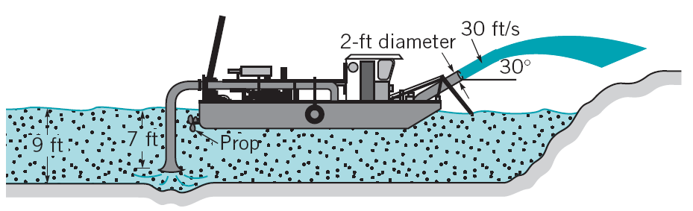
5.41 The hydraulic dredge shown in Figure P5.41 (copied at the right) is used to dredge sand from a river bottom. Estimate the thrust needed from the propeller to hold the boat stationary. Assume the specific gravity of the sand/water mixture is SG = 1.2.
We can start with the general momentum equation for direction k.
$$\frac{∂{\left({\text{mV}}_{k}\right)}_{\text{cv}}}{∂t}+\sum_{o=1}^{N_{\text{outlets}}}{ρ_{o}V_{o}A_{o}V_{k,o}}−\sum_{i=1}^{N_{\text{inlets}}}{ρ_{i}V_{i}A_{i}V_{k,i}}=\sum{F_{k}}$$
We can assume a steady process so that the time derivative is zero. From the diagram we see that there is one inlet and one outlet so the summations are not required. There is only one reaction force, F, and the inlet has no velocity component in the x-direction; thus this inlet term is zero. Using these assumptions and observations allows us to write the following equation for the force required to keep the boat in place.
$$ρ_{o}V_{o}A_{o}V_{x,o}=F_{x}$$
The density of the sand-water mixture can be computed from its specific gravity and the density of water at 60ºF (from Table 1.5 in the inside front cover.)
$$ρ_{o}={\text{SG}}_{o}ρ_{H_{2}O}=(1\text{.}2)\frac{1\text{.}\text{94} \text{slugs}}{{\text{ft}}^{3}}=\frac{2\text{.}\text{328} \text{slugs}}{{\text{ft}}^{3}}$$
The area of the outlet is found from the given diameter of 2 ft: A_{o} = πD_{o}²/4 = π(2 ft)²/4 = 3.1416 ft².
The x-component of the outlet velocity is found from the given value of V_{o} = 30 ft/s and the given angle of 30º.
$$ρ_{o}V_{o}A_{o}V_{x,o}=V_{o}\text{cos}θ=\frac{\text{30} \text{ft}}{s}\text{cos}{\text{30}}^{o}=\frac{\text{25}\text{.}\text{98} \text{ft}}{s}$$
Substituting the values found above into our momentum equation gives the desired result for the force.
$F_{x}=ρ_{o}V_{o}A_{o}V_{x,o}=\frac{2\text{.}\text{328} \text{slugs}}{{\text{ft}}^{3}}\left(3\text{.}\text{1416} {\text{ft}}^{2}\right)\frac{\text{30} \text{ft}}{s}\frac{\text{25}\text{.}\text{98} \text{ft}}{s}\frac{{\text{lb}}_{f}⋅s^{2}}{1 \text{slug}⋅\text{ft}}$= 5700 lb_{f}
The force is in the plus-x direction (to the right) opposing the thrust of the outlet which will tend to move the boat in the minus-x direction (to the left).
5.43 In a laminar pipe flow that is fully developed the velocity profile is parabolic, that is
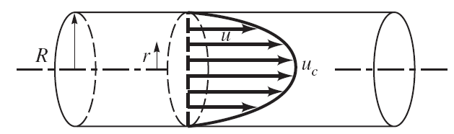
$$u=u_{c}\left[1−{\left(\frac{r}{R}\right)}^{2}\right]$$
as illustrated in Figure P5.43 (copied at the right). Compare the axial direction momentum flow rate computed with the mean velocity, $\bar{u}$, with the axial direction momentum flow rate with the nonuniform velocity distribution taken into account.
Equation 4.16 gives the following expression for the flow of a quantity b
$$\overset{˙}{B}=\int_{A}{ρbV⋅n\text{dA}}$$
In this case, $\overset{˙}{B}$is the integrated axial momentum flow rate that we are trying to compute and b is the local axial momentum per unit mass, which is simply the u velocity component. The dot product of the actual velocity vector, V, with the normal, n, is simply the velocity in the x direction, which is also u. Thus we have the following result for the momentum flow rate after substituting an integration over r and θ to cover the complete area of the circular pipe.
$$\overset{˙}{B}=\int_{A}{ρbV⋅n\text{dA}}=\int_{A}{ρ\text{uudA}}=\int_{A}{\text{uurdrd}θ}=ρ\int_{0}^{R}{\int_{0}^{2π}{u^{2}\text{rdrd}θ}}=2\text{πρ}\int_{0}^{R}{u^{2}\text{rdr}}$$
If the assume that the velocity is constant at its mean value $\bar{u}$over the cross section of the pipe, the momentum flow is found as follows.
$${{\overset{˙}{B}}_{\text{uniform}}=2\text{πρ}\int_{0}^{R}{u^{2}\text{rdr}}=2\text{πρ}\int_{0}^{R}{{\bar{u}}^{2}\text{rdr}}=2\text{πρ \{}\bar{u}}^{2}\int_{0}^{R}{\text{rdr}}=2\text{πρ \{}\bar{u}{}^{2}{\left[\frac{r^{2}}{2}\right]}_{0}^{R}=\text{πρ}{\left(R\bar{u}\right)}^{2}$$
Considering the actual velocity profile gives the following equation for the momentum flow.
$$\begin{matrix}{\overset{˙}{B}}_{\text{profile}}=2\text{πρ}\int_{0}^{R}{u^{2}\text{rdr}}=2\text{πρ}\int_{0}^{R}{u_{c}^{2}{\left(1−\frac{r^{2}}{R^{2}}\right)}^{2}\text{rdr}}=2\text{πρ}u_{c}^{2}\int_{0}^{R}{\left(1−\frac{2r^{2}}{R^{2}}+\frac{r^{4}}{R^{4}}\right)\text{rdr}} \\ 2\text{πρ}u_{c}^{2}\int_{0}^{R}{\left(r−\frac{2r^{3}}{R^{2}}+\frac{r^{5}}{R^{4}}\right)\text{dr}=2\text{πρ}u_{c}^{2}{\left[\frac{r^{2}}{2}−\frac{2r^{4}}{4R^{2}}+\frac{r^{6}}{6R^{4}}\right]}_{0}^{R}} \\ 2\text{πρ}u_{c}^{2}\left[\frac{R^{2}}{2}−\frac{R^{4}}{2R^{2}}+\frac{R^{6}}{6R^{4}}\right]=2\text{πρ}u_{c}^{2}R^{2}\left[\frac{1}{2}−\frac{1}{2}+\frac{1}{6}\right]=\frac{\text{πρ}{\left({\text{Ru}}_{c}\right)}^{2}}{3}\end{matrix}$$
In order to compare the results of the two calculations we need a relationship between the centerline velocity, u_{c}, and the mean velocity, $\bar{u}$. To get this relationship, we use the definition of the mean velocity as the uniform velocity that produces the same mass flow rate as the profile. This gives the following relationship.
$$\overset{˙}{m}=ρ\bar{u}A=ρ\bar{u}{πR}^{2}=\int_{A}{ρ\text{udA}}=ρ\int_{0}^{R}{\int_{0}^{2π}{\text{urdrd}θ}}=2\text{πρ}\int_{0}^{R}{\text{urdr}}=2\text{πρ}\int_{0}^{R}{u_{c}\left(1−\frac{r^{2}}{R^{2}}\right)\text{rdr}}$$
Solving this equation for $\bar{u}$and integrating gives the desired result.
$$\bar{u}=\frac{2u_{c}}{R^{2}}\int_{0}^{R}{\left(1−\frac{r^{2}}{R^{2}}\right)\text{rdr}=\frac{2u_{c}}{R^{2}}\int_{0}^{R}{\left(r−\frac{r^{3}}{R^{2}}\right)\text{dr}}}=\frac{2u_{c}}{R^{2}}{\left[\frac{r^{2}}{2}−\frac{r^{4}}{4R^{2}}\right]}_{0}^{R}=\frac{2u_{c}}{R^{2}}\left[\frac{R^{2}}{4}\right]=\frac{u_{c}}{2}$$
Substituting this result that u_{c} = 2$\bar{u}$ into the equation for B_{profile} and comparing the result to B_{uniform} gives
$${\overset{˙}{B}}_{\text{profile}}=\frac{\text{πρ}{\left({\text{Ru}}_{c}\right)}^{2}}{3}=\frac{\text{πρ}{\left(R2\bar{u}\right)}^{2}}{3}=\frac{4\text{πρ}{\left(R\bar{u}\right)}^{2}}{3}=\frac{4}{3}{\overset{˙}{B}}_{\text{uniform}}$$
Thus, the correct result for the axial momentum flow, considering the velocity profile, is 4/3 of the value computed using the mean velocity.
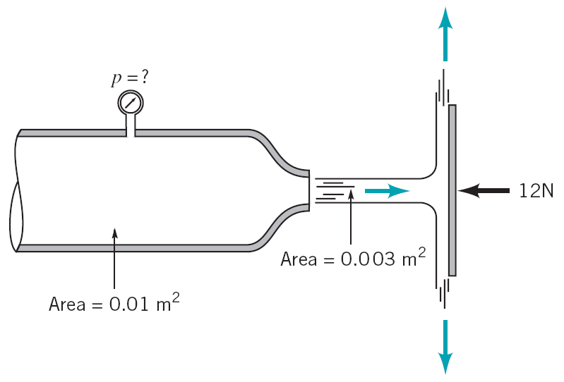
5.52 Air flows from a nozzle into the atmosphere and strikes a vertical plate as shown in Figure P5.52, (copied at the right). A horizontal force of 12 N is required to hold the plate in place. Determine the reading on the pressure gage. Assume the flow to be incompressible and frictionless.
(1)
(2)
(3)
In order to solve this problem we have to find a relationship between the flow at the pressure gage (point 1) and the flow at the outlet (point 2). We then have to augment this relationship with one between the flow leaving the nozzle and the flow striking and leaving the plate. We can combine these two relationships to get an overall equation that relates the restraining force of 12 N to the pressure at point 1.
We can apply the general momentum balance to the plate.
$$\frac{∂{\left({\text{mV}}_{k}\right)}_{\text{cv}}}{∂t}+\sum_{o=1}^{N_{\text{outlets}}}{ρ_{o}V_{o}A_{o}V_{k,o}}−\sum_{i=1}^{N_{\text{inlets}}}{ρ_{i}V_{i}A_{i}V_{k,i}}=\sum{F_{k}}$$
If we assume a steady process, the time derivative is zero and we note that there is no horizontal velocity component at the outlets so the outlet term is zero. The inlet velocity is in the x direction so V_{x} = V, and we can drop the subscript on density since we are given that the flow is incompressible. With these observations, the momentum equation reduces to the following simple form with one inlet (point 2) and one applied force.
$$−ρ_{2}V_{2}A_{2}V_{x,2}=−{ρV}_{2}^{2}A_{2}=F_{x}=−\text{12} N$$
This relates the velocity exiting the nozzle, V₂ to the force on the plate. We can relate this velocity and pressure at point 1 by using Bernoulli’s equation. We can use this equation because we are given that the flow is frictionless and incompressible. Here we apply the Bernoulli equation to a streamline in the center of the flow between points 1 and 2.
$${\text{gz}}_{1}+\frac{p_{1}}{ρ}+\frac{V_{1}^{2}}{2}={\text{gz}}_{2}+\frac{p_{2}}{ρ}+\frac{V_{2}^{2}}{2}$$
Points 1 and 2 are at the same elevation for our center streamline, so z₁ = z₂. The exit pressure p₂ is zero since it is atmospheric pressure. Our Bernoulli equation can then be written as follows.
$$\frac{p_{1}}{ρ}+\frac{V_{1}^{2}}{2}=\frac{V_{2}^{2}}{2} ⇒ p_{1}=\frac{ρ\left(V_{2}^{2}−V_{1}^{2}\right)}{2}$$
The two velocities are related by the continuity equation: V₁A₁ = V₂A₂. Since we have V₂ from our force balance, we use the continuity equation to eliminate V₁ from the Bernoulli equation.
$$p_{1}=\frac{ρ\left(V_{2}^{2}−V_{1}^{2}\right)}{2}=\frac{ρ\left[V_{2}^{2}−V_{2}^{2}\left(A_{2}^{2}/A_{1}^{2}\right)\right]}{2}=\frac{{ρV}_{2}^{2}}{2}\left[1−{\left(\frac{A_{2}}{A_{1}}\right)}^{2}\right]$$
We can now apply the equation that ρA₂V₂² = –F_{x} from the force balance on the vertical plate to replace ρV₂² in the equation above by –F_{x}/A₂.
$$p_{1}=\frac{{ρV}_{2}^{2}}{2}\left[1−{\left(\frac{A_{2}}{A_{1}}\right)}^{2}\right]=−\frac{F_{x}}{2A_{2}}\left[1−{\left(\frac{A_{2}}{A_{1}}\right)}^{2}\right]=−\frac{\left(−\text{12} N\right)}{2\left(0\text{.}\text{003} m^{2}\right)}\left[1−{\left(\frac{0\text{.}\text{003} m^{2}}{0\text{.}\text{01} m^{2}}\right)}^{2}\right]$$
p₁ = 1820 N/m² = 1820 Pa
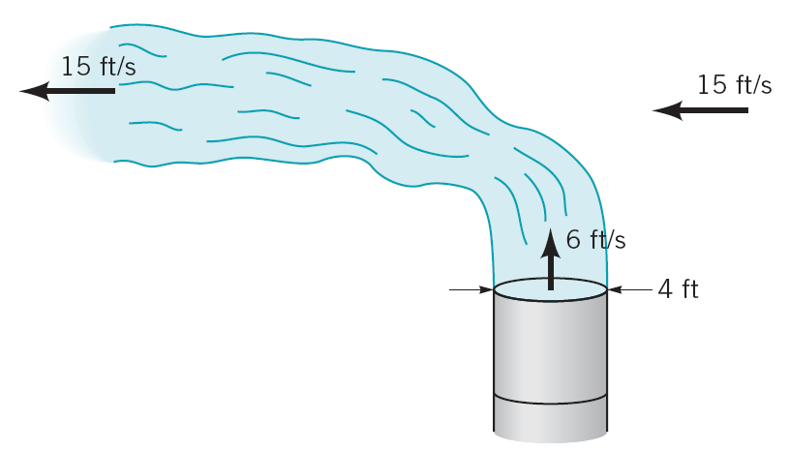
5.61 Exhaust (assumed to have the properties of standard air) leaves the 4-ft diameter chimney show in Video V5.3 and Figure 5.61 (copied at the right) with a speed of 6 ft/s. Because of the wind, after a few diameters downstream the exhaust flows in a horizontal direction with the speed of the wind, 15 ft/s. Determine the horizontal component of the force that the blowing wind puts on the exhaust gases.
We start with the general balance equation for momentum.
$$\frac{∂{\left({\text{mV}}_{k}\right)}_{\text{cv}}}{∂t}+\sum_{o=1}^{N_{\text{outlets}}}{ρ_{o}V_{o}A_{o}V_{k,o}}−\sum_{i=1}^{N_{\text{inlets}}}{ρ_{i}V_{i}A_{i}V_{k,i}}=\sum{F_{k}}$$
Here we apply this equation in the horizontal (x) direction using a control volume whose inlet is the stack exit and whose outlet is far downstream. If we assume a steady process, the time derivative is zero and we note that there is no horizontal velocity component at the control-volume inlet so the inlet term is zero. The outlet velocity is in the –x direction so V_{x} = –V = –15 ft/s. With these observations, the momentum equation reduces to the following simple form with one inlet and one applied force. Note that we are modeling the wind, which is a flow, as providing a force to bend the exhaust gases from the stack.
$$ρ_{o}V_{o}A_{o}V_{x,o}={\overset{˙}{m}}_{o}V_{x,o}=−{\overset{˙}{m}}_{o}V_{o}=F_{x}$$
Although we do not have enough information about the outlet to compute the mass flow there, we can use the continuity equation and the data on the control-volume inlet (stack outlet) to compute the mass flow there. By the continuity equation, the inlet and outlet mass flows are the same for this problem.
$${\overset{˙}{m}}_{o}={\overset{˙}{m}}_{i}=ρ_{i}V_{i}A_{i}=ρ_{i}V_{i}\frac{{πD}_{i}^{2}}{4}=\frac{0\text{.}\text{00238} \text{slug}}{{\text{ft}}^{3}}\frac{6 \text{ft}}{s}\frac{π{\left(4\text{ft}\right)}^{2}}{4}=\frac{0\text{.}\text{1794} \text{slug}}{s}$$
Substituting this mass flow rate into our force-momentum balance gives the required force of the wind.
$F_{x}=−{\overset{˙}{m}}_{o}V_{o}=\frac{0\text{.}\text{1794} \text{slug}}{s}\frac{\text{15} \text{ft}}{s}\frac{{\text{lb}}_{f}⋅s^{2}}{1 \text{slug}⋅\text{ft}}$ = –2.69 lb_{f}
The resultant force is in the –x direction, the same direction as the flow at the outlet of the control volume.
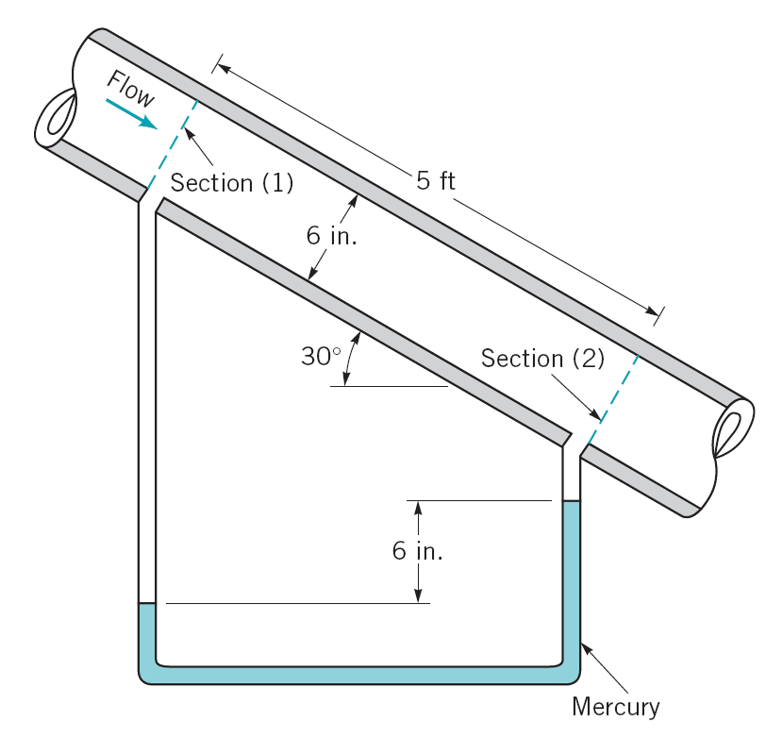
5.102 Water flows steadily down the inclined pipe as indicated in Figure P5.102 (copied at the right), Determine the following: (a) the difference in pressure, p₁ – p₂, (b) the loss per unit mass between sections (1) and (2), and (c) The net axial force exerted by the pipe wall on the flowing water between sections (1) and (2).
(a) The difference in pressure can be found from the manometer reading. The distance from the pipe at section 2 to the top of the mercury is an unknown distance, y. The distance from the pipe to the top of the mercury at section 1 is the sum of the mercury differential, 6 in = 0.5 ft, the vertical distance between stations 1 and 2 = (5 ft) sin(30º) = 2.5 ft, and the unknown distance y. At the mercury-water interface at section 1, the pressure, p_{left,} is given by the usual equation of fluid statics:
y
$$p_{\text{left}}=p_{1}+γ_{H_{2}O}(y+0\text{.}5 \text{ft}+2\text{.}5 \text{ft})=p_{1}+γ_{H_{2}O}(y+3 \text{ft})$$
This pressure equals the pressure at the same level on the right side of the manometer tube, p_{right}, which is also found from a manometer equation.
$$p_{\text{right}}=p_{2}+γ_{H_{2}O}y+γ_{\text{Hg}}(0\text{.}5 \text{ft})$$
Equating these two pressures gives the following equation for the desired pressure difference p₁ – p₂.
$$\begin{matrix}p_{\text{left}}=p_{1}+γ_{H_{2}O}(y+3 \text{ft})=p_{\text{right}}=p_{2}+γ_{H_{2}O}y+γ_{\text{Hg}}(0\text{.}5 \text{ft}) \\ p_{1}−p_{2}=γ_{H_{2}O}y+γ_{\text{Hg}}(0\text{.}5 \text{ft})−γ_{H_{2}O}(y+3 \text{ft})=γ_{\text{Hg}}(0\text{.}5 \text{ft})−γ_{H_{2}O}(3 \text{ft})\end{matrix}$$
Using the values of γ_{H2O} = 62.5 lb_{f}/ft³ and γ_{Hg} = 847 lb_{f}/ft³ from Table 1.5 on the inside front cover gives the following result for p₁ – p₂.
$p_{1}−p_{2}=γ_{\text{Hg}}(0\text{.}5 \text{ft})−γ_{H_{2}O}(3 \text{ft})=\frac{\text{847} {\text{lb}}_{f}}{{\text{ft}}^{3}}(0\text{.}5 \text{ft})−\frac{\text{62}\text{.}4 {\text{lb}}_{f}}{{\text{ft}}^{3}}(3 \text{ft})$= 236 lb_{f}/ft²
(b) The loss term in equation 5.79 represents the loss of available energy per unit mass that is sought in this problem. According to that equation, for a flow from inlet station 1 to outlet station 2, the loss is found to be
$$\text{loss}={\text{gz}}_{1}+\frac{p_{1}}{ρ}+\frac{V_{1}^{2}}{2}−\left({\text{gz}}_{2}+\frac{p_{2}}{ρ}+\frac{V_{2}^{2}}{2}\right)=g\left(z_{1}−z_{2}\right)+\frac{p_{1}−p_{2}}{ρ}+\frac{V_{1}^{2}−V_{2}^{2}}{2}$$
For the inclined pipe shown the areas at station 1 and station 2 are the same and we assume that the density of the water does not change. From continuity, then, we conclude that the velocities at stations 1 and 2 are the same. The value of p₁ – p₂ was just found in part (a), and the value of z₁ – z₂ was found in part(a) as (5 ft)sin(30º) = 2.5 ft. With the density of water, ρ = 1.94 slugs/ft³ from Table 1.5 on the inside front cover, we have the following value for the loss per unit mass:
$$\text{loss}=g\left(z_{1}−z_{2}\right)+\frac{p_{1}−p_{2}}{ρ}+\frac{V_{1}^{2}−V_{2}^{2}}{2}=\frac{\text{32}\text{.}\text{174} \text{ft}}{s^{2}}\left(2\text{.}5 \text{ft}\right)\frac{{\text{lb}}_{f}⋅s^{2}}{1 \text{slug}⋅\text{ft}}+\frac{\frac{\text{236} {\text{lb}}_{f}}{{\text{ft}}^{2}}}{\frac{1\text{.}\text{94} \text{slugs}}{{\text{ft}}^{3}}}+0$$
loss = 202 ft·lb_{f}/slug
(c) The net axial force is found from the usual momentum equation.
$$\frac{∂{\left({\text{mV}}_{k}\right)}_{\text{cv}}}{∂t}+\sum_{o=1}^{N_{\text{outlets}}}{ρ_{o}V_{o}A_{o}V_{k,o}}−\sum_{i=1}^{N_{\text{inlets}}}{ρ_{i}V_{i}A_{i}V_{k,i}}=\sum{F_{k}}$$
Here we apply this equation in a direction along the axis of the pipe using a control volume whose inlet is station 1 and whose outlet is station 2. If we assume a steady process, the time derivative is zero and we note that there is only one inlet and one outlet. This gives:
$$ρ_{o}V_{o}A_{o}V_{\text{axis},o}−ρ_{i}V_{i}A_{i}V_{\text{axis},i}=\sum{F_{\text{axis}}}$$
The density, area, velocity, and axial velocity component are the same at the inlet and outlet. Thus the momentum terms on the left side of this equation cancel. We are left with a sum of forces equal to zero. We take the axial direction to be the direction of the flowing water. The sum of forces in this direction contains the following terms: (i) the force of the wall on the water that we are looking for, R_{axis}, (ii) the pressure forces, and (iii) the weight of the water. These forces, summed to zero, give
$$\sum{F_{\text{axis}}}=p_{1}A−p_{2}A+{\left(γ_{H_{2}O}V\right)}_{\text{axis}}+R_{\text{axis}}=0$$
The pressure and reaction forces are in the direction of the axis. The weight of the water is in the vertical direction. The component of this force in the direction of the axis is the weight times the sine of 30º. The volume of water is simply the area times the length between the sections. Solving for R_{axis} and computing the area and volume gives the following.
$$R_{\text{axis}}=−\left(p_{1}−p_{2}\right)\frac{{πD}^{2}}{4}−γ_{H_{2}O}\frac{{πD}^{2}}{4}ℓ\text{sin}\left({\text{30}}^{o}\right)$$
$R_{\text{axis}}=−\frac{\text{236} {\text{lb}}_{f}}{{\text{ft}}^{2}}\frac{π{\left(0\text{.}5 \text{ft}\right)}^{2}}{4}−\frac{\text{62}\text{.}4 {\text{lb}}_{f}}{{\text{ft}}^{3}}\frac{π{\left(0\text{.}5 \text{ft}\right)}^{2}}{4}\left(5 \text{ft}\right)\text{sin}\left({\text{30}}^{o}\right)$ = –77.03 lb_{f}
Thus the force is opposite to the direction of flow.
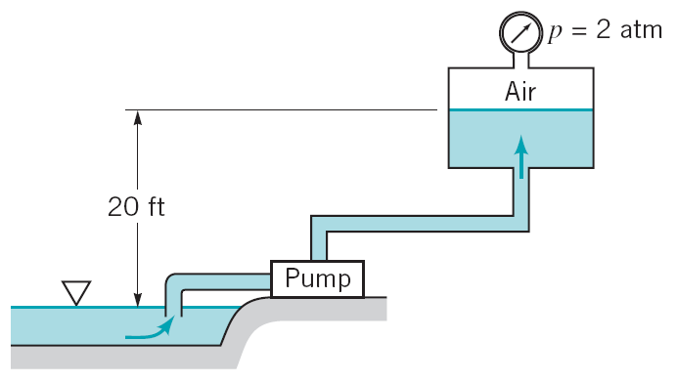
5.109 A pump is to move water from a lake into a large pressurized tank as shown in Figure P5.109 (copied at the right) at a rate of 1000 gal in 10 min or less. Will a pump that adds 3 hp to the water work for this purpose? Support your answer with appropriate calculations. Repeat the problem if the tank were pressurized to 3 atm rather than 2 atm.
in
out
To answer this question we can use the energy equation with energy input from the pump and a head loss. We know that the head loss must be positive. If it is or is not positive, it is or is not possible to accomplish the task. We can write the energy equation for the head loss as follows.
$$h_{L}=\frac{\text{loss}}{g}=\left(z_{\text{in}}−z_{\text{out}}\right)+\frac{p_{\text{in}}−p_{\text{out}}}{γ}+\frac{V_{\text{in}}^{2}−V_{\text{out}}^{2}}{2g}+h_{P}$$
We can define our control volume so that the inlet is the surface of the lake and the outlet is the water-air interface in the tank. This gives z_{in} – z_{out} = –20 ft. We can assume that the area of the lake at the control-volume inlet and the area of the tank at the control-volume outlet are so large that the V²/2g terms will be negligible compared to other terms in the energy equation; these velocity terms will be set to zero. Finally, we see that the lake surface is open to the atmosphere giving p_{in} = 0. With these observations we have the following terms in the energy equation.
$$h_{L}=\left(z_{\text{in}}−z_{\text{out}}\right)+\frac{p_{\text{in}}−p_{\text{out}}}{γ}+\frac{V_{\text{in}}^{2}−V_{\text{out}}^{2}}{2g}+h_{P}=−\text{20} \text{ft}−\frac{p_{\text{out}}}{γ}+0+h_{p}$$
The pumping head, h_{P} is defined in terms of the pump work, flow rate and specific weight by the following equation.
$$h_{P}=\frac{{\overset{˙}{W}}_{P}}{Qγ}=\frac{\left(3 \text{hp}\right)\frac{\text{33000} \text{ft}⋅{\text{lb}}_{f}}{\text{hp}⋅\text{min}}}{\frac{\text{1000} \text{gal}}{\text{10} \text{min}}\frac{1 {\text{ft}}^{3}}{7\text{.}\text{48} \text{gal}}\frac{\text{62}\text{.}4 {\text{lb}}_{f}}{{\text{ft}}^{3}}}=\text{118}\text{.}7 \text{ft}$$
Substituting this value into our head loss equation gives.
$$h_{L}=−\text{20} \text{ft}−\frac{p_{\text{out}}}{γ}+0+h_{p}=−\text{20} \text{ft}−\frac{p_{\text{out}}}{\frac{\text{62}\text{.}4 {\text{lb}}_{f}}{{\text{ft}}^{3}}}+\text{118}\text{.}7 \text{ft}=\text{98}\text{.}7 \text{ft}−\frac{p_{\text{out}}}{\frac{\text{62}\text{.}4 {\text{lb}}_{f}}{{\text{ft}}^{3}}}$$
If p_{out} = 2 atm = 2(14.696 psi) = 4232 lb_{f}/ft², the available head loss is
$$h_{L}=\text{98}\text{.}7 \text{ft}−\frac{p_{\text{out}}}{\frac{\text{62}\text{.}4 {\text{lb}}_{f}}{{\text{ft}}^{3}}}=\text{98}\text{.}7 \text{ft}−\frac{\frac{\text{4232} {\text{lb}}_{f}}{{\text{ft}}^{2}}}{\frac{\text{62}\text{.}4 {\text{lb}}_{f}}{{\text{ft}}^{3}}}=\text{30}\text{.}\text{87} \text{ft}$$
Since the head loss is positive, the desired pumping rate is possible when the tank pressure is 2 atm. We have to wait until Chapter 8 to see how to compute head losses from a design perspective to determine if the system as built will have a head loss smaller than this.
If p_{out} = 3 atm = 6349 lb_{f}/ft², the available head loss is
$$h_{L}=\text{98}\text{.}7 \text{ft}−\frac{p_{\text{out}}}{\frac{\text{62}\text{.}4 {\text{lb}}_{f}}{{\text{ft}}^{3}}}=\text{98}\text{.}7 \text{ft}−\frac{\frac{\text{6349} {\text{lb}}_{f}}{{\text{ft}}^{2}}}{\frac{\text{62}\text{.}4 {\text{lb}}_{f}}{{\text{ft}}^{3}}}=−3\text{.}\text{04} \text{ft}$$
Since the head loss is negative, the desired pumping rate is NOT possible when the tank pressure is 3 atm.

