Chapter 8
Standard Costs

True/False

1. A direct material quantity standard generally includes an allowance for waste.
Level: Easy LO: 1 Ans: T

2. Practical standards allow for normal machine downtime and employee rest periods.
Level: Easy LO: 1 Ans: T

3. Ideal standards can be used in forecasting and planning whereas practical standards cannot be used for such purposes.
Level: Easy LO: 1 Ans: F

4. Most companies compute the materials price variance when materials are placed into production.
Level: Easy LO: 2 Ans: F

5. A materials price variance is favorable if the actual price exceeds the standard price.
Level: Easy LO: 2 Ans: F

6. An unfavorable materials quantity variance occurs when the actual quantity used in production is less than the standard quantity allowed for the actual output of the period.
Level: Easy LO: 2 Ans: F

7. An unfavorable labor rate variance can occur if workers with high hourly wage rates are assigned to work on products whose standards assume workers with low hourly wage rates.
Level: Easy LO: 3 Ans: T

8. If variable manufacturing overhead is applied based on direct labor-hours, it is impossible to have a favorable labor efficiency variance and unfavorable variable overhead efficiency variance for the same period.
Level: Medium LO: 4 Ans: T

9. (Appendix) A favorable materials quantity variance would appear as a debit in a journal entry.
Level: Medium LO: 7 Ans: F

10. (Appendix) Although formal entry of standard costs and variances into the accounting records is not required, some organizations make such entries in order to emphasize the importance of variances as well as to simplify the bookkeeping process.
Level: Easy LO: 7 Ans: T

11. A standard can be regarded as the budgeted cost for one unit of product.
Level: Easy LO: 8 Ans: T

12. In using a statistical control chart, observation points plotted between the upper and lower limits are considered to be random or chance occurrences and would not typically result in an investigation.
Level: Easy LO: 8 Ans: T

Multiple Choice

13. Which of the following statements concerning ideal standards is incorrect?
A) Ideal standards generally do not provide the best motivation for workers.
B) Ideal standards do not make allowances for waste, spoilage, and machine breakdowns.
C) Ideal standards are better suited for cash budgeting than practical standards.
D) Ideal standards may be better than practical standards when managers seek continual improvement.
Source: CMA, adapted
Level: Medium LO: 1 Ans: C

14. Under traditional standard costing, which of the following would commonly be included when setting a standard quantity for direct material?

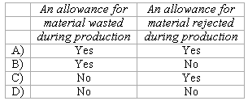

A) A above
B) B above
C) C above
D) D above
Level: Medium LO: 1 Ans: A

15. When computing standard cost variances, the difference between actual and standard price multiplied by actual quantity yields a(n):
A) combined price and quantity variance.
B) efficiency variance.
C) price variance.
D) quantity variance.
Source: CMA, adapted
Level: Easy LO: 2,3 Ans: C

16. Poor quality materials could have an unfavorable effect on which of the following variances?

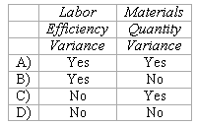

A) A above
B) B above
C) C above
D) D above
Level: Medium LO: 2,3 Ans: A

17. (Appendix) When the actual price paid on credit for a raw material exceeds its standard price, the journal entry would include:
A) Debit to Raw Materials; Credit to Materials Price Variance
B) Debit to Accounts Payable; Credit to Materials Price Variance
C) Debit to Raw Materials; Debit to Materials Price Variance
D) Debit to Accounts Payable; Debit to Materials Price Variance
Level: Medium LO: 2,7 Ans: C

18. (Appendix) When the actual price paid on credit for a raw material is less than its standard price, the journal entry would include:
A) Credit to Raw Materials; Credit to Materials Price Variance
B) Credit to Accounts Payable; Credit to Materials Price Variance
C) Credit to Raw Materials; Debit to Materials Price Variance
D) Credit to Accounts Payable; Debit to Materials Price Variance
Level: Medium LO: 2,7 Ans: B

19. (Appendix) When the actual amount of a raw material used in production is less than the standard amount allowed for the actual output, the journal entry would include:
A) Credit to Raw Materials; Credit to Materials Quantity Variance
B) Credit to Work-In-Process; Credit to Materials Quantity Variance
C) Credit to Raw Materials; Debit to Materials Quantity Variance
D) Credit to Work-In-Process; Debit to Materials Quantity Variance
Level: Medium LO: 2,7 Ans: A

20. (Appendix) When the actual amount of a raw material used in production is greater than the standard amount allowed for the actual output, the journal entry would include:
A) Credit to Raw Materials; Credit to Materials Quantity Variance
B) Credit to Work-In-Process; Credit to Materials Quantity Variance
C) Credit to Raw Materials; Debit to Materials Quantity Variance
D) Credit to Work-In-Process; Debit to Materials Quantity Variance
Level: Medium LO: 2,7 Ans: C

21. Which of the following would produce a materials price variance?
A) an excess quantity of materials used.
B) an excess number of direct labor-hours worked in completing a job.
C) shipping materials to the plant by air freight rather than by truck.
D) breakage of materials in production.
Level: Easy LO: 2 Ans: C

22. The standard price per unit of materials is used in the calculation of which of the following variances?

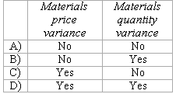

A) A above
B) B above
C) C above
D) D above
Source: CPA, adapted
Level: Medium LO: 2 Ans: D

23. (Appendix) A labor efficiency debit balance indicates that:
A) The wage rate paid to production workers was less the standard.
B) The wage rate paid to production workers was above the standard.
C) Less labor time was spent on production than was called for by the standard.
D) More labor time was spent on production than was called for by the standard.
Source: CPA, adapted
Level: Hard LO: 3,7 Ans: D
24. (Appendix) When the actual wage rate paid to direct labor workers exceeds the standard wage rate, the journal entry would include:
A) Credit to Wages Payable; Credit to Labor Rate Variance
B) Credit to Work-In-Process; Credit to Labor Rate Variance
C) Credit to Wages Payable; Debit to Labor Rate Variance
D) Credit to Work-In-Process; Debit to Labor Rate Variance
Level: Medium LO: 3,7 Ans: C

25. (Appendix) When the actual wage rate paid to direct labor workers is less than the standard wage rate, the journal entry would include:
A) Debit to Wages Payable; Credit to Labor Rate Variance
B) Debit to Work-In-Process; Credit to Labor Rate Variance
C) Debit to Wages Payable; Debit to Labor Rate Variance
D) Debit to Work-In-Process; Debit to Labor Rate Variance
Level: Medium LO: 3,7 Ans: B

26. (Appendix) When the actual direct labor-hours exceed the standard direct labor-hours allowed for the actual output of the period, the journal entry would include:
A) Credit to Wages Payable; Credit to Labor Efficiency Variance
B) Credit to Work-In-Process; Credit to Labor Efficiency Variance
C) Credit to Wages Payable; Debit to Labor Efficiency Variance
D) Credit to Work-In-Process; Debit to Labor Efficiency Variance
Level: Medium LO: 3,7 Ans: C

27. Which of the following would produce a labor rate variance?
A) Poor quality materials causing breakage and work interruptions.
B) Use of persons with high hourly wage rates in tasks that call for low hourly wage rates.
C) Excessive number of hours worked in completing a job.
D) An unfavorable variable overhead spending variance.
Level: Medium LO: 3 Ans: B

28. In a certain standard costing system direct labor-hours are used as the base for applying variable manufacturing overhead costs. The standard direct labor rate is twice the variable manufacturing overhead rate. Last period the labor efficiency variance was unfavorable. From this information one can conclude that last period the variable overhead efficiency variance was:
A) unfavorable and half the labor efficiency variance.
B) favorable and half the labor efficiency variance.
C) unfavorable and twice the labor efficiency variance.
D) favorable and twice the labor efficiency variance.
Level: Medium LO: 4 Ans: A

29. (Appendix) If raw materials are carried in the raw materials inventory at standard cost, then it is reasonable to assume that:
A) the price variance is recognized when materials are purchased.
B) the price variance is recognized when materials are placed into production.
C) all variances are prorated between work in process, finished goods, and cost of goods sold.
D) the raw materials account is overstated.
Level: Medium LO: 7 Ans: A

30. Which of the following statements is a good description of the variances that should be investigated under the management by exception concept?
A) all variances should be investigated.
B) only unfavorable variances should be investigated.
C) a small random sample of all variances should be investigated.
D) unusually large favorable and unfavorable variances should be investigated.
Level: Medium LO: 8 Ans: D

31. The following direct labor information pertains to the manufacture of product Glu:

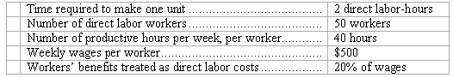

What is the standard direct labor cost per unit of product Glu?
A) $30
B) $24
C) $15
D) $12
Source: CPA, adapted
Level: Medium LO: 1 Ans: A

32. (Appendix) Anderson Company purchased 20,000 pounds of direct material at $0.70 per pound. The standard cost per pound of material is $0.60 per pound. The general ledger entry to record the issuance of materials would include:
A) a debit to Materials Price Variance $2,000.
B) a credit to Materials Price Variance of $2,000.
C) a credit to Raw Materials of $0.70 per pound times the number of pounds issued.
D) a credit to Raw Materials of $0.60 per pound times the number of pounds issued.
Level: Medium LO: 2,7 Ans: D

33. The following materials standards have been established for a particular raw material used in the company’s sole product:

The following data pertain to operations concerning the product for the last month:

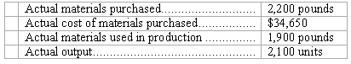

What is the materials quantity variance for the month?
A) $3,320 F
B) $3,150 F
C) $4,980 U
D) $4,725 U
Level: Easy LO: 2 Ans: A

34. The following materials standards have been established for a particular raw material used in the company’s sole product:

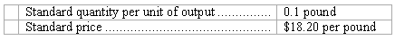

The following data pertain to operations for the last month:

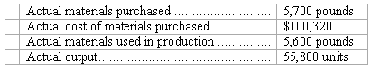

What is the materials price variance for the month?
A) $1,820 U
B) $1,760 U
C) $3,420 F
D) $352 U
Level: Easy LO: 2 Ans: C

35. A quantity of a particular raw material was purchased for $43,250. The standard cost of the material was $2.00 per kilogram and there was an unfavorable materials price variance of $3,250. How many kilograms were purchased?
A) 20,000
B) 21,625
C) 23,250
D) 24,875
Source: CIMA, adapted
Level: Hard LO: 2 Ans: A

36. A total of 6,850 kilograms of a raw material was purchased at a total cost of $21,920. The material price variance was $1,370 favorable. The standard price per kilogram for the raw material must be:
A) $0.20
B) $3.00
C) $3.20
D) $3.40
Source: CIMA, adapted
Level: Hard LO: 2 Ans: D

37. (Appendix) Results of operations for the Anderson Company indicated that the actual direct labor rate for the month of May was $9.75 while the standard rate was $10.00. The general ledger entry to record the incurrence of direct labor cost would include:
A) a debit to Work-In-Process for the actual number of hours times $9.75 per hour.
B) a debit to Work-In-Process for the standard number of hours times $10.00 per hour.
C) a debit to Work-In-Process for the standard number of hours times $9.75 per hour.
D) a debit to Work-In-Process for the actual number of hours times $10.00 per hour.
Level: Medium LO: 3,7 Ans: B

38. The following labor standards have been established for a particular product:

The following data pertain to operations concerning the product for the last month:

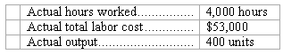
What is the labor efficiency variance for the month?
A) $10,600 U
B) $11,080 U
C) $11,080 F
D) $10,480 U
Level: Easy LO: 3 Ans: D

39. The following labor standards have been established for a particular product:

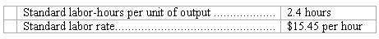

The following data pertain to operations concerning the product for the last month:

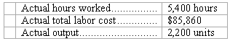

What is the labor rate variance for the month?
A) $1,908 U
B) $2,430 U
C) $4,284 U
D) $4,284 F
Level: Easy LO: 3 Ans: B

40. The following information pertains to Bates Company’s direct labor for March:

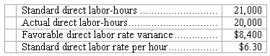

What was Bates’ total actual direct labor cost for March?
A) $117,600
B) $118,000
C) $134,000
D) $134,400
Source: CPA, adapted
Level: Hard LO: 3 Ans: A

41. The direct labor standards for a particular product are:
4 hours of direct labor @ $12.00 per direct labor-hour = $48.00
During October, 3,350 units of this product were made, which was 150 units less than budgeted. The labor cost incurred was $159,786 and 13,450 direct labor-hours were worked. The direct labor variances for the month were:

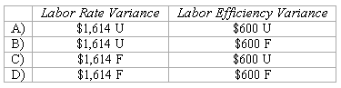

A) A above
B) B above
C) C above
D) D above
Source: CIMA, adapted
Level: Medium LO: 3 Ans: C

42. The standard cost card of a particular product specifies that it requires 4.5 direct labor-hours at $12.80 per direct labor-hour. During March, 2,300 units of the product were produced and direct labor wages of $128,300 were incurred. A total of 11,700 direct labor-hours were worked. The direct labor variances for the month were:

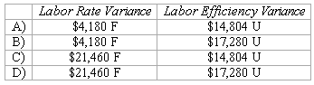

A) A above
B) B above
C) C above
D) D above
Source: CIMA, adapted
Level: Easy LO: 3 Ans: D

43. The following standards for variable manufacturing overhead have been established for a company that makes only one product:

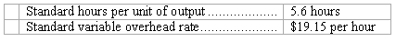

The following data pertain to operations for the last month:

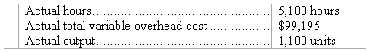

What is the variable overhead efficiency variance for the month?
A) $20,299 F
B) $18,769 F
C) $1,848 F
D) $20,617 F
Level: Easy LO: 4 Ans: A

44. The following standards for variable manufacturing overhead have been established for a company that makes only one product:

The following data pertain to operations for the last month:

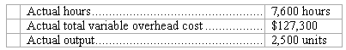

What is the variable overhead spending variance for the month?
A) $3,420 U
B) $3,150 F
C) $10,050 U
D) $13,200 U
Level: Easy LO: 4 Ans: A

45. (Appendix) During the month of May, Domino Manufacturing Corporation purchased materials that had a total standard cost of $57,000. The Materials Price Variance on these materials was $3,000 favorable. What summary journal entry would Domino make to record this purchase and variance for May?

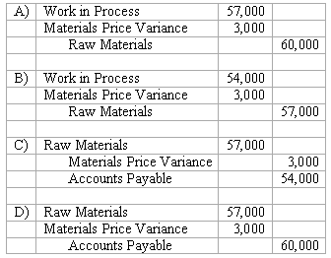

A) A above
B) B above
C) C above
D) D above
Level: Easy LO: 7 Ans: C

46. Polite Corporation is developing standards for its products. One product requires an input that is purchased for $44.00 per kilogram from the supplier. By paying cash, the company gets a discount of 7% off this purchase price. Shipping costs from the supplier’s warehouse amount to $2.89 per kilogram. Receiving costs are $0.51 per kilogram. The standard price per kilogram of this input should be:
A) $43.68
B) $50.48
C) $44.00
D) $44.32
Level: Easy LO: 1 Ans: D

47. Bjornstad Corporation is developing standards for its products. Each unit of output of the product requires 0.94 kilogram of a particular input. The allowance for waste and spoilage is 0.02 kilogram of this input for each unit of output. The allowance for rejects is 0.11 kilogram of this input for each unit of output. The standard quantity in kilograms of this input per unit of output should be:
A) 0.94
B) 1.07
C) 0.81
D) 0.92
Level: Easy LO: 1 Ans: B

48. Bellantuono Corporation is developing direct labor standards. The basic direct labor wage rate is $11.00 per hour. Employment taxes are 9% of the basic wage rate. Fringe benefits are $3.18 per direct labor-hour. The standard rate per direct labor-hour should be:
A) $15.17
B) $11.00
C) $6.83
D) $4.17
Level: Easy LO: 1 Ans: A

49. Hillestad Corporation is developing direct labor standards. A particular product requires 0.72 direct labor-hours per unit. The allowance for breaks and personal needs is 0.07 direct labor-hours per unit. The allowance for cleanup, machine downtime, and rejects is 0.09 direct labor-hours per unit. The standard direct labor-hours per unit should be:
A) 0.88
B) 0.56
C) 0.72
D) 0.65
Level: Easy LO: 1 Ans: A

50. (Appendix) Barbu Corporation has provided the following data concerning its direct labor costs for June:

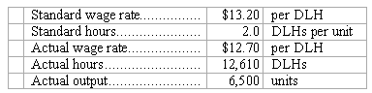

The Labor Rate Variance for June would be recorded as a:
A) credit of $6,305.
B) credit of $6,500.
C) debit of $6,305.
D) debit of $6,500.
Level: Easy LO: 3,7 Ans: A

51. (Appendix) Gainer Corporation’s standard wage rate is $11.70 per direct labor-hour (DLH) and according to the standards, each unit of output requires 3.9 DLHs. In February, 7,800 units were produced, the actual wage rate was $12.50 per DLH, and the actual hours were 29,940 DLHs. The Labor Rate Variance for February would be recorded as a:
A) debit of $23,952.
B) credit of $23,952.
C) credit of $24,336.
D) debit of $24,336.
Level: Easy LO: 3,7 Ans: A

52. (Appendix) Miolen Corporation has provided the following data concerning its direct labor costs for June:

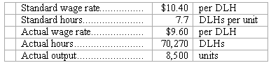

The Labor Efficiency Variance for June would be recorded as a:
A) credit of $50,128.
B) debit of $46,272.
C) debit of $50,128.
D) credit of $46,272.
Level: Easy LO: 3,7 Ans: C

53. (Appendix) Liukko Corporation’s standard wage rate is $14.90 per direct labor-hour (DLH) and according to the standards, each unit of output requires 2.8 DLHs. In June, 1,800 units were produced, the actual wage rate was $15.80 per DLH, and the actual hours were 5,110 DLHs. The Labor Efficiency Variance for June would be recorded as a:
A) debit of $1,106.
B) credit of $1,106.
C) credit of $1,043.
D) debit of $1,043.
Level: Easy LO: 3,7 Ans: D

54. (Appendix) Marusarz Corporation has provided the following data concerning its most important raw material, compound F55M:

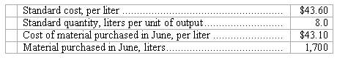

When recording the purchase of materials, Raw Materials would be:
A) credited for $74,120.
B) debited for $73,270.
C) debited for $74,120.
D) credited for $73,270.
Level: Easy LO: 7 Ans: C

55. (Appendix) Slife Corporation has provided the following data concerning its most important raw material, compound G81N:

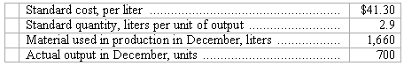
When recording the use of materials in production, Raw Materials would be:
A) debited for $68,558.
B) credited for $83,839.
C) credited for $68,558.
D) debited for $83,839.
Level: Easy LO: 7 Ans: C

56. (Appendix) Compound B73G is used to make Vasconcellos Corporation’s major product. The standard cost of B73G is $27.60 per ounce and the standard quantity is 8.6 ounces per unit of output. In the most recent month, 3,200 ounces of the raw material were purchased at a cost of $26.70 per ounce. When recording the purchase of materials, Raw Materials would be:
A) debited for $88,320.
B) debited for $85,440.
C) credited for $85,440.
D) credited for $88,320.
Level: Easy LO: 7 Ans: A

57. (Appendix) Compound K72R is used to make Munuz Corporation’s major product. The standard cost of compound K72R is $43.90 per ounce and the standard quantity is 1.4 ounces per unit of output. In the most recent month, 120 ounces of the compound were used to make 100 units of the output. When recording the use of materials in production, Raw Materials would be:
A) debited for $5,268.
B) credited for $6,146.
C) credited for $5,268.
D) debited for $6,146.
Level: Easy LO: 7 Ans: C

58. (Appendix) Data concerning the direct labor costs for March of Boler Corporation appear below:
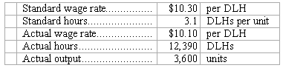
The journal entry to record the incurrence of direct labor costs in March would include the following for Work in Process:
A) credit of $125,139.
B) debit of $114,948.
C) credit of $114,948.
D) debit of $125,139.
Level: Easy LO: 7 Ans: B
59. (Appendix) Gramajo Corporation’s standard wage rate is $10.10 per direct labor-hour (DLH) and according to the standards, each unit of output requires 3.4 DLHs. In February, 2,400 units were produced, the actual wage rate was $9.40 per DLH, and the actual hours were 7,920 DLHs. In the journal entry to record the incurrence of direct labor costs in February, the Work in Process entry would consist of a:
A) credit of $74,448.
B) debit of $74,448.
C) debit of $82,416.
D) credit of $82,416.
Level: Easy LO: 7 Ans: C

Use the following information to answer 60-62
Stench Foods Company uses a standard cost system to collect costs related to the production of its garlic flavored yogurt. The garlic (materials) standards for each container of yogurt produced are 0.8 ounces of crushed garlic at a standard cost of $2.30 per ounce.
During the month of June, Stench purchased 75,000 ounces of crushed garlic at a total cost of $171,000. Stench used 64,000 of these ounces to produce 71,500 containers of yogurt.

60. What is Stench’s materials price variance for the month of June?
A) $1,500 favorable
B) $15,640 unfavorable
C) $17,250 favorable
D) $23,800 favorable
Level: Medium LO: 2 Ans: A

61. What is Stench’s materials quantity variance for the month of June?
A) $1,500 favorable
B) $15,640 unfavorable
C) $17,250 favorable
D) $23,800 favorable
Level: Medium LO: 2 Ans: B

62. Assume that it takes 15 minutes of labor time to crush enough garlic to fill one container of yogurt. Because the smell of the garlic can be unbearable, workers are given (and they take it!) 10 minutes of break time every hour (i.e., 50 minutes of work, 10 minutes of break). How many minutes should Stench use as a standard quantity of labor time per container of yogurt?
A) 18.0
B) 16.2
C) 17.0
D) 17.5
Level: Medium LO: 1 Ans: A

Use the following information to answer 63-64
Holiday Chemical Company uses a standard cost system to collect costs related to the production of its “bowling ball” fruitcakes. The direct labor standard for each fruitcake is 1.25 hours at a standard cost of $11.00 per hour. During the month of November, Holiday’s fruitcake production used 9,820 direct labor hours at a total direct labor cost of $106,547. This resulted in production of 8,500 fruitcakes for November.

63. What is Holiday’s labor rate variance for November?
A) $8,855 favorable
B) $1,473 favorable
C) $13,047 unfavorable
D) $14,520 unfavorable
Level: Medium LO: 3 Ans: B

64. What is Holiday’s labor efficiency variance for November?
A) $8,855 favorable
B) $10,328 favorable
C) $13,047 unfavorable
D) $14,520 unfavorable
Level: Medium LO: 3 Ans: A

65. Assume that 7 ounces of pecans are included in each bowling ball fruitcake. Because Holiday wants only the best pecans in its fruitcakes, the pecans they buy are inspected and some are discarded as unacceptable for fruitcake production. The loss rate is expected to be 1 ounce of pecans for every 5 ounces inspected. Under traditional standard costing, how many ounces of pecans should Holiday use as a standard quantity per fruitcake?
A) 7.20
B) 7.80
C) 8.40
D) 8.75
Level: Medium LO: 1 Ans: D

Use the following information to answer 66-67
Debit Dave and his four teaching assistants grade all 1,000 of their managerial accounting exams as a group. The average number of exams graded per hour by each person is as follows:

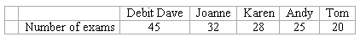

Debit Dave is considering the above information in setting a standard for grading the next examination.

66. Which amount above best represents a practical standard?
A) 45
B) 32
C) 25
D) 20
Level: Easy LO: 1 Ans: B

67. Which amount above best represents an ideal standard?
A) 45
B) 32
C) 25
D) 20
Level: Easy LO: 1 Ans: A

Use the following information to answer 68-73
Pardoe, Inc., manufactures a single product in which variable manufacturing overhead is assigned on the basis of direct labor hours. The company uses a standard cost system and has established the following standards for one unit of product:

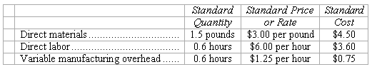

During March, the following activity was recorded by the company:

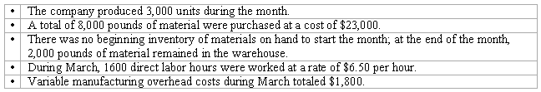

68. The materials price variance for March is:
A) $1,000 F
B) $1,000 U
C) $750 F
D) $750 U
Level: Medium LO: 2 Ans: A

69. The materials quantity variance for March is:
A) $4,500 F
B) $10,500 F
C) $10,500 U
D) $4,500 U
Level: Medium LO: 2 Ans: D

70. The labor rate variance for March is:
A) $480 U
B) $800 U
C) $480 F
D) $800 F
Level: Easy LO: 3 Ans: B

71. The labor efficiency variance for March is:
A) $5,040 U
B) $1,200 U
C) $1,200 F
D) $5,040 F
Level: Easy LO: 3 Ans: C

72. The variable overhead spending variance for March is:
A) $200 U
B) $600 U
C) $600 F
D) $200 F
Level: Easy LO: 4 Ans: D

73. The variable overhead efficiency variance for March is:
A) $1,050 F
B) $1,050 U
C) $250 F
D) $250 U
Level: Easy LO: 4 Ans: C

Use the following information to answer 74-75
The following data pertain to Nell Company’s operations for June:

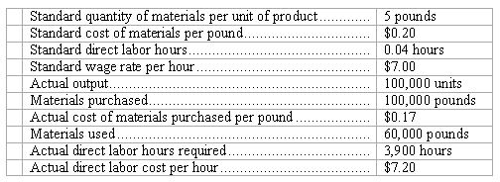

The materials price variance is recognized when materials are purchased.

74. Nell’s materials price variance for June was:
A) $3,000 favorable
B) $3,000 unfavorable
C) $2,000 favorable
D) $2,000 unfavorable
Source: CMA, adapted
Level: Medium LO: 2 Ans: A

75. Nell’s labor efficiency variance for June was:
A) $780 favorable
B) $780 unfavorable
C) $700 favorable
D) $700 unfavorable
Source: CMA, adapted
Level: Medium LO: 3 Ans: C

Use the following information to answer 76-79
The Collins Company uses standard costing and has established the following direct material and direct labor standards for each unit of the single product it makes:

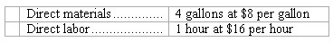

During July, the company made 6,000 units of product and incurred the following costs:

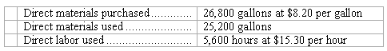

76. The material price variance for July was:
A) $5,360 favorable
B) $5,360 unfavorable
C) $5,040 favorable
D) $5,040 unfavorable
Level: Easy LO: 2 Ans: B

77. The materials quantity variance for July was:
A) $22,960 unfavorable
B) $22,400 unfavorable
C) $9,600 unfavorable
D) $9,840 unfavorable
Level: Easy LO: 2 Ans: C

78. The labor rate variance for July was:
A) $3,920 unfavorable
B) $6,120 unfavorable
C) $1,120 favorable
D) $3,920 favorable
Level: Easy LO: 3 Ans: D

79. The labor efficiency variance for July was:
A) $6,400 favorable
B) $89,600 favorable
C) $10,320 favorable
D) $6,120 favorable
Level: Easy LO: 3 Ans: A

Use the following information to answer 80-83
Jackson Industries employs a standard cost system in which direct materials inventory is carried at standard cost. Jackson has established the following standards for one unit of product.

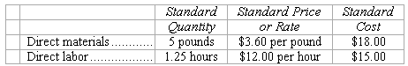

During May, Jackson purchased 125,000 pounds of direct material at a total cost of $475,000. The total factory wages for May were $364,000, 90 percent of which were for direct labor. Jackson manufactured 22,000 units of product during May using 108,000 pounds of direct material and 28,000 direct labor hours.

80. The price variance for the direct material acquired by Jackson Industries during May is:
A) $21,600 favorable
B) $25,000 unfavorable
C) $28,000 favorable
D) $21,600 unfavorable
Source: CMA, adapted
Level: Easy LO: 2 Ans: B

81. The direct material quantity variance for May is:
A) $7,200 unfavorable
B) $7,600 favorable
C) $5,850 unfavorable
D) $7,200 favorable
Source: CMA, adapted
Level: Easy LO: 2 Ans: D

82. The direct labor rate variance for May is:
A) $8,400 favorable
B) $7,200 unfavorable
C) $8,400 unfavorable
D) $6,000 favorable
Source: CMA, adapted
Level: Medium LO: 3 Ans: A

83. The direct labor efficiency variance for May is:
A) $5,850 favorable
B) $7,200 favorable
C) $6,000 unfavorable
D) $5,850 unfavorable
Source: CMA, adapted
Level: Easy LO: 3 Ans: C

Use the following information to answer 84-87
Arrow Industries employs a standard cost system in which direct materials inventory is carried at standard cost. Arrow has established the following standards for one unit of product.

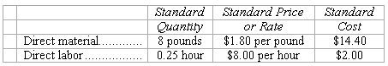

During November, Arrow purchased 160,000 pounds of direct material at a total cost of $304,000. The total factory wages for November were $42,000, 90 percent of which were for direct labor. Arrow manufactured 19,000 units of product during November using 142,500 pounds of direct material and 5,000 direct labor hours.

84. The direct material price variance for November is:
A) $16,000 favorable
B) $16,000 unfavorable
C) $14,250 favorable
D) $14,250 unfavorable
Source: CMA, adapted
Level: Easy LO: 2 Ans: B

85. The direct material quantity variance for November is:
A) $14,400 unfavorable
B) $1,100 favorable
C) $17,100 unfavorable
D) $17,100 favorable
Source: CMA, adapted
Level: Easy LO: 2 Ans: D

86. The direct labor rate variance for November is:
A) $2,200 favorable
B) $1,900 unfavorable
C) $2,000 unfavorable
D) $2,090 favorable
Source: CMA, adapted
Level: Medium LO: 3 Ans: A

87. The direct labor efficiency variance for November is:
A) $2,200 favorable
B) $2,000 favorable
C) $2,000 unfavorable
D) $1,800 unfavorable
Source: CMA, adapted
Level: Easy LO: 3 Ans: C

Use the following information to answer 88-92
The Dresden Company uses standard costing for the single product the company makes and sells. The following data are for the month of April:

Actual cost of direct material purchased and used: $62,400
Material price variance: $4,800 unfavorable
Total materials variance: $14,400 unfavorable
Standard cost per pound of material: $6
Standard cost per direct labor hour: $8
Actual direct labor hours: 3,800 hours
Labor efficiency variance: $1,600 favorable
Standard number of direct labor hour per unit of product: 2
Total labor variance: $680 unfavorable

88. The total number of units produced during April was:
A) 8,000
B) 12,000
C) 2,000
D) 3,800
Level: Hard LO: 2 Ans: C

89. The standard quantity of material allowed to produce one unit of product was:
A) 1 pound
B) 4 pounds
C) 6 pounds
D) 2 pounds
Level: Hard LO: 2 Ans: B

90. The actual material cost per pound was:
A) $6.50
B) $6.00
C) $5.00
D) $7.20
Level: Hard LO: 2 Ans: A

91. The actual direct labor rate per hour was:
A) $16.00
B) $6.50
C) $8.00
D) $8.60
Level: Hard LO: 3 Ans: D

92. The labor rate variance was:
A) $2,280 favorable
B) $2,280 unfavorable
C) $920 favorable
D) $920 unfavorable
Level: Hard LO: 3 Ans: B

Use the following information to answer 93-94
The following materials standards have been established for a particular product:

The following data pertain to operations concerning the product for the last month:

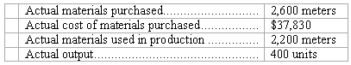

93. What is the materials price variance for the month?
A) $650 F
B) $550 U
C) $550 F
D) $650 U
Level: Easy LO: 2 Ans: A

94. What is the materials quantity variance for the month?
A) $5,820 U
B) $24,272 F
C) $5,920 U
D) $23,862 F
Level: Easy LO: 2 Ans: B

Use the following information to answer 95-96
Blaster, Inc., manufactures portable radios. Each radio requires 3 units of Part XBEZ52, which has a standard cost of $1.45 per unit. During May, the company purchased 12,000 units of the part for a total of $18,000. Also during May, the company manufactured 3,000 radios, using 10,000 units of part XBEZ52.

95. During May, the materials price variance for part XBEZ52 was:
A) $450 U
B) $450 F
C) $600 F
D) $600 U
Level: Easy LO: 2 Ans: D

96. During May, the materials quantity variance for part XBEZ52 was:
A) $1,450 U
B) $1,450 F
C) $4,350 F
D) $4,350 U
Level: Easy LO: 2 Ans: A
Use the following information to answer 96-98
The following labor standards have been established for a particular product:

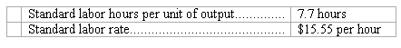

The following data pertain to operations concerning the product for the last month:
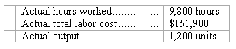

97. What is the labor rate variance for the month?
A) $490 F
B) $60 F
C) $60 U
D) $490 U
Level: Easy LO: 3 Ans: A

98. What is the labor efficiency variance for the month?
A) $8,680 U
B) $8,708 U
C) $8,218 F
D) $8,218 U
Level: Easy LO: 3 Ans: B

Use the following information to answer 99-100
A product’s standard cost card specifies that a unit of the product requires 4 direct labor-hours. During September, 3,350 units were made, which was 150 units less than budgeted. The total budgeted direct labor cost for September was $117,600. The direct labor cost incurred during September was $111,850 and 13,450 direct labor-hours were worked.

99. The direct labor rate variance for the month was:
A) $5,750 F
B) $5,750 U
C) $1,130 F
D) $1,130 U
Level: Hard LO: 3 Ans: C

100. The direct labor efficiency variance for the month was:
A) $420.00 U
B) $420.00 F
C) $415.80 U
D) $415.80 F
Level: Hard LO: 3 Ans: A
Use the following information to answer 101-102
The following standards for variable manufacturing overhead have been established for a company that makes only one product:

The following data pertain to operations for the last month:

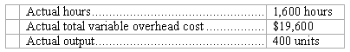

101. What is the variable overhead spending variance for the month?
A) $3,344 F
B) $720 U
C) $3,344 U
D) $720 F
Level: Easy LO: 4 Ans: D

102. What is the variable overhead efficiency variance for the month?
A) $576 U
B) $4,064 U
C) $3,920 U
D) $3,920 F
Level: Easy LO: 4 Ans: B

Use the following information to answer 103-104
The Maxwell Company has a standard costing system in which variable manufacturing overhead is assigned to production on the basis of machine hours. The following data are available for July:

Actual variable manufacturing overhead cost incurred: $22,620
Actual machine hours worked: 1,600
Variable overhead spending variance: $3,420 unfavorable
Total variable overhead variance: $4,620 unfavorable

103. The variable overhead efficiency variance for July is:
A) $8,040 unfavorable
B) $8,040 favorable
C) $1,200 unfavorable
D) $1,200 favorable
Level: Medium LO: 4 Ans: C

104. The standard number of machine hours allowed for July production is:
A) 1,500 hours
B) 1,600 hours
C) 1,700 hours
D) 2,270 hours
Level: Hard LO: 4 Ans: A

Use the following information to answer 105-106
Vermeillen Corporation uses a standard costing system in which variable manufacturing overhead is assigned to production on the basis of the number of machine setups. The following data pertain to one month’s operations:

Variable manufacturing overhead cost incurred: $70,000
Total variable overhead variance: $4,550 favorable
Standard machine setups allowed for actual production: 3,550
Actual machine setups incurred: 3,500

105. The standard variable overhead rate per machine setup is:
A) $20.00
B) $21.30
C) $18.44
D) $21.00
Level: Hard LO: 4 Ans: D

106. The variable overhead spending variance is:
A) $1,000 favorable
B) $1,000 unfavorable
C) $3,500 unfavorable
D) $3,500 favorable
Level: Hard LO: 4 Ans: D

Use the following information to answer 107-108
Wolk Corporation is developing standards for its products. One product requires an input that is purchased for $68.00 per kilogram from the supplier. By paying cash, the company gets a discount of 4% off this purchase price. Shipping costs from the supplier’s warehouse amount to $5.54 per kilogram. Receiving costs are $0.55 per kilogram. Each unit of output of the product requires 0.73 kilogram of this input. The allowance for waste and spoilage is 0.02 kilogram of this input for each unit of output. The allowance for rejects is 0.14 kilogram of this input for each unit of output.

107. The standard price per kilogram of this input should be:
A) $64.63
B) $76.81
C) $68.00
D) $71.37
Level: Easy LO: 1 Ans: D

108. The standard quantity in kilograms of this input per unit of output should be:
A) 0.71
B) 0.89
C) 0.57
D) 0.73
Level: Easy LO: 1 Ans: B

Use the following information to answer 109-110
Oien Corporation is developing direct labor standards. The basic direct labor wage rate is $14.00 per hour. Employment taxes are 9% of the basic wage rate. Fringe benefits are $3.28 per direct labor-hour. A particular product requires 0.98 direct labor-hours per unit. The allowance for breaks and personal needs is 0.02 direct labor-hours per unit. The allowance for cleanup, machine downtime, and rejects is 0.12 direct labor-hours per unit.

109. The standard rate per direct labor-hour should be:
A) $18.54
B) $4.54
C) $14.00
D) $9.46
Level: Easy LO: 1 Ans: A

110. The standard direct labor-hours per unit should be:
A) 0.84
B) 1.12
C) 0.96
D) 0.98
Level: Easy LO: 1 Ans: B

Use the following information to answer 111-114
(Appendix) Florea Corporation has provided the following data concerning its most important raw material, compound K09B:

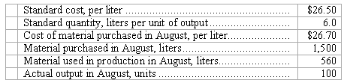

The raw material was purchased on account.

111. The debits to the Raw Materials account for August would total:
A) $39,750
B) $15,900
C) $14,840
D) $40,050
Level: Medium LO: 2,7 Ans: A

112. The credits to the Raw Materials account for August would total:
A) $40,050
B) $14,840
C) $39,750
D) $15,900
Level: Medium LO: 2,7 Ans: B

113. The Materials Price Variance for August would be recorded as a:
A) Credit of $112
B) Credit of $300
C) Debit of $112
D) Debit of $300
Level: Medium LO: 2,7 Ans: D

114. The Materials Quantity Variance for August would be recorded as a:
A) Credit of $24,910
B) Credit of $1,060
C) Debit of $1,060
D) Debit of $24,910
Level: Medium LO: 2,7 Ans: B

Use the following information to answer 115-118
(Appendix) Compound K52E is a raw material used to make Pinkos Corporation’s major product. The standard cost of compound K52E is $46.00 per ounce and the standard quantity is 5.0 ounces per unit of output. Data concerning the compound for March appear below:

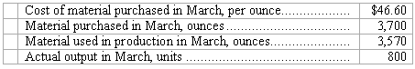

The raw material was purchased on account.

115. The debits to the Raw Materials account for March would total:
A) $170,200
B) $172,420
C) $184,000
D) $164,220
Level: Medium LO: 2,7 Ans: A

116. The credits to the Raw Materials account for March would total:
A) $172,420
B) $184,000
C) $170,200
D) $164,220
Level: Medium LO: 2,7 Ans: D

117. The Materials Price Variance for March would be recorded as a:
A) Debit of $2,220
B) Debit of $2,142
C) Credit of $2,220
D) Credit of $2,142
Level: Medium LO: 2,7 Ans: A

118. The Materials Quantity Variance for March would be recorded as a:
A) Credit of $19,780
B) Credit of $5,980
C) Debit of $19,780
D) Debit of $5,980
Level: Medium LO: 2,7 Ans: A

Use the following information to answer 119-121
(Appendix) Cafferty Corporation has provided the following data concerning its direct labor costs for March:

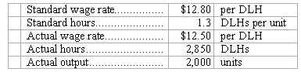

119. The journal entry to record the incurrence of direct labor costs in March would include the following for Work in Process:
A) Credit of $33,280
B) Debit of $35,625
C) Debit of $33,280
D) Credit of $35,625
Level: Medium LO: 3,7 Ans: C
120. The Labor Rate Variance for March would be recorded as a:
A) Credit of $855
B) Credit of $780
C) Debit of $780
D) Debit of $855
Level: Medium LO: 3,7 Ans: A

121. The Labor Efficiency Variance for March would be recorded as a:
A) Debit of $3,200
B) Credit of $3,125
C) Credit of $3,200
D) Debit of $3,125
Level: Medium LO: 3,7 Ans: A

Use the following information to answer 122-124
(Appendix) Enwall Corporation’s standard wage rate is $11.20 per direct labor-hour (DLH) and according to the standards, each unit of output requires 2.9 DLHs. In December, 5,900 units were produced, the actual wage rate was $10.20 per DLH, and the actual hours were 14,150 DLHs.

122. In the journal entry to record the incurrence of direct labor costs in December, the Work in Process entry would consist of a:
A) credit of $144,330.
B) debit of $191,632.
C) debit of $144,330.
D) credit of $191,632.
Level: Medium LO: 3,7 Ans: B

123. The Labor Rate Variance for December would be recorded as a:
A) debit of $14,150.
B) credit of $17,110.
C) debit of $17,110.
D) credit of $14,150.
Level: Medium LO: 3,7 Ans: D

124. The Labor Efficiency Variance for December would be recorded as a:
A) debit of $33,152.
B) credit of $30,192.
C) credit of $33,152.
D) debit of $30,192.
Level: Medium LO: 3,7 Ans: C

Essay

125. (Appendix) The following standards have been established for a raw material used in the production of product G13:

The following data pertain to a recent month’s operations:

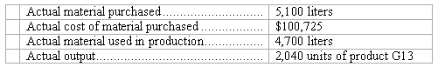

Required:
(a.) What is the materials price variance for the month?
(b.) What is the materials quantity variance for the month?
(c.) Prepare journal entries to record the purchase and use of the raw material during the month. (All raw materials are purchased on account.)
Level: Medium LO: 2,7
Ans:
(a.) Materials price variance = (AQ × AP) – (AQ × SP)
= $100,725 – (5,100 × $19.00) = $3,825 U
(b.) Materials quantity variance = SP(AQ – SQ*)
= $19.00(4,700 – 4,692) = $152 U
*SQ = Standard quantity per unit × Actual output
= 2.3 × 2,040 = 4,692

(c.) Journal entries to record the purchase and use of the raw material:
Record the purchase of the raw material:

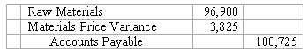

Record the use of the raw material:

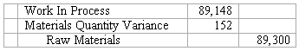

126. (Appendix) The standards for product F28 call for 2.7 pounds of a raw material that costs $16.50 per pound. Last month, 4,100 pounds of the raw material were purchased for $70,520. The actual output of the month was 1,300 units of product F28. A total of 3,500 pounds of the raw material were used to produce this output.
Required:
(a.) What is the materials price variance for the month?
(b.) What is the materials quantity variance for the month?
(c.) Prepare journal entries to record the purchase and use of the raw material during the month. (All raw materials are purchased on account.)
Level: Medium LO: 2,7
Ans:
(a.) Materials price variance = (AQ × AP) – (AQ × SP)
= $70,520 – (4,100 × $16.50) = $2,870 U
(b.) Materials quantity variance = SP(AQ – SQ*)
= $16.50(3,500 – 3,510) = $165 F
*SQ = Standard quantity per unit × Actual output
= 2.7 × 1,300 = 3,510
(c.) Journal entries to record the purchase and use of the raw material:

Record the purchase of the raw material:

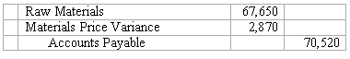

Record the use of the raw material:

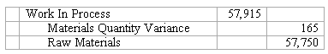

127. The following materials standards have been established for a particular product:

The following data pertain to operations concerning the product for the last month:

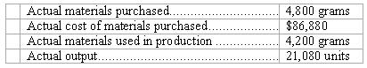

Required:
(a.) What is the materials price variance for the month?
(b.) What is the materials quantity variance for the month?
Level: Easy LO: 2
Ans:
Materials price variance = (AQ × AP) – (AQ × SP)
= $86,880 – (4,800 × $18.90) = $3,840 F
SQ = Standard quantity per unit × Actual output
= 0.2 × 21,080 = 4,216
Materials quantity variance = SP(AQ – SQ)
= $18.90(4,200 – 4,216) = $302 F

128. The following standards have been established for a raw material used to make product I92:

The following data pertain to a recent month’s operations:

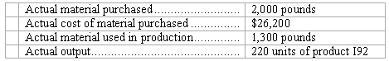

Required:
(a.) What is the materials price variance for the month?
(b.) What is the materials quantity variance for the month?
Level: Easy LO: 2
Ans:
(a.) Materials price variance = (AQ × AP) – (AQ × SP)
= $26,200 – (2,000 × $13.90) = $1,600 F
(b.) Materials quantity variance = SP(AQ – SQ*)
= $13.90(1,300 – 990) = $4,309 U
*SQ = Standard quantity per unit × Actual output
= 4.5 × 220 = 990

129. The standards for product K17 call for 5.0 meters of a raw material that costs $19.10 per meter. Last month, 2,700 meters of the raw material were purchased for $51,435. The actual output of the month was 460 units of product K17. A total of 2,500 meters of the raw material were used to produce this output.
Required:
(a.) What is the materials price variance for the month?
(b.) What is the materials quantity variance for the month?
Level: Easy LO: 2
Ans:
(a.) Materials price variance = (AQ × AP) – (AQ × SP)
= $51,435 – (2,700 × $19.10) = $135 F
(b.) Materials quantity variance = SP(AQ – SQ*)
= $19.10(2,500 – 2,300) = $3,820 U
*SQ = Standard quantity per unit × Actual output
= 5.0 × 460 = 2,300

130. (Appendix) The following direct labor standards have been established for product N30A:

The following data pertain to the most recent month’s operations during which 400 units of product N30A were made:

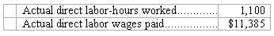
Required:
(a.) What was the labor rate variance for the month?
(b.) What was the labor efficiency variance for the month?
(c.) Prepare a journal entry to record direct labor costs during the month, including the direct labor variances.
Level: Medium LO: 3,7
Ans:
(a.) Labor rate variance = (AH × AR) – (AH × SR)
= $11,385 – (1,100 × $10.50) = $165 F
(b.) Labor efficiency variance = SR(AH – SH*)
= $10.50 (1,100 – 1,320) = $2,310 F
*SH = Standard hours per unit × Actual output
= 3.3 × 400 = 1,320
(c.) Journal entries to record the direct labor costs:

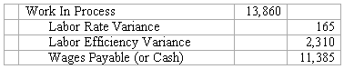

131. (Appendix) The standards for product Q58W specify 8.4 direct labor-hours per unit at $14.00 per direct labor-hour. Last month 400 units of product Q58W were produced using 2,800 direct labor-hours at a total direct labor wage cost of $41,020.
Required:
(a.) What was the labor rate variance for the month?
(b.) What was the labor efficiency variance for the month?
(c.) Prepare a journal entry to record direct labor costs during the month, including the direct labor variances.
Level: Medium LO: 3,7
Ans:
(a.) Labor rate variance = (AH × AR) – (AH × SR)
= $41,020 – (2,800 × $14.00) = $1,820 U
(b.) Labor efficiency variance = SR(AH – SH*)
= $14.00 (2,800 – 3,360) = $7,840 F
*SH = Standard hours per unit × Actual output
= 8.4 × 400 = 3,360
(c.) Journal entries to record the direct labor costs:

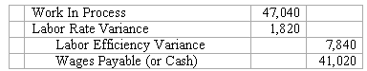

132. The following labor standards have been established for a particular product:

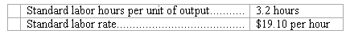

The following data pertain to operations concerning the product for the last month:

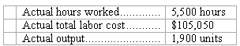

Required:
(a.) What is the labor rate variance for the month?
(b.) What is the labor efficiency variance for the month?
Level: Easy LO: 3
Ans:
Labor rate variance = (AH × AR) – (AH × SR)
= $105,050 – (5,500 × $19.10) = $0 U
SH = Standard hours per unit × Actual output
= 3.2 × 1,900 = 6,080
Labor efficiency variance = SR(AH – SH)
= $19.10(5,500 – 6,080) = $11,078 F

133. The following direct labor standards have been established for product S57S:

The following data pertain to last month’s operations:

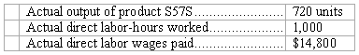

Required:
(a.) What was the labor rate variance for the month?
(b.) What was the labor efficiency variance for the month?
Level: Easy LO: 3
Ans:
(a.) Labor rate variance = (AH × AR) – (AH × SR)
= $14,800 – (1,000 × $14.70) = $100 U
(b.) Labor efficiency variance = SR(AH – SH*)
= $14.70 (1,000 – 1,080) = $1,176 F
*SH = Standard hours per unit × Actual output
= 1.5 × 720 = 1,080

134. The standards for product F88W specify 3.4 direct labor-hours per unit at $13.00 per direct labor-hour. Last month 800 units of product F88W were produced using 2,500 direct labor-hours at a total direct labor wage cost of $30,500.
Required:
(a.) What was the labor rate variance for the month?
(b.) What was the labor efficiency variance for the month?
Level: Easy LO: 3
Ans:
(a.) Labor rate variance = (AH × AR) – (AH × SR)
= $30,500 – (2,500 × $13.00)
= $2,000 F
(b.) Labor efficiency variance = SR(AH – SH*)
= $13.00 (2,500 – 2,720)
= $2,860 F

*SH = Standard hours per unit × Actual output
= 3.4 × 800 = 2,720

135. The following standards for variable manufacturing overhead have been established for a company that makes only one product:

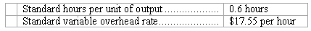

The following data pertain to operations for the last month:

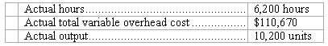
Required:
(a.) What is the variable overhead spending variance for the month?
(b.) What is the variable overhead efficiency variance for the month?
Level: Easy LO: 4
Ans:
Variable overhead spending variance = (AH × AR) – (AH × SR)
= $110,670 – (6,200 × $17.55) = $1,860 U
SH = Standard hours per unit × Actual output
= 0.6 × 10,200 = 6,120
Variable overhead efficiency variance = SR(AH – SH)
= $17.55(6,200 – 6,120) = $1,404 U
136. Deschamp Corporation’s variable manufacturing overhead is applied on the basis of direct labor-hours. The company has established the following variable manufacturing overhead standards for product O28H:

The following data pertain to the most recent month’s operations during which 2,160 units of product O28H were made:

Required:
(a.) What was the variable overhead spending variance for the month?
(b.) What was the variable overhead efficiency variance for the month?
Level: Easy LO: 4
Ans:
(a.) Variable overhead spending variance = (AH × AR) – (AH × SR)
= $44,980 – (5,200 × $7.70) = $4,940 U
(b.) Variable overhead efficiency variance = SR(AH – SH*)
= $7.70(5,200 – 5,400) = $1,540 F
*SH = Standard hours per unit × Actual output
= 2.5 × 2,160 = 5,400

137. Shawl Corporation’s variable manufacturing overhead is applied on the basis of direct labor-hours. The standard cost card for product F02E specifies 5.5 direct labor-hours per unit of F02E. The standard variable manufacturing overhead rate is $6.80 per direct labor-hour. During the most recent month, 1,560 units of product F02E were made and 8,700 direct labor-hours were worked.
The actual variable manufacturing overhead incurred was $52,635.
Required:
(a.) What was the variable overhead spending variance for the month?
(b.) What was the variable overhead efficiency variance for the month?
Level: Easy LO: 4
Ans:
(a.) Variable overhead spending variance = (AH × AR) – (AH × SR)
= $52,635 – (8,700 × $6.80) = $6,525 F
(b.) Variable overhead efficiency variance = SR(AH – SH*)
= $6.80(8,700 – 8,580) = $816 U
*SH = Standard hours per unit × Actual output
= 5.5 × 1,560 = 8,580

138. Sarne Corporation is developing standards for its products. One product requires an input that is purchased for $64.00 per kilogram from the supplier. By paying cash, the company gets a discount of 3% off this purchase price. Shipping costs from the supplier’s warehouse amount to $4.59 per kilogram. Receiving costs are $0.88 per kilogram. Each unit of output requires 0.40 kilogram of this input. The allowance for waste and spoilage is 0.06 kilogram of this input for each unit of output. The allowance for rejects is 0.12 kilogram of this input for each unit of output.
Required:
(a.) Determine the standard price per kilogram of this input. Show your work!
(b.) Determine the standard kilograms of this input per unit of output. Show your work!
Level: Easy LO: 1
Ans:

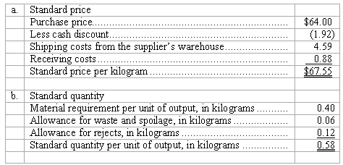

139. London Corporation is developing standards for its products. One product requires an input that is purchased for $41.00 per kilogram from the supplier. By paying cash, the company gets a discount of 9% off this purchase price. Shipping costs from the supplier’s warehouse amount to $3.32 per kilogram. Receiving costs are $0.82 per kilogram.
Required:
Determine the standard price per kilogram of this input. Show your work!
Level: Easy LO: 1
Ans:

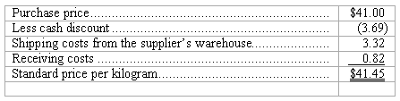

140. Sarkisian Corporation is developing standards for a product. Each unit of output of the product requires 0.52 kilogram of a particular input. The allowance for waste and spoilage is 0.06 kilogram of this input for each unit of output. The allowance for rejects is 0.13 kilogram of this input for each unit of output.
Required:
Determine the standard kilograms of this input per unit of output. Show your work!
Level: Easy LO: 1
Ans:

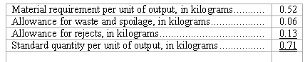

141. Finnerty Corporation is developing direct labor standards. The basic direct labor wage rate is $13.00 per hour. Employment taxes are 10% of the basic wage rate. Fringe benefits are $4.33 per hour. A particular product requires 0.69 direct labor-hours per unit. The allowance for breaks and personal needs is 0.04 direct labor-hours per unit. The allowance for cleanup, machine downtime, and rejects is 0.14 direct labor-hours per unit.
Required:
(a.) Determine the standard rate per direct labor-hour. Show your work!
(b.) Determine the standard direct labor-hours per unit of product. Show your work!
(c.) Determine the standard labor cost per unit of product to the nearest cent. Show your work!
Level: Easy LO: 1
Ans:

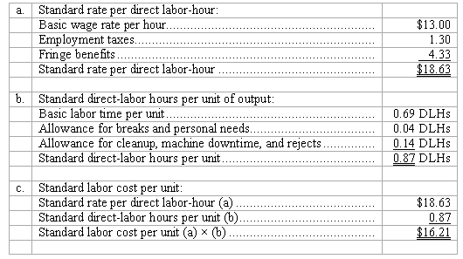

142. Barboza Corporation is developing direct labor standards. The basic direct labor wage rate is $10.30 per hour. Employment taxes are 10% of the basic wage rate. Fringe benefits are $3.39 per hour.
Required:
Determine the standard rate per direct labor-hour. Show your work!
Level: Easy LO: 1
Ans:

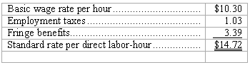

143. Mouw Corporation is developing direct labor standards. A particular product requires 0.66 direct labor-hours per unit. The allowance for breaks and personal needs is 0.02 direct labor-hours per unit. The allowance for cleanup, machine downtime, and rejects is 0.10 direct labor-hours per unit.
Required:
Determine the standard direct labor-hours per unit of product. Show your work!
Level: Easy LO: 1
Ans:

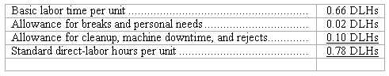

144. (Appendix) Ungvarsky Corporation has provided the following data concerning its most important raw material, compound J38F:

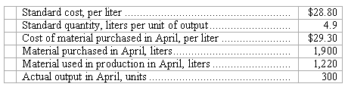

The raw material was purchased on account.
Required:
(a.) Record the purchase of the raw material in a journal entry.
(b.) Record the use of the raw material in production in a journal entry.
Level: Easy LO: 2,7
Ans:
(a.) Entry to record purchase of materials:

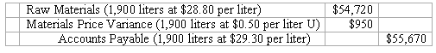

(b.) Entry to record use of materials:
Standard quantity allowed for the actual output (300 units at 4.9 liters per unit) = 1,470

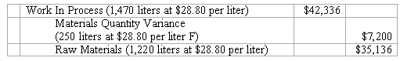

145. (Appendix) Compound C65Z is used by Sinkey Corporation to make one of its products. The standard cost of compound C65Z is $21.10 per ounce and the standard quantity is 2.0 per unit of output. Data concerning the compound in the most recent month appear below:

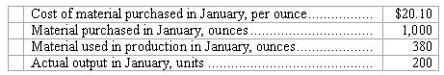

The raw material was purchased on account.
Required:
(a.) Record the purchase of the raw material in a journal entry.
(b.) Record the use of the raw material in production in a journal entry.
Level: Easy LO: 2,7
Ans:
(a.) Entry to record purchase of materials:

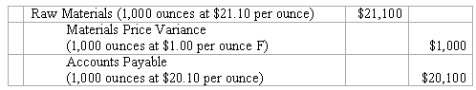

(b.) Entry to record use of materials:
Standard quantity allowed for the actual output (200 units at 2.0 ounces per unit) = 400

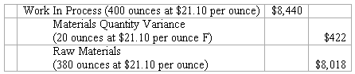

146. (Appendix) Pinkney Corporation has provided the following data concerning its direct labor costs for November:

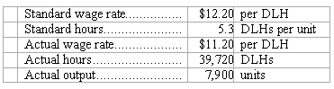

Required:
Prepare the journal entry to record the incurrence of direct labor costs.
Level: Easy LO: 3,7
Ans:
Standard quantity allowed for the actual output (7,900 units at 5.3 DLHs per unit) = 41,870DLHs

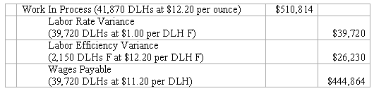

147. (Appendix) The direct labor standards at Hebden Corporation are $10.30 per direct labor-hour (DLH) and 3.4 DLHs per unit of output. In December, 7,800 units were produced, the actual wage rate was $9.90 per DLH, and the actual hours were 21,340 DLHs.
Required:
Prepare the journal entry to record the incurrence of direct labor costs.
Level: Easy LO: 3,7
Ans:
Standard quantity allowed for the actual output (7800 units at 3.4 DLHs per unit) = 26,520DLHs

