Prologue
Lecture Notes

Prologue theme: Before embarking on the study of management accounting, students need to develop an appreciation for the larger business environment within which it operates. The Prologue breaks down the description of this larger business context into nine sections.
2

- Globalization

  - The world has become more intertwined over the last 20 years because of:

    - Reductions in tariffs, quotas and other barriers to free trade.
3
    - Improvements in global transportation systems.

    - An expansion in Internet usage.

    - Increasing sophistication in international markets.

  - The Global Marketplace

    - Companies that have been successful in their local markets may suddenly find themselves facing competition from halfway around the globe.
4

      - For example, in the 1980s American automobile manufacturers began losing market share to Japanese competitors.

    - Although globalization leads to greater competition, it also means greater access to:

      - New markets
        - The emerging markets of China, India, Russia, and Brazil contain more than 2.5 billion potential customers and workers.
      - New customers
5
        - Companies such as FedEx, McDonald’s, and Nike are actively seeking to grow sales by investing in emerging markets.
      - New workers
        - Financial services and high-tech jobs are transferring to less expensive labor markets such as India, China, Africa, Eastern Europe and Latin America.

“In Business Insights”
“The Implications of Globalization” (see page 3)

- Strategy

  - A strategy is a “game plan” that enables a company to attract customers by distinguishing itself from competitors. There are three customer value propositions that companies can offer its target customers:
6

    - Customer intimacy – companies pursuing this value proposition understand and respond to individual customer needs better than their competitors.
      - Ritz-Carlton, Nordstrom, and Home Depot rely primarily on a customer intimacy value proposition.

    - Operational excellence – companies pursuing this value proposition deliver products and services faster, more conveniently, and at a lower price than their competitors.

      - Southwest Airlines, Wal-Mart, and The Vanguard Group rely primarily on an operational excellence value proposition.
6

    - Product leadership – companies pursuing this value proposition offer higher quality products than their competitors.

      - BMW, Cisco Systems, and W.L. Gore rely primarily on a product leadership value proposition.

“In Business Insights”
“Operational Excellence Comes to the Diamond Business” (see page 4)

- Organizational Structure

  - Decentralization

    - Decentralization is the delegation of decision-making authority throughout an organization by providing managers with the authority to make decisions relating to their area of responsibility.
7

  - The functional view of organizations

    - An organization chart shows how responsibility is divided among managers and it shows formal lines of reporting and communication.
7

    - An organization chart also depicts line and staff positions in an organization.

      - A person in a line position is directly involved in achieving the basic objectives of the organization.
8
      - A person in a staff position is indirectly involved in achieving those basic objectives. Staff positions support line positions, but they do not have direct authority over line positions.

    - The Chief Financial Officer (CFO) is the member of the top management team who occupies a staff position and is responsible for providing timely and relevant information to support planning and control activities and for preparing financial statements for external users.
9

      - The controller reports to the CFO.

- Process management

  - Key definitions

    - A business process is a series of steps that are followed in order to carry out some task in a business.
10

    - A value chain consists of the major business functions that add value to a company’s products and services.
11

      - A value chain typically spans functional departments to form business processes.

  - Lean production

    - Traditional thinking

      - Minimize unit costs by maximizing output and spreading fixed costs over as many units as possible.
12
      - Keep everyone busy. Idleness wastes money.
      - Push products through the system even if unsold inventory piles up in warehouses.

    - Lean thinking – five steps

      - Step one – identify the value to customers in specific products and services.
      - Step two – identify the business process that delivers this value to customers.
      - Step three – organize work arrangements around the flow of the business process.
13
      - Step four – create a pull system where production is not initiated until a customer has ordered a product.
        - This facet of the lean thinking model is often called just-in-time production, or JIT for short.
      - Step five – continuously pursue perfection.

    - Supply chain management

      - The lean thinking model can also be used to improve the business processes that link companies together.
14
      - The term supply chain management is commonly used to refer to the coordination of business processes across companies to better serve end consumers.

“In Business Insights”
“The Power of Lean” (see page 9)

  - The Theory of Constraints (TOC)

    - Key definitions/concepts

      - A constraint (also called a bottleneck) is anything that prevents you from getting more of what you want.
        - The constraint in a system is determined by the step that has the smallest capacity.
15
      - The Theory of Constraints (TOC) is based on the insight that effectively managing the constraint is the key to success.
        - The goal is to manage the constraint with the intent of generating more business rather than cutting the workforce.

Helpful Hint: Explain to students that the theory of constraints (TOC) can help a company prioritize the use of time. Ask students whether they would be better off spending their available time studying for a course in which they have an A average or one in which they have a C average.

    - The TOC approach to process improvement

      - First, identify the weakest link in the chain, which is the constraint.
      - Second, do not place a greater strain on the system than the weakest link can handle – if you do, the chain will break.
      - Third, concentrate improvement efforts on strengthening the weakest link.
16
      - Fourth, if the improvement efforts are successful, eventually the weakest link will improve to the point where it is no longer the weakest link.
        - At this point, the new weakest link must be identified and the improvement process starts over again.

“In Business Insights”
“Watch Where You Cut Costs” (see page 10)

  - Six Sigma

    - Key definition

      - Six Sigma is a process improvement method that relies on customer feedback and fact-based data gathering and analysis techniques to drive process improvement.
17

“In Business Insights”
“3M Doubles its Efforts with Six Sigma” (see page 11)

    - The DMAIC framework – the most common framework used to guide Six Sigma process improvement efforts.

      - The Define stage – focuses on defining the scope and purpose of the project, the flow of the current process, and the customer’s requirements for the process.
      - The Measure stage – gathers baseline performance data concerning the existing process and narrows the scope of the project to the most important problems.
      - The Analyze stage – focuses on identifying the root causes of the problems that were identified during the Measure stage.
18
        - This stage often reveals the existence of many non-value added activities within the current process.
      - The Improve stage – focuses on developing, evaluating, and implementing solutions to the problems uncovered in the Analyze stage.
      - The Control stage – ensures that the problems remain fixed and that the new methods are improved over time.

    - Translating improvements into financial benefits
19
      - Six Sigma improvements can only increase profits in two ways – decrease costs or increase sales.
        - Cutting costs by laying off workers is likely to have adverse behavioral effects on the workforce.
19
        - Therefore, Six Sigma is best used as a tool to generate more business rather than to cut the workforce.

- Technology in business

  - E-commerce

    - Key definitions/concepts

      - E-commerce refers to business that is conducted using the Internet.
      - At the turn of the new millennium, dot.com businesses were riding high. By the spring of 2001, the dot.com collapse was under way.
      - In recent years, e-commerce has slowly been rebuilding momentum.
20
        - Internet advertising is projected to exceed $12 billion per year before the end of the decade.
      - Growth in e-commerce is occurring because the Internet has important advantages over conventional marketplaces for many kinds of transactions. For example:
        - The Internet is an ideal technology for streamlining the mortgage lending process.

“In Business Insights”
“Internet Innovations” (see page 13)

  - Enterprise systems

    - A historical perspective

      - Most companies used to implement specific software programs to support specific business functions. For example:
        - The accounting department would select its own software applications to meet its needs without consideration for other departments.
21
      - The separate systems were not integrated and could not easily pass data back and forth.
      - The end result was data duplication and data inconsistencies coupled with lengthy customer response times and high costs.

    - An enterprise system overcomes these problems by integrating data across an organization into a single software system that enables all employees to have simultaneous access to a common set of data.

      - Data are recorded only once in the company’s centralized digital data repository known as a database.
22
      - The unique data elements contained within the database can be linked together, thus explaining why this type of database is called a relational database.
      - These key aspects of data integration help employees better communicate with one another as well as their suppliers and customers.

“In Business Insights”
“The Benefits of Data Integration” (see page 14)

- The importance of ethics in business

  - Why is ethical behavior so important?

    - Ethical behavior is important for a very practical reason – if people did not behave ethically, then the economy and all of us would suffer.
23
    - Abandoning ethical behavior would lead to a lower standard of living with lower quality goods and services, less to choose from, and higher prices. In short, ethical behavior is essential for the smooth functioning of an advanced market economy.

“In Business Insights”
“No Trust – No Enron” (see page 15)

  - Code of conduct for management accountants – the IMA’s Standards of Ethical Conduct has two main parts – guidelines for ethical behavior and guidelines for resolution of an ethical conflict.
24

    - Guidelines for ethical behavior

      - Competence
        - Maintain professional competence.
25
        - Follow applicable laws, regulations, and standards.
        - Prepare complete and clear reports after appropriate analysis.

      - Confidentiality
        - Do not use confidential information for personal advantage.
        - Do not disclose confidential information unless legally obligated to do so.
26
        - Ensure that subordinates do not disclose confidential information.
      - Integrity
        - Do not subvert the organization’s legitimate objectives.
        - Avoid conflicts of interest and advise others of potential conflicts.
        - Recognize and communicate personal and professional limitations.
27
        - Refrain from activities that would discredit the profession.
        - Avoid activities that could affect your ability to perform duties.
        - Refuse gifts or favors that might influence behavior.
        - Communicate unfavorable as well as favorable information.
      - Objectivity
        - Communicate information fairly and objectively.
28
        - Disclose all information that might be useful to management.

    - Guidelines for resolution of an ethical conflict
29
      - Follow the organization’s established policies for resolving ethical conflict. If this does not work consider the following steps:
        - Discuss the conflict with immediate supervisor or next highest uninvolved managerial level.
29
        - If immediate supervisor is the CEO, consider the board of directors or the audit committee.
        - Except where legally required, maintain confidentiality.
        - Clarify issues in a confidential discussion with an objective advisor.
30
        - Consult an attorney regarding your legal obligations.
        - The last resort is to resign.

“In Business Insights”
“Who is to Blame?” (see page 17)

  - Company codes of conduct

    - Many companies have adopted formal codes of conduct.

      - These codes are generally broad-based statements of a company’s responsibilities to its employees, its customers, its suppliers, and the communities in which the company operates.
31
      - A code of conduct is meaningless unless employees and top managers in particular adhere to it when making decisions.

“In Business Insights”
“Where Would You Like to Work?” (see page 19)

  - Codes of conduct on the international level

    - The Code of Ethics for Professional Accountants, issued by the International Federation of Accountants (IFAC), governs the activities of all professional accountants throughout the world.

    - In addition to outlining ethical requirements in matters dealing with integrity and objectivity, resolution of ethical conflicts, competence, and confidentiality, the IFAC’s code also outlines the accountants ethical responsibilities in matters relating to:
32

      - Taxes
      - Independence
      - Fees and commissions
      - Advertising and solicitation
      - The handling of monies
      - Cross-border activities

- Corporate governance

  - Key definitions/concepts

    - Corporate governance is the system by which a company is directed and controlled.
33
    - If properly implemented it should provide incentives for the board of directors and top management to pursue objectives that are in the interests of the company’s owners and it should provide for effective monitoring of performance.

    - The scandals of recent years raised questions about the adequacy of the existing corporate governance system. The U.S. Congress responded to these concerns by passing new legislation.
33

“In Business Insights”
“Spilled Milk at Parmalat” (see page 20)

  - The Sarbanes-Oxley Act of 2002

    - This Act is intended to protect the interests of those who invest in publicly traded companies by improving the reliability and accuracy of corporate financial reports and disclosures. There are six key aspects of this legislation:
34

      - The Act requires both the CEO and CFO to certify in writing that their company’s financial reports are fairly stated – with possible jail time for certifying results that they know are false.
      - The Act establishes the Public Company Accounting Oversight Board to provide additional oversight over the audit profession.
35
      - The Act places the power to hire, compensate and terminate auditors in the hands of the audit committee of the board of directors.
        - All members of the audit committee must be independent.

      - The Act prohibits public accounting firms from providing a wide variety of non-auditing services to an audit client.
      - The Act requires that a company’s annual report contain an internal control report.
36
      - The Act establishes severe penalties for criminal acts such as destroying documents that may eventually be used in an official proceeding and retaliating against a “whistle blower.”

“In Business Insights”
“Sarbanes-Oxley: An Expensive Piece of Legislation” (see page 21)

- Enterprise risk management

  - Key definitions/concepts

    - Every business strategy or decision has risks associated with it. Enterprise risk management is a process used by a company to proactively identify the business risks that it faces and to develop responses to those risks that enable the company to be reasonably assured of satisfying stakeholder expectations.
37

  - Identifying and controlling business risks

    - Companies should identify foreseeable risks before they occur. Once a risk has been identified, a company can respond in various ways such as accepting, avoiding, sharing, or reducing the risk.
38

    - Perhaps the most common risk management tactic is to reduce risks by implementing specific controls.
39

      - Examples of business risks and controls to reduce those risks are shown on the slide.

“In Business Insights”
“Managing Weather Risk” (see page 22)

- The Certified Management Accountant (CMA)

  - The key facts

    - A management accountant who possesses the necessary qualifications and who passes a rigorous professional exam earns the right to be known as a Certified Management Accountant (CMA).
40

    - Information about becoming a CMA and the CMA program can be accessed on the IMA’s website at www.imanet.org or by calling 1-800-638-4427.

“In Business Insights”
“How’s the Pay?” (see page 23)

AGENDA: MANAGEMENT ACCOUNTING
AND THE BUSINESS ENVIRONMENT
1. Globalization.
2. Strategy.
3. Organizational structure.
4. Process management.
• Lean Production.
• The Theory of Constraints (TOC).
• Six Sigma.
5. The importance of ethics in business.
6. Corporate governance.
- The Sarbanes-Oxley Act of 2002.
7. Enterprise risk management.
GLOBALIZATION: A LOOK AT THE NUMBERS
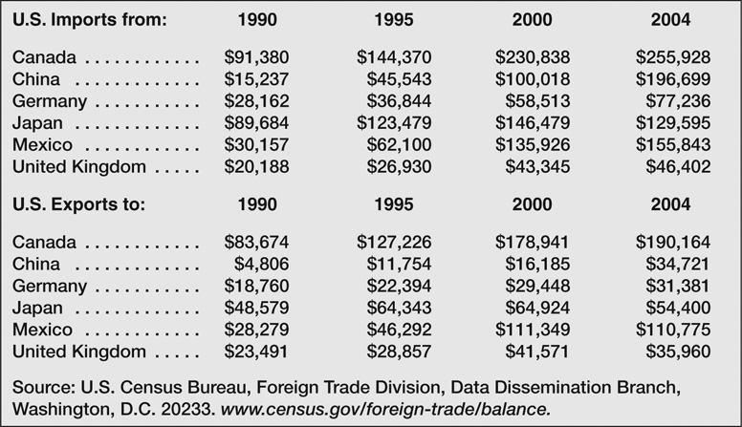
STRATEGY
A strategy is a “game plan” that enables a company to attract customers by distinguishing itself from competitors.
CUSTOMER INTIMACY
• Understanding and responding to individual customer needs better than competitors.
- Ritz-Carlton, Nordstrom, Home Depot
OPERATIONAL EXCELLENCE
• Delivering products and services faster, more conveniently, and at a lower price than competitors.
- Southwest Airlines, Wal-Mart, and The Vanguard Group
PRODUCT LEADERSHIP
- Offering higher quality products than competitors.
- BMW, Cisco Systems, and W.L. Gore
AN ORGANIZATION CHART
(Exhibit P-3)
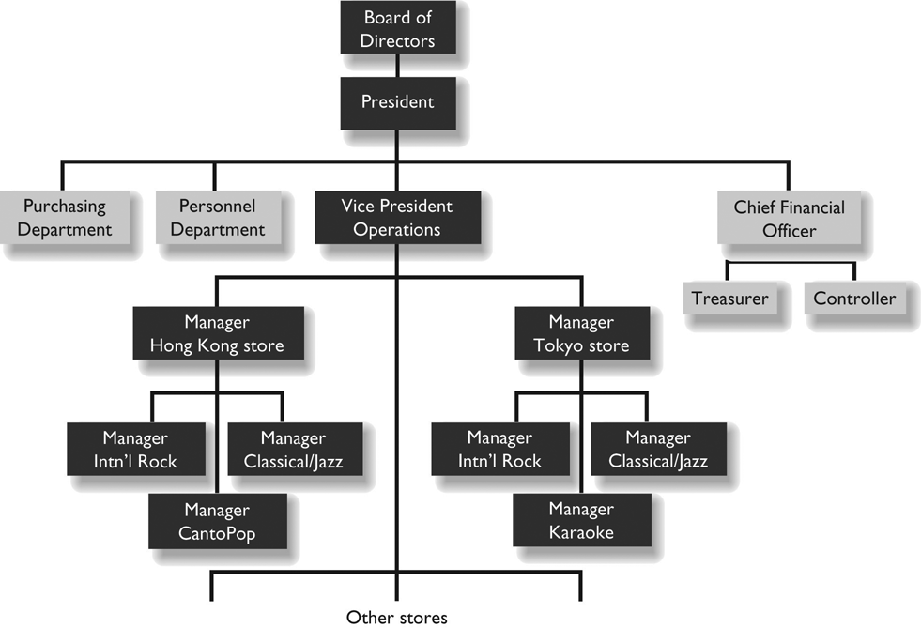

PROCESS MANAGEMENT
- A business process is a series of steps that are followed in order to carry out some task in a business.
- A value chain, as shown below, consists of the major business functions that add value to a company’s products and services.

THE LEAN THINKING MODEL

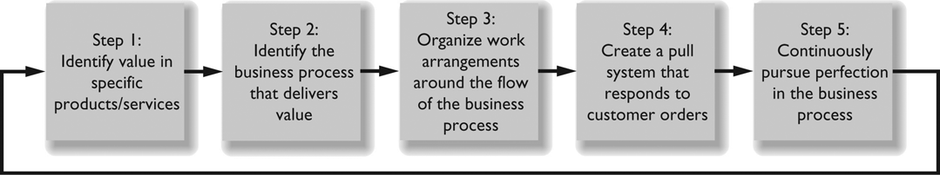
THEORY OF CONSTRAINTS
(TOC)
• A constraint is anything that limits the ability of an individual or organization to attain its objectives.
• If the factory cannot satisfy demand, the constraint is in the factory. The constraint (i.e., bottleneck) is likely to be the workstation that has the lowest rate of output and smallest capacity.
• The rate of output of the entire factory is determined by the rate of output of the constraint.
• The other, non-constraint, work stations have excess capacity.
• Improvement efforts should usually be focused on the constraint.
• Improvements that increase the rate of output and capacity of the constraint will increase the output of the entire factory.
• Improvements that increase the rate of output and capacity of workstations that are not constraints will simply increase their excess capacity.
• If the current bottleneck is improved enough, the constraint will shift. Improvement efforts should then be shifted to the new constraint (bottleneck).
SIX SIGMA: THE DMAIC FRAMEWORK

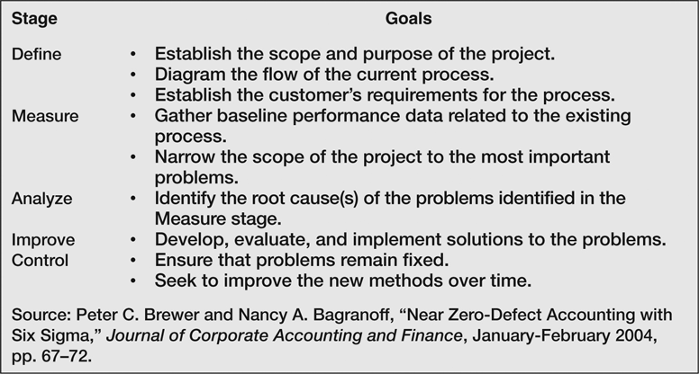
STANDARDS OF ETHICAL CONDUCT
FOR MANAGEMENT ACCOUNTANTS
(adapted from IMA)
COMPETENCE
• Maintain professional competence.
• Follow laws, regulations, and standards.
• Prepare complete and clear reports and recommendations after appropriate analysis.
CONFIDENTIALITY
• Don’t disclose confidential information.
• Ensure that subordinates do not disclose confidential information.
• Do not use confidential information for personal gain or advantage.
INTEGRITY
• Avoid actual or apparent conflicts of interest.
• Refuse gifts, favors, or hospitality that might influence objectivity.
• Refrain from subverting the organization’s legitimate objectives.
• Recognize and communicate personal limitations.
• Communicate unfavorable as well as favorable information and opinions.
• Refrain from actions that discredit the profession.
OBJECTIVITY
• Communicate information fairly and objectively.
• Fully disclose all information that could be expected to influence a user’s understanding.
COMPANY CODES OF CONDUCT

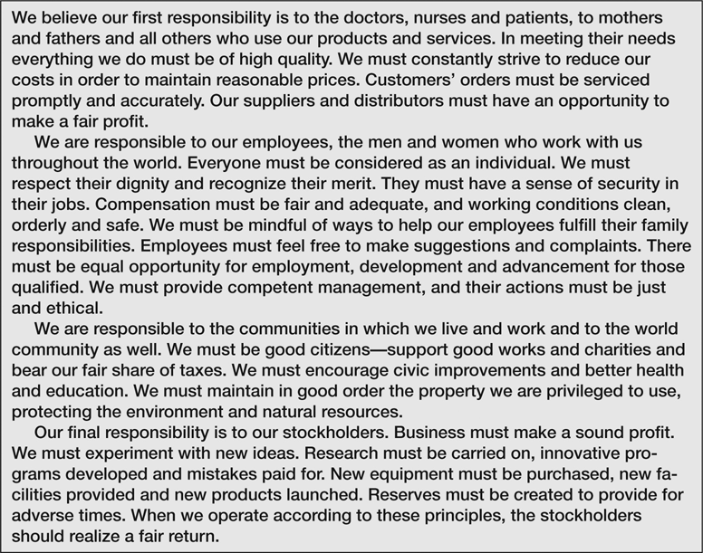
CORPORATE GOVERNANCE: THE SARBANES-OXLEY ACT OF 2002
SIX KEY ASPECTS OF THE LEGISLATION
• CEO and CFO must certify financial statements.
• Public Company Accounting Oversight Board established to provide additional oversight over the audit profession.
• Audit committee of the board of directors given the power to hire, compensate and terminate a company’s public accounting firm.
- Public accounting firms prohibited from providing a wide variety of non-auditing services to an audit client.
- A company’s annual report must contain an internal control report.
- Severe penalties established for altering or destroying documents that may be used in an official proceeding and for retaliating against a “whistle blower.”
ENTERPRISE RISK MANAGEMENT



