Chapter 10
Lecture Notes

Chapter theme: Managers in large organizations have to delegate some decisions to those who are at the lower levels in the organization. This chapter explains how responsibility accounting systems and measures such as return on investment (ROI) and residual income are used to help control decentralized organizations.
1

- Decentralization in organizations

  - A decentralized organization does not confine decision-making authority to a few top executives; rather, decision-making authority is spread throughout the organization. The advantages and disadvantages of decentralization are as follows:

    - Advantages of decentralization

      - It enables top management to concentrate on strategy, higher-level decision-making, and coordinating activities.
      - It acknowledges that lower-level managers have more detailed information about local conditions that enable them to make better operational decisions.
2
      - It enables lower-level managers to quickly respond to customers.
      - It provides lower-level managers with the decision-making experience they will need when promoted to higher level positions.
      - It often increases motivation, resulting in increased job satisfaction and retention, as well as improved performance.
    - Disadvantages of decentralization

      - Lower-level managers may make decisions without fully understanding the “big picture.”
      - There may be a lack of coordination among autonomous managers.
      - Lower-level managers may have objectives that differ from those of the entire organization.
        - This problem can be reduced by designing performance evaluation systems that motivate managers to make decisions that are in the best interests of the company.
3
4. It may be difficult to effectively spread innovative ideas in a strongly decentralized organization.
a. This problem can be reduced through the effective use of intranet systems, which enable globally dispersed employees to electronically share ideas.

“In Business Insights”
“Decentralization: A Delicate Balance” (see page 431)

Responsibility accounting

Responsibility accounting systems link lower-level managers’ decision-making authority with accountability for the outcomes of those decisions. The term responsibility center is used for any part of an organization whose manager has control over, and is accountable for cost, profit, or investments. The three primary types of responsibility centers are cost centers, profit centers, and investment centers.
4
4
- Cost center

- The manager of a cost center has control over costs, but not over revenue or investment funds.
- Service departments such as accounting, general administration, legal, and personnel are usually classified as cost centers, as are manufacturing facilities.
5
- Standard cost variances and flexible budget variances, such as those discussed in Chapters 8 and 9, are often used to evaluate cost center performance.

- Profit center

- The manager of a profit center has control over both costs and revenue.
6
- Profit center managers are often evaluated by comparing actual profit to targeted or budgeted profit.

- Investment center

- The manager of an investment center has control over cost, revenue, and investments in operating assets.
7

- Investment center managers are usually evaluated using return on investment (ROI) or residual income, as discussed later in this chapter.
7
“In Business Insights”
“Responsibility Accounting: A Chinese Perspective” (see page 432)

“In Business Insights”
“Extreme Incentives” (see page 432)

An organizational view of responsibility centers

    - Superior Foods Corporation provides an example of the various kinds of responsibility centers that exist in an organization.

      - The President and CEO as well as the Vice President of Operations manage investment centers.
8
      - The Chief Financial Officer, General Counsel, and Vice President of Personnel all manage cost centers.
      - Each of the three product managers that report to the Vice President of Operations (e.g., salty snacks, beverages, and confections) manages a profit center.
9
      - The bottling plant manager, warehouse manager, and distribution manager all manage cost centers that report to the Beverages product manager
10

“In Business Insights”
“Meeting Targets the Wrong Way” (see page 434)

Decentralization and segment reporting

    - Effective decentralization requires segmented reporting. In addition to the companywide income statement, reports are needed for individual segments of the organization. A segment is a part or activity of an organization about which managers would like cost, revenue, or profit data.
11

      - Cost, profit, and investment centers are segments as are sales territories, service centers, individual stores, marketing departments, individual customers, and product lines.

Traceable and Common Fixed Costs

    - In segment reports, traceable fixed costs should be distinguished from common fixed costs.
12

    - A traceable fixed cost of a segment is a fixed cost that is incurred because of the existence of the segment. If the segment were eliminated, the fixed cost would disappear. Examples of traceable fixed costs include:
13
      - The salary of the Fritos product manager at PepsiCo is a traceable fixed cost of the Fritos business segment of PepsiCo.
      - The maintenance cost for the building in which Boeing 747s are assembled is a traceable fixed cost of the 747 business segment of Boeing.
    - A common fixed cost is a fixed cost that supports the operations of more than one segment, but is not traceable in whole or in part to any one segment. Examples of common fixed costs include:
14
      - The salary of the CEO of General Motors is a common fixed cost of the various divisions of General Motors.
      - The cost of heating a Safeway or Kroger grocery store is a common fixed cost of the various departments – groceries, produce, bakery, etc.

- Rate of return for measuring managerial performance

Learning Objective 1: Compute the return on investment (ROI) and show how changes in sales, expenses, and assets affect an organization’s ROI.
15

Key concepts/definitions

i. Investment center performance is often evaluated using a measure called return on investment (ROI), which is defined as follows:

16

ii. Net operating income is income before taxes and is sometimes referred to as EBIT (earnings before interest and taxes). Operating assets include cash, accounts receivable, inventory, plant and equipment, and all other assets held for operating purposes.

1. Net operating income is used in the numerator because the denominator consists only of operating assets.
16
2. The operating asset base used in the formula is typically computed as the average of the assets between the beginning and the end of the year.

iii. Net book value versus gross cost

    - Most companies use the net book value (i.e., acquisition cost less accumulated depreciation) of depreciable assets to calculate average operating assets.
      - With this approach, ROI mechanically increases over time as the accumulated depreciation increases. Replacing a fully-depreciated asset with a new asset will decrease ROI.
17
2. An alternative to net book value is the gross cost of the asset, which ignores accumulated depreciation.
a. With this approach, ROI does not grow automatically over time, rather it stays constant. Replacing a fully-depreciated asset does not adversely affect ROI.

Understanding ROI – the DuPont perspective
18
i. DuPont pioneered the use of ROI and recognized the importance of looking at the components of ROI, namely margin and turnover.

1. Margin is computed as shown and is improved by increasing sales or reducing operating expenses. The lower the operating expenses per dollar of sales, the higher the margin earned.
18
2. Turnover is computed as shown. It incorporates a crucial area of a manager’s responsibility – the investment in operating assets. Excessive funds tied up in operating assets depress turnover and lower ROI.

Helpful Hint: Emphasize that both margin and turnover affect profitability. As an example, ask students to
compare the margins and turnovers of grocery stores to jewelry stores. In equilibrium, every industry should have roughly the same ROI. Groceries, because of their short shelf life, have high turnovers relative to fine jewelry. If the ROIs are to be comparable in grocery stores and in jewelry stores, the margins would have to be higher in jewelry stores.

ii. Any increase in ROI must involve at least one of the following – increased sales, reduced operating expenses, or reduced operating assets. The following example shows four different ways to increase ROI:
19

1. Assume that Regal Company reports the results as shown.
20
a. Given this information, its current ROI is 15%.
21

2. The first way to increase ROI is to increase sales without any increase in operating assets.
a. Assume that: (1) Regal’s manager was able to increase sales to $600,000 (an increase of 20%), (2) operating expenses increased to $558,000 (an increase of 18.7%), (3) net income increased to $42,000, and (4) average operating assets remained unchanged.
22
b. In this case, the ROI increases from 15% to 21%. Notice, for ROI to increase, the percentage increase in sales must exceed the percentage increase in operating expenses.
23
3. The second way to increase ROI is to decrease operating expenses with no change in sales or operating assets.
24
a. Assume that Regal’s manager was able to reduce operating expenses by $10,000 without affecting sales or operating assets.
b. In this case, the ROI increases from 15% to 20%.
25
4. The third way to increase ROI is to decrease operating assets with no change in sales or operating expenses.
a. Assume that Regal’s manager was able to reduce inventories by $20,000 by using lean production techniques without affecting sales or operating expenses.
26
b. In this case, the ROI increases from 15% to 16.7%.
27
5. The fourth way to increase ROI is to invest in operating assets to increase sales.
a. Assume that Regal’s manager invests in a $30,000 piece of equipment that increases sales by $35,000 while increasing operating expenses by $15,000.
28
b. In this case, the ROI increases from 15% to 21.8%.
29

“In Business Insights”
“Insuring the Bottom Line” (see page 437)

“In Business Insights”
“McDonald Chic” (see page 440)

C. ROI and the balanced scorecard

i. It may not be obvious to managers how to increase sales, decrease costs, and decrease investments in a way that is consistent with the company’s strategy. A well-constructed balanced scorecard can provide managers with a road map that indicates how the company intends to increase ROI. A scorecard can answer questions such as:
30

1. Which internal business processes should be improved?
2. Which customers should be targeted and how will they be attracted and retained at a profit?

D. Criticisms of ROI

i. Just telling managers to increase ROI may not be enough. Managers may not know how to increase ROI in a manner that is consistent with the company’s strategy.

1. This is why ROI is best used as part of a balanced scorecard.

  - A manager who takes over a business segment typically inherits many committed costs over which the manager has no control. This may make it difficult to assess this manager relative to other managers.
31

  - A manager who is evaluated based on ROI may reject investment opportunities that are
profitable for the whole company but that would have a negative impact on the manager’s performance evaluation.

Helpful Hint: When discussing the criticisms of ROI and other measures of profitability, ask students to play the role of a manager who anticipates a short tenure. This manager will want to increase ROI as quickly as possible. Ask students to list the activities that could be undertaken to increase ROI that, in reality, would hurt the company as a whole.

“In Business Insights”
“Let the Buyer Beware” (see page 441)

VI. Residual income – another measure of performance

Learning Objective 2: Compute residual income and understand the strengths and weaknesses of this method of measuring performance.
32

A. Key definition

i. Residual income is the net operating income that an investment center earns above the minimum required return on its assets.
33

1. Economic Value Added (EVA®) is an adaptation of residual income. We will not distinguish between the two terms in this class.

“In Business Insights”
“Heads I Win, Tails You Lose” (see page 442)

B. Calculating residual income

i. The equation for computing residual income is as shown. Notice:

  - This computation differs from ROI. ROI measures net operating income earned relative to the investment in average operating assets. Residual income measures net operating income earned less the minimum required return on average operating assets.
34

ii. Zepher, Inc. – an example

1. Assume the information as given for a division of Zepher, Inc.
35
2. The residual income ($10,000) is computed by subtracting the minimum required return ($20,000) from the actual income ($30,000).
36

C. Motivation and residual income

i. The residual income approach encourages managers to make investments that are profitable for the entire company but that would be rejected by managers who are evaluated using the ROI formula. More specifically:
37

1. This occurs when the ROI associated with an investment opportunity exceeds the company’s minimum required return but is less than the ROI being earned by the division manager contemplating the investment.

Quick Check – ROI versus residual income
38-47

“In Business Insights”
“Shoring up Return on Capital” (see page 444)

D. Divisional comparison and residual income
48
i. The residual income approach has one major disadvantage. It cannot be used to compare the performance of divisions of different sizes.

ii. Zepher, Inc. – continued

1. Recall that the Retail Division of Zepher had average operating assets of $100,000, a minimum required rate of return of 20%, net operating income of $30,000, and residual income of $10,000.
49
2. Assume that the Wholesale Division of Zepher had average operating assets of $1,000,000, a minimum required rate of return of 20%, net operating income of $220,000, and residual income of $20,000.
3. The residual income numbers suggest that the Wholesale Division outperformed the Retail Division because its residual income is $10,000 higher. However,
a. The Retail Division earned an ROI of 30% compared to an ROI of 22% for the Wholesale Division. The Wholesale Division’s residual income is larger than the Retail Division simply because it is a bigger division.
50

E. Transfer Prices

i. Key concepts/definitions

  - A transfer price is the price charged when one segment of a company provides goods or services to another segment of the company.
51
  - The fundamental objective in setting transfer prices is to motivate managers to act in the best interests of the overall company.
  - There are three primary approaches to setting transfer prices, namely negotiated transfer prices, transfers at the cost to the selling division, and transfers at market price.
52

AGENDA: SEGMENT REPORTING AND DECENTRALIZATION
A. Return on investment (ROI).
B. Residual income.
C. Transfer pricing.
Segments Classified as Cost, Profit, and Investment Centers
(Exhibit 10-1)
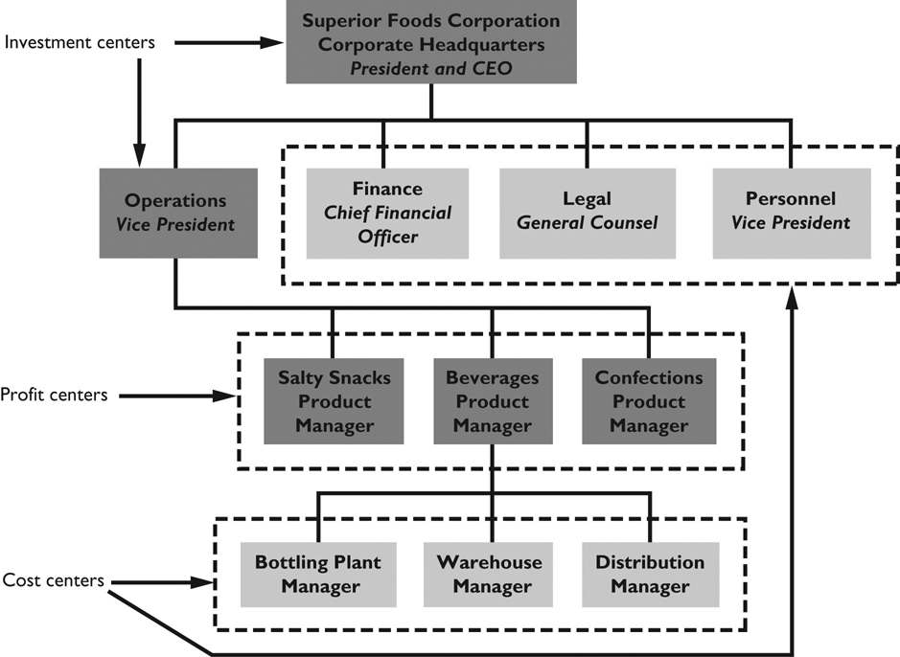

RETURN ON INVESTMENT
Investment centers are often evaluated based on their return on investment (ROI), which is computed as follows:
or
ROI = Margin × Turnover
where:

EXAMPLE: Regal Company reports the following data for last year’s operations:

Net operating income | $30,000
Sales | $500,000
Average operating assets | $200,000

A manager can improve ROI in three basic ways:
1. Increase sales.
2. Reduce expenses.
3. Reduce operating assets.
RETURN ON INVESTMENT (cont’d)
Example 1—Increase sales:
Assume that Regal Company is able to increase sales to $600,000. Net operating income increases to $42,000, and the operating assets remain unchanged.
(compared to 15% before)

Example 2—Reduce expenses:
Assume that Regal Company is able to reduce expenses by $10,000 per year, so that net operating income increases from $30,000 to $40,000. Sales and operating assets remain unchanged.
(compared to 15% before)

Example 3—Reduce assets:
Assume that Regal Company is able to reduce its average operating assets from $200,000 to $125,000. Sales and net operating income remain unchanged.
(compared to 15% before)
RESIDUAL INCOME
Residual income is the net operating income that an investment center earns above the minimum rate of return on its operating assets.
EXAMPLE: Marsh Company has two divisions, A and B. Division A has $1,000,000 and Division B has $3,000,000 in average operating assets. Each division is required to earn a minimum return of 12% on its investment in operating assets.

 | Division A | Division B
Average operating assets | $1,000,000 | $3,000,000
Net operating income | $ 200,000 | $ 450,000
Minimum required return:  12% × average operating assets | 120,000 | 360,000
Residual income | $ 80,000 | $ 90,000

Economic value added (EVA) is a concept similar to residual income.
RESIDUAL INCOME (cont’d)
The residual income approach encourages managers to make profitable investments that would be rejected under the ROI approach.

EXAMPLE: Marsh Company’s Division A has an opportunity to make an investment of $250,000 that would generate a return of 16% on invested assets (i.e., $40,000 per year). This investment would be in the best interests of the company since the rate of return of 16% exceeds the minimum required rate of return. However, this investment would reduce the division’s ROI:

 | Present | New  Project | Overall
Average operating assets (a) | $1,000,000 | $250,000 | $1,250,000
Net operating income (b) | $200,000 | $40,000 | $240,000
ROI (b) ÷ (a) | 20.0% | 16.0% | 19.2%

On the other hand, this investment would increase the division’s residual income:

Average operating assets (a) | $1,000,000 | $250,000 | $1,250,000
Net operating income (b) | $200,000 | $40,000 | $240,000
Minimum required return:  12% × (a) | 120,000 | 30,000 | 150,000
Residual income | $ 80,000 | $10,000 | $ 90,000
TRANSFER PRICING
A transfer price is the price charged when one segment (for example, a division) provides goods or services to another segment of the same company.
• Transfer prices are necessary to calculate costs in a cost, profit, or investment center.
• The buying division will naturally want a low transfer price and selling division will want a high transfer price.
• From the standpoint of the company as a whole, transfer prices involve taking money out of one pocket and putting it into the other.
• An optimal transfer price is one that leads division managers to make decisions that are in the best interests of the company as a whole.

