Sankaran Excel Lab Worksheet – 2 SOM 120

Exercise I:

Input problem #45 data on page 339 of text (as reproduced below in columns A thru C). Create a new column Diff by subtracting values in column B from column C for each row. Select Tools|Data Analysis|Descriptive Statistics. For Input Range, select D2:D10. Check Labels in first row, Summary statistics, and Confidence Interval for mean. For Output range, type F2. Click OK. Learn how to interpret the output.
Again, select Tools|Data Analysis|t-Test:Paired Two-Sample for Means|OK. For Variable 1 Range: type in B2:B10. For Variable 2 Range: type in C2:C10. For Hypothesized Mean Difference, type in 0. Check Labels. For Output Range, type in I2. Click OK. Learn to interpret output and make conclusion on the null hypothesis (you may check the answer in the text).

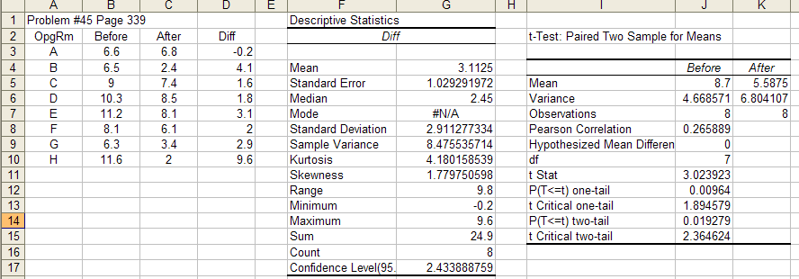

Exercise II:

1. Click Start|Programs|Microsoft Office|Excel.
2. Enter the following data.
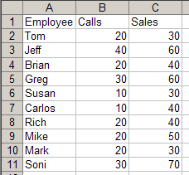
3. Click Tools|DataAnalysis|Regression|OK.
4. For Input Y range, enter C1:C11; For X range, enter B1:B11. Check Labels, Confidence Level:95%. Check Line Fit Plots. Click OK.
5. A new worksheet will show the regression output and the chart. Select the chart. Stretch it vertically so you can see scatter dots clearly. You will see Chart as a menu item at the top. Select it and click on the item Add Trendline. You will see a window pop up with type Linear selected by default. Click OK.
6. The Regression output has four parts: Summary, that gives descriptive statistics; ANOVA(Analysis of Variance); Coefficients; Residual Output.

7.Summary Output:
a. Multiple R is the Correlation Coefficient (75.9%).
b. R-Square (Coefficient of Determination) shows the variation in Y (Sales) accounted by variation in X (Calls) (57.6%).
c. Adjusted RSq provides a better estimate (improves the fit to a population).
d. Standard Error is the estimated measure of the scatter, or dispersion of the observed values around the regression line. The smaller this value the better the line fit (and regression model).

8. ANOVA:
a. The Significance F is the p-value for regression. If p< 0.05, the model is considered useful to predict.
b. The SS (Sums of Squares) for Regression row (1065.789) shows the amount of variation accounted by the regression line of the Total variation of 1850. Notice that 1065.789/1850 is 57.6% (which is same as RSq).
c. SS for Residual (784.21) shows the unexplained variation, which is caused by the errors in prediction.

9. Coefficients:
a. Intercept (18.94) represents the constant term in the equation to the regression line (also called Y intercept). If its p-value is less than 0.05, we reject the hypothesis that the intercept is zero. This means intercept value is significant to the regression model. In our case, it shows that we will be able sell 18.94 copiers without making any calls at all.
b. Calls (1.18) is the independent variable. It is the slope of the line. It means for every call, we increase the sales by 1.18 copiers. Notice that the p-value is 0.01. Since it is less that 0.05, it shows Calls as a significant variable in the model, ie it is a useful variable in predicting sales.
c. The regression equation can written using the Intercept and Calls coefficients as, Y’=18.94+1.18X. Using this equation, you can predict Sales for any value of Calls.
d. You can calculate the Confidence Interval at 95% for this predicted value by subtracting & adding, 2 SEs (Empirical rule).

10. Residual Output:
Shows the errors in prediction, Y’-Y. Note the Standard error is calculated using these errors.

Exercise III:
Perform the regression for the data shown in A1 thru C6. Compare your results with what is shown below. Learn to interpret the output as described in the earlier exercise.
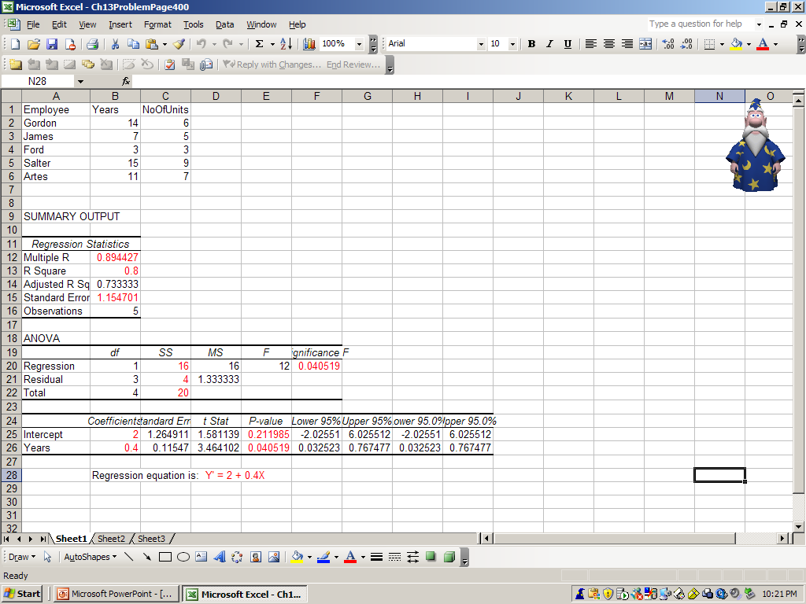
Answer the following questions:
1. What is the independent variable?
2. What is the dependent variable?
3. What is the regression equation?
4. Is it a significant predictor of #Units? Why?
5. Is Years a sig. predictor of #Units? Why?
6. If one had Years=20, predict #Units.
7. Construct a 95% CI around it.
8. What % variation in No Of Units is accounted by Years?
9. Can you see how the above value can also be calculated using ANOVA table?
10. In the coefficients table, how do you interpret the p-values.

Exercise IV:

This is an example of multiple regression, ie. it uses two (can be more) independent variables: Bedrooms and Baths. Together they are trying to predict the dependent variable, Price.
Enter the data shown in A1:C11. Repeat the same steps as in linear regression except for the Input X Range for which you should enter A1:B11 (note that you are entering two columns as against just one for the linear regression). Compare your results with what is shown below.

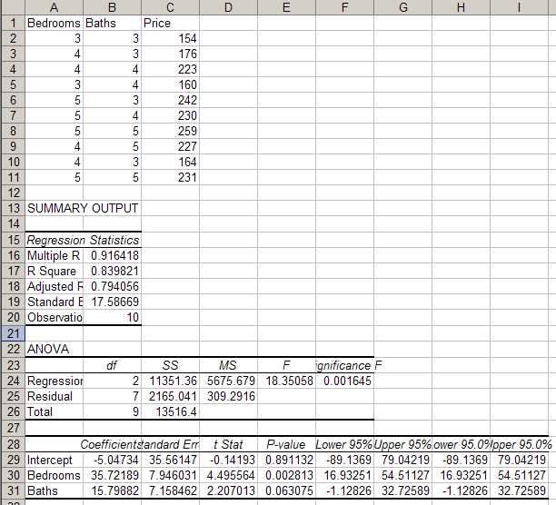

Learn to interpret the output as described in the earlier exercise. Are both the variables significant? If one is not significant, eliminate it and re-run the regression. Learn to compute the CIs for a predicted value.

