# Health Sciences 237- Introduction to Health Education (HSCI 237)

# Spring 2014 | MyCSUNtablet Initiative | Project Assessment

# Overview

During the 2014 spring semester, Carla Valdez, MPH, part-time faculty in the Department of Health Sciences, had the opportunity to teach 2 courses as part of the MyCSUNtablet initiative. One course was Health Sciences 441, part one of a 2-part course designed to take Public Health seniors through all of the stages of public health promotion program planning. The second course was Health Sciences 237-Introduction to Health Education, the first core course for the major Public Health Promotion. In addition to the iPad section of HSCI 237, the instructor also taught 2 non-iPad sections of the same course.

The 2014 spring semester was the first time the Department of Health Sciences participated in the MyCSUNtablet Initiative.

# Assessment Proposal and Plan

The main question to examine in the assessment is: What is the impact of the iPad on student achievement of learning outcomes. The assignment that submitted for assessment was the Healthy People 2020 paper. In this assignment, students are asked to select an appropriate topic area and compose a 6-8 page paper discussing the health issue (epidemiological data, risk factors, etc.), health behaviors associated with the topic, Healthy People goals and objectives, proposed interventions, and roles and responsibilities of a health educator.

To prepare for the Healthy People 2020 paper, a number of assignments and class activities were planned. First, an iPad specific introduction to the Healthy People 2020 paper was created and presented in class including some step-by-step instruction on navigating the website, practice with looking up required elements of the paper, etc. Second, a 10-point writing assignment was designed to encourage students to become familiar with the Healthy People 2020 initiative. Students were asked to explore the site and it’s many resources, infographics, archived webinars, etc. to learn about the project and the various components. Next, 3 options were given to students to complete the assignment, they could; 1) create a brochure, 2) write a frequently asked questions (FAQ) page for the Healthy People 2020 site, or 3) write a 1-2 page executive summary of the Healthy People project. Last, once students selected the topic area for the paper, students were required to create a mini-presentation on their topic area to present to a small group of peers in class. The mini-presentation served several purposes; to assist students in understanding the chosen topic area, to practice creating content and delivering presentations via the iPad, to assist students in organizing the Healthy People 2020 paper, to provide an opportunity to practice public speaking skills, and to allow for peer-to-peer feedback.

Rather than looking at the grades that each student earned, the plan was to assess the students' perspective of the impact of the iPad on their learning and on their preparedness to complete the assignment. Additionally, a subsidiary question was considered; what are the strengths and limitations of using the iPad for achieving learning outcomes?

# Survey

A 7-question survey was designed to gather data from HSCI 237 students. Of the 34 students enrolled in the course, 20 students participated in the survey.

The survey was conducted via SurveyMonkey in May 2014. The survey was sent to all HSCI 237 iPad students via email.

# Results

Question 1:

***Did you use the iPad to… (check all that apply)***

* access course content (material from Moodle or supplemental information such as news articles)
* take notes during class
* read the e-version of the textbook
* study for exams
* do research for assignments such as the Healthy People 2020 paper
* create content (mini presentations or writing assignments)
* work in small groups or with a partner during in-class activities
* participate in a survey or quiz in class
* None of these

Answered: 20

Skipped: 0

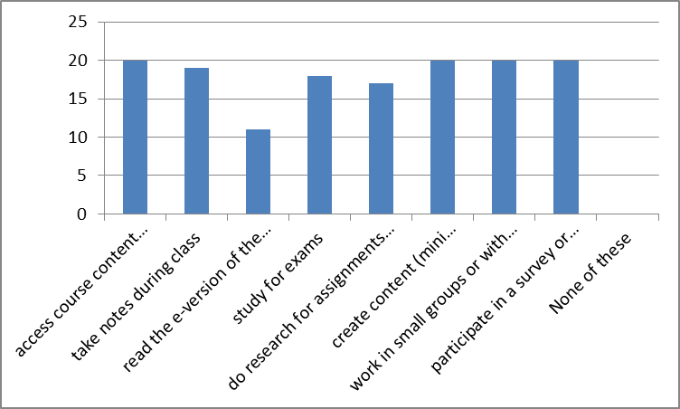

Question 2:

***How helpful was the iPad in the following areas?***

* Being able to access course material (Moodle and supplemental information such as news articles)
* Being able to take notes on the iPad during class
* Being able to read the text book electronically
* Being able to study for the exam
* Being able to do research for assignments such as the Healthy People 2020 paper
* Being able to create content (mini presentations, writing assignments)
* Being able to work in small groups or with a partner on in class activities/discussions
* Being able to participate in a survey or quiz in class

Answered: 20

Skipped: 0

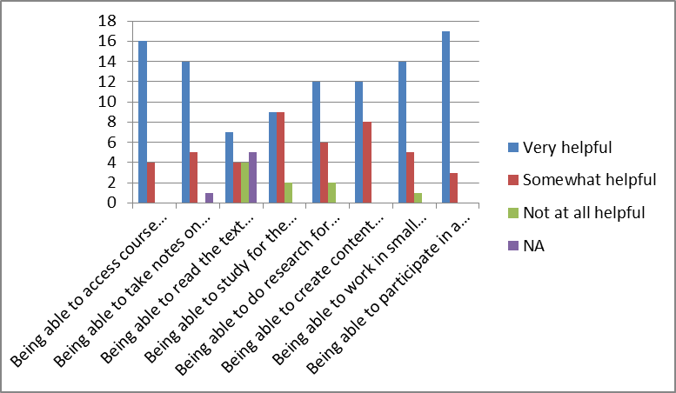

Question 3:

***Which of the following activities helped you to understand and prepare for writing the Healthy People 2020 paper? (check all that apply)***

* Healthy People 2020 paper overview and instructions (provided on your iPad, presented with iPad)
* Writing Assignment (Healthy People 2020 summary)
* Healthy People 2020 mini presentation (created and presented with iPad)
* None of these

Answered: 20

Skipped: 0

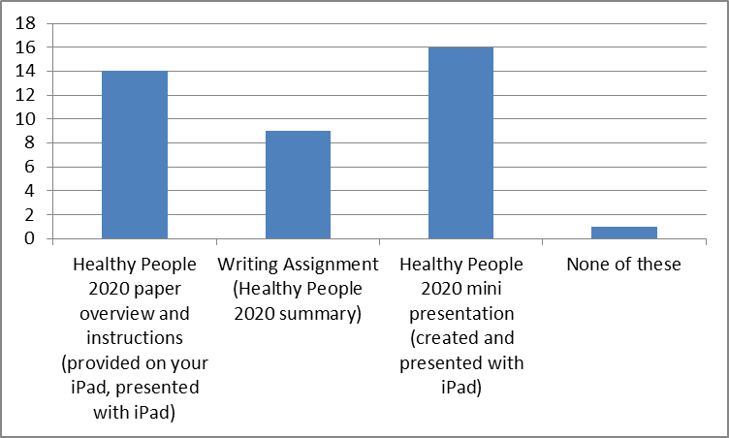

Question 4:

***Please indicate the extent to which you agree with the following:***

* Using the iPad helped to keep me engaged during class.
* I liked using the iPad to take class/lecture notes.
* I liked using the iPad to work in pairs or small groups during in-class activities.
* Using the iPad (to access lecture materials, create new content, etc.) was easy.
* I liked using survey/quiz apps during class.

Answered: 20

Skipped: 20

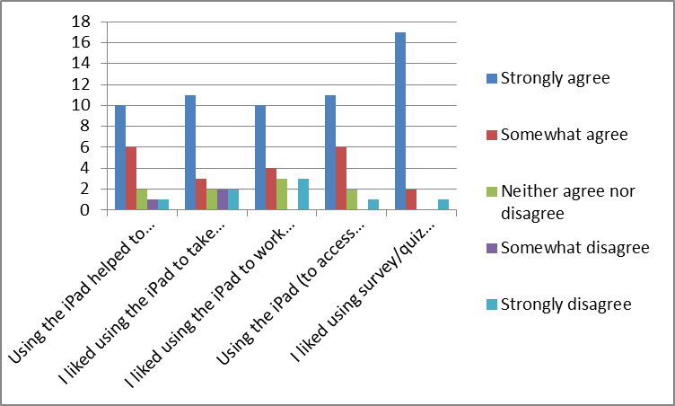

Question 5:

***How likely are you to recommend an iPad (myCSUNtablet) course to a friend?***

* Definitely would recommend
* Probably would recommend
* Unsure
* Probably would not recommend
* Definitely would not recommend

Answered: 20

Skipped: 20

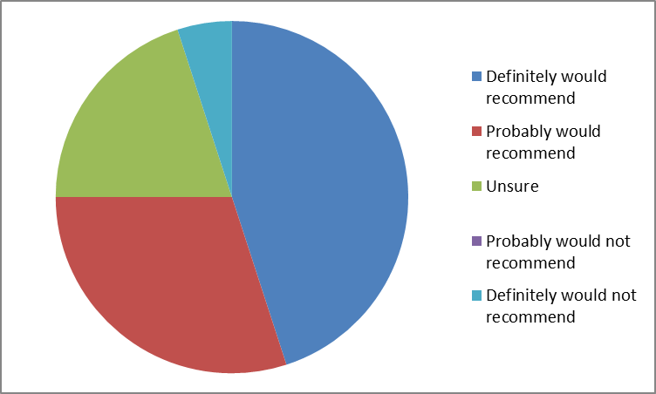

Question 6:

***What suggestions or ideas do you have for improving the HSCI 237 iPad class?***

Note: All responses are presented as entered by the students

* not requiring the online book, its too hard to navigate through on the iPad
* More interactive activities with the class
* always notify students of what they will need to download prior to class. trying to do all that in class took away too much time
* Work out all of the technical probably prior to the semester starting. Make sure the professor FULLY understand how to work the tablet, wifi, "box".
* Spending less time trying to figure out how to use the iPad
* Suggest the students to different apps the can write notes in
* N/A
* Be more prepared. Prep before class so you know if the app is working properly
* Prior to taking the class the CSUN technical support team should host an event where individuals taking the iPad course may familiarize themselves with the programs.
* The class is way too dependent on the ipad. If the ipad malfunction there literally is no class. There needs to be a back up solution
* Probably making sure that students can easily access course materials without a hassle. Also the selection of apps, making them available to everyone with no additional cost so perhaps teacher knows enough information on the app to guide their student if a problem arises while using app.
* i don't have any suggestions that come up to my mind right now. it was a great experience learning with new technology that we will be using in our life.
* Get rid of iPads! don't waste a class section on a class that didn't even receive full enrollment because students could not afford them!
* Resolving technical issues and learning how to use them PRIOR to the beginning of the semester. (For professors and students. This is so class time is not wasted.
* Nothing really, it was overall helpful and engaging.
* Maybe not require the e textbook because it was somewhat hard to read and to take notes. The whole login to access I disliked but other than that I really liked it.
* Ensure a steady pace lecture, as students are used to taking quick notes by paper and pencil/pen. Sometimes i would fall behind in keeping up because i am not used to taking notes with the ipad
* Give more clear instruction on how to use the I pad in the begining of the semester.
* It would be ideal to have an outlet available next to every seat for charging purposes. Having a knowledgeable person to assist us on the first day would have been helpful.
* Having an IT person here the first week to guide use and answer any questions

Answered: 20

Skipped: 0

Question 7:

***Do you have any additional comments?***

Note: All responses are presented as entered by the students

* No
* Have a backup if it doesn't work.
* N/A
* I loved the idea of the ipad class. Cant wait for it to be polished up and ran effectively from beginning to end.
* ipads are a waste of money, it would have been much more beneficial to have the class section without iPads. 99% of the material is compatible with a laptop and most students already own laptops compared to the few that owned an ipad before the class started. Also, reading the material on a screen and taking notes was very tiring for my eyes and frequently gave me headaches. In addition,it was easy to get distracted by having access to social networking, games and other apps.
* I love doing presentations on the ipad; it is so easy and offers diverse programs that makes it fun for class activities and assignments.
* I greatly enjoyed the capability of using my iPad in class. It made turning assignments in easier and sharing websites and documents with others a breeze. I would definitely take an iPad course again.

Answered: 7

Skipped: 13

# Analysis

Overall, the results from the survey appear positive. The data seem to suggest that the students liked using the iPad for taking notes, creating content such as the mini-presentations, participating in quizzes, and for in-class activities and group work. Students seem most dissatisfied with using the iPad for accessing the course text. Additionally, it seems that at the end of the semester, the students had not forgotten the many technical difficulties that we had getting up and running.

From the instructor perspective, a number of positive aspects to the iPad course as well as several areas for development.

The following are examples of the encouraging aspects of the iPad course:

1. **Opportunity to try something new**

Teaching an iPad course for the first time compels the instructor to evaluate the course design, course materials, the approach to teaching, etc. In the spring semester, one minor example of this was the fact that students in the iPad section were provided a skeleton of the lecture material (power point slides that were converted to PDF and offered to students to be able to take notes directly on to the course material) whereas students in the non-iPad sections were not given the lecture material.

1. **New way of engaging students**

Through the use of the iPad, in some cases, students are able to participate anonymously. This has the potential of creating a space where any question is welcome and opinions can be shared more readily including among students who traditionally would not raise their hand to contribute or to ask questions. Also, having the iPad made on-the-spot searching for class content, examples, data, etc. accessible for each student. Additionally, students seemed to enjoy completing mini quizzes via the Socrative app.

1. **Facilitate grading**

Using the iPad to grade (Turnitin) was simple, user-friendly, and seemed to make the grading process more efficient.

1. **Ability for students to submit class work via Moodle immediately**

Using the iPad to facilitate in-class activities, discussions, and small group work, allowed for creation and immediate submission of work via Moodle. Students often completed work in class but didn’t submit the work, being able to take photos of their work several times during class hold students responsible for staying engaged during class.

The following are examples of limitations and challenging aspects of the iPad course:

1. **Time**

Some activities and class work designed to be done via iPad took longer than the process for learning the same content in a non-iPad class. Teaching 3 sections of the same course, an instructor would usually try move through content at the same pace but in the iPad section content and activities had to be cut in order to get through the course. Moving forward, strategies such as lecture capture may be useful. Also, knowing that time will be a challenge, the instructor can be prepared by prioritizing content for in-class lecture and activities rather than thinking that the course should stay in line with the non-iPad sections.

1. **Participation**

While the iPad was terrific for engaging students in some ways, in this specific iPad course students seemed to be much more quiet and hesitant to participate out loud. This was very different than typical HSCI 237 sections. In the future, beginning the course with iPad activities that are more interactive and engaging than the quiz apps may help.

1. **Technical difficulties**

During the first few weeks, the class had trouble connecting to Eduroam (having to change user name and password, not being able to connect, etc.) Also, getting students set up with box was challenging.

## Final Remarks from Professor Valdez

While I attended a few tablet workshops prior to actually teaching an iPad course and attend a "kickoff" event immediately before the spring 2014 semester, I did not feel well trained or prepared. After the kickoff, Melissa Lalum (Journalism) was kind enough to provide me with some one-on-one coaching.

I found the panel discussion (at kickoff event) and my meeting with Melissa to be most helpful. The workshops that I attended seemed to be focused on convincing faculty to adopt and embrace this technology and the initiative. I was eager to participate so I left the meetings excited to be a part of this initiative but I didn't believe that I gained any practical skills. I didn't actually learn HOW to teach with ipad, best practices, the best apps, how to use the apps, etc. This is why I found the panel discussion and my personal coaching session with Melissa to be so valuable. It was really the first time I was able to get ideas and ask practical questions, and get tips from faculty how had actually used the iPad in teaching. The challenge after the panel discussion and meeting with Melissa is that the start of the semester was upon us so ultimately I didn't have very much time to prep and plan. This semester has been quite a bit of trial and error and has felt less productive because I don't think I was as prepared as I should have been.

I was so pleased to see that Faculty Technology Center planned a MyCSUNtablet Academy for summer 2014. And even though the academy was designed for new faculty joining the tablet initiative, I was selected to attend. The 3.5-day workshop was exactly what is needed for faculty new to teaching with iPads and I would have loved to gone through this training prior to my first semester teaching in the tablet initiative. The academy should be mandatory for any faculty joining MyCSUNtablet!

Last, I believe that cross-department collaboration and support is valuable to assisting all iPad instructors with learning new ideas and testing concepts out on colleagues who are familiar with this teaching approach. I hope to lead some iPad meetings this semester in my department and I am optimistic that working groups across departments will continue post-academy.