FINANCIAL ACCOUNTING

Topic 1: Define and articulate the four basic financial statements.

Reference: Kimmel, Paul. D., Weygandt, Jerry. J. & Kieso, Donald. E. (2006). Financial Accounting: Tools for Business Decision Making (4th ed.). Hoboken, NJ: John Wiley & Sons. Used with permission from the publisher.

Basic Financial Statements

Assets, liabilities, expenses, and revenues are of interest to users of accounting information. For business purposes, it is customary to arrange this information in the format of four different financial statements, which form the backbone of financial accounting:

- To present a picture at a point in time of what your business owns (its assets) and what it owes (its liabilities), you would present a balance sheet.

- To show how successfully your business performed during a period of time, you would report its revenues and expenses in an income statement.

- To indicate how much of previous income was distributed to you and the other owners of your business in the form of dividends, and how much was retained in the business to allow for future growth, you would present a retained earnings statement.

- To show from what sources your business obtained cash during a period of time and how that cash was used, you would present a statement of cash flows.

To introduce you to these statements, we have prepared the financial statements for a marketing agency, Sierra Corporation.

Income Statement

The purpose of the income statement is to report the success or failure of the company's operations for a period of time. To indicate that its income statement reports the results of operations for a period of time, Sierra dates the income statement “For the Month Ended October 31, 2007.” The income statement lists the company's revenues followed by its expenses. Finally, Sierra determines the net income (or net loss) by deducting expenses from revenues. Sierra Corporation's income statement is shown in Illustration 1.

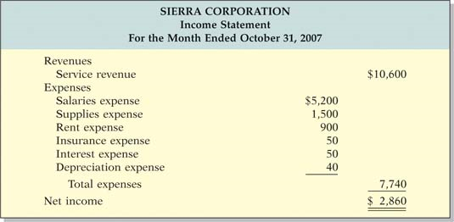
Illustration 1 Sierra Corporation's income statement

Why are financial statement users interested in net income? Investors are interested in Sierra's past net income because it provides information about future net income. Investors buy and sell stock based on their beliefs about Sierra's future performance. If you believe that Sierra will be even more successful in the future and that this success will translate into a higher stock price, you should buy its stock. Creditors also use the income statement to predict the future. When a bank loans money to a company, it does so with the belief that it will be repaid in the future. If it didn't think it would be repaid, it wouldn't loan the money. Therefore, prior to making the loan the bank loan officer will use the income statement as a source of information to predict whether the company will be profitable enough to repay its loan.

Amounts received from issuing stock are not revenues, and amounts paid out as dividends are not expenses. As a result, they are not reported on the income statement. For example, Sierra Corporation did not treat as revenue the $10,000 of cash received from issuing new stock, nor did it regard as a business expense the $500 of dividends paid.

Retained Earnings Statement

If Sierra is profitable, at the end of each period it must decide what portion of profits to pay to shareholders in dividends. In theory it could pay all of its current-period profits, but few companies choose to do this. Why? Because they want to retain part of the profits to allow for further expansion. High-growth companies, such as Google and Cisco Systems, often choose to pay no dividends. Retained earnings is the net income retained in the corporation.

The retained earnings statement shows the amounts and causes of changes in retained earnings during the period. The time period is the same as that covered by the income statement. The beginning retained earnings amount appears on the first line of the statement. Then the company adds net income and deducts dividends to determine the retained earnings at the end of the period. If a company has a net loss, it deducts (rather than adds) that amount in the retained earnings statement. Illustration 2 presents Sierra Corporation's retained earnings statement.

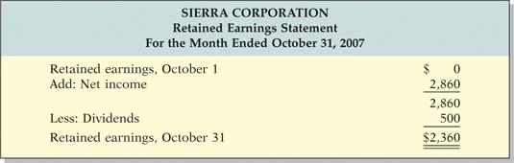
Illustration 2 Sierra Corporation's retained earnings statement

By monitoring the retained earnings statement, financial statement users can evaluate dividend payment practices. Some investors seek companies, such as Dow Chemical, that have a history of paying high dividends. Other investors seek companies, such as Amazon.com, that instead of paying dividends, reinvest earnings to increase the company's growth. Lenders monitor their corporate customers' dividend payments because any money paid in dividends reduces a company's ability to repay its debts.

Balance Sheet

The balance sheet reports assets and claims to those assets at a specific point in time. These claims are subdivided into two categories: claims of creditors and claims of owners. As noted earlier, claims of creditors are called liabilities. Claims of owners are called stockholders' equity.

The relationship among the categories on the balance sheet is shown in equation form in Illustration 3. This equation is referred to as the basic accounting equation.

Illustration 3 Basic accounting equation

This relationship is where the name “balance sheet” comes from. Assets must be in balance with the claims to the assets.

As you can see from looking at Sierra's balance sheet in Illustration 4, the balance sheet presents the company's financial position as of a specific date— in this case, October 31, 2007. It lists assets first, followed by liabilities and stockholders' equity. Stockholders' equity is comprised of two parts: (1) common stock and (2) retained earnings. As noted earlier, common stock results when the company sells new shares of stock; retained earnings is the net income retained in the corporation. Sierra has common stock of $10,000 and retained earnings of $2,360, for total stockholders' equity of $12,360.

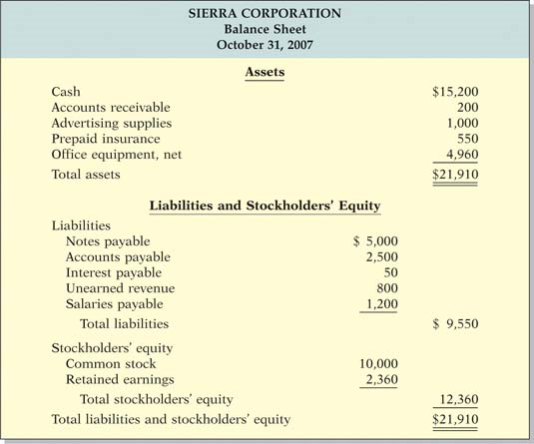
Illustration 4 Sierra Corporation's balance sheet

Creditors analyze a company's balance sheet to determine the likelihood that they will be repaid. They carefully evaluate the nature of the company's assets and liabilities. For example, does Sierra have assets that could be easily sold to repay its debts? Sierra's managers use the balance sheet to determine whether cash on hand is sufficient for immediate cash needs. They also look at the relationship between debt and stockholders' equity to determine whether the company has a satisfactory proportion of debt and common stock financing.

Statement of Cash Flows

The primary purpose of a statement of cash flows is to provide financial information about the cash receipts and cash payments of a business for a specific period of time. To help investors, creditors, and others in their analysis of a company's cash position, the statement of cash flows reports the cash effects of a company's operating, investing, and financing activities. In addition, the statement shows the net increase or decrease in cash during the period and the amount of cash at the end of the period.

Users are interested in the statement of cash flows because they want to know what is happening to a company's most important resource. The statement of cash flows provides answers to these simple but important questions:

- Where did cash come from during the period?
- How was cash used during the period?
- What was the change in the cash balance during the period?

The statement of cash flows for Sierra, in Illustration 5, shows that cash increased $15,200 during the month. This increase resulted because operating activities (services to clients) increased cash $5,700, and financing activities increased cash $14,500. Investing activities used $5,000 of cash for the purchase of equipment.

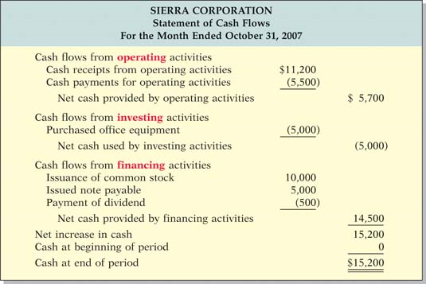
Illustration 5 Sierra Corporation's statement of cash flows

Interrelationships of Statements

Because the results on some statements become inputs to other statements, the statements are interrelated. Illustration 6 shows the interrelationships for Sierra's statements, which we describe below.

- The retained earnings statement depends on the results of the income statement. Sierra reported net income of $2,860 for the period. It adds the net income amount to the beginning amount of retained earnings in order to determine ending retained earnings.

- The balance sheet and retained earnings statement also are interrelated: Sierra reports the ending amount of $2,360 on the retained earnings statement as the retained earnings amount on the balance sheet.

- Finally, the statement of cash flows relates to information on the balance sheet. The statement of cash flows shows how the cash account changed during the period. It shows the amount of cash at the beginning of the period, the sources and uses of cash during the period, and the $15,200 of cash at the end of the period. The ending amount of cash shown on the statement of cash flows must agree with the amount of cash on the balance sheet.

Study these interrelationships carefully. To prepare financial statements you must understand the sequence in which these amounts are determined, and how each statement impacts the next.

See Illustration 6 on next page.

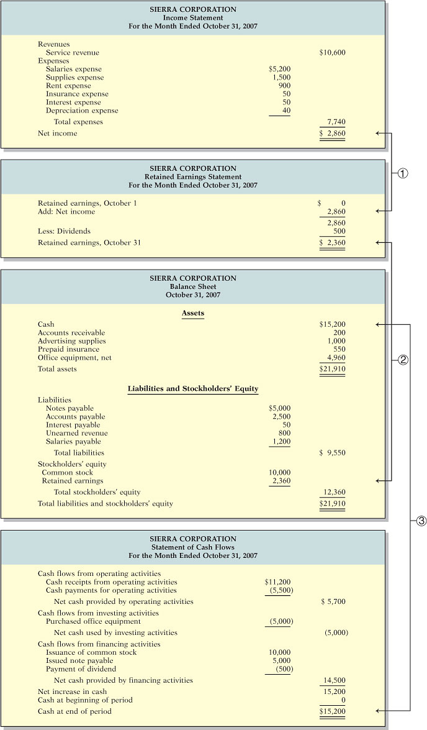
Illustration 6 Sierra Corporation's financial statements
Example:

CSU Corporation began operations on January 1, 2007. The following information is available for CSU Corporation on December 31, 2007: service revenue $17,000; accounts receivable $4,000; accounts payable $2,000; building rental expense $9,000; notes payable $5,000; common stock $10,000; retained earnings $?; equipment $16,000; insurance expense $1,000; supplies $1,800; supplies expense $200; cash $1,400; dividends $600.

Prepare an income statement, a retained earnings statement, and a balance sheet using this information.

Solution

CSU CORPORATION
Income Statement
For the Year Ended December 31, 2007
Revenues
Service revenue |  | $17,000
Expenses
Rent expense | $9,000
Insurance expense | 1,000
Supplies expense | 200
Total expenses |  | 10,200
Net income |  | $ 6,800

CSU CORPORATION
Retained Earnings Statement
For the Year Ended December 31, 2007
Retained earnings, January 1 | $ 0
Add: Net income | 6,800
 | 6,800
Less: Dividends | 600
Retained earnings, December 31 | $6,200

CSU CORPORATION
Balance Sheet
December 31, 2007
Assets
Cash |  | $ 1,400
Accounts receivable |  | 4,000
Supplies |  | 1,800
Equipment |  | 16,000
Total assets |  | $23,200
Liabilities and Stockholders' Equity
Liabilities
Notes payable | $ 5,000
Accounts payable | 2,000
Total liabilities |  | $ 7,000
Stockholders' equity
Common stock | 10,000
Retained earnings | 6,200
Total stockholders' equity |  | 16,200
Total liabilities and stockholders' equity |  | $23,200

### End of Topic 1 ###

Topic 2: Identify the usefulness and relevance of the three basic financial statements.

Reference: Kimmel, Paul. D., Weygandt, Jerry. J. & Kieso, Donald. E. (2006). Financial Accounting: Tools for Business Decision Making (4th ed.). Hoboken, NJ: John Wiley & Sons. Used with permission from the publisher.

The Financial Statements Revisited

In Topic 1 we introduced the four financial statements. In this topic we review the financial statements and explore how they are used. We begin by introducing the classified balance sheet.

The Classified Balance Sheet

The balance sheet presents a snapshot of a company's financial position at a point in time. To improve users' understanding of a company's financial position, companies often group similar assets and similar liabilities together. This is useful because it tells you that items within a group have similar economic characteristics. A classified balance sheet generally contains the standard classifications listed in Illustration 1.

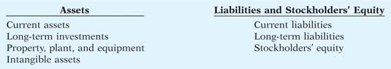
Illustration 7 Standard balance sheet classifications

These groupings help readers determine such things as (1) whether the company has enough assets to pay its debts as they come due, and (2) the claims of short- and long-term creditors on the company's total assets. Many of these groupings can be seen in the balance sheet of Franklin Corporation shown in Illustration 2. In the sections that follow, we explain each of these groupings.

See Illustration 2 on next page.
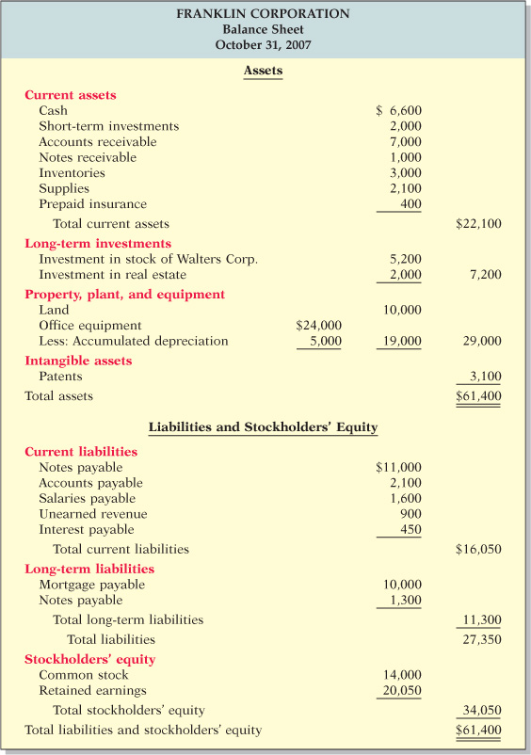
Illustration 8 Classified balance sheet

Current Assets
Current assets are assets that a company expects to convert to cash or use up within one year. In Illustration 2, Franklin Corporation had current assets of $22,100. For most businesses the cutoff for classification as current assets is one year from the balance sheet date. For example, accounts receivable are current assets because the company will collect them and convert them to cash within one year. Supplies is a current asset because the company expects to use it up in operations within one year.

Some companies use a period longer than one year to classify assets and liabilities as current because they have an operating cycle longer than one year. The operating cycle of a company is the average time that it takes to purchase inventory, sell it on account, and then collect cash from customers. For most businesses this cycle takes less than a year, so they use a one-year cutoff. But, for some businesses, such as vineyards or airplane manufacturers, this period may be longer than a year. Except where noted, we will assume that companies use one year to determine whether an asset or liability is current or long-term.

Common types of current assets are (1) cash, (2) short-term investments (such as short-term U.S. government securities), (3) receivables (notes receivable, accounts receivable, and interest receivable), (4) inventories, and (5) prepaid expenses (insurance and supplies). On the balance sheet, companies usually list these items in the order in which they expect to convert them into cash (order of liquidity).
Long-Term Investments
Long-term investments are generally investments in stocks and bonds of other corporations that are normally held for many years. This category also includes investments in long-term assets such as land or buildings that a company is not currently using in its operating activities. In Illustration 2 Franklin Corporation reported total long-term investments of $7,200 on its balance sheet.
Property, Plant, and Equipment
Property, plant, and equipment are assets with relatively long useful lives that a company is currently using in operating the business. This category includes land, buildings, machinery and equipment, delivery equipment, and furniture. In Illustration 2 Franklin Corporation reported property, plant, and equipment of $29,000.
Depreciation is the practice of allocating the cost of assets to a number of years. Companies do this by systematically assigning a portion of an asset's cost as an expense each year (rather than expensing the full purchase price in the year of purchase). The assets that the company depreciates are reported on the balance sheet at cost less accumulated depreciation. The accumulated depreciation account shows the total amount of depreciation that the company has expensed thus far in the asset's life. In Illustration 2 Franklin Corporation reported accumulated depreciation of $5,000.
Intangible Assets
Many companies have assets that do not have physical substance yet often are very valuable. We call these assets intangible assets. They include patents, copyrights, and trademarks or trade names that give the company exclusive right of use for a specified period of time. Franklin Corporation reported intangible assets of $3,100.
Current Liabilities
In the liabilities and stockholders' equity section of the balance sheet, the first grouping is current liabilities. Current liabilities are obligations that the company is to pay within the coming year. Common examples are accounts payable, wages payable, bank loans payable, interest payable, and taxes payable. Also included as current liabilities are current maturities of long-term obligations—payments to be made within the next year on long-term obligations. In Illustration 2 Franklin Corporation reported five different types of current liabilities, for a total of $16,050.

Within the current liabilities section, companies usually list notes payable first, followed by accounts payable. Other items then follow in the order of their magnitude. In your homework, you should present notes payable first, followed by accounts payable, and then other liabilities in order of magnitude.
Long-Term Liabilities
Long-term liabilities are obligations that a company expects to pay after one year. Liabilities in this category include bonds payable, mortgages payable, long-term notes payable, lease liabilities, and pension liabilities. Many companies report long-term debt maturing after one year as a single amount in the balance sheet and show the details of the debt in notes that accompany the financial statements. Others list the various types of long-term liabilities. In Illustration 2 Franklin Corporation reported long-term liabilities of $11,300. In your homework, list long-term liabilities in the order of their magnitude.
Stockholders' Equity
Stockholders' equity consists of two parts: common stock and retained earnings. Companies record as common stock the investments of assets into the business by the stockholders. They record as retained earnings the income retained for use in the business. These two parts, combined, make up stockholders' equity on the balance sheet. In Illustration 2 Franklin reported common stock of $14,000 and retained earnings of $20,050
Example
Baxter Hoffman recently received the following information related to Hoffman Corporation's December 31, 2007, balance sheet. Prepare the assets section of Hoffman Corporation's balance sheet.

Prepaid expenses | $ 2,300 | Inventory | $3,400
Cash | 800 | Accumulated depreciation | 2,700
Property, plant, and equipment | 10,700 | Accounts receivable | 1,100

Solution
HOFFMAN CORPORATION
Balance Sheet (partial)
December 31, 2007
Assets
Current assets
Cash | $ 800
Accounts receivable | 1,100
Inventory | 3,400
Prepaid expenses | 2,300
Total current assets |  | $ 7,600
Property, plant, and equipment | 10,700
Less: Accumulated depreciation | 2,700 | 8,000
Total assets |  | $15,600

Using the Income Statement
Best Buy Company generates profits for its shareholders by selling electronics goods. The income statement reports how successful it is at generating a profit from its sales. The income statement reports the amount earned during the period (revenues) and the costs incurred during the period (expenses). Illustration 3 shows a simplified income statement for Best Buy.
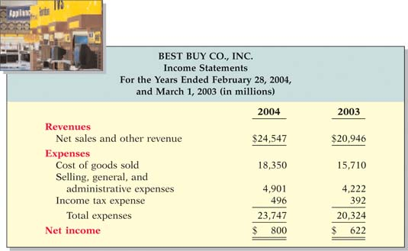
Illustration 9 Best Buy's income statement

From this income statement we can see that Best Buy's sales and net income both increased during the year. Net income increased from $622,000,000 to $800,000,000. Best Buy's primary competitor is Circuit City. Circuit City reported a net loss of $787,000 for the year ended February 29, 2004.
Using the Statement of Stockholders' Equity
As discussed in Topic 1, the retained earnings statement describes the changes in retained earnings during the year. This statement adds net income and then subtracts dividends from the beginning retained earnings to arrive at ending retained earnings.

Recall, however, that stockholders' equity is comprised of two parts: retained earnings and common stock. Therefore, the stockholders' equity of most companies is affected by factors other than just changes in retained earnings. For example, the company may issue or retire shares of common stock. Most companies, therefore, use what is called a statement of stockholders' equity, rather than a retained earnings statement, so that they can report all changes in stockholders' equity accounts. Illustration 4 is a simplified statement of stockholders' equity for Best Buy.
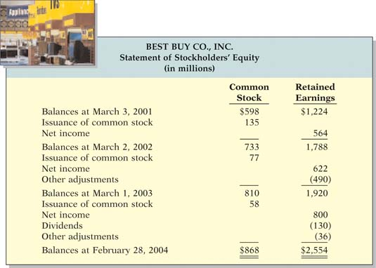
Illustration 10 Best Buy's statement of stockholders' equity

We can observe from this financial statement that Best Buy's common stock increased as the result of issuance of common stock in each of the three years. Another observation from this financial statement is that Best Buy paid no dividends until the most recent year.
Using a Classified Balance Sheet
You can learn a lot about a company's financial health by also evaluating the relationship between its various assets and liabilities. Illustration 5 provides a simplified balance sheet for Best Buy.
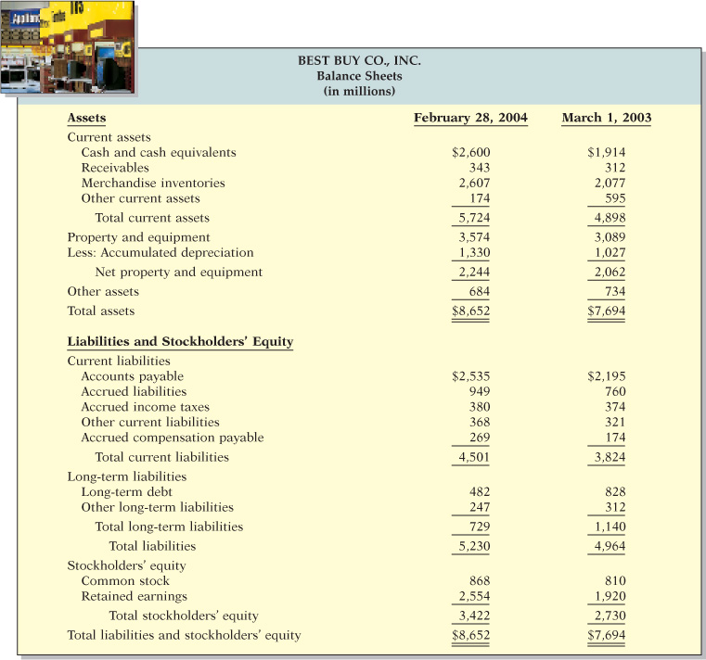
Illustration 11 Best Buy's balance sheet

Using the Statement of Cash Flows
As you learned in Topic 1, the statement of cash flows provides financial information about the sources and uses of a company's cash. Investors, creditors, and others want to know what is happening to a company's most liquid resource—its cash. In fact, people often say that “cash is king” because if a company cannot generate cash, it will not survive. To aid in the analysis of cash, the statement of cash flows reports the cash effects of (1) a company's operating activities, (2) its investing activities, and (3) its financing activities.
Sources of cash matter. For example, you would feel much better about a company's health if you knew that the company generates its cash from the operations of the business rather than borrows it. A cash flow statement provides this information. Similarly, net income does not tell you how much cash the company generated from operations. The statement of cash flows can tell you that. In summary, neither the income statement nor the balance sheet directly answers most of the important questions about cash, but the statement of cash flows does. Illustration 6 shows a simplified statement of cash flows for Best Buy.
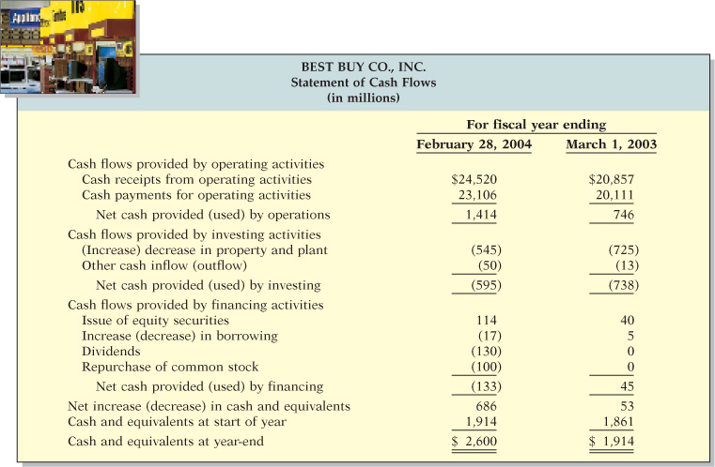
Illustration 12 Best Buy's statement of cash flows

Different users have different reasons for being interested in the statement of cash flows. If you were a creditor of Best Buy (either short term or long term), you would be interested to know the source of its cash in recent years. This information would give you some indication of where it might get cash to pay you. If you have a long-term interest in Best Buy as a stockholder, you would look to the statement of cash flows for information regarding the company's ability to generate cash over the long run to meet its cash needs for growth.

Companies get cash from two sources: operating activities and financing activities. In the early years of a company's life it typically will not generate enough cash from operating activities to meet its investing needs, so it will have to issue stock or borrow money. An established company, however, will often be able to meet most of its cash needs with cash from operations. Best Buy's cash provided by operating activities during these two years was sufficient to meet its needs for acquisitions of property, plant, and equipment. For example, in 2004 cash provided by operating activities was $1,414,000,000, whereas cash spent on property, plant, and equipment was $545,000,000.
Free Cash Flow
In the statement of cash flows, cash provided by operating activities is intended to indicate the cash-generating capability of the company. Analysts have noted, however, that cash provided by operating activities fails to take into account that a company must invest in new property, plant, and equipment (capital expenditures) just to maintain its current level of operations. Companies also must at least maintain dividends at current levels to satisfy investors. A measurement to provide additional insight regarding a company's cash-generating ability is free cash flow. Free cash flow describes the cash remaining from operations after adjusting for capital expenditures and dividends.
Consider the following example: Suppose that MPC produced and sold 10,000 personal computers this year. It reported $100,000 cash provided by operating activities. In order to maintain production at 10,000 computers, MPC invested $15,000 in equipment. It chose to pay $5,000 in dividends. Its free cash flow was $80,000 ($100,000 − $15,000 − $5,000). The company could use this $80,000 to purchase new assets to expand the business, to pay off debts, or to increase its dividend distribution. In practice, analysts often calculate free cash flow with the formula in Illustration 7. Alternative definitions for free cash flow also exist.

Illustration 13 Free cash flow

Illustration 8 shows calculation of Best Buy's free cash flow. Best Buy generated free cash flow of $739 million which is available for the acquisition of new assets, the retirement of stock or debt, or the payment of additional dividends. Long-term creditors consider a high free cash flow amount an indication of solvency. Circuit City's free cash flow for 2004 is a negative $322 million. This lack of free cash flow calls into question Circuit City's ability to repay its long-term obligations as they come due.

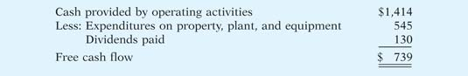
Illustration 14 Calculation of Best Buy's free cash flow ($ in millions)

### End of Topic 2 ###

Topic 3: Know the basic concepts underlying financial reporting (e.g. consistency, verifiability).

Reference: Kimmel, Paul. D., Weygandt, Jerry. J. & Kieso, Donald. E. (2006). Financial Accounting: Tools for Business Decision Making (4th ed.). Hoboken, NJ: John Wiley & Sons. Used with permission from the publisher.

Financial Reporting Concepts

In Topics 1 and 2 you learned about the four financial statements, and in this Topic we will discuss concepts that underlie these financial statements. It would be unwise to make business decisions based on financial statements without understanding the implications of these concepts.

The Standard-Setting Environment

How does a company like Best Buy decide on the amount and type of financial information to disclose? What format should it use? How should it measure assets, liabilities, revenues, and expenses? The answers to these questions are found in accounting guidelines referred to as generally accepted accounting principles (GAAP). Various standard-setting bodies, in consultation with the accounting profession and the business community, determine these guidelines.

The Securities and Exchange Commission (SEC) is the agency of the U.S. government that oversees U.S. financial markets and accounting standard-setting bodies. The primary accounting standard-setting body in the United States is the Financial Accounting Standards Board (FASB). Many countries outside of the United States have adopted the accounting standards issued by the International Accounting Standards Board (IASB). In recent years the FASB and IASB have worked closely to try to minimize the differences in their standards.
Characteristics of Useful Information
In establishing guidelines for reporting financial information, the FASB believes that the overriding consideration should be the generation of financial information useful for making business decisions. To be useful, information should possess these characteristics: relevance, reliability, comparability, and consistency.
Relevance
Accounting information is relevant if it would make a difference in a business decision. For example, the information in Best Buy's financial statements is considered relevant because it provides a basis for forecasting Best Buy's future earnings. Accounting information is also relevant to business decisions because it confirms or corrects prior expectations. Financial statements provide relevant information that helps predict future events and provide feedback about prior expectations for the financial health of the company.
For accounting information to be relevant it must be timely. That is, it must be available to decision makers before it loses its capacity to influence decisions. The SEC requires that public companies provide their annual reports to investors within 60 days of their year-end.
Reliability
Reliability of information means that the information can be depended on. To be reliable, accounting information must be verifiable—we must be able to prove that it is free of error. Also, the information must be a faithful representation of what it purports to be—it must be factual. If Best Buy's income statement reports sales of $20 billion when it actually had sales of $10 billion, then the statement is not a faithful representation of Best Buy's financial performance. Finally, accounting information must be neutral—it cannot be selected, prepared, or presented to favor one set of interested users over another. To ensure reliability, certified public accountants audit financial statements.
Comparability
In accounting, comparability results when different companies use the same accounting principles. U.S. accounting standards are relatively comparable because they are based on certain basic principles and assumptions. However, these principles and assumptions allow for some variation in methods. For example, there are a variety of ways to report inventory. Often these different methods result in different amounts of net income. To make comparison across companies easier, each company must disclose the accounting methods used.
Consistency
To compare Best Buy's net income over several years, you would need to know that it used the same accounting principles from year to year. Consistency means that a company uses the same accounting principles and methods from year to year. Thus, if a company selects one inventory accounting method in the first year of operations, it is expected to continue to use that same method in succeeding years.

A company can change to a new method of accounting if management can justify that the new method produces more useful financial information. In the year in which the change occurs, the change must be disclosed in the notes to the financial statements so that users of the statements are aware of the lack of consistency.

Illustration 1 summarizes the characteristics that make accounting information useful.

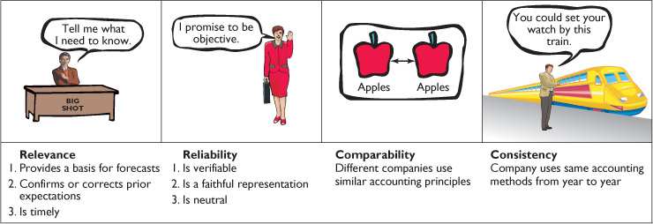
Illustration 15 Characteristics of useful information
Assumptions and Principles in Financial Reporting
To develop accounting standards, the FASB relies on some key assumptions and principles.
Monetary Unit Assumption
The monetary unit assumption requires that only those things that can be expressed in money are included in the accounting records. Because the exchange of money is fundamental to business transactions, it makes sense that we measure a business in terms of money.

However, the monetary unit assumption also means that certain important information needed by investors, creditors, and managers is not reported in the financial statements. For example, customer satisfaction is important to every business, but it is not easily quantified in dollar terms; thus it is not reported in the financial statements.
Economic Entity Assumption
The economic entity assumption states that every economic entity can be separately identified and accounted for. For example, suppose you are a stockholder of Best Buy. The amount of cash you have in your personal bank account and the balance owed on your personal car loan are not reported in Best Buy's balance sheet. In order to accurately assess Best Buy's performance and financial position, it is important that we not blur it with your personal transactions, or the transactions of any other person (especially its managers) or company.
Time Period Assumption
Next, notice that the income statement, retained earnings statement, and statement of cash flows all cover periods of one year, and the balance sheet is prepared at the end of each year. The time period assumption states that the life of a business can be divided into artificial time periods and that useful reports covering those periods can be prepared for the business. All companies report financial results at least annually. Many also report every three months (quarterly) to stockholders, and many prepare monthly statements for internal purposes.
Going Concern Assumption
The going concern assumption states that the business will remain in operation for the foreseeable future. Of course many businesses do fail, but in general, it is reasonable to assume that the business will continue operating. If going concern is not assumed, then the company should state plant assets at their liquidation value (selling price less cost of disposal), rather than at their cost. Only when liquidation of the business appears likely is the going concern assumption inappropriate.

Illustration 2 shows these four accounting assumptions graphically.

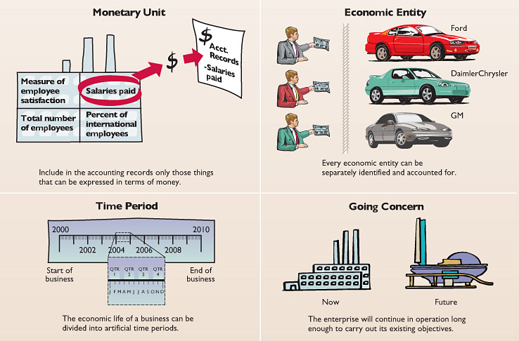
Illustration 16 Accounting assumptions
Cost Principle
The cost principle dictates that assets be recorded at their cost. This is true not only at the time the asset is purchased, but also over the time the asset is held. For example, if Best Buy were to purchase some land for $30,000, the company would initially report it on the balance sheet at $30,000. But what would Best Buy do if, by the end of the next year, the land had increased in value to $40,000? Under the cost principle the company would continue to report the land at $30,000.

The cost principle is often criticized as being irrelevant. Critics contend that market value would be more useful to financial decision makers. Proponents of the cost principle counter that cost is the best measure because it can be easily verified from transactions between two parties, whereas market value is often subjective. Recently, the FASB has changed some accounting rules requiring that certain investment securities be recorded at their market value. In choosing between cost and market value, the FASB weighed the reliability of cost figures versus the relevance of market value.
Full Disclosure Principle
The full disclosure principle requires that companies disclose all circumstances and events that would make a difference to financial statement users. Some important financial information is not easily reported on the face of the statements. For example, Best Buy has debt outstanding. Investors and creditors would like to know the terms of the debt; that is, when does it mature, what is its interest rate, and is it renewable? Or Best Buy might be sued by one of its customers. Investors and creditors might not know about this lawsuit. If an important item cannot reasonably be reported directly in one of the four types of financial statements, then it should be discussed in notes that accompany the statements. Some investors who lost money in Enron, WorldCom, and Global Crossing complained that the lack of full disclosure regarding some of the companies' transactions caused the financial statements to be misleading. Illustration 3 depicts these two accounting principles.

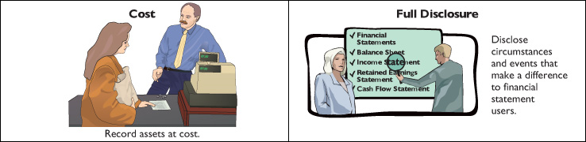
Illustration 17 Accounting principles
Constraints in Accounting
Taken to the extreme, efforts to provide useful financial information could be far too costly to a company. Therefore, the profession has agreed upon constraints to ensure that companies apply accounting rules in a reasonable fashion, from the perspectives of both the company and the user. The constraints are materiality and conservatism.
Materiality
Materiality relates to a financial statement item's impact on a company's overall financial condition and operations. An item is material when its size makes it likely to influence the decision of an investor or creditor. It is immaterial if it is too small to impact a decision maker. In short, if the item does not make a difference, the company does not have to follow GAAP in reporting it. To determine the materiality of an amount—that is, to determine its financial significance—the company compares the item with such items as total assets, sales revenue, and net income.

To illustrate, assume that Best Buy made a $100 error in recording revenue. Best Buy's total revenue is $24.5 billion; thus a $100 error is not material.
Conservatism
Conservatism in accounting means that when preparing financial statements, a company should choose the accounting method that will be least likely to overstate assets or income. It does not mean, however, that a company should intentionally understate assets or income.

A common application of the conservatism constraint is in valuing inventories. Companies normally record inventories at their cost. Conservatism, however, requires that companies write down inventories to market value if market value is below cost. Conservatism also requires that when the market value of inventory exceeds cost, the company should not increase the value of the inventory on the books, but instead keep it at cost. This practice results in lower net income on the income statement and a lower amount reported for inventory on the balance sheet. Illustration 4 graphically depicts the two constraints.

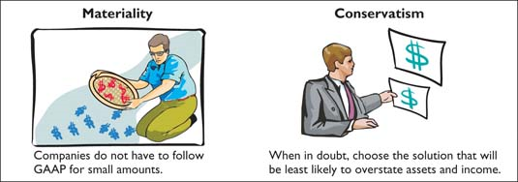
Illustration 18 Accounting constraints

### End of Topic 3 ###

Topic 4: Know how to record and read a simple business transaction relative to the basic accounting equation.

Reference: Weiss, E. J. & Stone, R. S. (2008). Virtual Accounting: An Accounting Primer and Computerized Simulation (5th. ed. - updated). Used with permission of the authors.

Accounting can be described as a system designed to provide financial information about economic entities that is intended to be useful in making decisions. The following summary contains examples of major users of financial information and the decisions made by each.
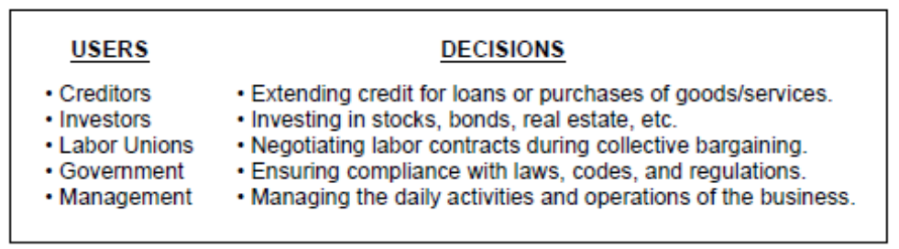

Like all systems, the accounting system consists of the input, processing, and output phases.
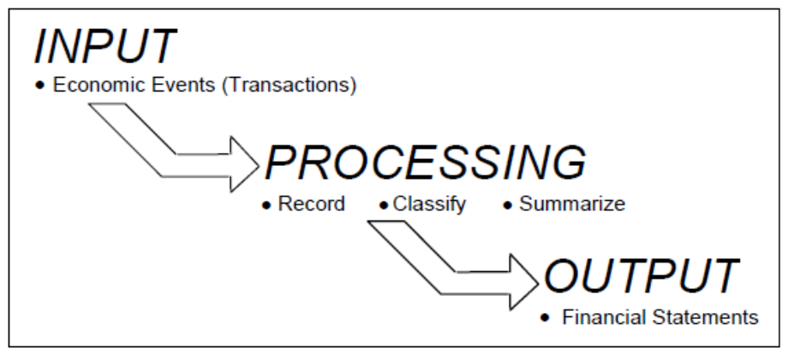

The Accounting Equation

The study of financial accounting begins with the accounting equation. For a
corporation, the accounting equation consists of

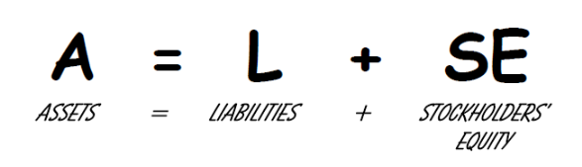

And for a sole proprietorship, the SE becomes OE (owner’s equity). Like any equation, the left side must always equal the right side. Assets must always be equal to liabilities plus stockholders’ equity. Assets represent the resources of the business, and liabilities and stockholders’ equity represent the sources of these assets (from where the assets were obtained). Another version of the accounting equation is


An equity is a claim on the assets of the business. Liabilities represent claims on the
assets by creditors. And stockholders’ equity represents claims on the assets by the
stockholders (owners of the business).

The terms “asset” and “liability” also have formal definitions. An asset can be
defined as a probable future economic benefit that is owned or controlled. A more
simple definition is “something of value that is owned.” The most common examples
are cash and accounts receivable (money owed by customers for past goods or
services provided to them on credit).

A liability can be defined as a probable future sacrifice of economic benefits.
It represents an obligation or debt (a promise) to pay cash or provide services in the
future. The most common example is accounts payable (money owed to creditors or
vendors for past goods or services received from them on credit).

Stockholders’ equity has two components – retained earnings and capital
stock.
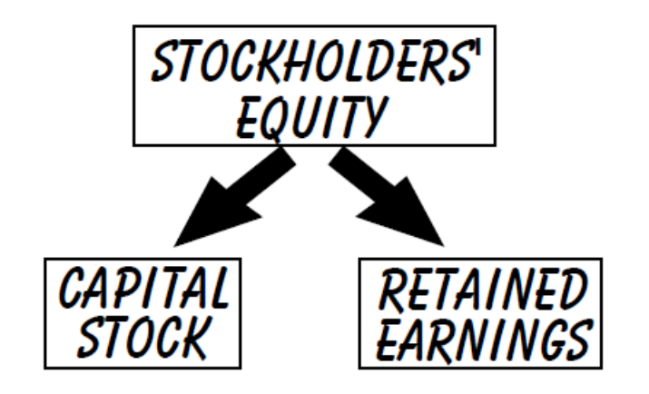

Capital stock represents the dollar amount of stock sold to investors (stockholders)
who become owners as a result of their investment in a corporation. Retained earnings represents the total net income (minus any net loss) from all prior years that have been retained (not distributed to the stockholders as dividends). Thus, the claims on the assets by stockholders are identified by what is earned (retained earnings) and by what is invested (capital stock). For a sole proprietorship, both of these components would be combined into one owner’s capital account.

Retained earnings consists of revenues, expenses, and dividends. Revenues
increase retained earnings, while expenses and dividends decrease retained
earnings.
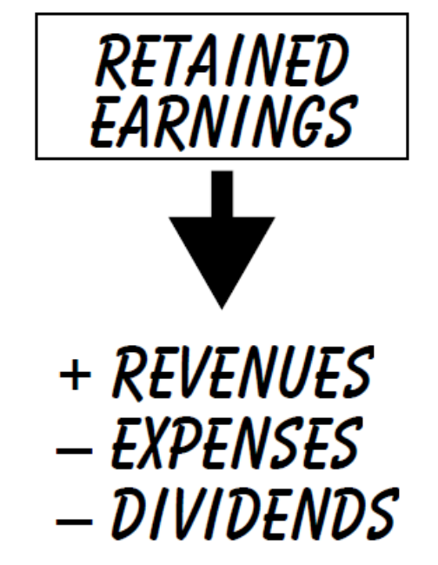

Revenues measure what is earned, most often as the result of providing goods or
services to customers. An expense represents a cost that helps to produce a
revenue. Total revenues minus total expenses equals net income (or net loss). Never treat a dividend as an expense. It is not an expense, because it does not satisfy the definition of an expense –– “a cost that helps to produce a revenue.” Revenues and expenses will be more thoroughly discussed later in this topic.

The following examples illustrate the accounting equation and how it remains balanced after recording a transaction (economic event).
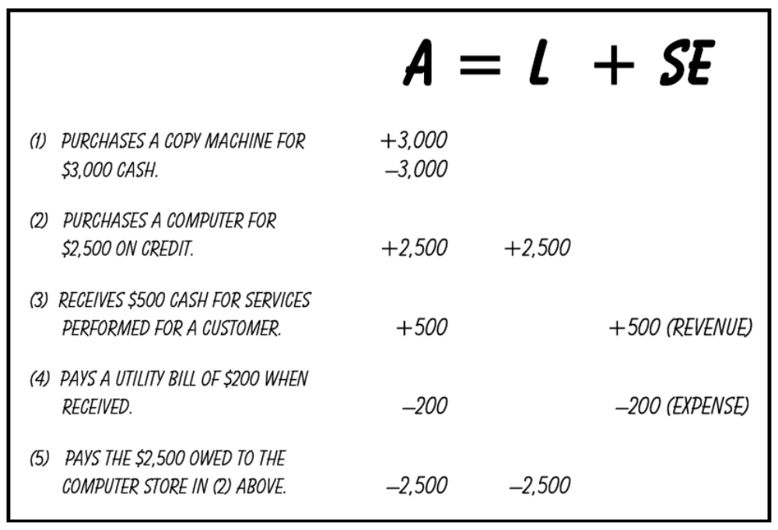

Using Debits and Credits

Debits and credits are used to record transactions. The term debit means “left side” and the term credit means “right side.” One way to illustrate debits and credits is through the use of T-accounts. A T-account is a learning and teaching tool (and often an analytical tool) used to represent an account in the general ledger. The debit is recorded on the left side of the T-account and the credit is recorded on the right side.

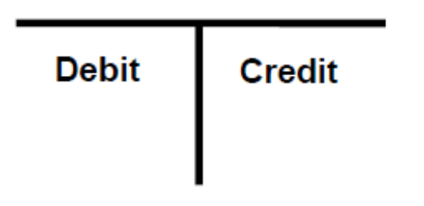

To help you remember how to record debits and credits, the following learning aid might help: A debit (defined as left side) is used to increase the left side of the accounting equation (assets) and a credit (defined as right side) is used to increase the right side of the accounting equation (liabilities and stockholders’ equity).

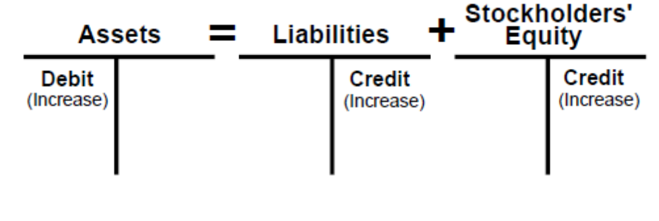

The debit or credit side that increases the T-account is called the normal balance, because this is the balance you would expect to find at the end of the accounting period. For example, you would expect the normal balance for an asset to be a debit.

Of course, if a debit increases assets, then a credit has the opposite effect – it decreases assets. Likewise, if a credit increases liabilities and stockholders’ equity, then a debit has the opposite effect – it decreases liabilities and stockholders’ equity.

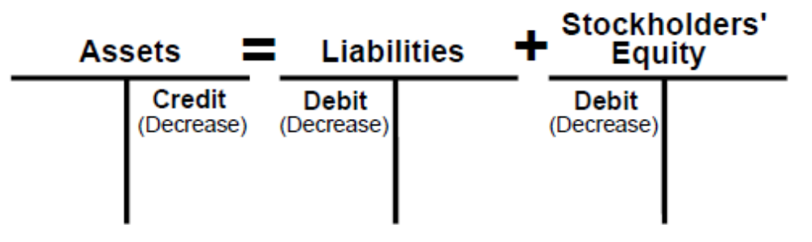

As previously explained, stockholders’ equity is comprised of capital stock and retained earnings. Therefore, if stockholders’ equity has a normal “credit” balance, capital stock and retained earnings will also have a credit balance, because each increases stockholders’ equity.

The use of debits and credits with revenues, expenses and dividends is most easily explained by examining retained earnings. If retained earnings has a normal “credit” balance, and if revenues increase retained earnings, then revenues must also have a normal credit balance. Likewise, if expenses and dividends decrease retained earnings, they must have a normal “debit” balance.

Thus, by combining T-accounts and an expanded version of the accounting equation, normal balances can be clearly summarized as follows:

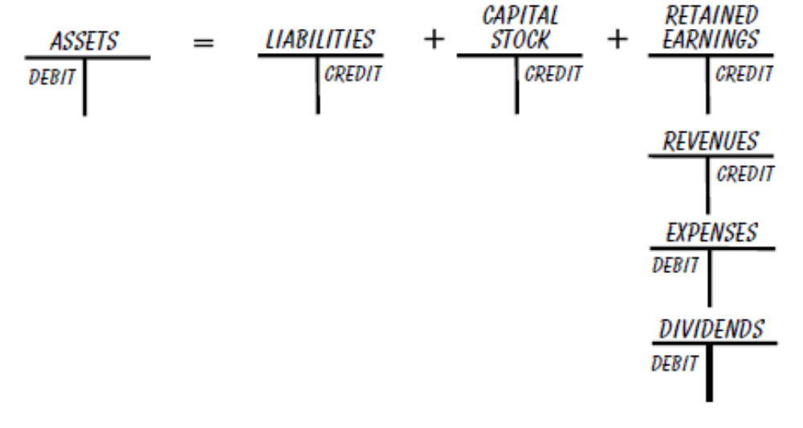

Recording Journal Entries

In practice (the real world), transactions are not recorded using T-accounts. Instead, a journal entry is recorded. This name is derived from transactions that were entered in a book called the general journal prior to the use of computers. Journal entries use accounts, which are specific names given to assets, liabilities, revenues, expenses, and other components that make up stockholders’ equity, in order to provide a more detailed record of the transaction. The names “dividends” and “retained earnings” are specific enough to be used as account names. Every business establishes a list of accounts (by name and number). This list is called the chart of accounts.

A journal entry retains the same debit (left side) and credit (right side) format as the T-account. All individual debit entries are recorded first, followed by all individual credit entries. Observe in the examples beginning on the next page that after all the debit entries have been recorded, the credit entries are indented to the right of the debit line and recorded, thus retaining the left side/right side format.

In accounting, transactions are recorded using a double-entry system. What this means is that every journal entry requires at least one debit and one credit, and the total debits must equal the total credits. Often, a transaction uses more than one debit and/or credit. This is called a compound journal entry. For example, the same transaction might require you to record three debits and two credits or some other combination.

When recording the journal entry for a transaction, a helpful approach for you to use consists of the following steps:

(a) Identify the accounts that are involved (ask what was given up and what was received);

(b) Determine whether the balances in these accounts have increased or decreased;

(c) Record the debits and/or credits required to increase or decrease these accounts.

To illustrate how debits and credits are used to record transactions, we will use the same five transactions that were analyzed earlier in this topic. For each transaction, the correct debit and credit will be recorded using both a T-account and a journal entry.

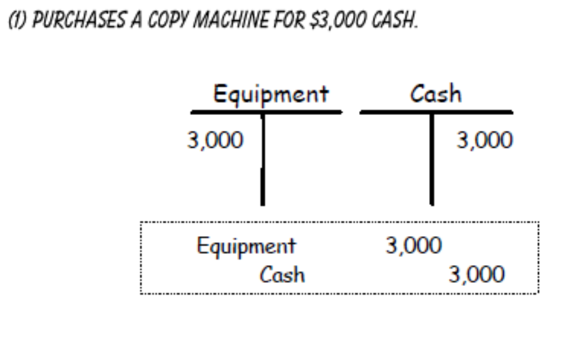

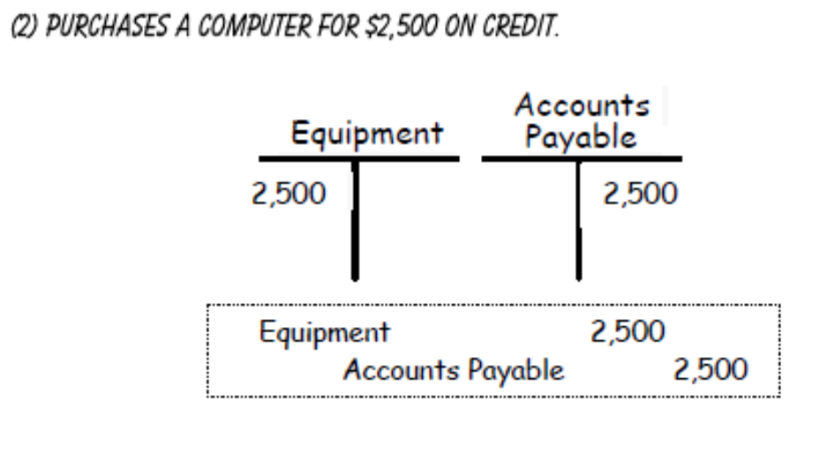

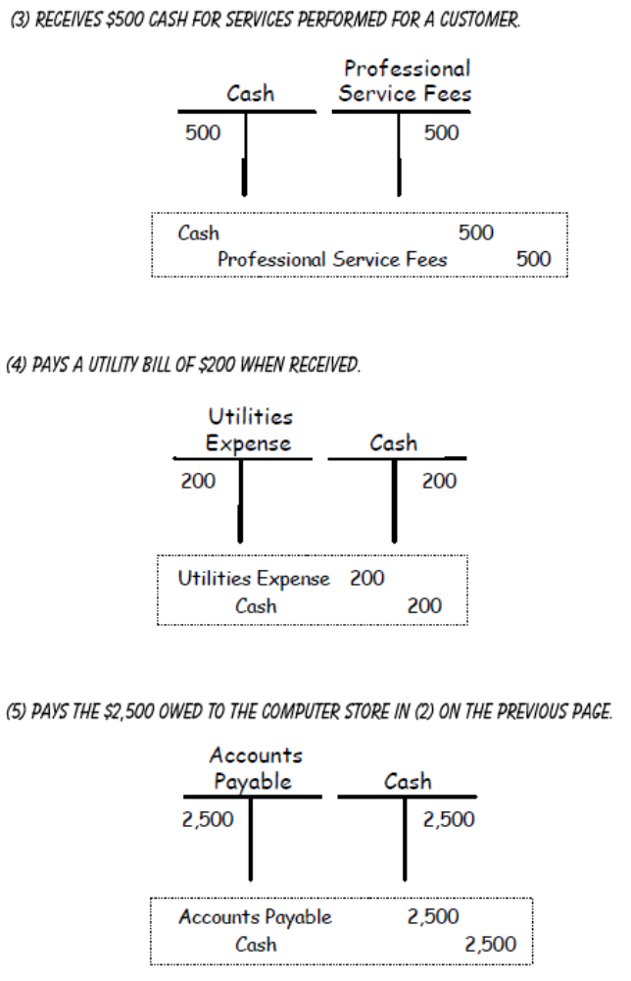

### End of Topic 4 ###

Topic 5: Compute the cash flow and GAAP income on a set of transactions.

Reference: Weiss, E. J. & Stone, R. S. (2008). Virtual Accounting: An Accounting Primer and Computerized Simulation (5th. ed. - updated). Used with permission of the authors.

The accounting cycle is a more detailed version of the accounting system that was briefly described in Topic 4. Sometimes these terms are used interchangeably. The inputs (economic events/transactions) are processed into the outputs (financial statements). The following seven steps describe the accounting cycle:

STEP ONE is to identify and analyze the transactions (economic events). This requires the existence of objective evidence to establish that a transaction has taken place. Most often, this is accomplished by analyzing source documents. Examples of source documents are invoices (bills to customers and from vendors), bank checks, purchase orders, receipts, bank statements, receiving reports, sales orders, payroll time cards, cash register tapes, contracts, deposit slips, and memoranda.

STEP TWO is to record the transaction in the general journal (and/or special journals). This journal contains pages (or data fields on a computer) of journal entries that have been made to record transactions.

STEP THREE is to post (transfer) the entries from the general journal (or special journal) to each account in the general ledger. The general ledger contains one or more pages (or data fields) for each account listed in the chart of accounts.

STEP FOUR is to prepare an unadjusted trial balance, which lists the ending balance for each account contained in the general ledger. The purpose of the trial balance is to verify that the total debits equal the total credits. It should be noted that even though they equal, this does not guarantee that the ending balance of each account is correct.

STEP FIVE is to record adjusting journal entries in the general journal and post
them to the general ledger. Adjusting journal entries are described later in this topic.

STEP SIX is to prepare the financial statements from the adjusted trial balance.

STEP SEVEN is to close the books, which is described later in this topic.
The following flowchart summarizes the accounting cycle.

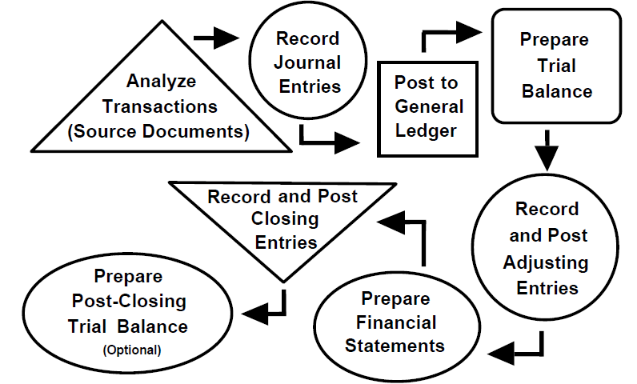
Accrual Accounting

Generally accepted accounting principles (GAAP) require the use of accrual basis accounting. The best way to describe the accrual concept is to compare it to cash basis accounting. In cash basis accounting, revenue is recognized only when cash is received, and expenses are recognized only when cash is paid. With accrual basis accounting, revenue is recognized when earned (most often when goods or services are provided) and expenses are recognized when incurred (matched to the revenues they help produce). It doesn't matter when cash is paid or received.

Using the timeline below, goods or services provided to customers in 2009 must be recorded as revenue in 2009 even if the cash is not received from the customers until 2010.

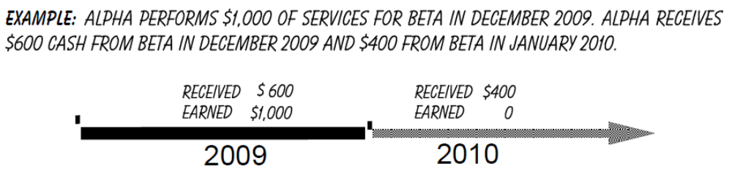

Revenue should be recognized as follows:

Cash basis accounting –– record revenue of $600 in 2009 and $400 in 2010.

Accrual basis accounting –– record revenue of $1,000 in 2009, the year in which it is earned.
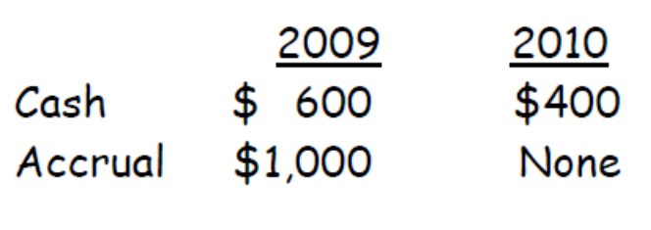

In the case of expenses, accrual basis accounting requires expenses to be matched to the revenues they help produce. Using the timeline below, expenses incurred in 2009 must be recorded in 2009 even if the cash is not paid until 2010.

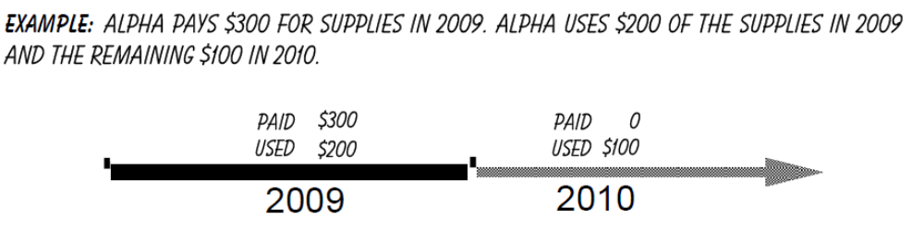

Expenses should be recognized as follows:

Cash basis accounting –– expense $300 in 2009.
Accrual basis accounting –– expense $200 in 2009 and $100 in 2010.

Adjusting Journal Entries

As previously described, to properly measure net income (revenues minus expenses) using accrual accounting, it is necessary to record all revenues in the period earned and all expenses in the period incurred (matched to the revenues they help produce), regardless of when cash is paid or received. Thus, the matching of revenues and expenses in the same accounting period is the very foundation of accrual accounting. When the same transaction affects the net income of more than one accounting period, adjusting journal entries (AJE) are used to allocate revenues and expenses to the proper periods.

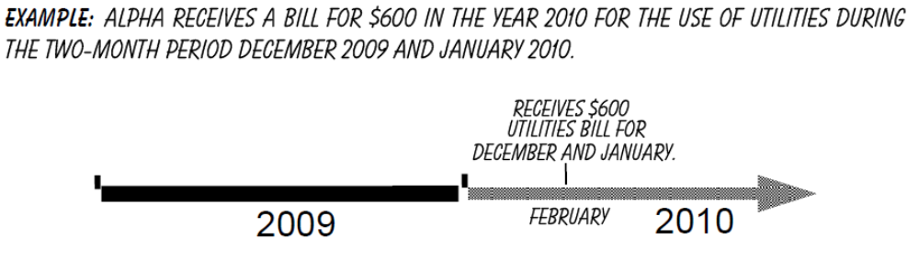
However, prior to receiving the bill in 2010, Alpha needs to prepare its financial statements for the year ending December 31, 2009. If Alpha waits until the bill arrives in February of 2010 to record the $600, the utilities expense will be overstated for the year 2010 and understated for the year 2009 by one month of utilities. The use of utilities in December 2009 helps to produce revenues in 2009 and, therefore, must be expensed (matched to revenues) in that year. This is where the adjusting process is used. But how much do we record for December? Since the bill might not be received until after the financial statements are prepared, we really don't know. One approach would be to estimate the utilities used for December and expense it using an adjusting entry. If we estimate $250 based upon December utilities from last year, the following adjustment should be recorded:

Dec 31 Utilities Expense 250
Utilities (or Accounts) Payable 250

Why do we also record a liability for $250? The reason is because we have used one month of utilities and have created an obligation as of the end of 2009 to pay in the future even though the bill has not yet been received. So remember that adjusting journal entries involve both balance sheet and income statement accounts.

The economic events requiring adjusting entries are both continuous and internal, and most often will not be evidenced by new additional source documents. Therefore, the challenge is the task of identifying those events requiring adjustments. Examples of the more common revenues and expenses you might need to adjust are listed below.
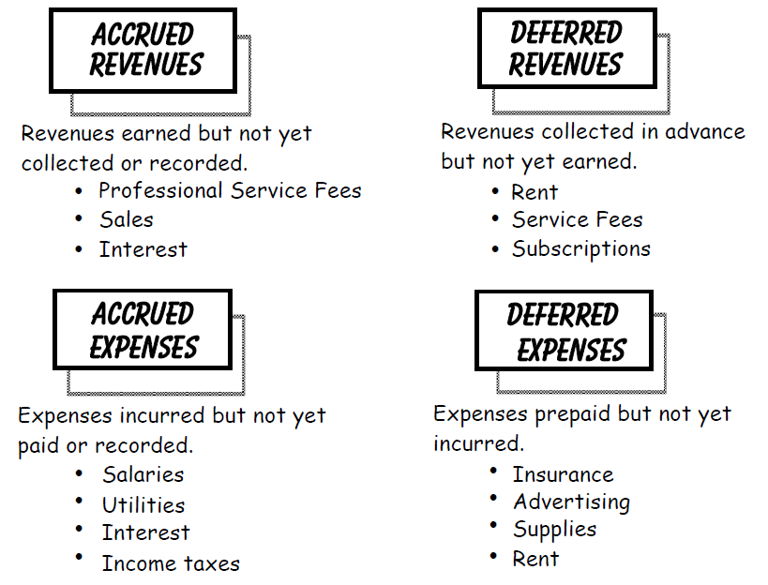

In summary, adjusting journal entries are made at the end of the accounting period to update the accounts for internal transactions, and to make sure that the financial statements reflect all the events that occurred during a specific period, thereby ensuring the proper matching of revenues and expenses.

Examples of Adjusting Entries

1. ACCRUED REVENUE – Revenue that is earned but not yet collected or recorded.

EXAMPLE: On December 1, Alpha makes a 60-day loan of $4,000 to another company. Alpha will receive interest of $100 at the end of 60 days.

Observe that by the end of the year, Alpha has earned half of the interest even though Alpha won't receive the cash until the note matures in the following year. This interest won't be reported as revenue in the current year unless Alpha records the following adjusting journal entry:

Dec 31 Interest Receivable 50
Interest Revenue 50

2. ACCRUED EXPENSE – An expense that is incurred but not yet paid or recorded.

EXAMPLE: Alpha pays employee wages of $5,000 per week. Paychecks are issued on the 2nd and 4th Friday of each month. Using the calendar below, the last payday in December is Friday the 26th.

There are three working days 29th, 30th, 31st) remaining in the current year in which labor was used to produce revenues. But this expense won’t be recorded in the current year unless Alpha records the following adjusting journal entry:

Dec 31 Salaries Expense 3,000
Salaries Payable 3,000

3. DEFERRED REVENUE – A revenue that is collected in advance of being earned (recorded as a liability until earned).

EXAMPLE: On December 1, Alpha rents one of its vacant warehouses to another company for 6 months at $1,000 per month. The total rent of $6,000 is received in advance.
NOTE: Whenever cash is received in advance, it is recorded as a liability. Why? Because a promise is being made to provide goods or services in the future in return for receiving the cash in advance. This promise creates a liability. We refer to this liability by a very unusual but accurately descriptive name –– Unearned Revenue. The original transaction on December 1 is recorded as follows:

Dec 1 Cash 6,000
Unearned Rent Revenue 6,000

By the end of the year, Alpha has earned one month of the rent that was received in advance. This rent won't be reported as revenue in the current year unless Alpha records the following adjusting journal entry:

Dec 31 Unearned Rent Revenue 1,000
Rent Revenue 1,000

Remember, the receipt of cash cannot be recognized as revenue until it is earned. Therefore, as long as it is unearned, it remains a liability.

4. DEFERRED EXPENSE – An expense that is paid in advance of being incurred (recorded as a prepaid asset until used).

EXAMPLE: On January 1, Alpha purchases a 3-year insurance policy for $3,000.

By the end of the year, Alpha has used one year or $1,000 of the insurance that was prepaid. This insurance won't be reported as an expense in the current year unless Alpha records the following adjusting journal entry:

Dec 31 Insurance Expense 1,000
Prepaid Insurance 1,000

5. DEPRECIATION – Allocates the cost of an asset to future accounting periods in which the use of the asset will help produce revenues.

EXAMPLE: Alpha purchases a $500 piece of equipment at the beginning of 2009 (the current year) which is expected to have a useful life of 5 years (ignore salvage value).

Allocating the cost of this equipment equally over five years requires Alpha to record the following adjusting journal entry each year:

Dec 31 Depreciation Expense 100
Accumulated Depreciation 100

For each of the next five years, the asset section of the balance sheet reports the following:

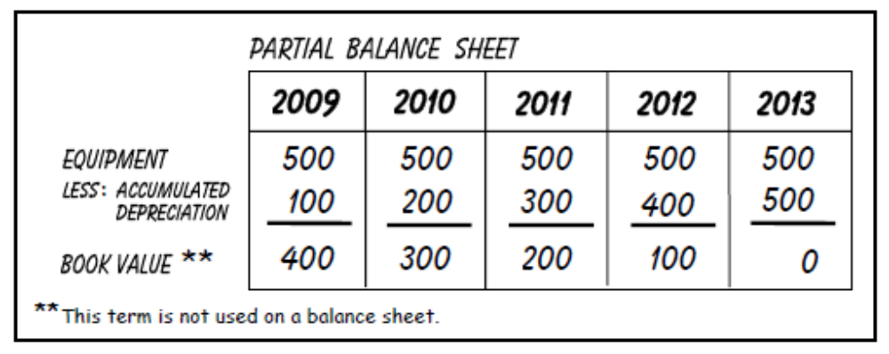

NOTE: The account “Accumulated Depreciation” is called a contra account. A contra account is used to show a reduction of another account (“Equipment” in this example) without actually reducing the balance of that account. With the use of the contra account Accumulated Depreciation, we are able to continue to disclose the original (historical) cost of the asset on the balance sheet. The difference between the original cost and the accumulated depreciation is the asset's book value. Book value represents the cost of the asset that has not been used to produce revenues and, therefore, the remaining undepreciated cost. Book value is also used to find the gain or loss from the disposal of depreciable assets. A gain results if the proceeds received are greater than the book value, and a loss results if the proceeds received are less than book value.

### End of Topic 5 ###

